***E-Fixed Deposit***

**Description**

**A global bank to introduce a few feature:**

**Current State**

**Overview and Summary**

**One of the leading banks across the globe, is ABC Bank. It has a presence in 56 countries in the world.**

**ABC Bank currently has a manual option to create fixed deposits. The bank users go to the nearest ABC Bank branch and create a fixed deposit. ABC Bank has a future vision of being a 100% online bank and wants to do away with all its manual banking processes. They have identified the need to create e-fixed deposits.**

**ABC Bank currently wants to introduce this to their existing bank users with a future plan of introducing this feature to non-ABC Bank users.**

**Advantages of opening an FD online**

* **Easy and less time-consuming: An online FD can eliminate the process of visiting the bank physically and makes the process of creating an FD an extremely easy and hassle-free process.**
* **Easy payment: Paying for the FD is extremely easy and can be done directly through net banking that makes the process of payment very convenient. All that is required is to transfer the money from the savings account to the respective FD account.**
* **Easy renewal and closure: Once an FD account is opened online, it is possible to renew and close the deposit online instantly. Therefore, it eliminates the need of going to the bank for any of these purposes.**

**ABC Bank invited Business Analysts trained at Simplilearn to capture the requirements to create this feature on their existing web portal.**

**Future State**

**ABC Bank has given them the following requirements:**

1. **The bank users can create a fixed deposit using their existing online banking account or through their existing mobile banking account.**
2. **Checklist or requirements for opening ABC Bank FD online are:**

* **A savings account with ABC Bank**
* **An online banking account**
* **A mobile banking account**

1. **User should be shown various FD rates as mentioned below:**

|  |  |  |
| --- | --- | --- |
| **Period** | **Rates for amounts <1.5 Million USD** | **Rates for amounts >=1.5 Million to < 4 Million USD** |
|  | **User Rates** | **Senior Citizen Rates** | **User Rates** | **Senior Citizen Rates** |
| **7 - 14 days** | **3.00%** | **3.50%** | **3.50%** | **4.00%** |
| **15 - 45 days** | **3.50%** | **4.00%** | **4.00%** | **4.50%** |
| **46 – 90 days** | **4.00%** | **4.50%** | **4.50%** | **5.00%** |
| **91 days – 6 months** | **4.50%** | **5.00%** | **5.00%** | **5.50%** |
| **6 months 1 day to 1 year** | **5.00%** | **5.50%** | **5.60%** | **6.10%** |
| **1 year 1 day – 2 years** | **5.60%** | **6.10%** | **5.75%** | **6.25%** |
| **2 years 1 day – 3 years** | **5.75%** | **6.25%** | **5.50%** | **6.10%** |
| **3 years 1 day – 5 years** | **5.75%** | **6.25%** | **5.50%** | **6.00%** |
| **5 years 1 day – 10 years** | **5.75%** | **6.25%** | **5.50%** | **6.00%** |

**The rate applicable to all the Senior Citizens who are 60 years of age and above will be 0.50% above the applicable rate.**

1. **There should be a fixed deposit calculator. The user will enter his/her age and the amount he/she wants to create an FD for. The FD calculator will display the maturity amount.**
2. **In cases where a user has multiple bank accounts, he/she should be able to select which account to debit for the FD**
3. **Users should be able to select one of the two maturity instructions.**

* **Renew FD for same tenor**
* **Credit maturity amount to my savings or current account.**

1. **There should be an option to create Joint FDs. In this case the name of the other customer along with his/her SSN details should be taken.**
2. **Users should have an option to enter a *nominee*. In case of a nominee, the age should be asked. If the nominee is a minor, then guardian details need to be taken.**
3. **Once the FD is created. The user should be emailed a PDF copy of the FD.**
4. **The PDF copy of the FD generated should be reflected in the online banking account and mobile banking account as well.**
5. **The bank wants to generate certain reports:**

* **Total value of FDs for users with tenor of less than 6 months.**
* **Total value of FDs for senior citizens with tenor of less than 6 months.**
* **Total value of FDs for users with tenor of between 6 months 1 day and 1 year.**
* **Total value of FDs for senior citizens with tenor of between 6 months 1 day and 1 year.**
* **Number of FDs that are more than 1.5 Million USD for normal users.**
* **Number of FDs that are more than 1.5 Million USD for senior citizen users.**

**You can download the Data sets from here. - [](https://lms.simplilearn.com/user/project/download-attachment?file=1592292572_datasetbanking.xlsx)**

**Project Task: Week 1 and Week 2 (This is on the Business Analysis concepts taught)**

1. **Identifying Stakeholders – Create a list of stakeholders (as taught in Business Analysis Planning and Monitoring Knowledge Area)**
2. **Create As-Is and Future Process map (using flowcharts). You can use any of the popular tools in the market like Microsoft Visio, Lucid Chart, Creately, Pidoco, or Balsamiq**
3. **As a Business Analyst working on this project, find out the scope of online FD creation. Write down the main features that need to be developed.**
4. **Write the in-scope and out-of-scope items for this software.**
5. **Write out the business requirements, both functional and nonfunctional requirements.**
6. **Draw wireframes or mock screens for any two of the features. Use the technique prototyping or wireframing that is taught in the training. You can use any of the wireframing tools like Microsoft PowerPoint, Microsoft Word, Balsamiq, Sketch, Adobe XD, Adobe ILLustrator, Figma, UXPin, InVision Studio, Invision Freehand, or Moqups.**

**Project Task: Week 3 (This is on the Tableau concepts taught)**

|  |  |  |  |  |  |  |
| --- | --- | --- | --- | --- | --- | --- |
| **Product**  **Code** | **JAN** | **FEB** | **MAR** | **APR** | **MAY** | **JUNE** |
| **HDH** | **64,726,472** | **54,726,472** | **65,444,578** | **73,565,954** | **78,787,787** | **15,151,518** |
| **SDF** | **78,787,777** | **68,787,777** | **58,451,511** | **42,959,494** | **15,484,844** | **78,451,215** |
| **FSF** | **45,454,541** | **25,454,541** | **15,151,544** | **4,545,454** | **33,565,954** | **53,565,954** |
| **SEE** | **45,444,578** | **65,444,578** | **78,785,111** | **65,444,578** | **32,959,494** | **52,959,494** |
| **SFS** | **78,451,511** | **58,451,511** | **15,151,518** | **58,451,511** | **25,851,151** | **45,454,544** |
| **ZXD** | **12,121,451** | **2,121,451** | **78,451,215** | **15,151,518** | **65,444,578** | **33,333,333** |
| **DSF** | **15,484,844** | **1,484,844** | **3,565,595** | **78,451,215** | **58,451,511** | **65,444,578** |
| **DST** | **45,597,911** | **65,597,911** | **23,565,954** | **4,848,444** | **15,184,848** | **58,451,511** |
| **YFF** | **9,451,664** | **19,451,664** | **22,959,494** | **9,595,999** | **29,595,944** | **18,518,111** |

1. **Create a dashboard for senior management to view FDs created over the last 6 months. Make assumptions as appropriate and create the dashboard using your own mock data. For any missing data, make your assumptions to create mock data. Write down the assumptions as well.**

**Excel**

**Question 1:**

|  |  |
| --- | --- |
| **Period** | **Rates for amounts <2 crores** |
|  | **User FDs created worth:** | **Senior Citizen FDs created worth:** |
| **7 - 14 days** | **64,726,472** | **998,989,888** |
| **15 - 45 days** | **78,787,777** | **245,454,541** |
| **46 – 90 days** | **45,454,541** | **345,444,578** |
| **91 days – 6 months** | **45,444,578** | **478,451,511** |
| **6 months 1 day to 1 year** | **78,451,511** | **512,121,451** |
| **1 year 1 day – 2 years** | **12,121,451** | **315,484,844** |
| **2 years 1 day – 3 years** | **15,484,844** | **115,484,844** |
| **3 years 1 day – 5 years** | **45,597,911** | **145,597,911** |
| **5 years 1 day – 10 years** | **9,451,664** | **19,451,664** |

1. **Create a bar graph showing the FD sales for different periods of investment. Draw two bar graphs: one for normal users and other for senior citizens. label the chart drawn correctly so that senior management gets a clear report of sales.**
2. **Arrange the data above in excel in an ascending and descending order.**

**Question 2:**

|  |  |  |  |
| --- | --- | --- | --- |
| **Period** |  | **Rates for amounts <2 crores** | **Rates for amounts >=2 Crore to < 5 Crores** |
|  | **Product**  **Code** | **User Rates** | **Senior Citizen Rates** | **User Rates** | **Senior Citizen Rates** |
| **7 - 14 days** | **HDH** | **3.00%** | **3.50%** | **3.50%** | **4.00%** |
| **15 - 45 days** | **SDF** | **3.50%** | **4.00%** | **4.00%** | **4.50%** |
| **46 – 90 days** | **FSF** | **4.00%** | **4.50%** | **4.50%** | **5.00%** |
| **91 days – 6 months** | **SEE** | **4.50%** | **5.00%** | **5.00%** | **5.50%** |
| **6 months 1 day to 1 year** | **SFS** | **5.00%** | **5.50%** | **5.60%** | **6.10%** |
| **1 year 1 day – 2 years** | **ZXD** | **5.60%** | **6.10%** | **5.75%** | **6.25%** |
| **2 years 1 day – 3 years** | **DSF** | **5.75%** | **6.25%** | **5.50%** | **6.10%** |
| **3 years 1 day – 5 years** | **DST** | **5.75%** | **6.25%** | **5.50%** | **6.00%** |
| **5 years 1 day – 10 years** | **YFF** | **5.75%** | **6.25%** | **5.50%** | **6.00%** |

1. **Using vlookup for product code HDH, find the rate for senior citizens for amounts less than 2 crore.**
2. **Using vlookup for product code YFF, find the rate for senior citizens for amounts less than 2 crore.**

**Project Overview**

One of the leading banks across the globe, is ABC Bank. It has a presence in 56 countries in the world.

ABC Bank currently has a manual option to create fixed deposits. The bank users go to the nearest ABC Bank branch and create a fixed deposit. ABC Bank has a future vision of being a 100% online bank and wants to do away with all its manual banking processes. They have identified the need to create e-fixed deposits.

ABC Bank currently wants to introduce this to their existing bank users with a future plan of introducing this feature to non-ABC Bank users.

Business Analysis Core concept model

|  |  |
| --- | --- |
| Business Need/  Problem Statement | * Implement e-fixed deposits to streamline the internet banking process. |
| Change | * Initially introduce e-fixed deposits to existing bank users. * Future expansion to include non-ABC Bank users. |
| Solution | * Develop a secure online platform for e-fixed deposits. * Pilot the feature with existing customers. * Gather feedback and optimize the process. * Launch the feature to a broader audience, including non-ABC Bank users. |
| Objectives | * Provision to create a fixed deposit using their existing online acc. * Provision to create a fixed deposit using their existing mobile acc. * Provision to create joint FD Allows hassle free, easy, and less time-consuming process of creating a FD * Making payment to FD though online process making it more secure for the bank users * Easy Renew paperless process * Credit maturity amount to user's savings or current account * Reduced time to generate daily reports as the process is automated and the records are generated real time |
| Stakeholder | Onion Peel Diagram: |
| Outcome | * Transition to a 100% online bank. * Eliminate all manual banking processes. * Enhance user convenience and accessibility. * Reduce operational costs associated with manual processes. * Position ABC Bank as a leader in digital banking. |

As - Is

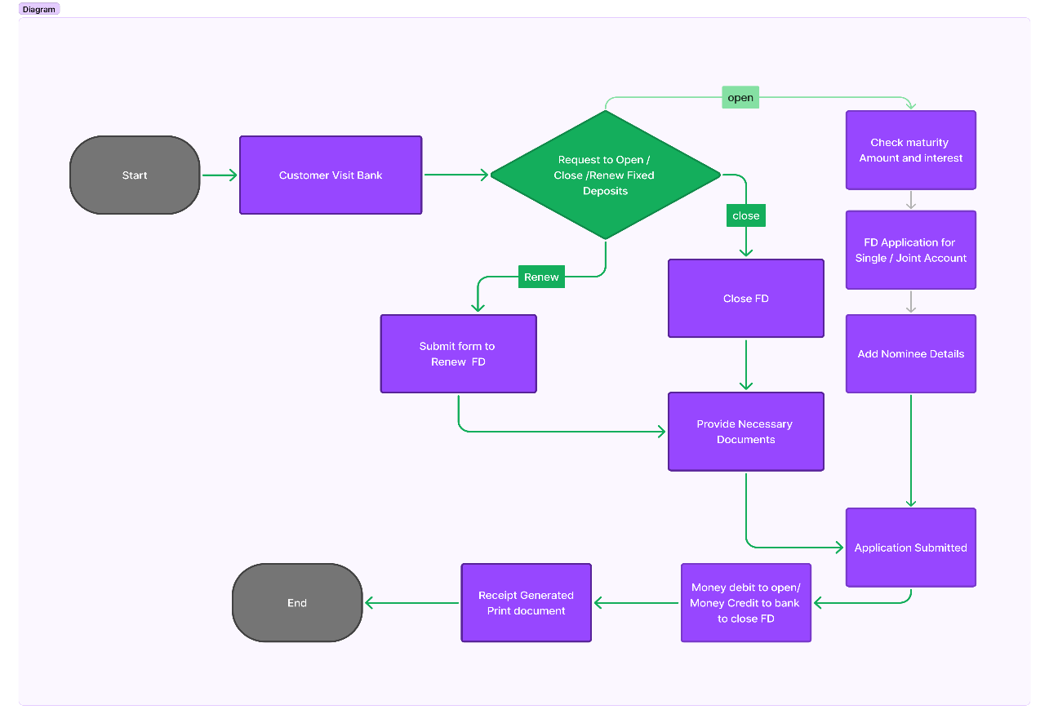

Future State : 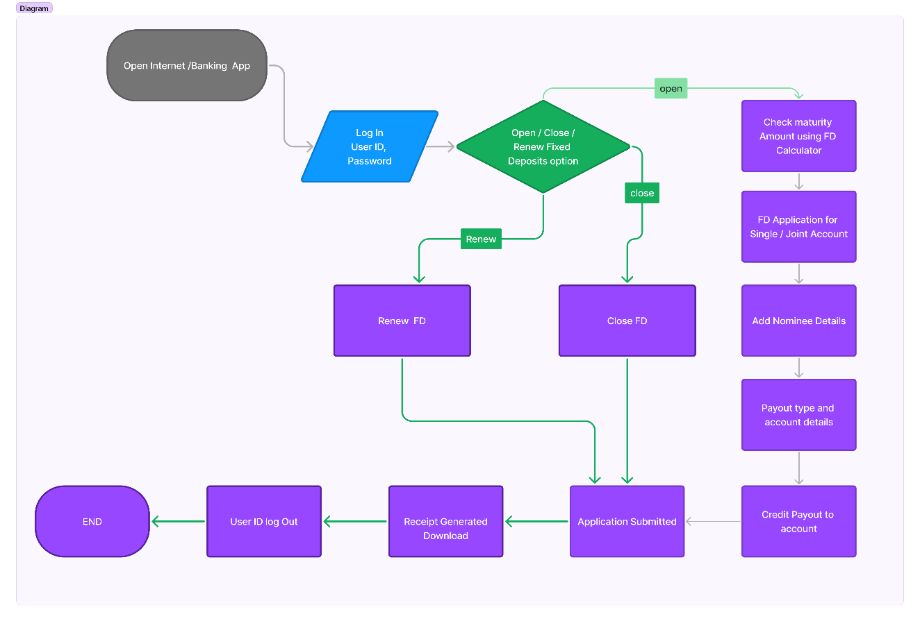

Main Features to be developed:

1. Feature to create Online FD using existing mobile banking account.

2. Feature to upload require documents from application itself.

3. Feature to check various FD rates on online portal.

4. Feature of FD calculator to calculate maturity amount.

5. Feature to select required bank account for auto debit of FD amount in case of multiple bank accounts.

6. Feature to create joint FDs and capability of entering other person's SSN details.

7. Feature to add nominee details along with age, gender, and relationship.

8. Feature to break FD online without visiting bank.

9. Feature to renew FD which was opened online without visiting bank.

10. Feature to view PDF copy of FD generated on online account and send copy of same automatically on user's Email.

11. Feature to generate various reports as required by the management.

Functional Requirements:

1. **FD Calculator**:
   * Users can input age/years  and FD amount.
   * Calculator displays the maturity amount.
2. **Multiple Bank Accounts**:
   * Users can select which account to debit for the FD.
3. **Maturity Instructions**:
   * Option to renew FD for the same tenor.
   * Option to credit maturity amount to savings or current account.
4. **Joint FDs**:
   * Capture joint customer's name and SSN.
5. **Nominee Option**:
   * Capture nominee's age.
   * If the nominee is a minor, capture guardian details.
6. **Email Notification**:
   * Send PDF copy of FD to user upon creation.
7. **Online Banking Integration**:
   * Reflect the PDF copy of FD in online and mobile banking accounts.

Non-Functional Requirements

1. **Performance**:
   * Ensure quick and responsive calculations for the FD calculator.
   * Support seamless selection and processing for multiple bank accounts.
2. **Usability**:
   * User-friendly interface for entering FD details and selecting options.
   * Easy-to-access PDF copies in online and mobile banking accounts.
3. **Security**:
   * Secure handling of personal information, SSN, and account details.
   * Robust encryption for data storage and transmission.

|  |  |
| --- | --- |
| **In Scope** | **Out Scope** |
| * E-Fixed Deposit Creation:   + Online FD creation via web and mobile banking.   + Display of various FD rates based on amount and tenure. * FD Calculator:   + Calculate maturity amount based on user's age and FD amount. * Account Selection:   + Option to select the account to debit for FD. * Maturity Instructions:   + Renew FD for same tenor.   + Credit maturity amount to savings/current account. * Joint FDs:   + Capture joint customer's name and SSN details. * Nominee Option:   + Collect nominee’s age and guardian details if nominee is a minor. * Email Notification:   + Send PDF copy of FD to user upon creation. * Integration with Banking Systems:   + Reflect the PDF copy of FD in online and mobile banking accounts. * Reporting:   + Generate reports for FD values and counts based on specific criteria. | * Non-ABC Bank Users:   + - Initially, the feature will be limited to existing ABC Bank users.     - Expansion to non-ABC Bank users will be part of future plans. * In-branch Services:   + - All related processes and services will remain manual for now. * Third-party Integrations:   + - Any integrations with external financial services or platforms. * International Regulations:   + - Handling of international regulatory compliance for FD products. |

Excel Task

**Create a bar graph showing the FD sales for different periods of investment. Draw two bar graphs: one for normal users and other for senior citizens. label the chart drawn correctly so that senior management gets a clear report of sales.**

**Arrange in descending order**

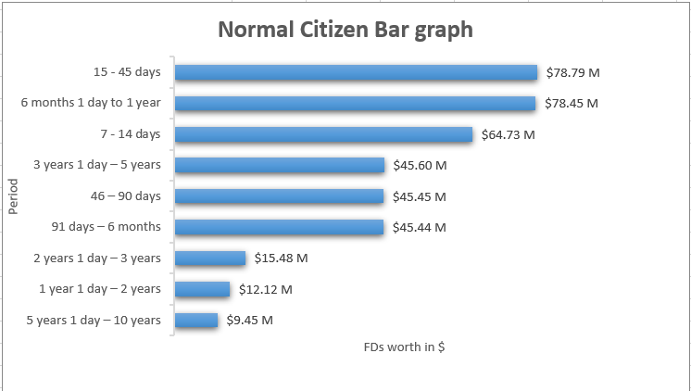

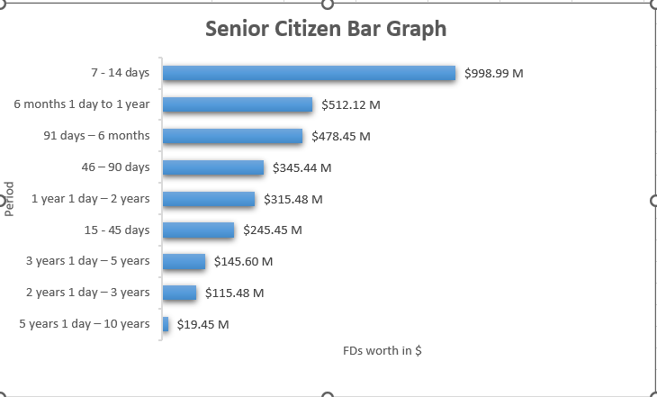

**Using vlookup for product code HDH, find the rate for senior citizens for amounts less than 2 crore.**

**Using vlookup for product code YFF, find the rate for senior citizens for amounts less than 2 crore.**

