Database Re-creation/Restore workflow

Here is the high level workflow of the data migration process:

# Follow the steps below to recreate/restore Chronozoom database

1. Login into Azure management portal – <http://windows.azure.com> – you need to have username and pwd for this. Please contact Kalpanav or Ddalal or v-palav for credentials
2. **Create BacPac from Source SQL Azure server:**
   1. In the management portal, select database option from the left menu

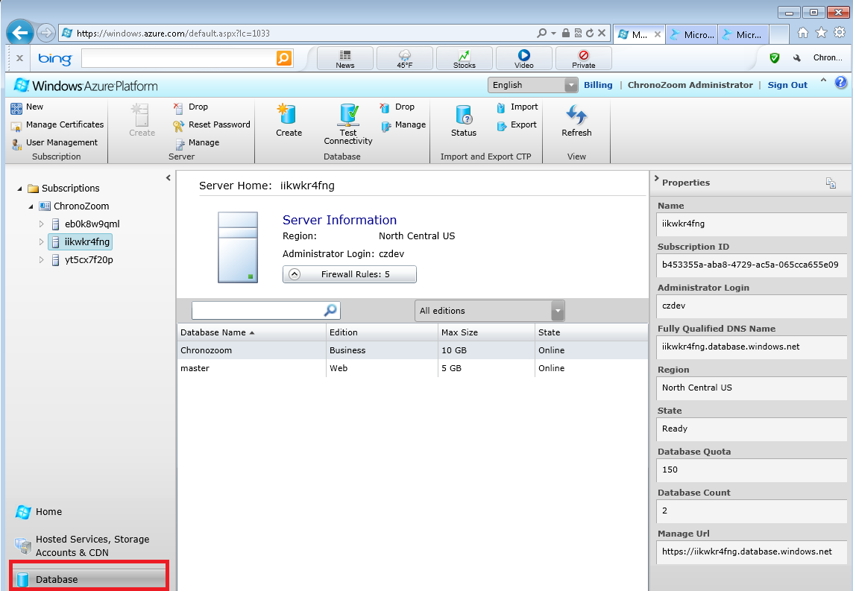

* 1. Select the current production SQL Server (iikwkr4fng) and choose Export from the menu on top

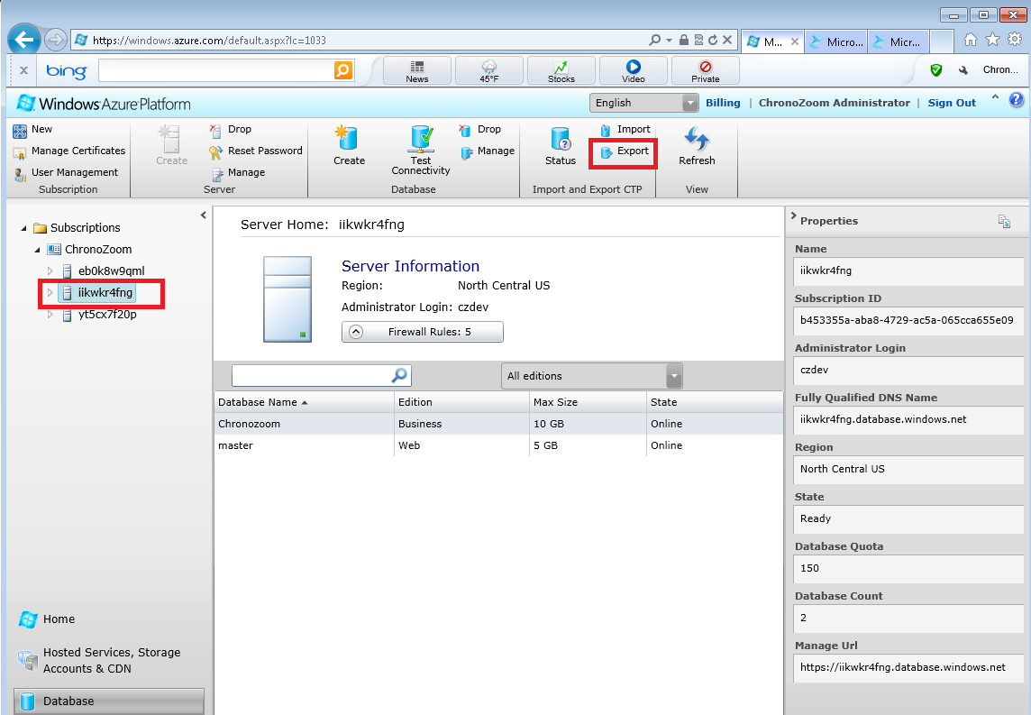

* 1. In the export dialog box, provide the sql user credentials (czdev is the username) and the blob url (<http://czbeta.blob.core.windows.net/database/czbackup<date>>). You need to have the primary key of the blob store as shown below

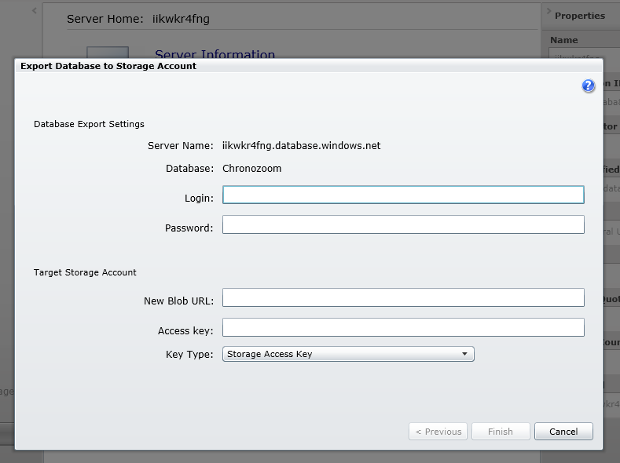

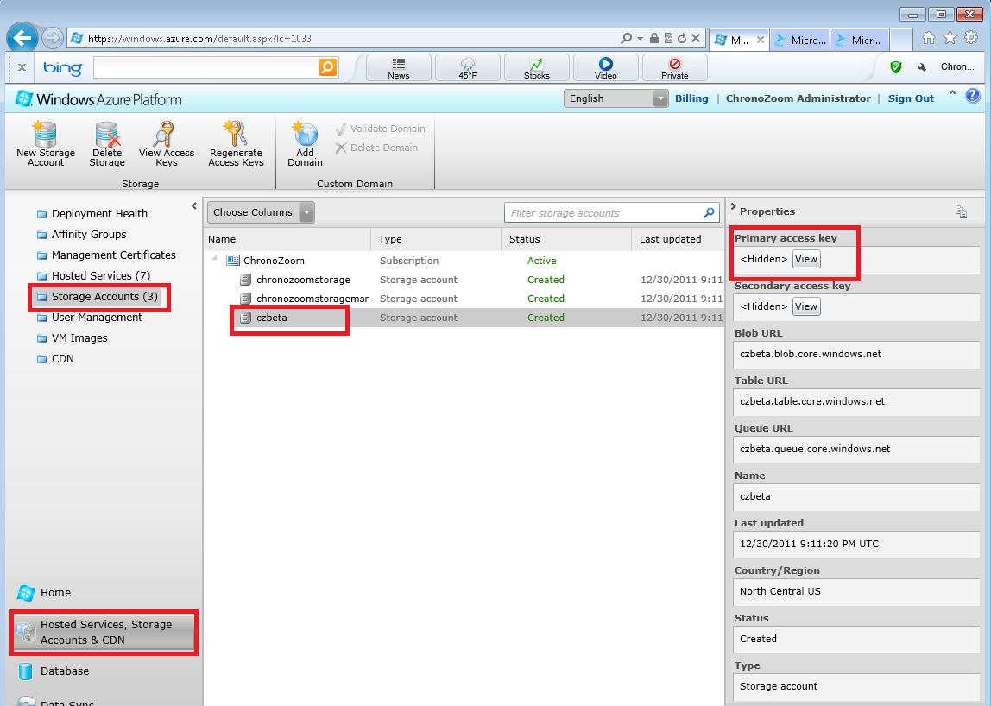

* 1. Click Finish on the export dialog box, you will then see a message to check status on this export.
  2. To check the status go back to management portal, database and select Status

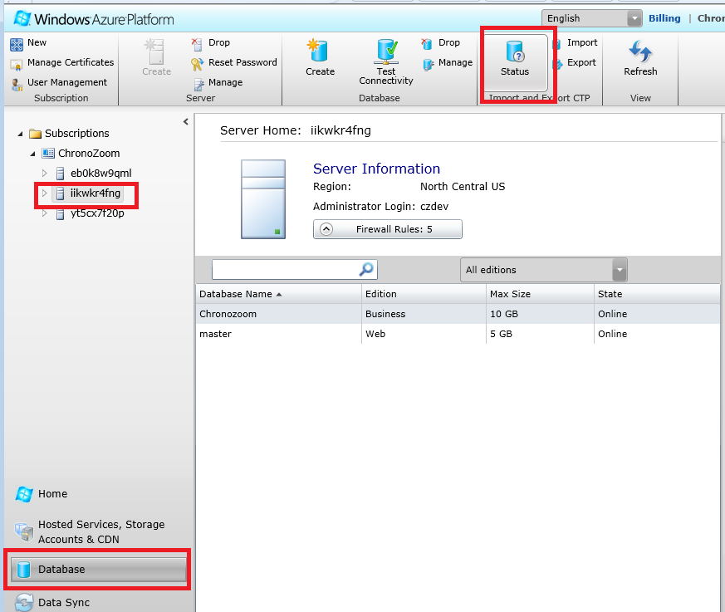

* 1. Status will be show completed when done

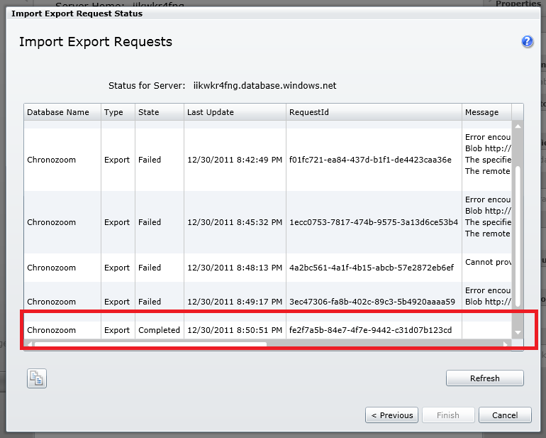

* 1. You have now created the bacpac file in the blob store. If you are familiar with Azure Storage Explorer – you can use that tool to verify the file did get created in Blob – this is optional.

1. **Import BacPac to target SQL Azure server:**
   1. Select the target SQL Azure server to recreate/import this bacpac – select import

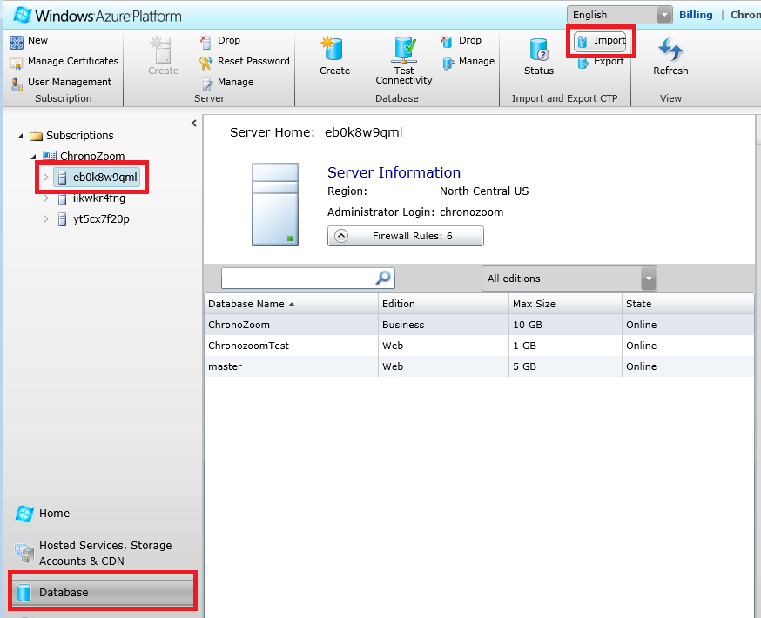

* 1. Provide the credential and blob url to import from – as shown in the diagram below

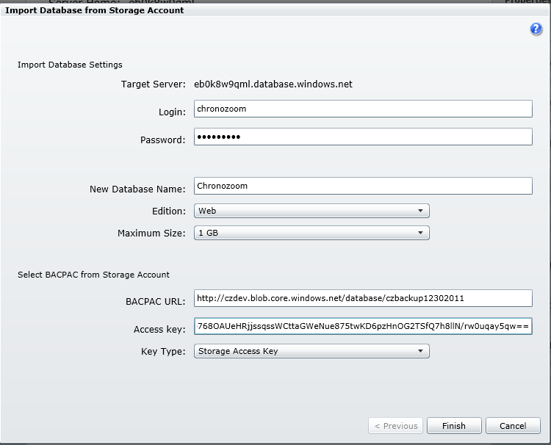

* 1. Click finish, you will then see a message to check status on this import.
  2. To check the status, go back to management portal, database and select status as shown

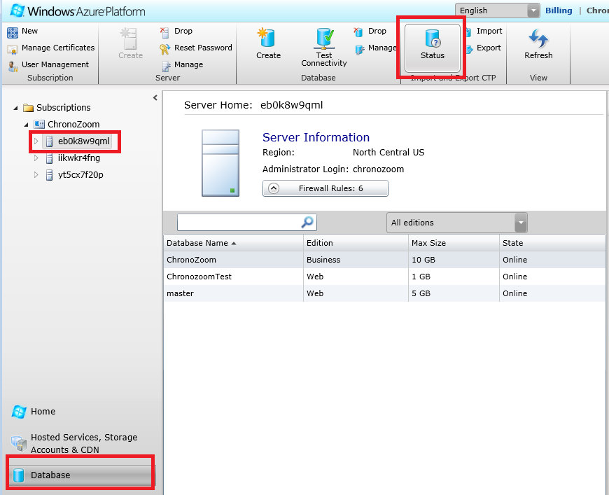

* 1. Provide the SQL database credentials and then status will show completed when done.
  2. You have now successfully restored/recreated the chronozoom database with content.
  3. To verify, go back to management portal and check the database.