PRODUCT PRICE PREDICTION USING NEURAL NETWORKS AND ENSEMBLE META-FEATURE ANALYSIS
-Ajay kannan and Sabthagirivasan V
2014103618 & 2014103019

The project is based on predicting the cost price of a given garment, which is supplied to the system in the form of images (Jpeg) as in the DATA (see link for downloading the same). The images are processed through regression using neural networks and the cost for the garment are predicted as the final ouput. As a further add-on, meta features pertaining to these garments, along with the predicted value are further analysed using SVR regression approach for yeilding a better accuracy in prediction.

IMAGE DATASET

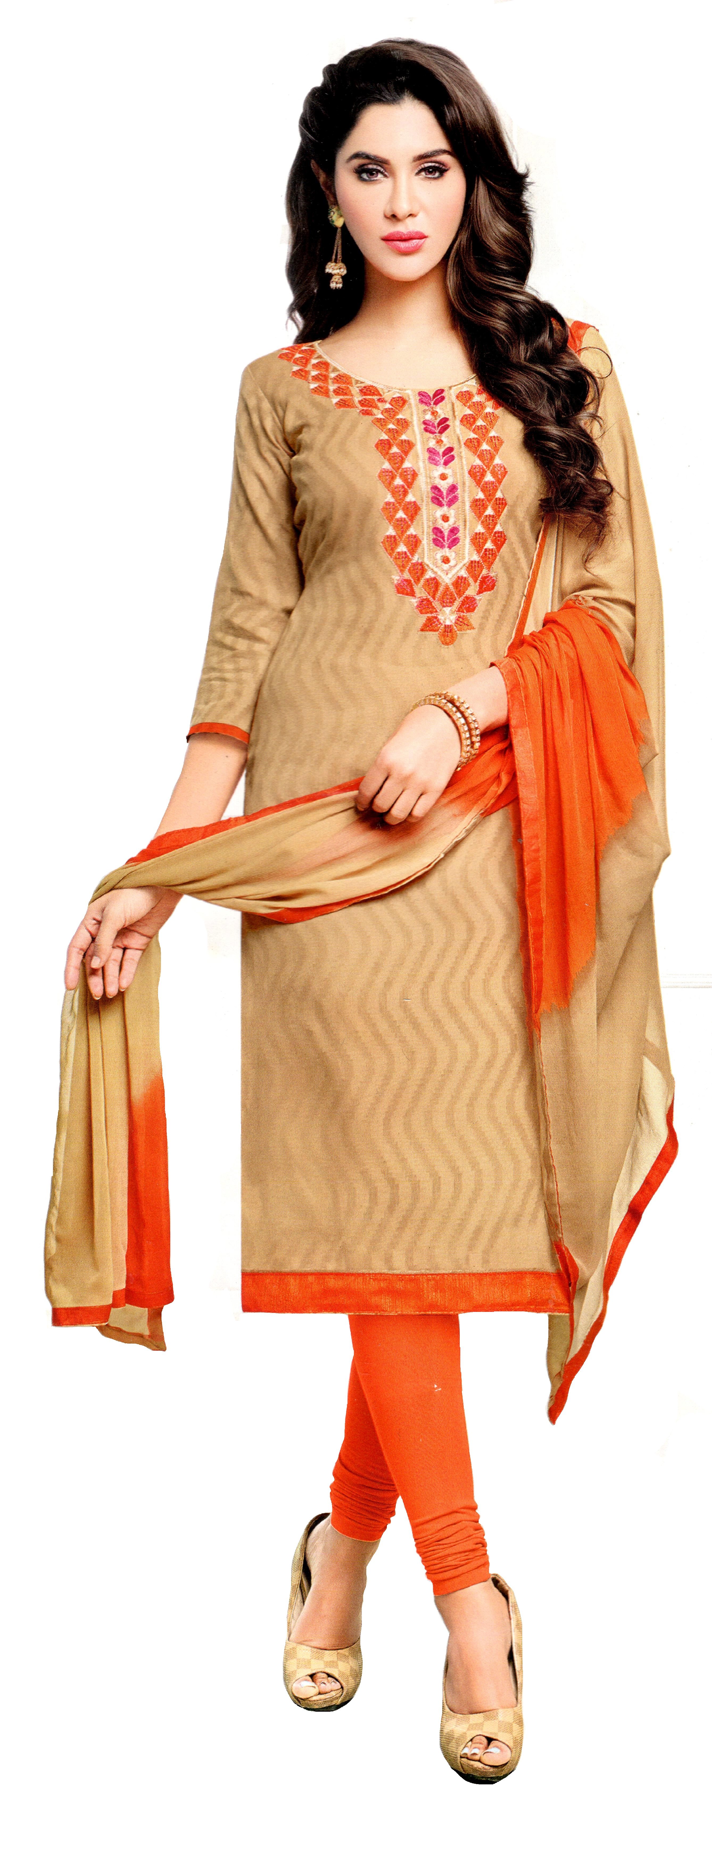
The images are of two types sets, where the first containst the set of images which are pre-processed through background elimination while the other set contains images with the background. The images in both datasets are images of women wearing the garments whose price needs to be predicted.

The images are in the form of JPG format and are of varying resolutions. A sample image is shown below. (AKIRA Folder image)

The image shown here is an image where the background been eliminated using the paint tool and only the required garment is processed.

The images in the second data set contain images including the background which in turn affect the memory size of the image.


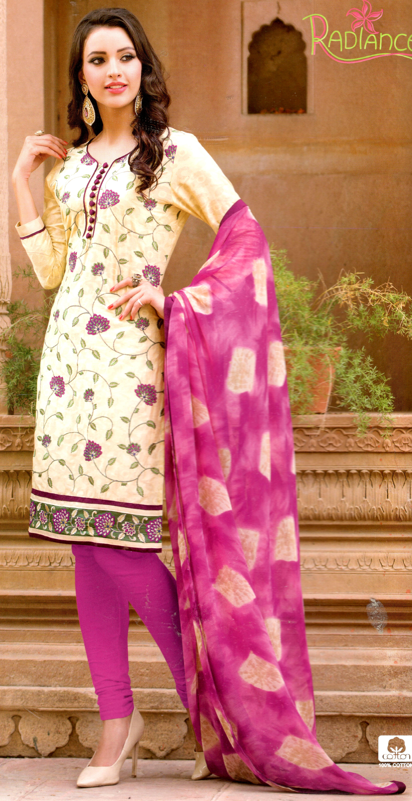

The above 2 are examples of images which contain unwarranted background which only inherits the accuracy in which the price can be predicted. But to validate this premise both datasets have been tested and validated.

Since these images are of varying resolution, they have been resized usinf the PIL libraray. Using anti-alisasing downsampling method, the images have been resized to 30x30x3 (or an alterante 50x50x3) due to hardware constraints.

An example of a downsampled image has been shown below.
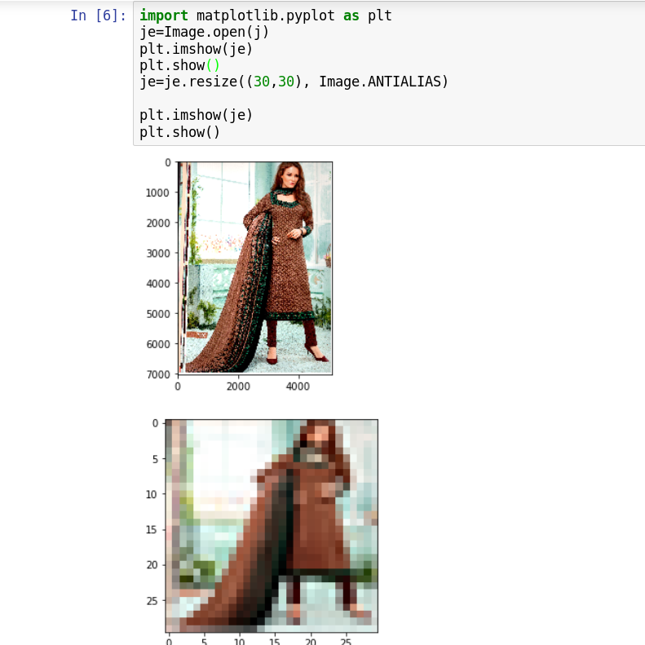

The example above has been resized to 30x30 while it could also be resized to other dimension, thus making the dimensionality itself as a hyper-parameter. Yet, we have just seen the same for 2 cases as mentioned above due to hardware constraints.

PREDICTION USING NEURAL NETWORK

The reduced images are passed through a feed forward neural network which uses 3 hidden layers to process the images. The input layer contains the same number of nodes as that of the number of pixels in the images. Hence the images are flattens into a 1-Dimensional Array which is then sent through the network. The ouput layer is a single node which is the prediction of the price.

The neural network is trained based on the ground truths for each image over 10 epochs for 90% of the dataset (being the training set) and is tested for the remaining 10%.

The neural networks have been tested using the activation functions ReLu and Sigmoid alone, using the optimizers Adam, Adagrad and SGD. The results for the same have been shown below, which showcase the Mean Squared Error Percentage.

The optimisation in loss from training for the training data for all the three optimizers is shown below through ten epochs.
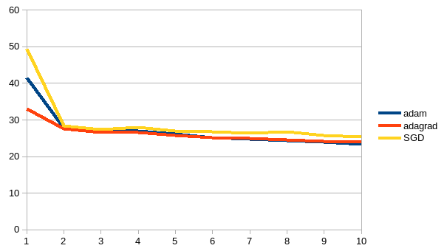
The garph is taken for 30x30x3 images.

This graph is taken for 50x50x3 images.

The above graphs prove that the neural network is able to learn and train in the data set.

META FEATURE ANALYSIS

Since, the nerual network as a stand alone does not yeild a good efficiency. Hence with the suppliment of 3 specific meta features namely, Work, Height and Celebrity status, the output from the neural network is trained through a regression method, SVR using an RBF Kernal which further predicts a new price for the product. This emsemble approach hopes to improve the accuracy of the system and is validated in the graphs below.

The graph below showcases the accuracy percentage of the system through various combinations of parameters for the data set pertaining to images without background.

The below graph is for the set with background.

DISCUSSIONS & FUTURE WORKS

1) The datasets prove to be efficient when the background has been eliminated.
2) The accruacy also proves to be higher when the images have been reduced to 30x30x3 rather than the higher dimensional 50x50x3.
3) The best efficiency proves to be the ReLu activation along with an adagrad optimizer, when background has been eliminated.
4) The images can also be processed through convolutional neural networks.
5) The images can be resized to a larger dimensionality with a better hardware resource.
6) The images can be fed along with further analysed meta features.
7) The images which lie outside the error can be visualised in the below graph.

8) When the background is not eliminated, the results show that image processing without meta features yields better accuracy.

