A Beginner’s Guide to Web Scraping Methodology- Regular Expressions

Broadly speaking, the extraction methodology to extract items of interest from a document has two distinct phases:

- A manual Analysis Phase
- An automated Implementation Phase

1. Analysis Phase:

1.1. Conceptual Modeling:

The user begins the analysis by identifying items of interest in a document that he/she wishes to extract. Having a conceptual model of the items in the document facilitates this. An elegant and intuitive way of modeling the document is to view the document as a collection of abstract objects. Each object is associated with a set of attributes.

Example 1:
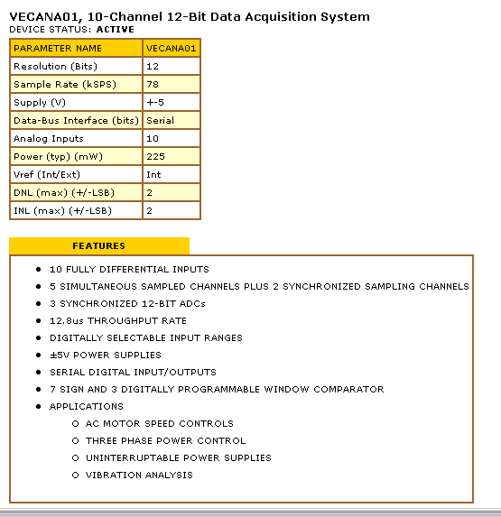

Figure 1
In Figure 1 we have two tables – a specification table (the top one) and a features table (the bottom one). The specification table denotes the parameters of an electronic chip for data acquisition while the bottom table presents its features and applications. From a modeling perspective we can view it as two collections of objects denoting the top and bottom tables, respectively. The attributes of the first set of objects are the parameters in the specification table while the features constitute the attributes of the second set of objects.

1.2. Extraction Plan:

From an extraction viewpoint the object model provides two key pieces of information. Firstly, it denotes the items of interest that will be extracted from the document and the types of their values. Secondly, it conveys how these items are structured within the document. The next decision to make is how to extract these items and their attribute values. Towards this end we will define some useful concepts. We will begin with regular expressions.

(I) Regular Expressions -
Regular expressions, denoted as RE’s, are a language to specify patterns. A regular expression engine uses these patterns to parse, interpret and search and replace text.

Example 3:
The regular expression \$[0-9]+(\.[0-9][0-9])? Matches any dollar amount in the text that may be followed by a decimal point followed by two digits such as $10.23, $105, etc.

Remark: Read the documentation on regular expressions accompanying this tutorial for an overview of this topic.

The core technology used for extraction is based on regular expressions. In particular, patterns used for extracting attribute values of objects are specified as regular expressions.

Example 4:
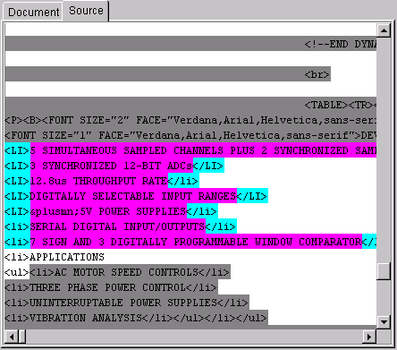
<[Ll][Ii]>([^<]*?)</[Ll][Ii]>
(regular expression)
Figure 3
Figure 3 depicts a fragment of the HTML source view of the bottom table of Figure 1. Applying the regular expression to the right of the figure results in matching each of the values between a <LI> and </LI>.

(ii) Magnets and Transducers:

These are two concepts used in extraction. If items in the document appear in a regular, tabular format, with each item having all the attributes, the best method of extraction uses a transducer, which is a single pattern that extracts all the attributes of each item. If all attributes were not present in all items, a better approach to extraction would be through the use of magnets. A magnet is a pattern that extracts a particular attribute. For example, if the items to extract were books, there might be a title magnet, a price magnet, and an author magnet.

Example 5 - (Magnet)

Applying the magnet <[Ll][Ii]>([^<]*?)</[Ll][Ii]> to the features table in Figure 1 will extract all of the 8 feature values. Note that the sub-expression ([^<]*?) specifies the pattern to match the feature value. The rest of the expression surrounding it specifies the context within which the feature value appears in the source text.

Example 6 – (Transducer)

To extract the parameter name and value from the top table in Figure 1 we use the following regular expression:

<TR><TD BGCOLOR="#FFFF[^>]*?"><FONT SIZE="1" FACE="Verdana,Arial,Helvetica,sans\-serif">([^<]*?)</FONT></TD> <TD BGCOLOR="#FFFF[^>]*?"><FONT SIZE="1" FACE="Verdana,Arial,Helvetica,sans\-serif">([^<]*?)</FONT></TD></TR>

Note that there are two columns in the table. In the above expression each column value is embedded within a <TD> and </TD>. The sub-expression ([^<]*?) specifies the pattern to match the column value. There are two such sub-expressions in the transducer corresponding to the two values that are to be extracted, namely, parameter name and parameter value. The rest of the expression surrounding them specifies the context within which they appear in the source text. Applying the transducer to the top table in Figure 5 will yield all of the 9 parameter name and value pairs.

(iii) Isolating Regular Expressions –

Sometimes it is difficult to develop a pattern that pattern might provide all the desired information, but then match an irrelevant piece of the document as well. An isolating pattern, which only matches the desired area of the document, can isolate a section of the document. After an isolating pattern has been applied, subsequent patterns will only match within the isolated portion of the document.only matches desirable information. A

Example 7 – (Isolating RE)

Suppose we want to isolate the top table in Figure 1. Notice that the table has a header labeled “PARAMETER NAME”. We can use this as the cue to isolate this entire table.
The isolating RE parameter\s*name[\w\W]*?</Table isolates the table in the source enclosed within parameter and the first occurrence of </Table> that denotes the end of the table.

1.3 Putting It All Together:

We have now developed all of the basic concepts for putting together an extraction plan.
The extraction plan essentially puts all the RE’s (magnets, transducers and isolating patterns) together into a siteplan.

Creating the Agent –

Use the following library:
Regular Expressions for Java, http://docs.oracle.com/javase/tutorial/essential/regex/

Algorithm: Main(URL)

- RootPage = fetch(URL);
- Extract_first_page(RootPage, Data);

Algorithm: Extract_first_page(RootPage)
/* Apply an isolating_re to isolate a region in text */
- myMatch = Match(Page, ISOLATE_RE);
- SubString = get_string(myMatch)
/* Apply two magnets to get the values of two attributes */
- myAttr1 = Match(SubString, MAGNET1);
- Attr1 = get_string(myMatch)
- myAttr2 = Match(SubString, MAGNET2_with_sub_expression);
- Attr2 = myAttr2.get_sub_string(1)
/* Transducer for extracting a 2-column table */
- myTrans1 = Match(SubString, TRANSDUCER_with_two_sub_expressions)
/* for every row in the table do the following */
- for ID = every match in myTrans1
- Attr3 = myTrans2.get_sub_string(1)
/* lets assume Attr4 is a URL */
- Attr4 = myTrans2.get_sub_string(2)
- Extract_second_page(ID, Attr1, Attr2, Attr3, Attr4)
- endfor

Algorithm: Extract_second_page(ID, Attr1, Attr2, Attr3, URL)
- SecondPage = fetch(URL);
- /* perform some extraction for Attr5, Attr6, … */
- Output data into bar separated file ID|Attr1|Attr2|Attr3|URL|Attr5|Attr6|…

Use Case 1:

Use the following library:
Regular Expressions for Java, http://docs.oracle.com/javase/tutorial/essential/regex/ or
Phyton http://docs.python.org/library/re.html

- Build a wrapper for extracting latest US News by subjects:
  - Fetch the pages by letter & subjects at https://www.usnews.com/topics/subjects
  - Browse and extract the latest news subject-by-subject
  - Your output should be a file: News.txt with following columns:
<DATE, SUBJECT, TITLE, 1st-PARAGRAPH, SOURCE-AGENCY, URL>

