|  |  |
| --- | --- |
| **Ex no: 1** | **Spring - MVC** |
| **Date :** |

**Question**

Develop a web project that uses Spring MVC architecture.

**Aim**

To develop a project that uses Spring MVC architecture.

**Code**

**Index.jsp**

<%@ page language="java" contentType="text/html; charset=ISO-8859-1"

pageEncoding="ISO-8859-1"%>

<!DOCTYPE html>

<html>

<head>

<meta charset="ISO-8859-1">

<title>Insert title here</title>

</head>

<body>

<h1>hello,world</h1>

</body>

</html>

**HelloController.java**

package com.wipro.hello.controller;

import org.springframework.stereotype.Controller;

import org.springframework.web.bind.annotation.RequestMapping;

import org.springframework.web.bind.annotation.RequestMethod;

@Controller

public class Hellocontroller {

@RequestMapping(value = "/")

public String index() {

return "index";

}

}

**Output**

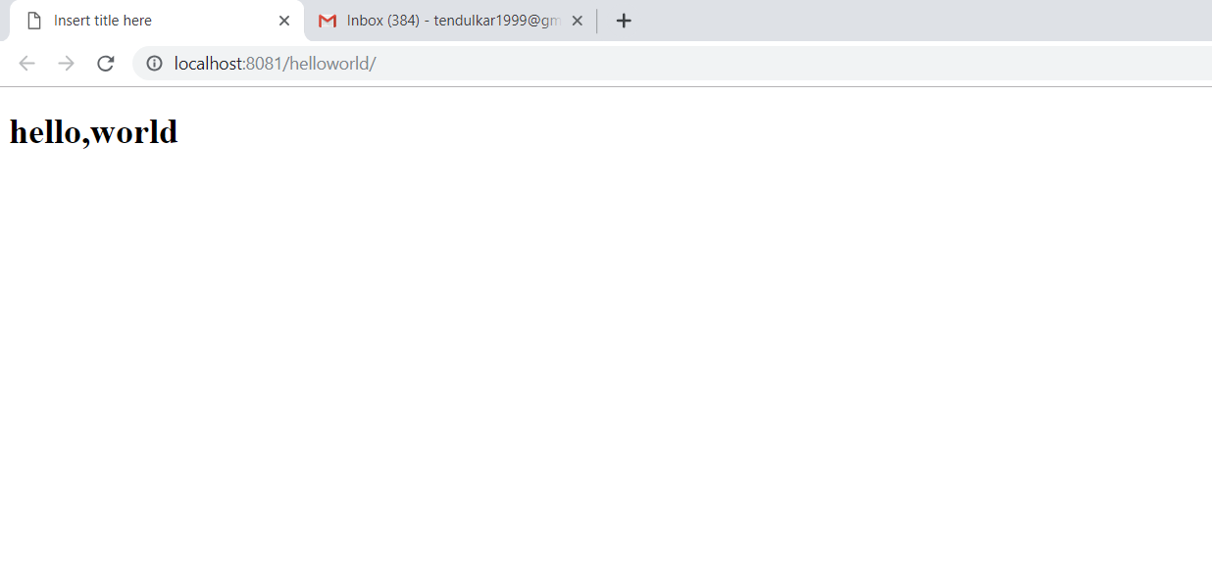

**Result**

Thus the project was done successfully using spring MVC.

|  |  |
| --- | --- |
| **Ex no: 5** | **Using Git with Eclipse** |
| **Date :** |

**Question**

Integrate Git with Eclipse.

**Aim**

To integrate Git with Eclipse.

**Procedure**

**Creating a github repository**

* Goto <https://github.com/> and create a new account.
* After signing in create a new repository

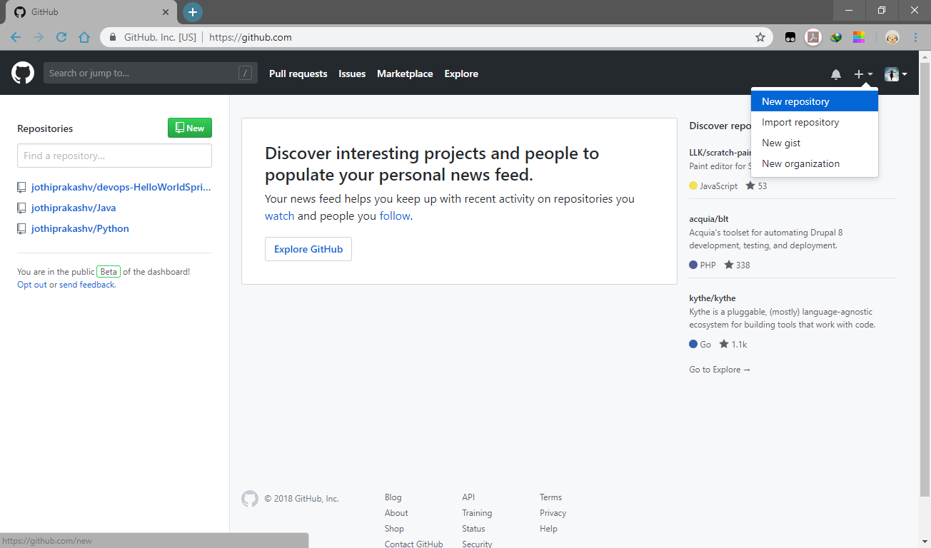

* Give the name and description for the repository and click create.

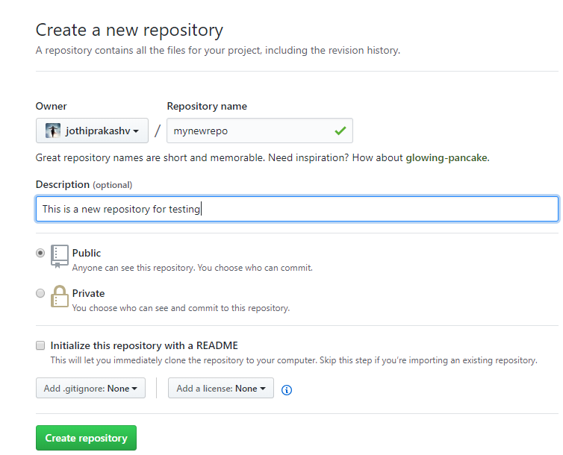

* Now you can see a variety of options.
* We have successfully created a GitHub repo.

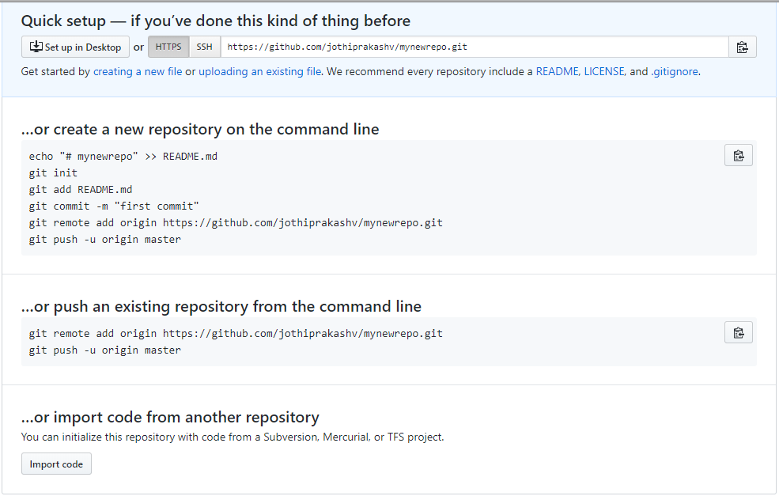

**Sharing an eclipse project**

* In Eclipse, right-click Your project -> Team -> Share Project

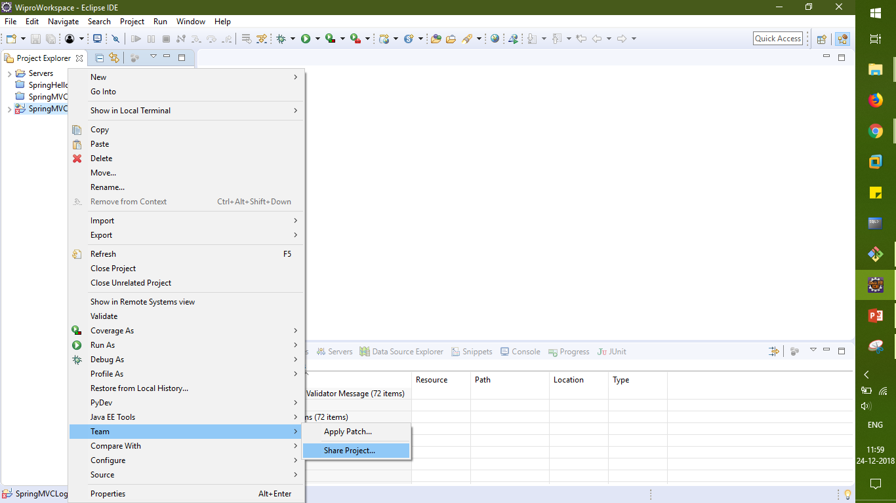

* You’ll get the following window.

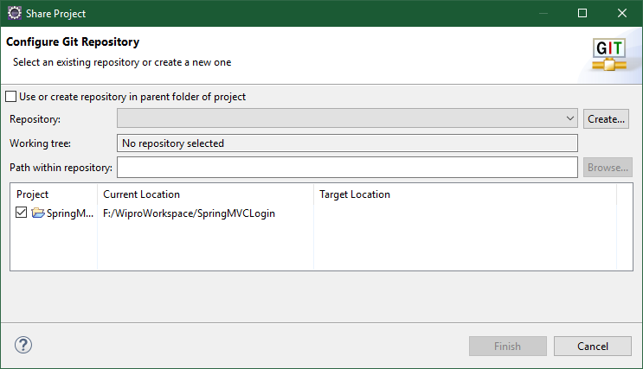

* Check the “Use or create repository ….” check box
* Select the project and click on Create repository and then Click Finish.

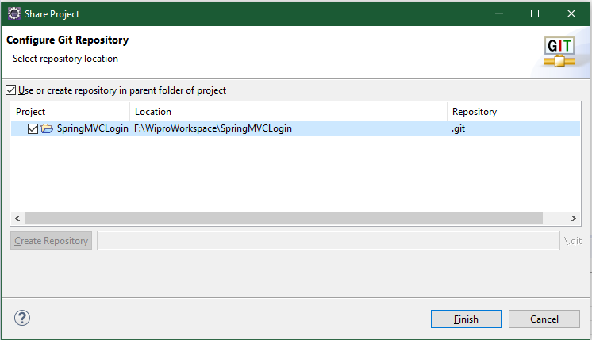

* Goto Window -> show view -> Other -> Git Repositories

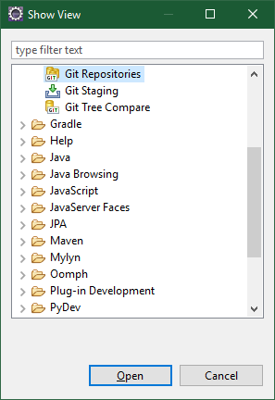

* Now you can see the Git Repository that has been created and Git is tracking your project.

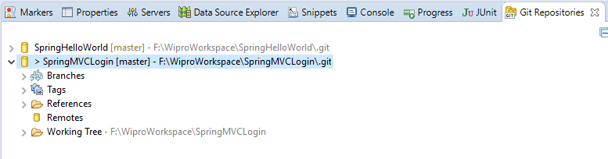

* To Commit the project, Right-click project -> Team -> commit
* Click the  button to add all the unstaged files or manually add the individual files.
* Give a commit message, Author and Commiter details and click Commit and Push.

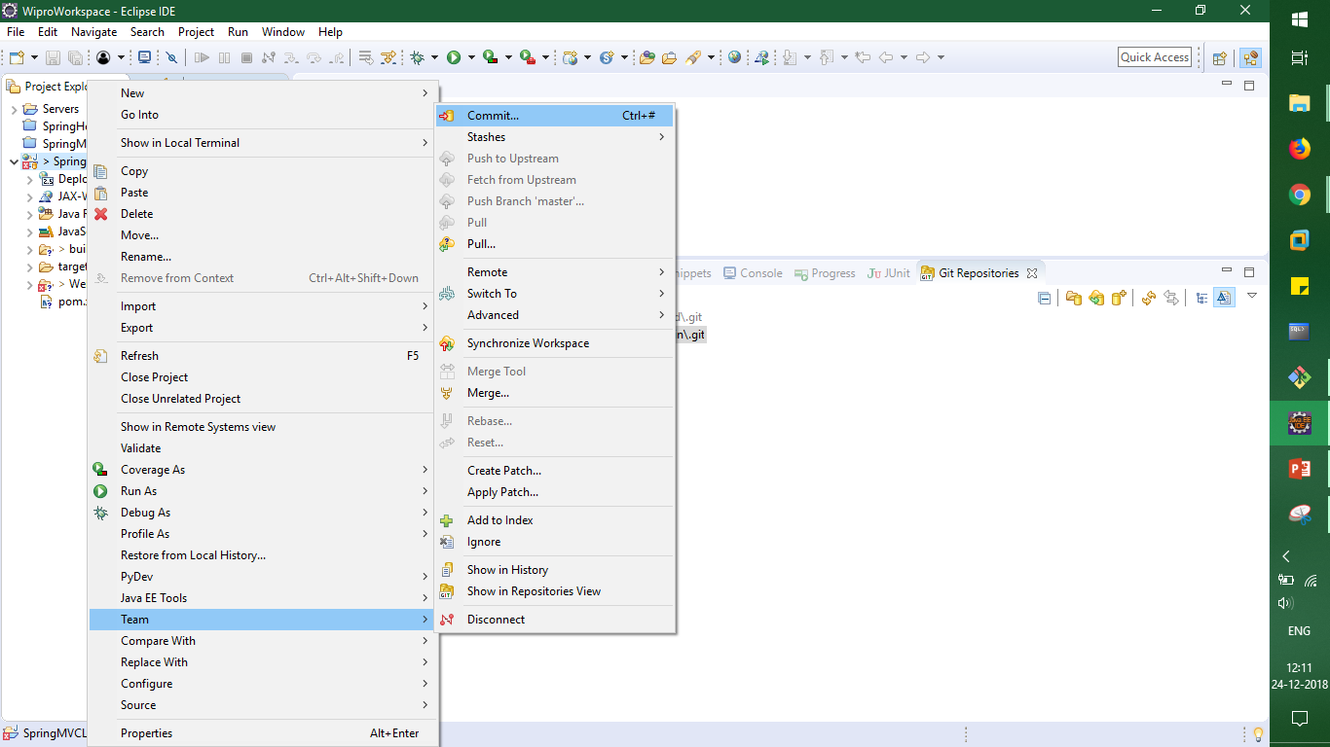

**Staging the files**

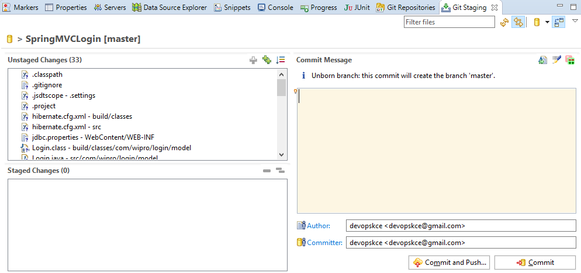

**Commiting the files**

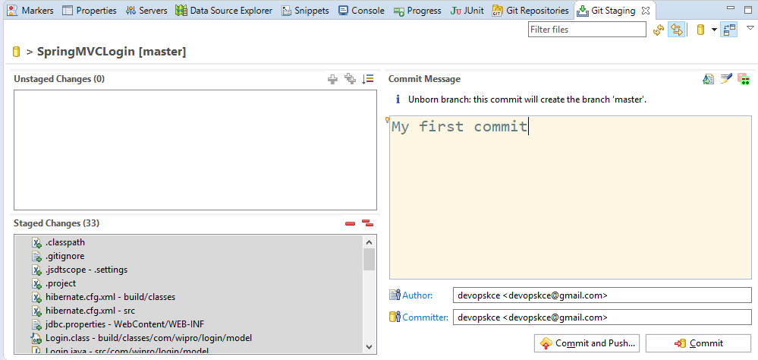

**Uploading to github**

* In the new window that is opened
* Give the GitHub URI and the login Credentials.
* Click Next

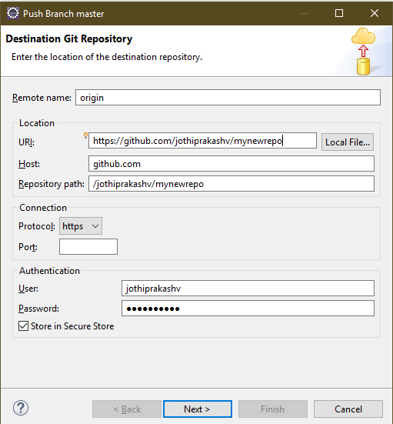

* Leave the default settings and Click Next

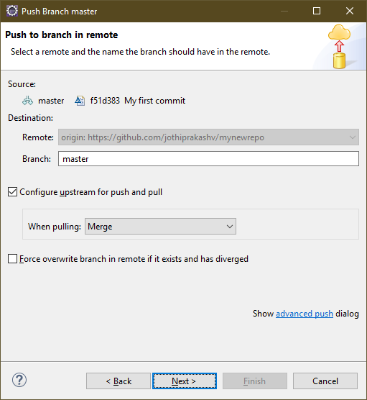

* You’ll get the push confirmation.
* You can cancel the push if needed.
* Click on Finish to push the files to the GitHub repo.

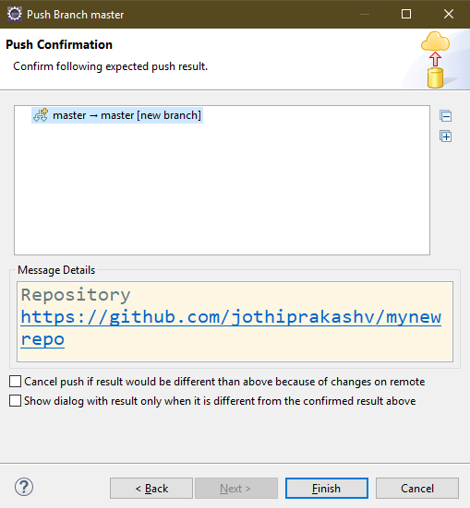

* Now you’ll see the push results Window.

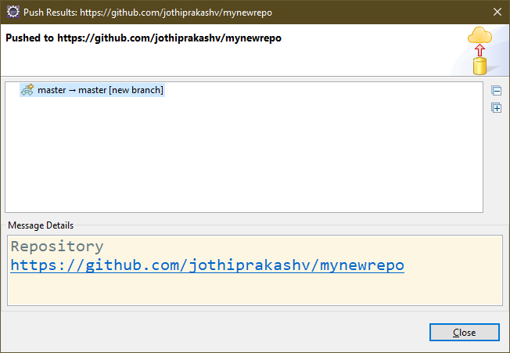

* Now if you refresh your GitHub repo you will see that the project has been added.

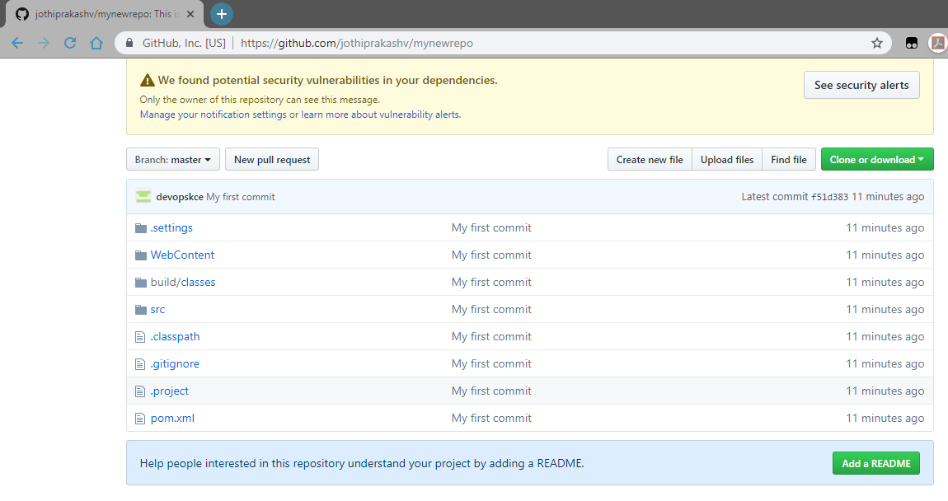

**Making changes in project**

* Now if we make any changes in the eclipse project, you can see that the file will automatically get added to the unstaged changes

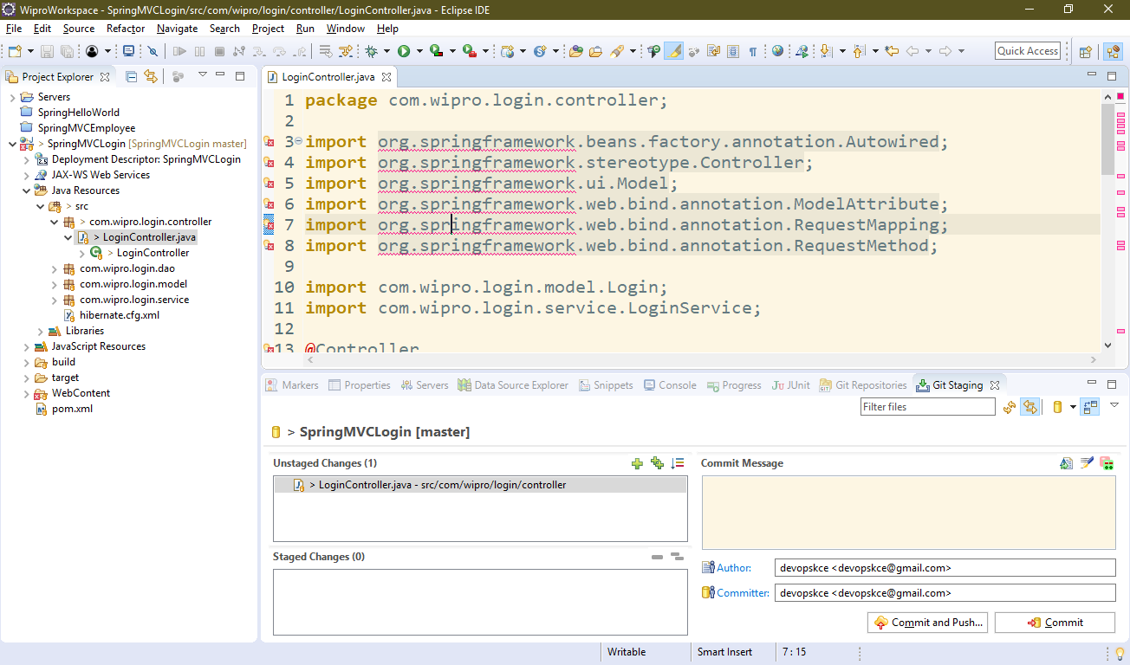

* Now you can again repeat the same process to kee your project up-to-date

**Result**

Thus the integrating eclipse with Git was done successfully.