|  |  |
| --- | --- |
| **Ex no: 2** | **Spring - MVC** |
| **Date :** |

**Question**

Read form data and Login validation that uses Spring MVC architecture.

**Aim**

To read form data and Login validation that uses Spring MVC architecture

**Code:**

**Home.jsp**

<h1>Hello World</h1>

<a href="${pageContext.request.contextPath}/addStudent">addStudent</a>

<a href="${pageContext.request.contextPath}/login">login</a>

**Login.jsp**

<%@taglib uri="http://www.springframework.org/tags/form" prefix="form" %>

<html>

<body>

<form:form action="processLoginForm" method="post" modelAttribute="login">

<label>Username : </label>

<input type="text" name="userName"/>

<label>Password : </label>

<input type="password" name="password"/>

<input type="submit" value="login" />

</form:form>

</body>

</html>

**StudentForm.jsp**

<%@taglib uri="http://www.springframework.org/tags/form" prefix="form" %>

<html>

<body>

<form:form action="processStudentForm" method="post" modelAttribute="babu">

<label>FirstName : </label>

<input type="text" name="firstName"/>

<label>Address : </label>

<input type="text" name="address"/>

<input type="submit" value="add" />

</form:form>

</body>

</html>

**SuccessForm.jsp**

${student.getFirstName()}

${student.getAddress()}

**Student.java**

@Data

public class Student {

private int id;

private String firstName;

private String address;

}

**User.java**

public class User {

private String userName;

private String password;

}

**StudentController.java**

@Controller

public class StudentController {

@RequestMapping("/")

public String home(){

return "home";

}

@RequestMapping("/addStudent")

public String doStart(Model theModel){

theModel.addAttribute("babu",new Student());

return "studentForm";

}

@RequestMapping("/processStudentForm")

public String processStudentForm(@ModelAttribute("babu") Student theStudent,Model theModel){

theModel.addAttribute("student",theStudent);

return "successForm";

}

@RequestMapping("login")

public String login(Model theModel){

theModel.addAttribute("login",new User());

return "login";

}

@RequestMapping("processLoginForm")

@ResponseBody

public String processLoginForm(@ModelAttribute("login") User user){

if(user.getUserName().equals("admin") && user.getPassword().equals("admin")){

return "<h1>Login successful</h1>";

}

else{

return "<h1 style='color:red;'>Login invalid</h1>";

}}}

**Output**



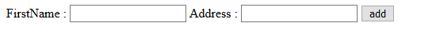



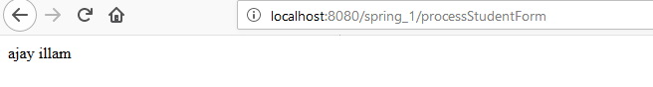







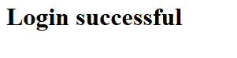

**Result**

Thus the project was done successfully using spring MVC.

|  |  |
| --- | --- |
| **Ex no: 3** | **Spring - MVC** |
| **Date :** |

**Question**

1. Create a Spring based MVC application with Hibernate for validating login credentialls.
2. Create a Spring based MVC application with Hibernate which collects Student details from the user and insert them into the database ,Update the details , delete student details and fetch details of specific student.

**Aim**

To create a Spring based MVC application with Hibernate

**Code:**

**Home.jsp**

<h1>Hello World</h1>

<a href="${pageContext.request.contextPath}/addStudent">addStudent</a>

<a href="${pageContext.request.contextPath}/login">login</a>

**Login.jsp**

<%@taglib uri="http://www.springframework.org/tags/form" prefix="form" %>

<html>

<body>

<form:form action="processLoginForm" method="post" modelAttribute="login">

<label>Username : </label>

<input type="text" name="userName"/>

<label>Password : </label>

<input type="password" name="password"/>

<input type="submit" value="login" />

</form:form>

</body>

</html>

**StudentForm.jsp**

<%@taglib uri="http://www.springframework.org/tags/form" prefix="form" %>

<html>

<body>

<form:form action="processStudentForm" method="post" modelAttribute="babu">

<label>FirstName : </label>

<input type="text" name="firstName"/>

<label>Address : </label>

<input type="text" name="address"/>

<input type="submit" value="add" />

</form:form>

</body>

</html>

**SuccessForm.jsp**

${student.getFirstName()}

${student.getAddress()}

**Student.java**

@Data

public class Student {

private int id;

private String firstName;

private String address;

}

**StudentController.java**

@Controller

public class StudentController {

@RequestMapping("/")

public String home(){

return "home";

}

@RequestMapping("/addStudent")

public ModelAndView doStart(){

return new ModelAndView("studentForm");

}

@RequestMapping("/processStudentForm")

public String processStudentForm(@ModelAttribute("student") Student theStudent,Model theModel){

studentDao.addStudent(theStudent);

return "successForm";

}}

**Output**



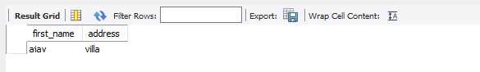

**Result**

Thus the project was done successfully using spring MVC.