|  |  |
| --- | --- |
| **Ex no: 5** | **Using Git with Eclipse** |
| **Date :** |

**Question**

Integrate Git with Eclipse.

**Aim**

To integrate Git with Eclipse.

**Procedure**

**Creating a github repository**

* Goto <https://github.com/> and create a new account.
* After signing in create a new repository

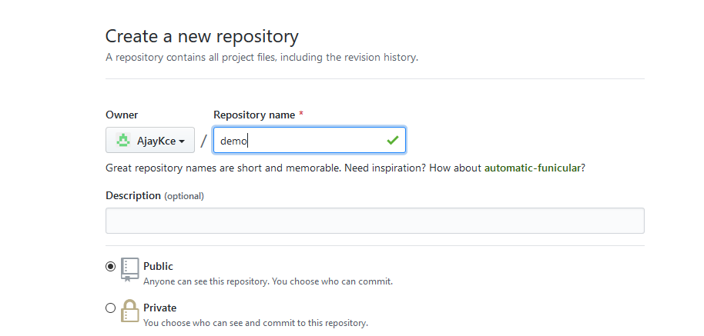

* Open the git bash and follow the initial commands

