**FINAL TEAM PROJECT**

**PANDEMIC SIMULATOR**

* Total population considered (N): 1000.
* ‘α’ value is in between 0 and 1. Each infected person may come into contact with (0 ≤ α ≤ 1) ratio of all the people (N) in each round of infection.
* ‘β’ value is in between 0 and 1. Each chance of contact between infected individual and healthy individual such that healthy person will be infected (0 ≤ β ≤ 1).
* $'γ^{'} value is in between$ $(0<γ≤1)$. $γ$ = 5/2000. A person infected will stay infectious for ‘5’ rounds
* Pandemic Simulator has 2000 rounds (T = 2000).

**SIR MODEL**

SIR Model for the Spread of Disease- Differential Equation Model

‘S’ =Susceptible

‘I’ = Infected

‘R’ = Recovered

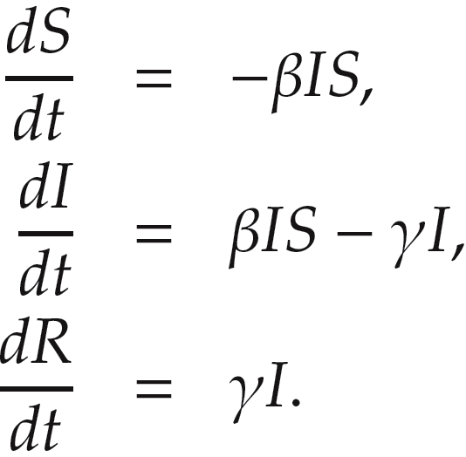At any given time ‘t’, Total Population (N) is the total of Infected, Susceptible and Recovered people.

24

$γ$*: recovering probability of an infected.*

S

I

R

$$γI$$

**SIR MODEL (I0= 10, R0= 0, S0 = 990):**

The below plot is for 2000 iterations for a total population of 1000 people, Here taken α = 0.005 and β = 0.01. Initial consideration is that all the population are susceptible for the disease and initial infection in the above graph is taken as 10 out of 1000 people.

From the below graph we can say that initially with the time a greater number of people get infected as we consider that all the people are susceptible and as the people get infected, they recover in time and so recovery count increases over time and as a result susceptible people count will gradually decreases to zero as the infection is spread to all the people and they recover over time.

When α = 0.005 and β = 0.01 are considered, we get a max infection count at 400 at around 750 iterations (As of Figure1). When β value is changed to 0.02, there is a higher chance of infection from the infected person to a healthy person, So we can see more early infections around 600 people infected at the peak time (As of Figure2).

From the below Figures 3 and 4 we can see that as β value increases, more number of early infections are seen as more number of people are getting in contact with the infected persons and so, as a result more number of people are getting infected. When β value is 0.1 then within no time almost all the people are getting infected (in early iterations) and so we can see a peak curve for the infected. As the infected rate is high susceptible curve goes down quickly in the initial stages.

Figure1: When α = 0.005, β = 0.01 and = 5/2000

Figure2: When α = 0.005, β = 0.02 and = 5/2000

Figure3: When α = 0.005, β = 0.03 and = 5/2000

Figure4: When α = 0.005, β = 0.1 and $γ$ = 5/2000

**SIRS MODEL**

‘S’ =Susceptible

‘I’ = Infected

‘R’ = Recovered

= 20/2000. A person who is recovered will be susceptible after 20 rounds as per the given problem, so $λ$ = 0.01.

**SIRS MODEL (I0= 5, R0= 0, S0 = 995):**

In the below figure for 2000 iterations as stated above we take initial infection count as ‘5’, So 995 people are susceptible. β value is considered as 0.01 and $λ$ = 0.001 that means a recovered person will be susceptible after 200 rounds and can be reinfected. So as the iterations pass through, we have at least some infected people and not all people will be in the recovered state. Here the people who are susceptible will never be zero and from the below figure 5 we can say that recovered people will be close to 600 and infected population is around 300 and the people who are susceptible will be around 100.

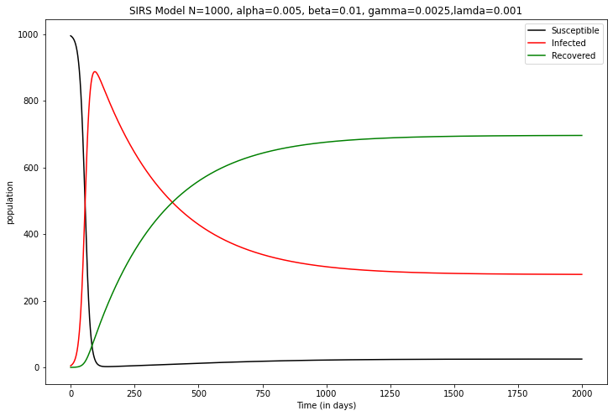

Figure5: When α = 0.005, β = 0.01, $γ$ = 0.0025 and $λ$ = 0.001

In the below figure if we increase the $λ$ value from 0.001 to 0.01 then we can see that a person will be in recovered state only for 20 iterations and again he the person will be in susceptible state. As the rate is higher more number of people will be infected as time in the recovery state is low. From the below figure 6 we can say that around 800 people will stay infected at a particular time and in contrast we have a count of around 150 people in the recovered state and very little people in susceptible state. If we further increase the β value there will be much more increase in the early infections and almost all the people will be in the infected state very early in the iterations.

Figure6: When α = 0.005, β = 0.01, $γ$ = 0.0025 and $λ$ = 0.01

**SECTION II**

**b) Introducing vaccine at time t3:**

As asked in this project we consider the simulation for a total of 2000 iterations (We may consider each iteration as a day). So, when a vaccine is introduced to the population at 3rd day we analyze the behavior of the infections in the population. In the below figure, we give effective vaccination to 50% of the population at time t3 (all at once), This vaccine has an efficacy rate of $θ$ = 0.8 that is even though half of the population is vaccinated the vaccine will provide immunity to 80% of the people who are vaccinated.

In the below figure we can see that the susceptible people count drops from 1000 to 600 after t3 and the peak infections will never go above 600, Here vaccinated people count in the graph is 400 because the efficacy rate is 80%, In this simulation we can see a max peak in cases at around 450.

In Figure 8 we only consider 40% people are vaccinated with 80% efficacy and so we can clearly see that more infections can occur as less amount of people are vaccinated. Here around 600 people are infected at the peak of the pandemic and at any given time higher amount of population is under infection state as very less vaccinations have been done.

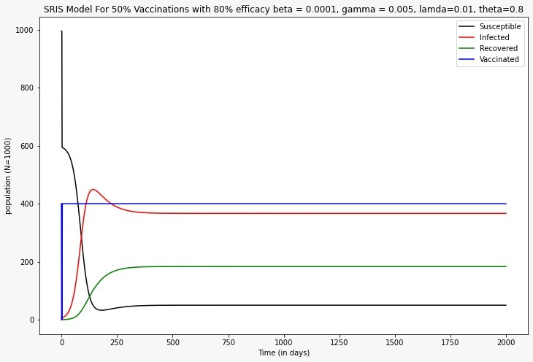

Figure7: 50% vaccination at t3, β = 0.005, $γ$ = 0.01 and = 0.8

Figure8: 40% vaccination at t3, β = 0.005, $γ$ = 0.01 and $θ$ = 0.8

**e) Introducing 15% more activity to the population:**

In this case we introduce 15% more activity in the population, we can see from below figure9, with 40% vaccination and 15% more activity we can say that around 300 people are completely vaccinated and here we can see a peak infections at around 500 and then later as the days pass through because of more activity between the people we again can see a hike in the infections.

Figure9: 40% vaccination at t3, $θ$ = 0.8 and 15% more activity

**f) Introducing 25% more activity to the population (like sports season):**

In figure 10 we have a 25% more activity at time 300-500 days (like a sports season like basketball season) and we can see that more number of infections at that particular time because of 25% more activity.

Figure10: Basketball season at time 300-500 days