DATA CLEANING AND PREPROCESSING
Yuva Platform Internship — Project 2
Project: Online Retail Transaction Data Cleaning
Tools: Python, Pandas, NumPy, Matplotlib, Scikit-learn
Environment: Visual Studio Code and Jupyter Notebook

1. Project Overview
This project focuses on cleaning and preprocessing an online retail transaction dataset. The workflow includes combining source sheets, removing exact duplicate records, investigating missing values, standardizing columns and data types, detecting statistical outliers, engineering features, and demonstrating encoding and numerical scaling.

2. Project Objectives
- Inspect and understand the structure of the source dataset.
- Identify and remove exact duplicate rows.
- Investigate missing descriptions and customer identifiers.
- Standardize column names and relevant data types.
- Detect and investigate outliers using the IQR method.
- Create transaction-value and date-related features.
- Demonstrate categorical encoding, standardization, Min-Max scaling, and normalization.
- Export the processed dataset and document the findings.

3. Dataset Description
The project uses the Online Retail II dataset, combining the 'Year 2009-2010' and 'Year 2010-2011' worksheets. The dataset contains transaction details such as invoice number, product code, description, quantity, invoice date, price, customer identifier, and country.
Metric | Result
Records after exact duplicate removal | 1,033,036
Columns after feature engineering | 17
Duplicate rows remaining | 0
Missing descriptions | 1,291
Missing customer IDs | 235,151
Negative quantity records | 22,496
Negative price records | 5
Zero price records | 6,014

4. Data Cleaning and Quality Assessment

4.1 Duplicate Removal
Exact duplicate rows were removed from the combined dataset. A total of 34,335 exact duplicates were removed, leaving 1,033,036 records. Validation confirms that no exact duplicate rows remain in the current cleaned dataset.

4.2 Missing Values
Some product descriptions were recovered using a conservative StockCode-to-description mapping when a code had a single distinct, non-empty description. A total of 1,291 descriptions remain missing. Customer IDs are missing in 235,151 records. Missing customer identifiers were not replaced with fabricated IDs, because doing so could distort customer-level analysis.

4.3 Standardization
Column names were converted to lowercase snake_case, and whitespace was stripped from relevant text fields. Customer IDs were converted to a nullable integer type, and invoice dates were retained as datetime values.

4.4 Negative and Zero Values
Negative quantities can represent cancellations or returns. Negative and zero prices require contextual investigation because they may represent adjustments, fees, credits, or unusual product transactions. These records were not automatically removed.

5. Outlier Detection Using the IQR Method
The Interquartile Range (IQR) method was used to identify statistically unusual values in quantity, price, and transaction value. The bounds were calculated as Q1 - 1.5 × IQR and Q3 + 1.5 × IQR.
Column | Q1 | Q3 | IQR | Lower bound | Upper bound | Count | Percent
quantity | 1.0 | 10.0 | 9.0 | -12.5 | 23.5 | 114434 | 11.08
price | 1.25 | 4.15 | 2.9 | -3.1 | 8.5 | 66196 | 6.41
transaction_value | 3.75 | 17.7 | 13.95 | -17.175 | 38.625 | 89005 | 8.62
Outliers were retained in the master dataset because unusual values may represent legitimate bulk orders, returns, fees, or adjustments. The IQR method identifies statistical extremes but does not prove that a record is erroneous.
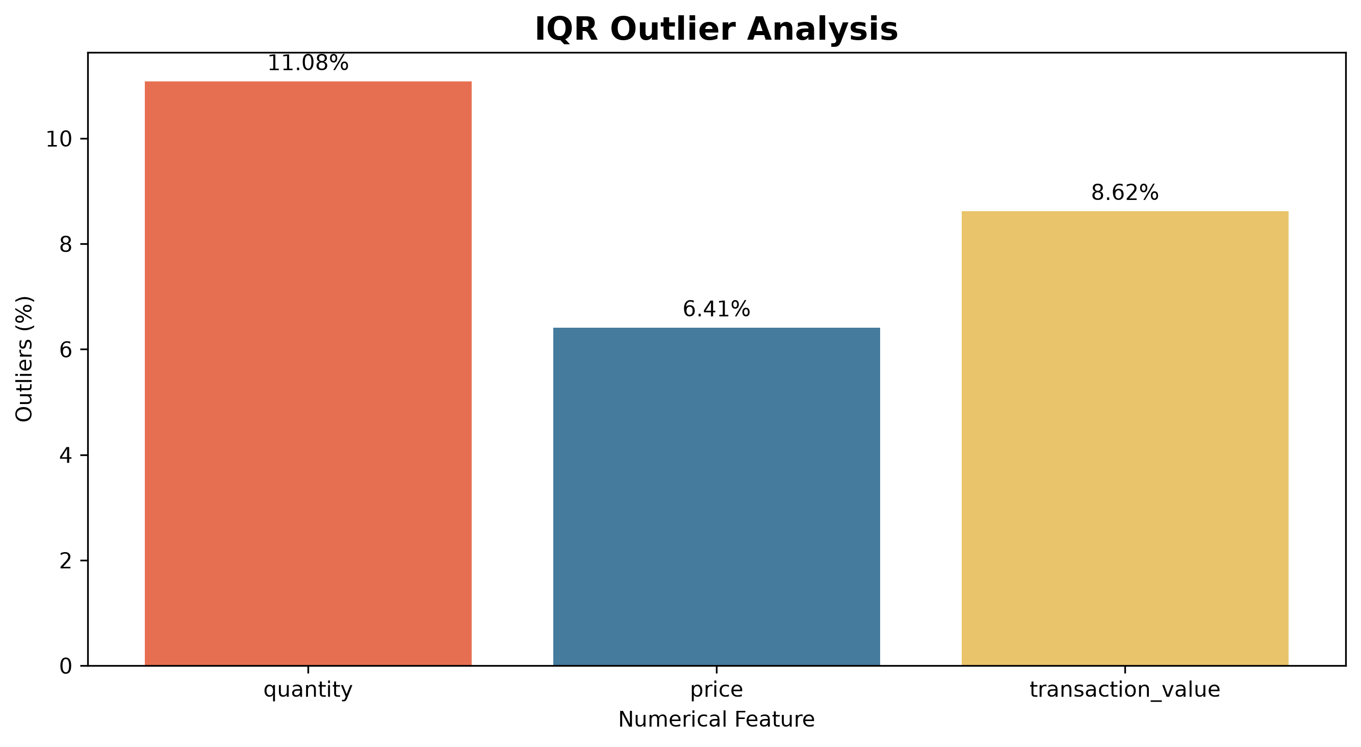
Figure 1. Outlier percentages by numerical feature.

6. Feature Engineering
The following features were created to support transaction analysis:
Feature | Description
transaction_value | Quantity multiplied by unit price.
invoice_year | Year extracted from the invoice date.
invoice_month | Month extracted from the invoice date.
invoice_quarter | Calendar quarter of the invoice date.
invoice_day | Day of the month.
invoice_day_of_week | Name of the weekday.
invoice_hour | Hour of the invoice timestamp.
invoice_year_month | Year-month period for time-based analysis.
transaction_type | Transaction category based on invoice prefix and quantity.
The transaction_type feature is a rule-based classification for exploratory analysis. It should not be interpreted as a definitive business classification of every transaction.

7. Encoding, Scaling, and Normalization
These preprocessing techniques were demonstrated on a representative sample of the dataset, leaving the master transaction data unchanged.
Technique | Purpose
One-hot encoding | Converts categorical values into binary indicator columns.
StandardScaler | Centers numerical features and scales them to unit variance.
MinMaxScaler | Scales numerical values to a range between 0 and 1.
Normalizer | Normalizes each observation based on its vector norm.
These demonstrations are intended to illustrate preprocessing methods. For future predictive modelling, transformations should be fitted on training data only and applied to validation or test data to reduce the risk of data leakage.

8. Project Outputs
- data/processed/online_retail_cleaned.csv
- outputs/data_quality_report.csv
- outputs/charts/outlier_analysis.png
- outputs/reports/Yuva_Project_2_Data_Cleaning_Report.docx

9. Conclusion
The project established a reproducible data-cleaning and preprocessing workflow for the Online Retail II dataset. Exact duplicates were removed, columns and data types were standardized, missing values were investigated, outliers were detected, and useful transaction and date features were engineered. Encoding and numerical scaling techniques were also demonstrated. Remaining missing values and unusual financial records were documented rather than automatically altered, preserving the information needed for further investigation.

10. Future Improvements
- Investigate unresolved descriptions and unusual financial adjustments.
- Develop reusable preprocessing functions and automated validation tests.
- Add further visualizations for missing values and transaction patterns.
- Use a train/test workflow if the dataset is later used for machine learning.

