**AWS cloud assignment**

**Q. Create a virtual network with 2 subnets. Each subnet should have 16 Ips only.**

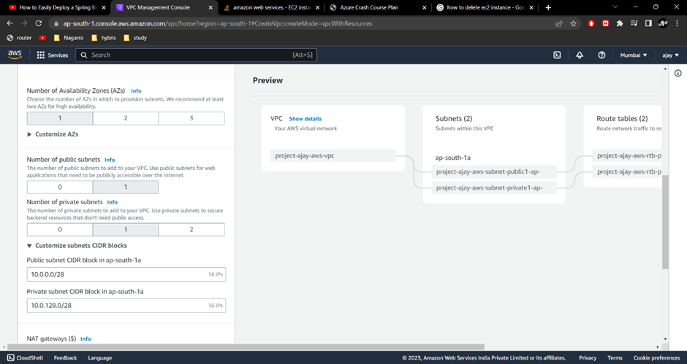

**Q. Inside one of the subnets, create a VM and deploy an application code inside it (any existing application created by you before). Make sure to use appropriate NACLs and SGs.**

Create security group

Create key pair

Create instance and select security group and key pair created above

Connect to the instance

Deploy/run your code inside the instance

**Q. Deploy the same application to Elastic beanstalk Service.**

Create a EC2 role with following policies

* AWSElasticBeanstalkWorkerTier
* AWSElasticBeanstalkMulticontainerDocker

Create application and environment using above role and put SERVER_PORT 5000 in env variables

Check if code is working

**Q. Create a Lambda that should trigger as soon as you upload a file in the S3 bucket. Function should be able to print the name of the file uploaded in the function.**

Create a lambda role with following policies

* AmazonDynamoDBFullAccess
* AWSLambdaBasicExecutionRole

Create a Lambda function using the role created above

Create a S3 bucket

Create a trigger in the lambda function we created, select S3 from dropdown menu and select the bucket we created above

Write following code in Code source in lambda function and deploy

Upload a file in s3 bucket we created

Check in the logs for the name of file uploaded by you

