Docker and Kubernetes Assignment

GitLab URL : <https://git.nagarro.com/GITG00641/Java/3184086/tree/Docker&K8s_Assignment>

Docker image creation –

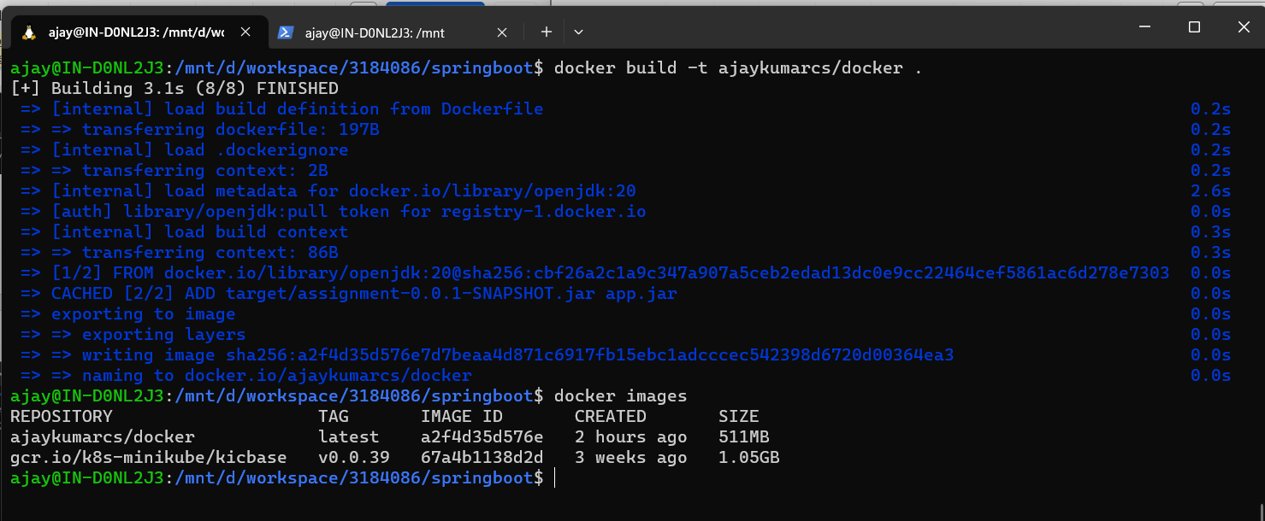

Docker hub image repo url - <https://hub.docker.com/layers/ajaykumarcs/docker/latest/images/sha256-300f35d12620491d10690fcb81c28d2ac69c6f86169994b88f0af7979e13db1b?context=repo>

Deployment –

Service –

Pods –

Application in browser –

