Task 1

s1. Create the resource group with name: newRg

s2. In resource group (newRg) create the virtual Network name (Myvnet01) and Address space (10.0.0.0/16)

s3. create 2 subnets with Ip address 16 and Address space : 10.0.0.0/28

Virtual network

Task 2

virtual machine

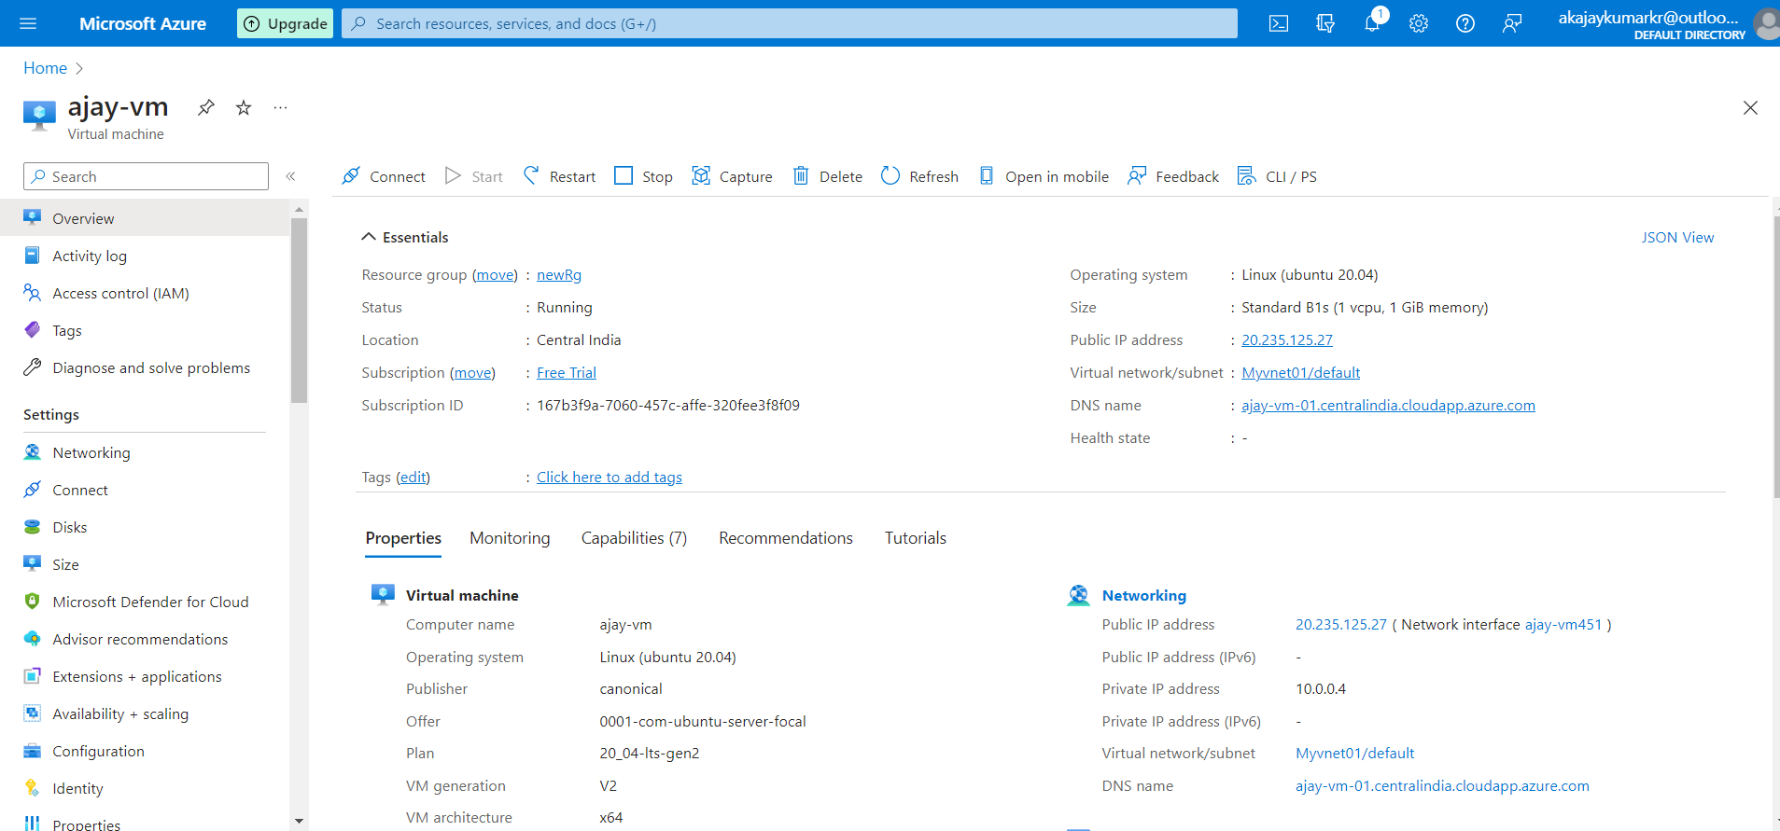Tomcat server

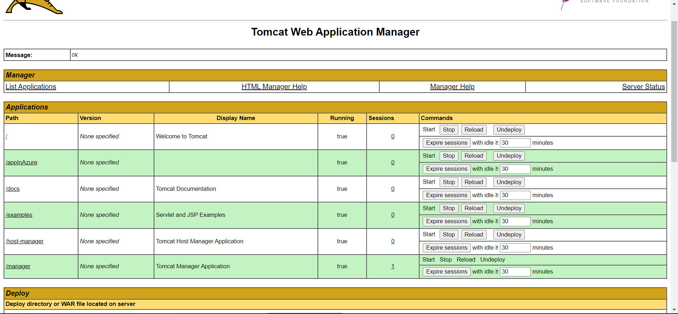

TASK 3

1.Create a springboot project from the springinitializer then write the java code.

2.Deploy the code on the gitlab.

3.create App service and deployed the gitlab repository on the Azure Microsoft.

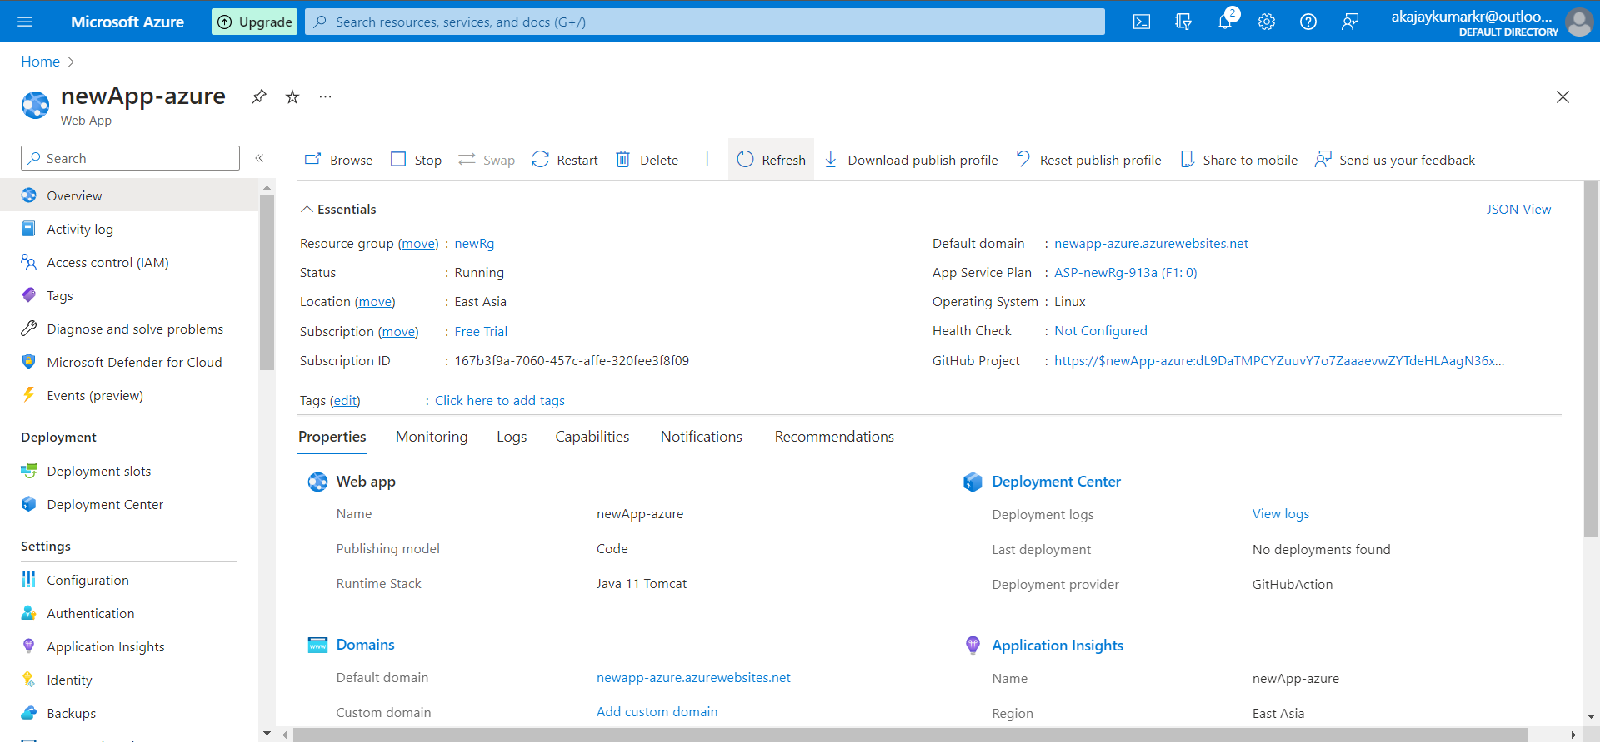

get and post request after the deployment of database

Task 4

Create a kubernate cluster

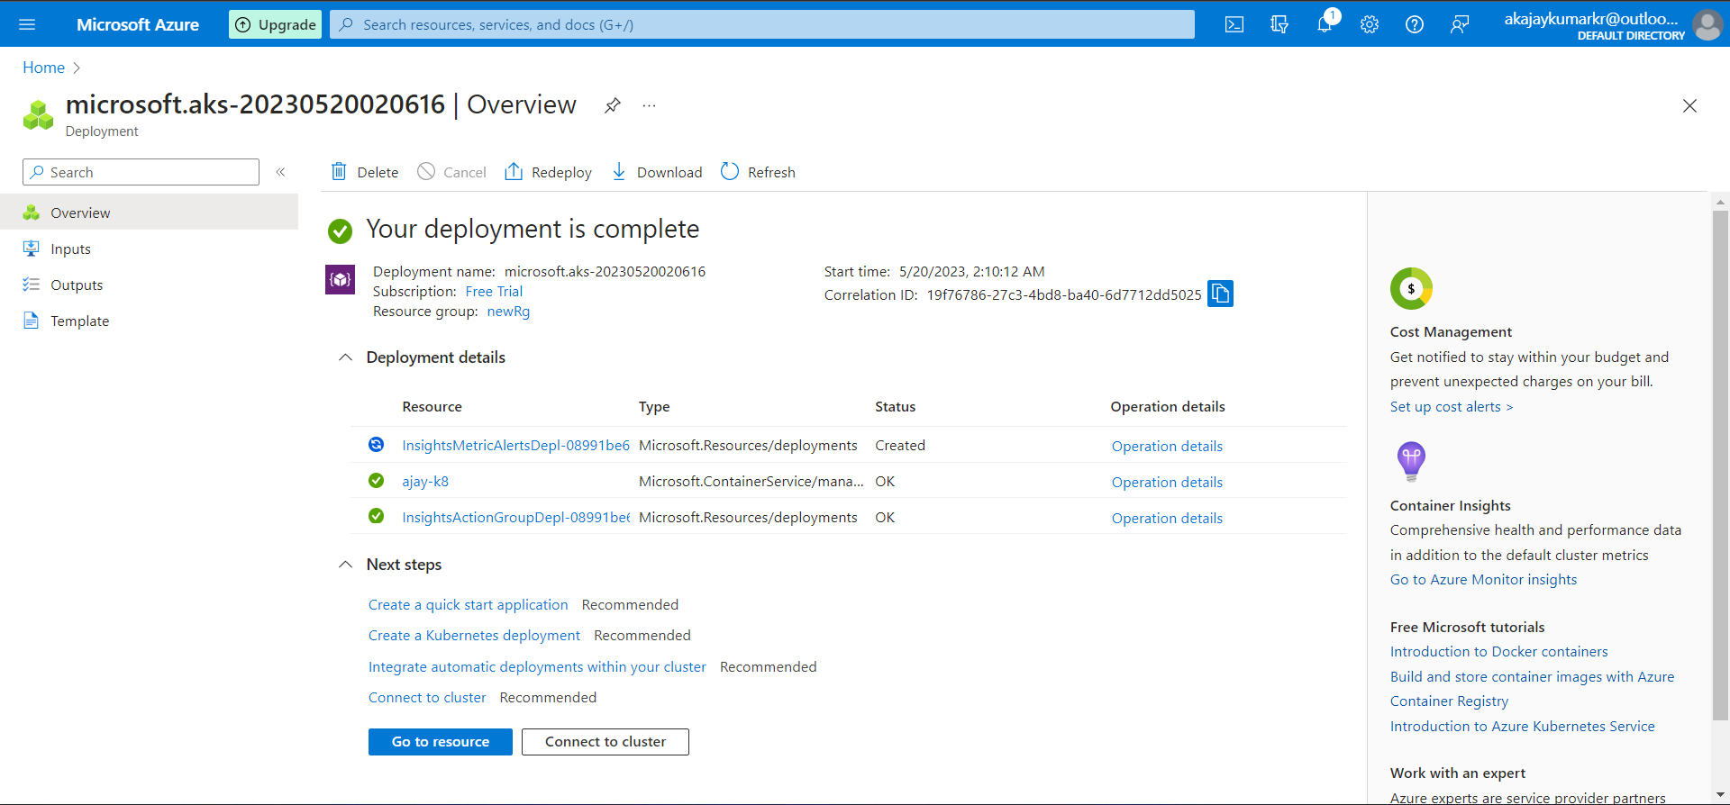

Communicating with Kubernetes Cluster using cloud shell

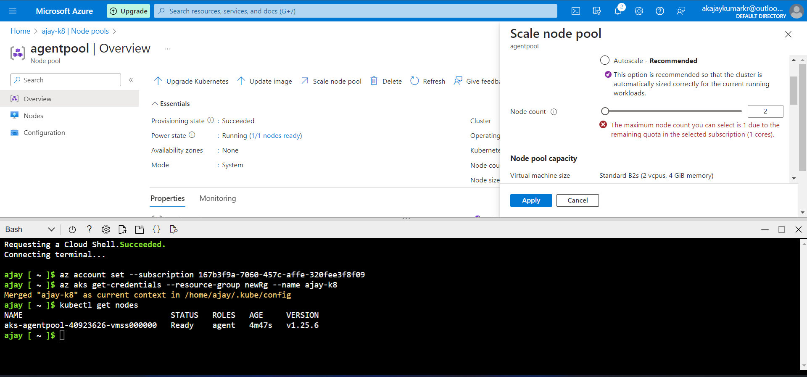

Deploy service on the Kubernetes cluster with the help of azure-vote.yaml

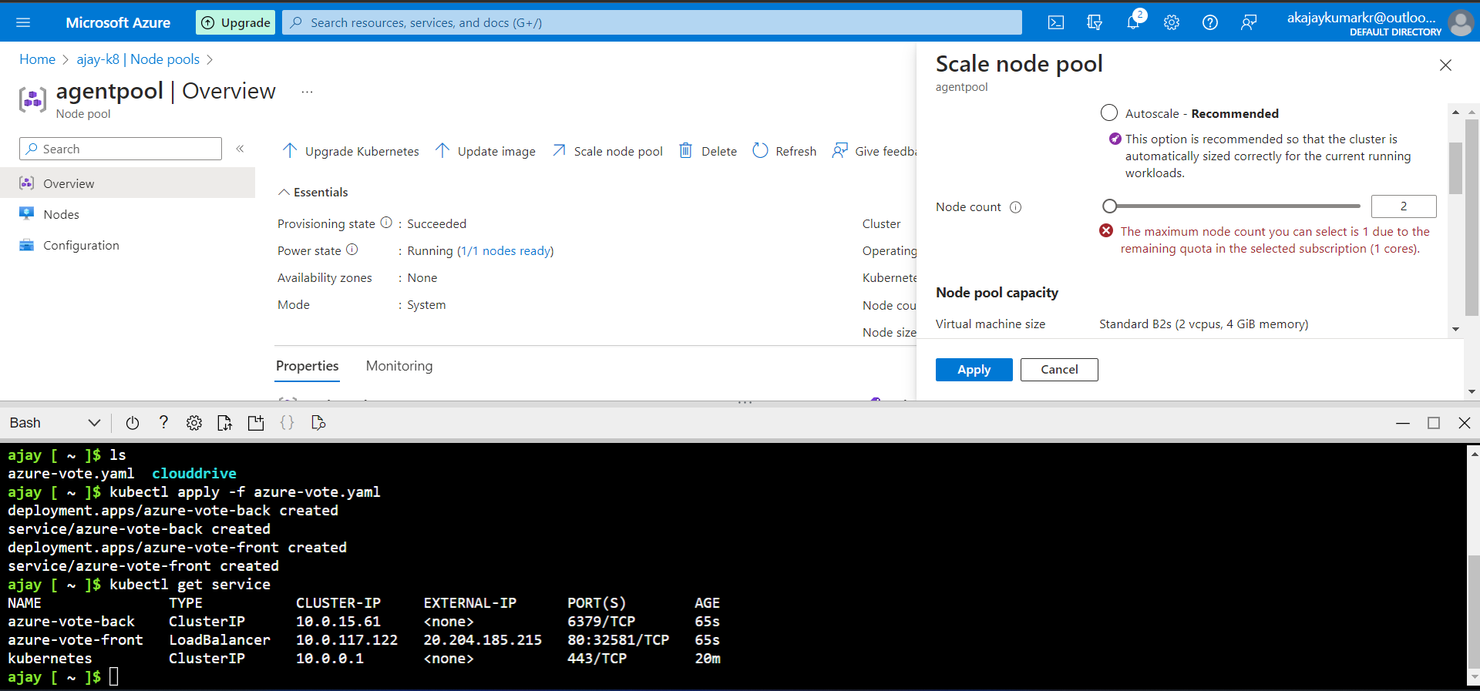

Service that is accessible from the internet

Task 5

S1: Create resource group name: newRg-02.

S2: Create Storage Account name: storagefileblob.

S3: write the following command in powershell

*az functionapp create --consumption-plan-location westus --name* *ajayNewFunc01 --os-type Windows --resource-group newRg-02 --runtime node --functions-version 3 --storage-account storagefileblob*

this command create the azure function app with name ajayNewFunc01

create Blog trigger function in function App (ajayNewFunc01) name: BlobTrigger

then again go into Blogtrigger and select code + test and upload file in container

result is highlighted part

