Assignment-2

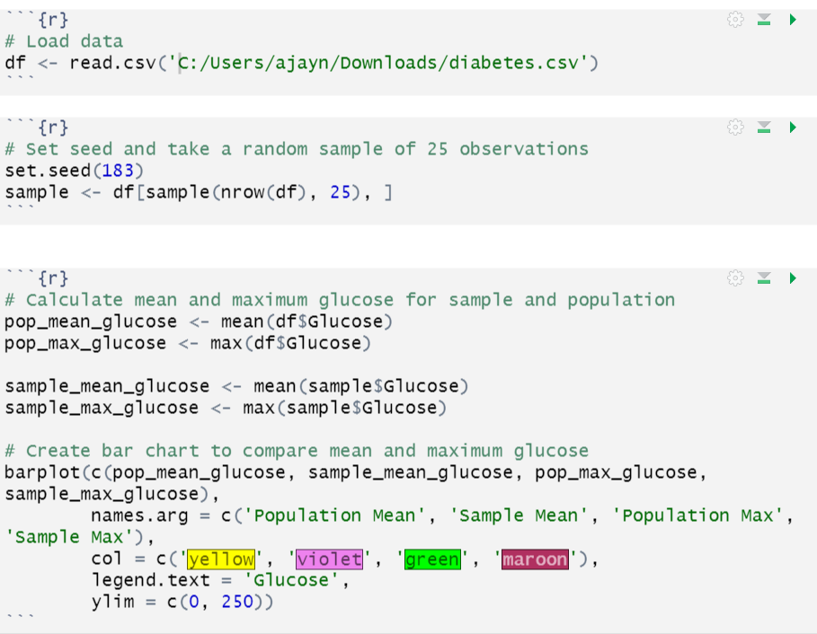a)

Output

b)

c)

Output:

