**Phase-4: Implementation**

|  |  |  |  |  |  |
| --- | --- | --- | --- | --- | --- |
| **Phases** | **Targeted Implementations** | **Tools Required** | **Number of instances** | **Status/duration** | **Supporting Documents** |
| **Phase-4.1** | Bitbucket installation with DB | Bitbucket, PostgreSQL | 1 Ubuntu | Completed in one day | AWS-Bitbucket-PostgreSQL.sh, AWS-Bitbucket-PostgreSQL-Installation.doc |
| **Phase-4.2** | Integration of the tools: Bitbucket + JIRA | - | - | Completed in one day | AWS-Bitbucket-JIRA-PostgreSQL.doc |
| **Phase-4.3** | Integration of the tools & CI Setup: Bitbucket + JIRA, Bitbucket + Jenkins, JIRA + Jenkins | Jenkins, Git, Bitbucket, JIRA, Maven, tomcat | 1 Ubuntu, 2 RHEL | Completed in one day | AWS-Jenkins-Bitbucket-JIRA-CI-CD-Practice.doc |
| **Phase-4.4** | Documentation of Phase-5 tasks | Google Docs/sheets | - | Completed in one day | **DevOps-Setup-Phase4-Docs-v0.2.zip** |

Example work-flow:

Requirement (in terms of JIRA task issue) 🡪 Coding in local machine and then push to remote server like bitbucket 🡪 Automatic Jenkins job build on new changes 🡪 Deploy the package to tomcat server. 🡪 if any issues open a bug/defect issue in JIRA to the dev team. Repeat the steps. i.e., CI --- Continuous Integration.

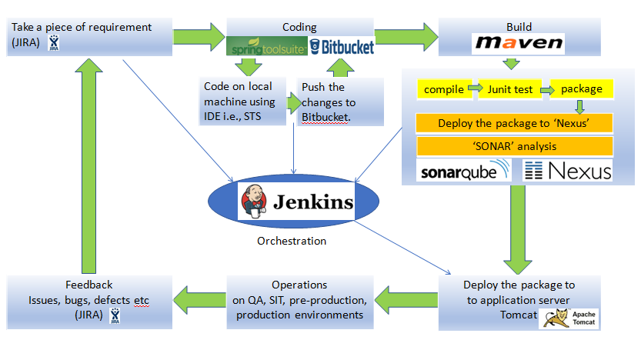

Required Tools & servers:

|  |  |  |  |
| --- | --- | --- | --- |
| **Server/Type** | Server1(RHEL) | Server2 (Ubuntu) | Server3(RHEL) |
| **Server Activity** | Jenkins master | Bitbucket - code repository | JIRA – bug tracker OR issue management OR project management tool |
| **Tools** need to be installed | Java, Tomcat, Maven, Git, Jenkins | Bitbucket  PostgreSQL | JIRA  PostgreSQL |

Communication between servers:

|  |
| --- |
| Server2(Ubuntu) |
| Bitbucket - code repository |
| Bitbucket with PostgreSQL.  Build bucket integrated with Jenkins. Once the code pushed to the repo, the Jenkins job will be triggered automatically. |

|  |
| --- |
| Server1(Linux) |
| Jenkins master |
| Checkout the code & Build the recently checked-in code. |
| Deploy the package to nexus server. (as per Phase-1 implementation) |
| Deploy the package to Tomcat server. |

Build the latest code

As per one of the project requirement, developer will work on one of the project **JIRA task** and changes will be pushed into the code repo (Bitbucket server) with the JIRA reference issue.

|  |
| --- |
| Server3(Linux) |
| JIRA – bug tracker |
| JIRA with PostgreSQL and this server integrated to Bitbucket server (server2) and Jenkins server (server1).  Epics, Stories, Tasks, Bugs, defects are managed in JIRA projects. |

After manual test or   
  
 automated selenium,  
  
 the test engineer will   
  
 open a defect or bug in  
  
 JIRA to fix the error   
  
 if any error  
  
 noticed while testing.

(Refer the below image, in case the above tables are not proper in your word document)

