**Name: Prashasti Gupta**

**Roll No: R171218077**

**Sap ID: 500068493**

**Exp: 10 -- Nexus integration with Jenkins**

Start the Jenkins service and go to **localhost:8080** on a web browser.

Go to **Manage Jenkins**, then go to **Install Plugins** and install “Nexus Platform”.

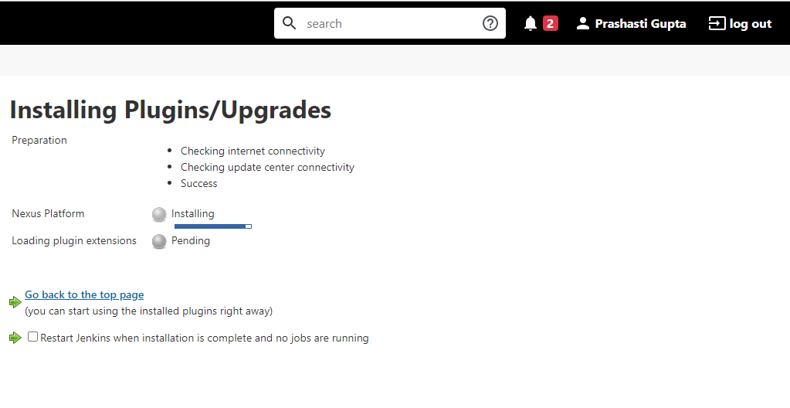

Now, go back to Jenkins dashboard. Click on **New Item.**

Give a name to the item and then choose Maven Project.

On the page you see now, scroll down to **Source Code Management** section and then add the URL of the github repository.

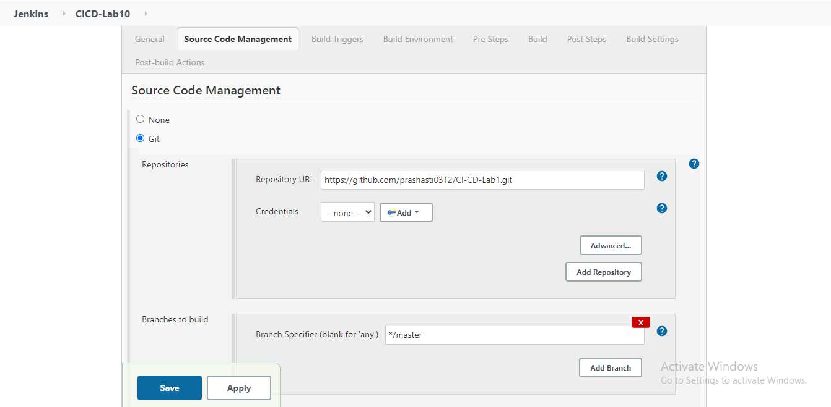

Move down to the **Build** section and then specify the path of pom.xml in your github repository and then write the goal.

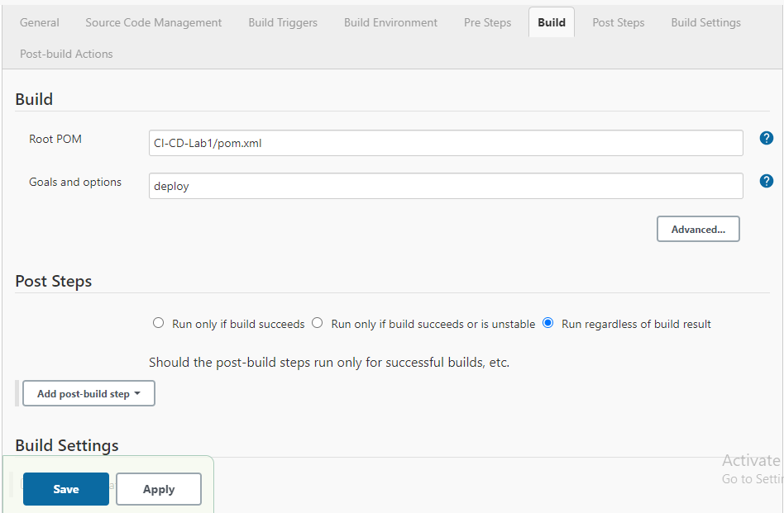

Click on **Save.**

Now go to **Configure Systems** option in **Manage Jenkins** and search for the tab “Sonatype Nexus”. Enter the details for the same and run the “test connection” option to check whether connection is connected or not.

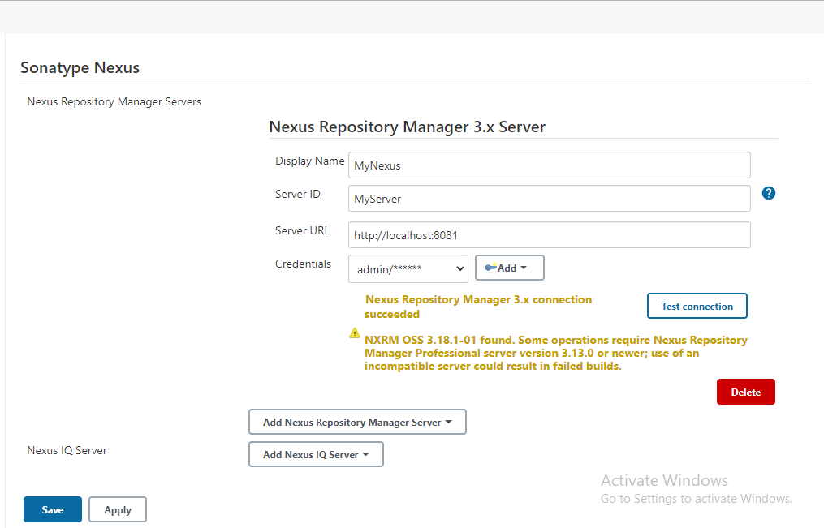

Now after connection is successful, save the changes and you will be directed to Jenkins dashboard page. Select option **Build Now** and go to console output option to check the output.

