**Name: Prashasti Gupta**

**Roll Number: R171218077**

**SAP ID: 500068493**

**Exp: 09 -- Uploading artifacts on Nexus server using command line**

Go to <https://www.sonatype.com/nexus/repository-oss/download> to download Nexus.

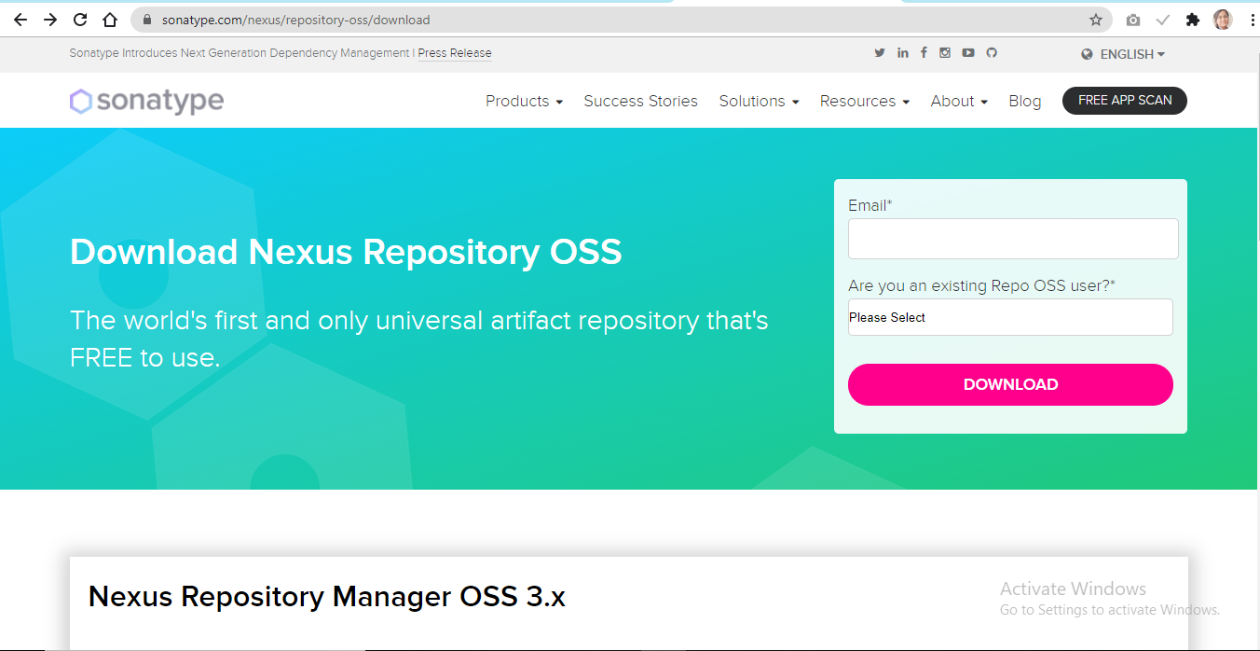

Open command prompt and move to the folder where Nexus is installed. After that, go to bin folder and then run the following command:

**Nexus.exe /run**

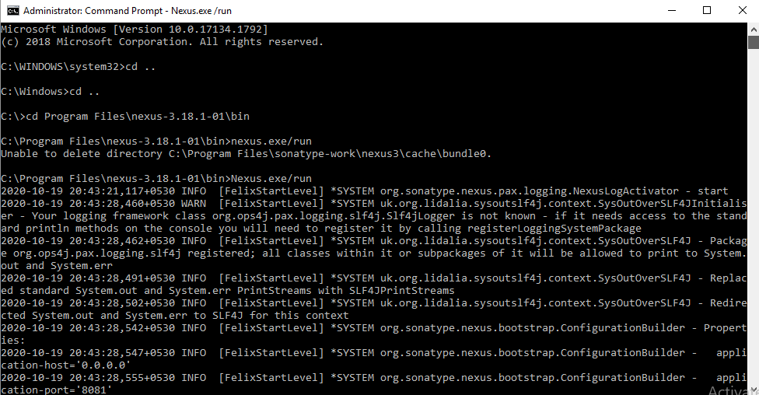

Now, go to **localhost:8081**, the port where Nexus server runs.

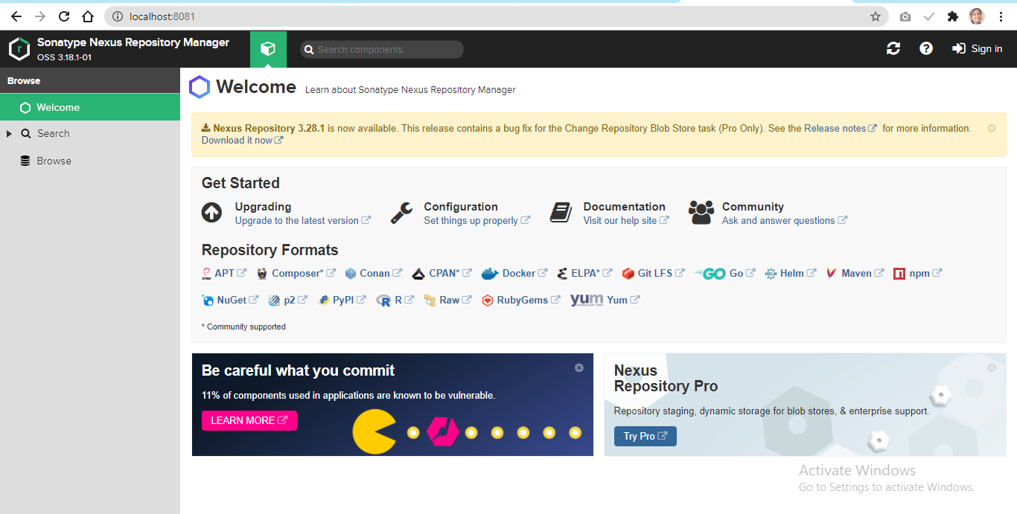

For the first time, nexus requests the admin password. You will find it in **sonatype-work\nexus3** folder with the name admin.password

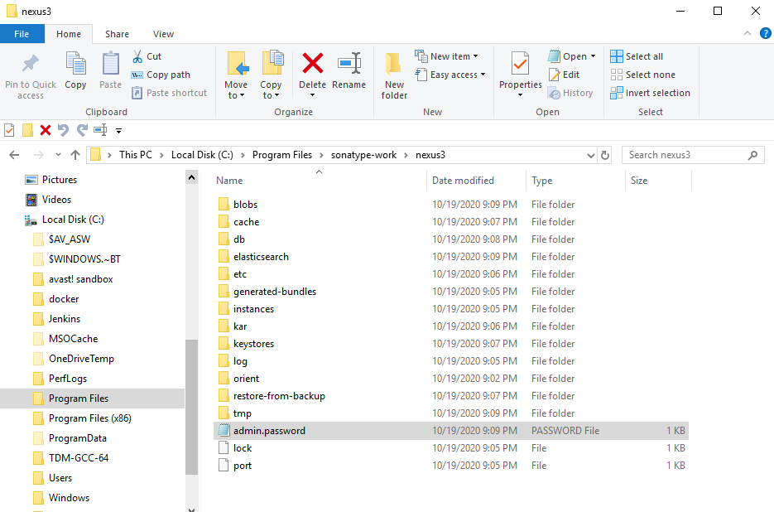

Complete the setup process to start using Nexus.

Now, create a new repository in Nexus (here called “firstrepo”) and copy its URL.

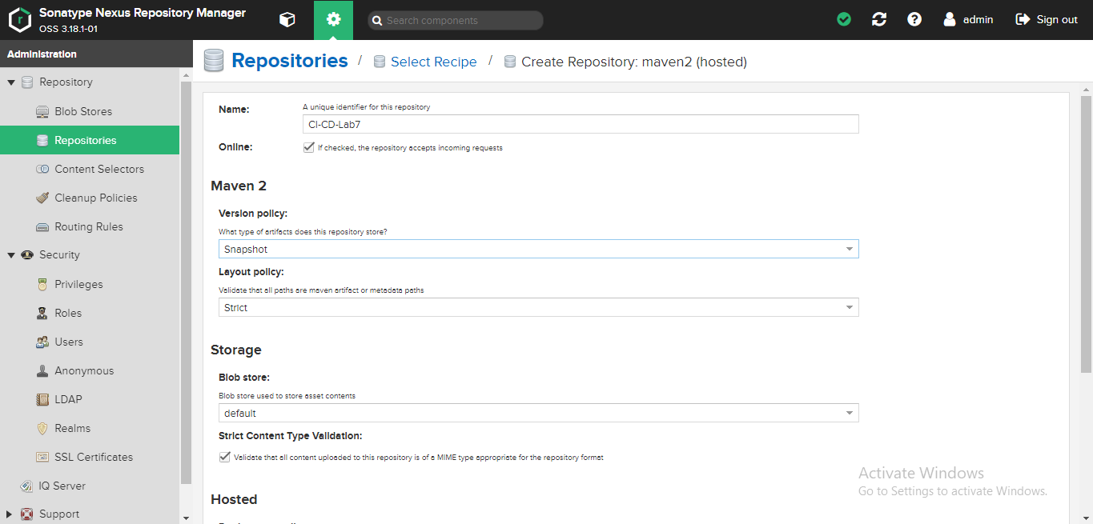

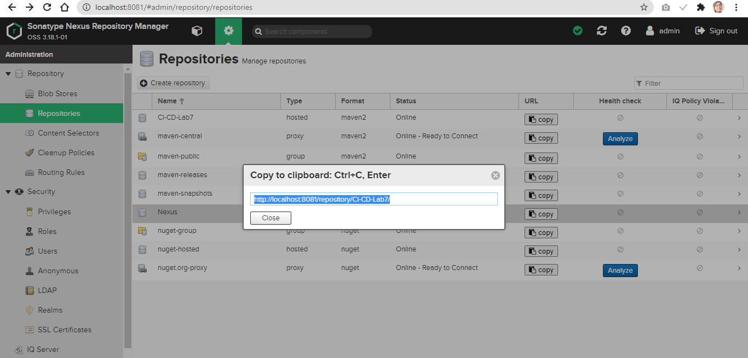

Open the pom.xml of the maven project which you want to be published to Nexus.

Add the snapshotRepository tag into the pom.xml and give the URL of Nexus repository copied.

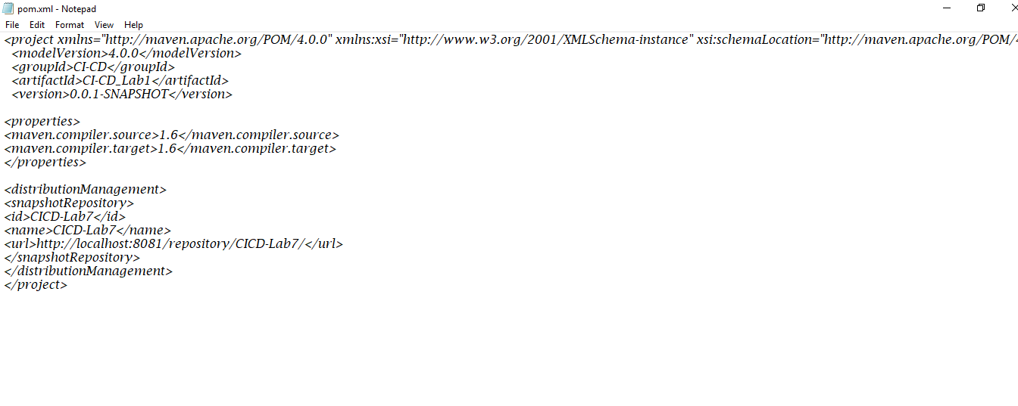

Now, open setting.xml in the **apache-maven-3.6.3** folder and add the tag of server with the required credentials.

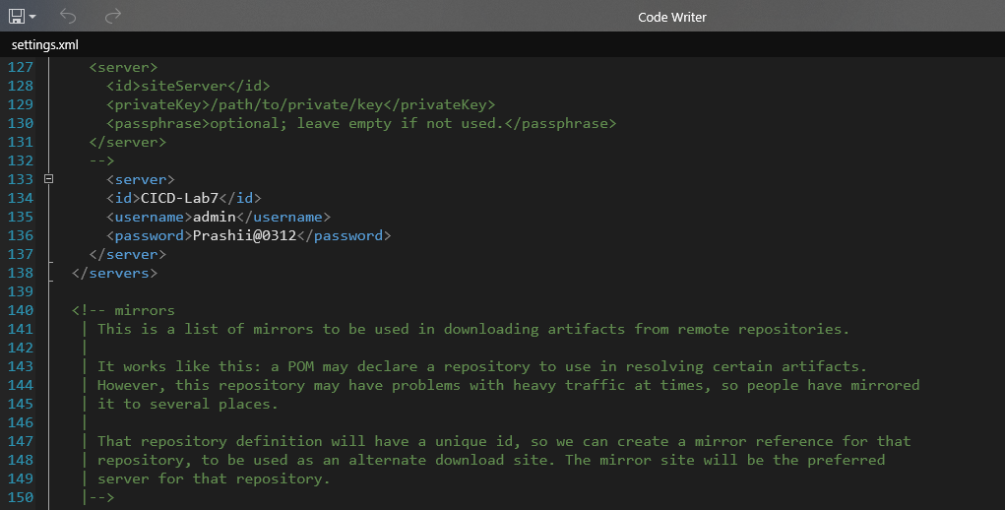

Now, open command prompt and move to the maven project folder and then run **mvn clean** and **mvn install** on it.

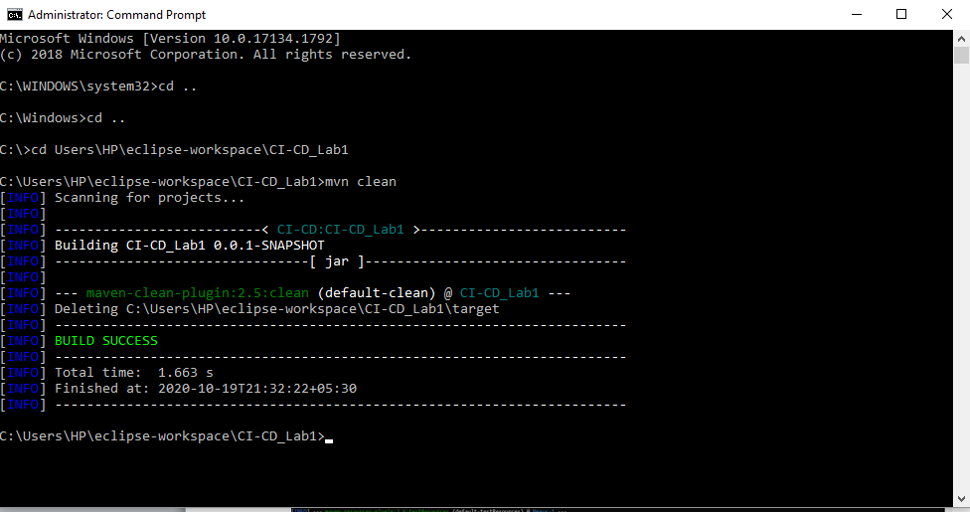

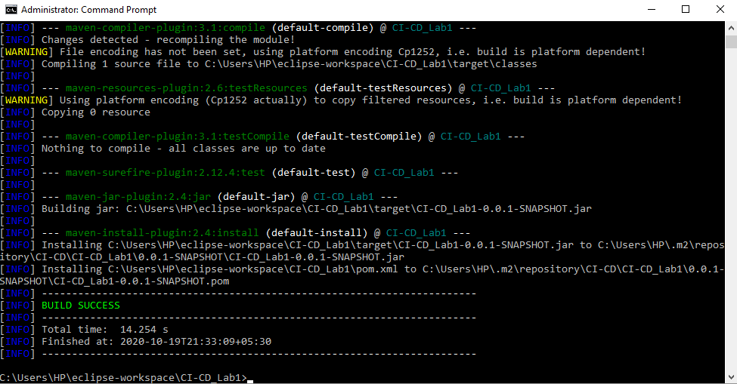

After mvn install command, a jar file will be created in **target** folder.

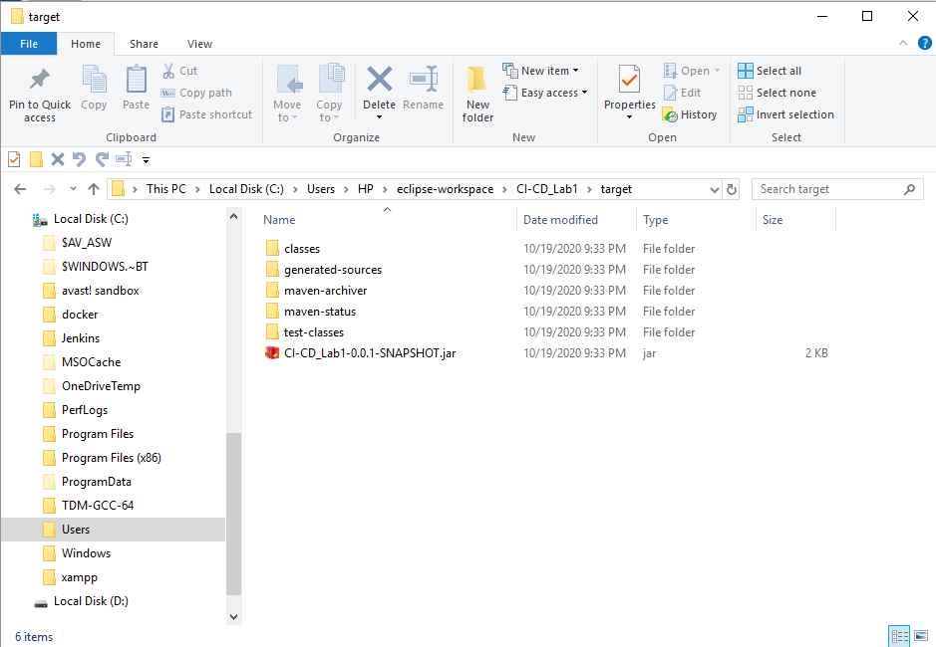

Run **mvn deploy** to deploy the built jar on the Nexus server.

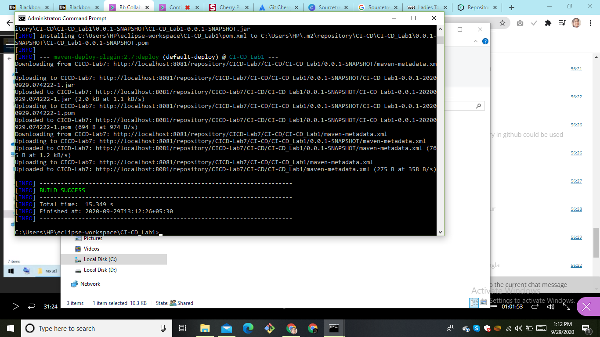

Browse the Nexus repository now to see the deployed jar.

