**EXPERIMENT-1**

Name:Aayush Kumar

DevopsB1

R171218002

Aim: Installation of Jenkins and execution of a simple job in Jenkins.

1) Download Jenkins war file from the internet and store it into the folder.

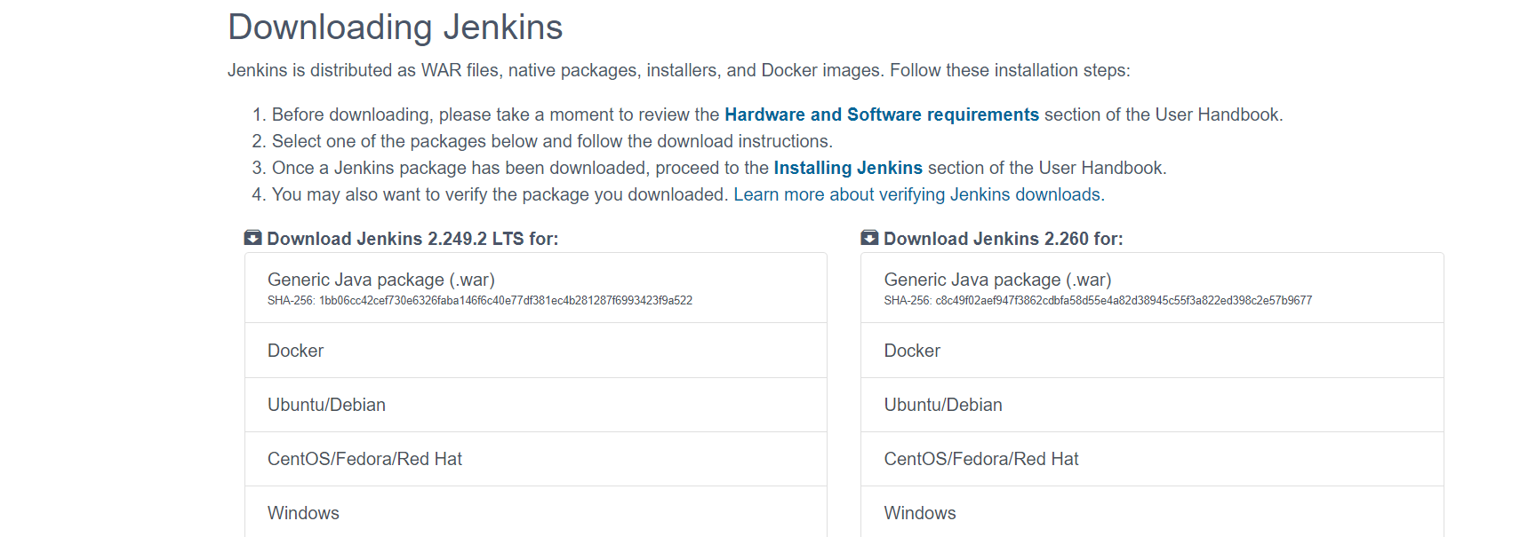

2) To start Jenkins, go to the folder where you stored the war file and type the command java -jar jenkins.war

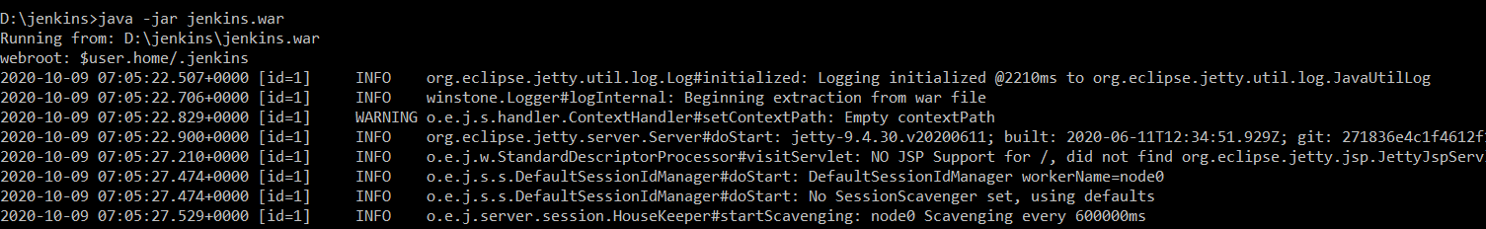

3) Jenkins will start now. We can open it on port 8080. Note that first time you will open the jenkins the password will be provided in the terminal. 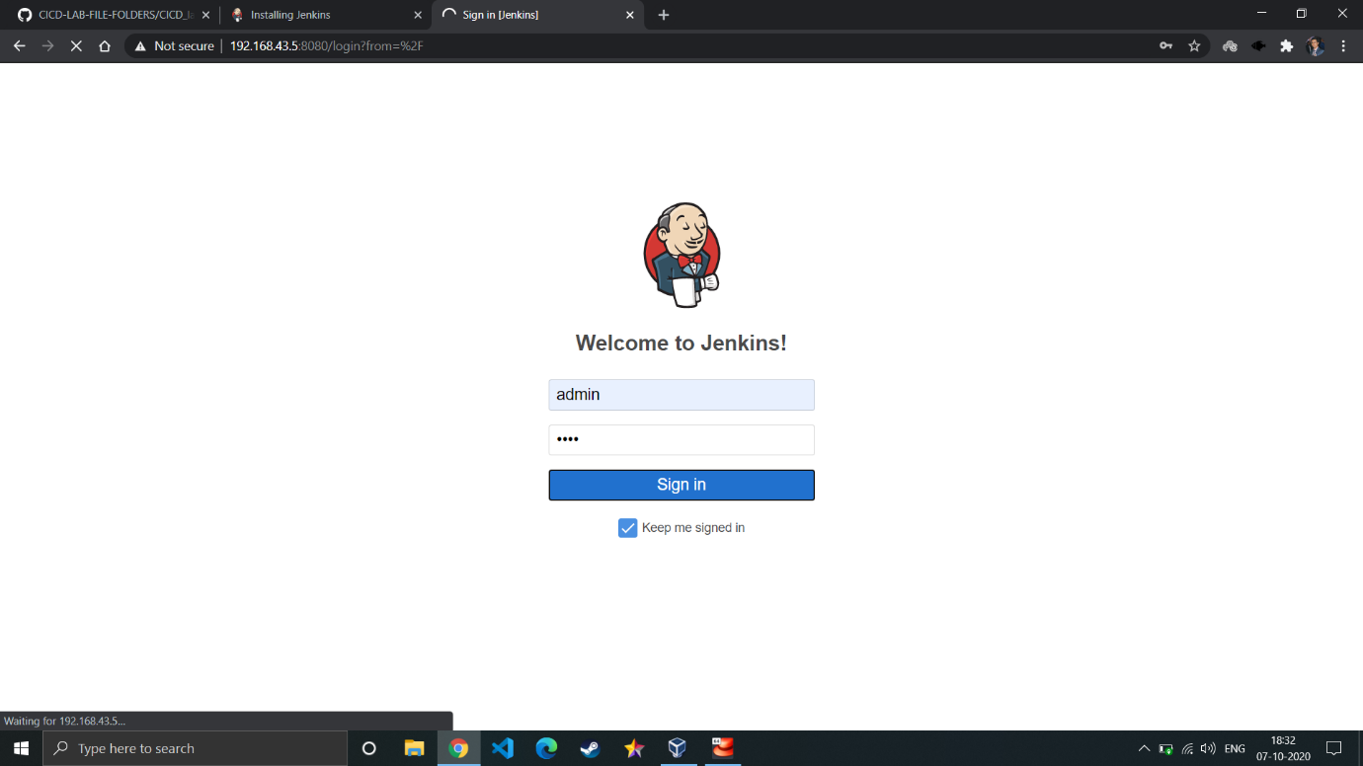

1. After login you will land on dashboard.

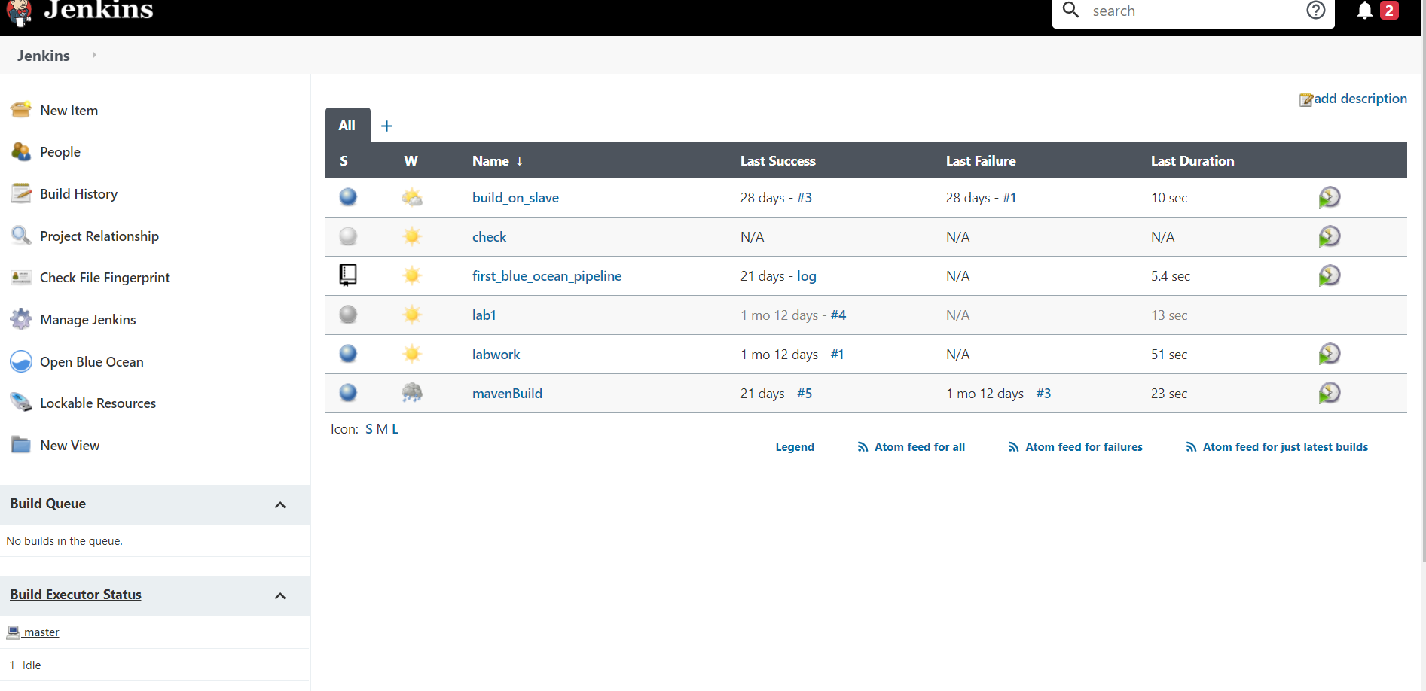

5) To create a pipeline, click on new item. Type the name and click on free style and then click ok.

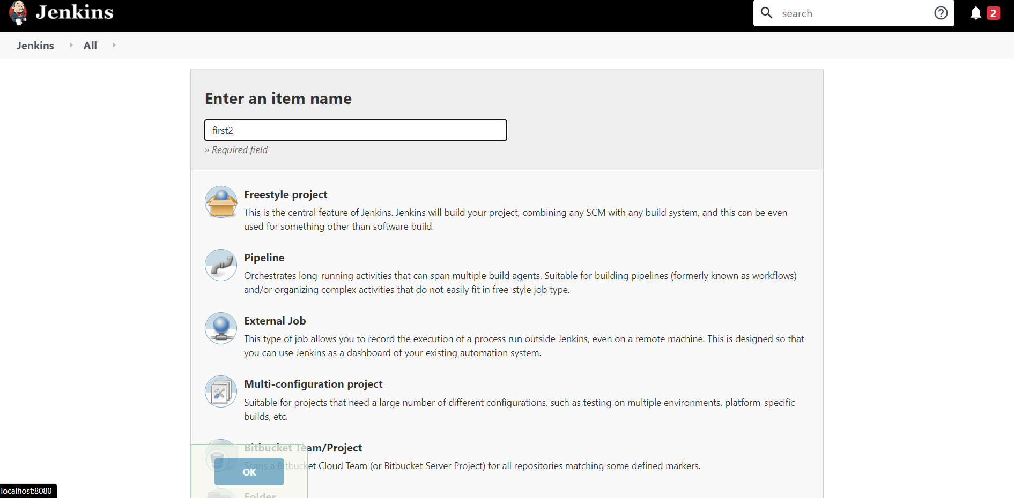

1. We will run just some basic command like printing something and then save.

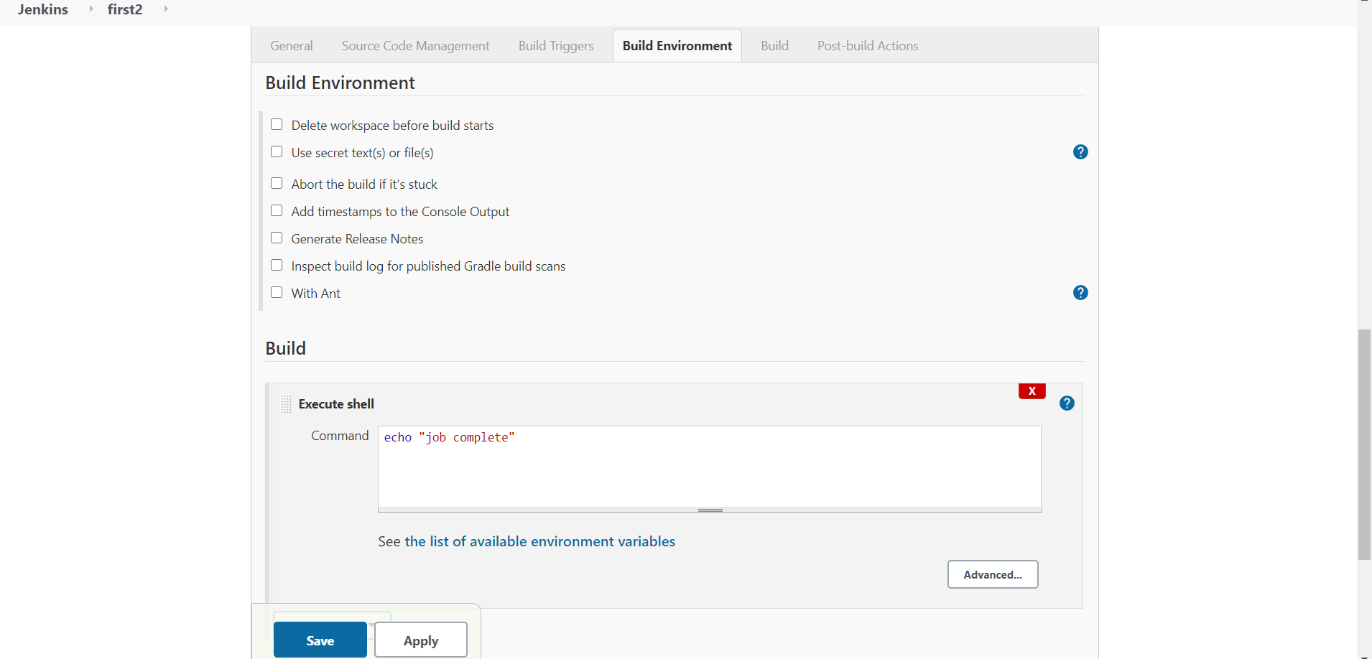

1. Then click on the build now options on the left panel and the output will be show in the console.

