**EXPERIMENT-10**

Name: Aayush Kuamar

500069079

R171218002

Aim: Nexus Integration with Jenkins.

1. To integrate Nexus with Jenkins you need to install Nexus Platform plugin.

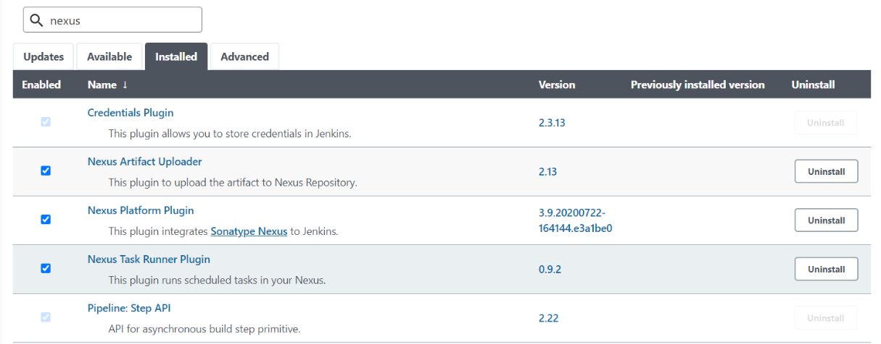

1. Now go to manage Jenkins Global configuration. In global configuration, add jdk and Sonatype Nexus version and location.

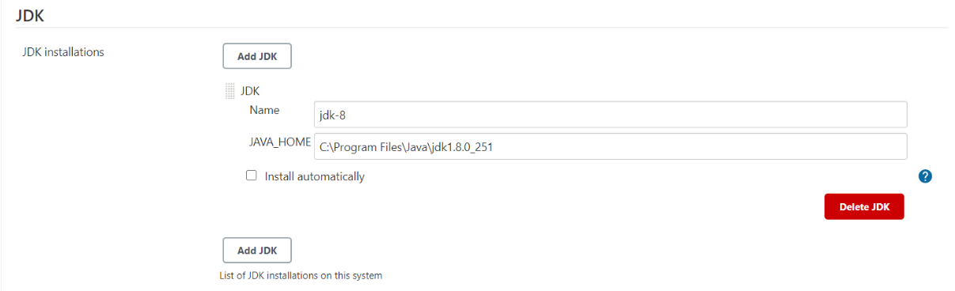

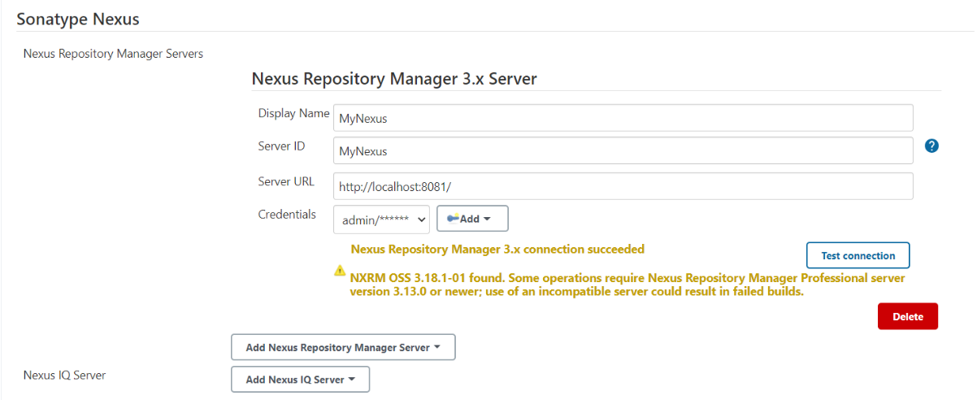

1. Create a new job and configure:

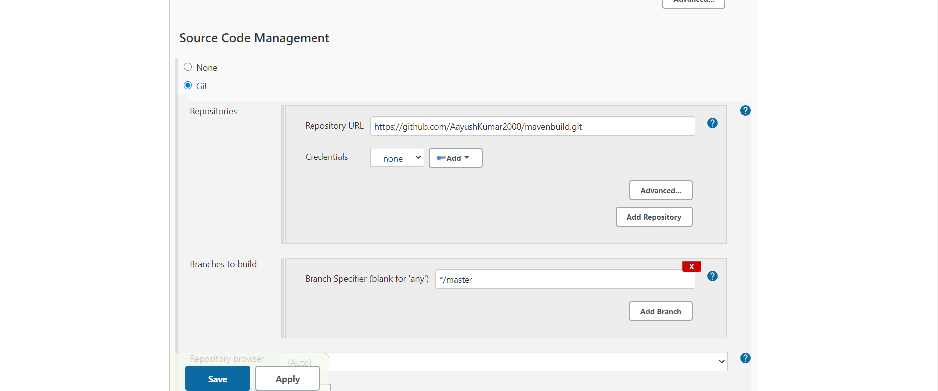

1. After running job successfully check nexus server for deployed project.

