**EXPERIMENT-2**

Name: AayushKumar

R171218002

DevOpsB1

Aim: Jenkins integration with GitHub.

1) To integrate GitHub with Jenkins, we first need to install git plugin. For this go to manage Jenkins -> manage plugins -> install.

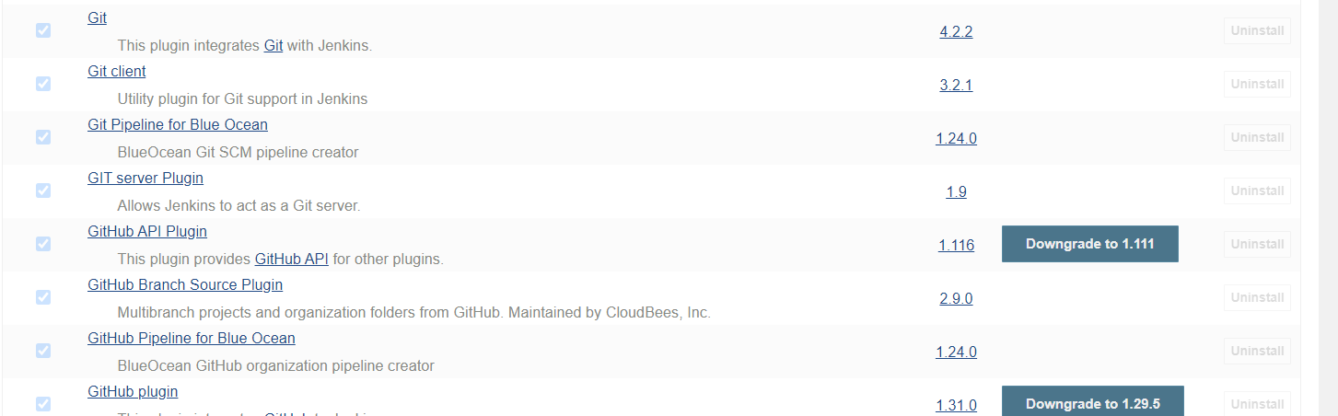

1. Now create a pipeline and now git option will be available. Give url of the GitHub repository and then click on save.

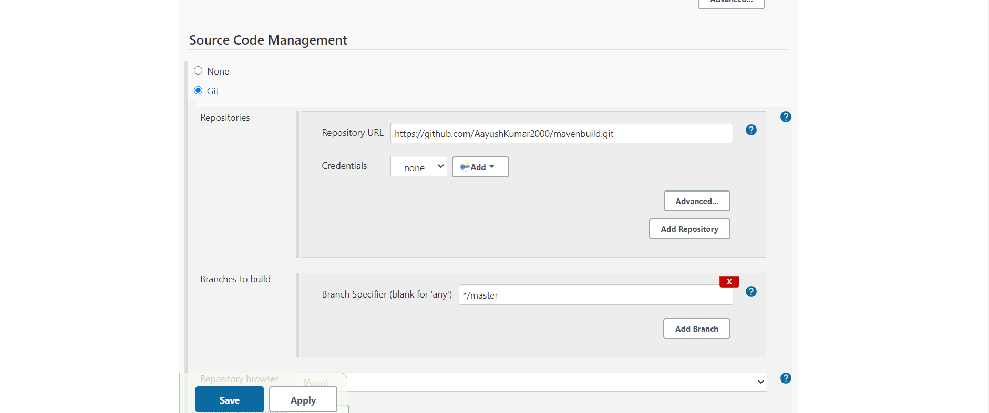

1. Then click on build now jenkins will fetch all the files from the gitHub.

