**EXPERIMENT-5**

Name: Aayush Kumar

R171218002

DevopsB1

Aim: Jenkins integration with SonarQube.

1. To integrate Jenkins with SoanrQube, download sonarqube scanner plugin.

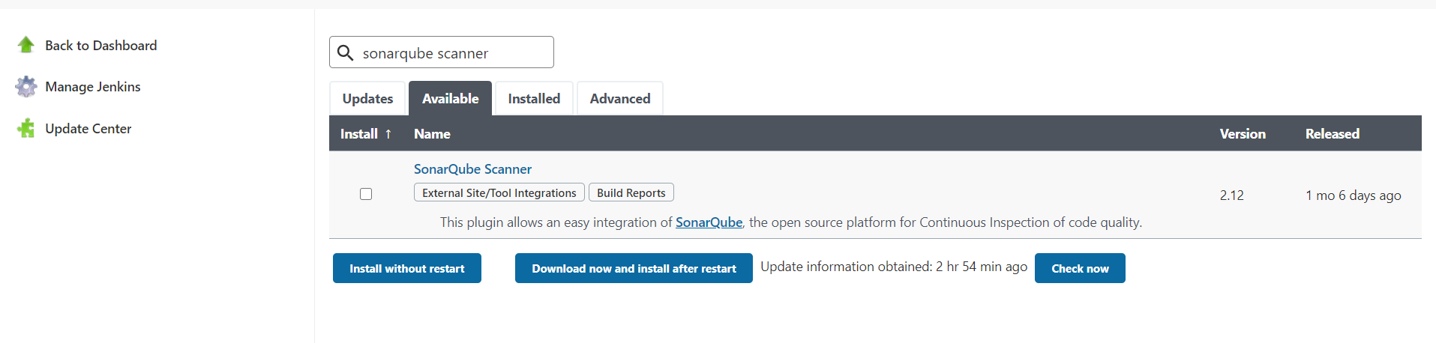

2) Now create a maven job and give GitHub Repository url and in goal write the following :- 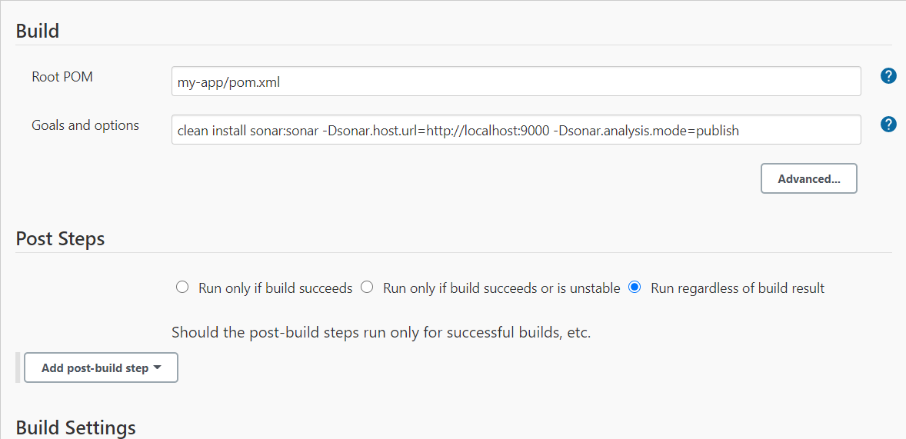

3) If this Jenkins job runs successfully, you may see the following output of the job.  
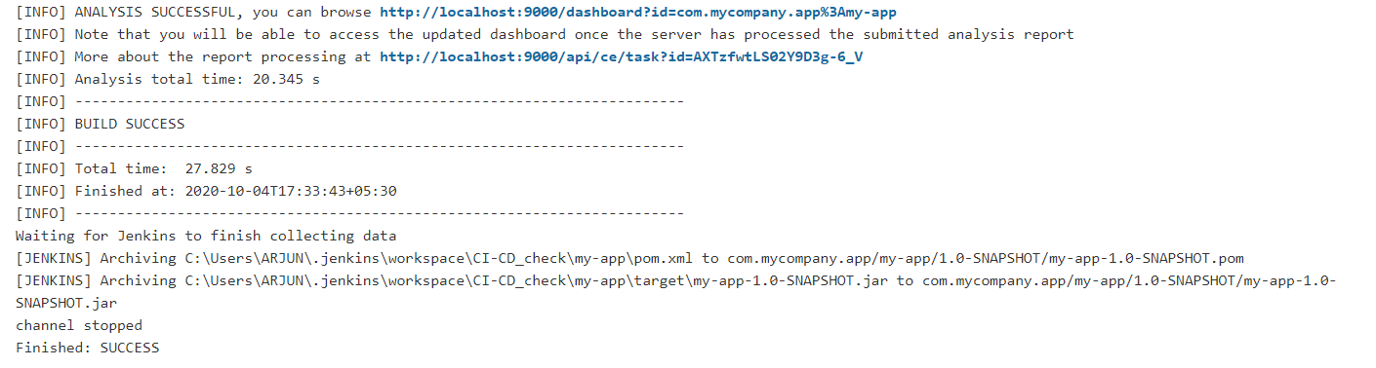

4) Now go to SonarQube and see the static code analysis of your maven project.  
