**EXPERIMENT-6**

Name:Aayush Kumar

500069079

R171218002

Aim: Create Pipeline using Jenkinsfile.

1. Click on the new item on the left panel and then enter your item name and select pipeline and click ok.

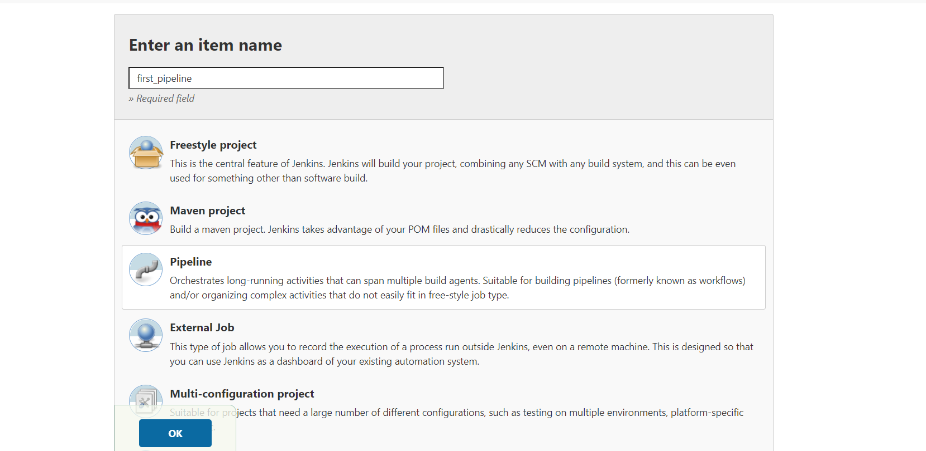

1. Now give GitHub repository url and path of Jenkisfile and then click on save.

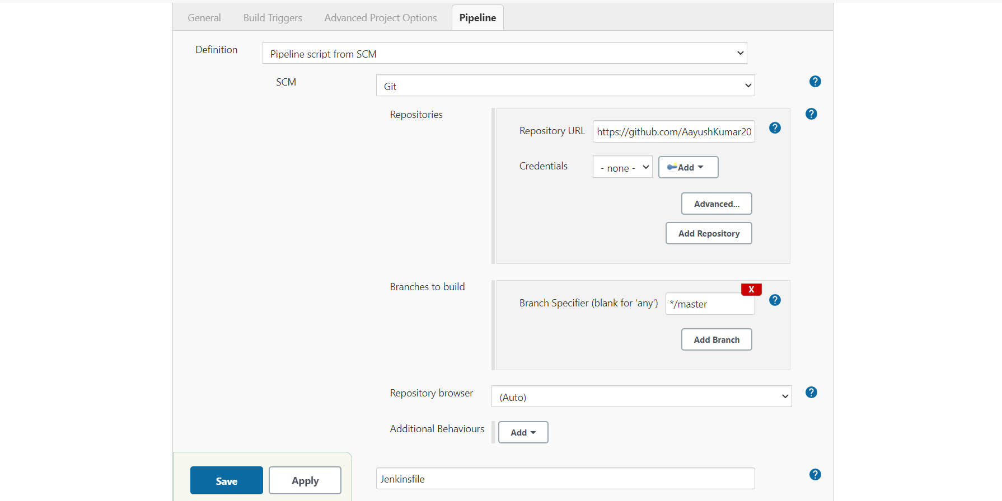

1. Then click on Build now and this is the log output of the build.

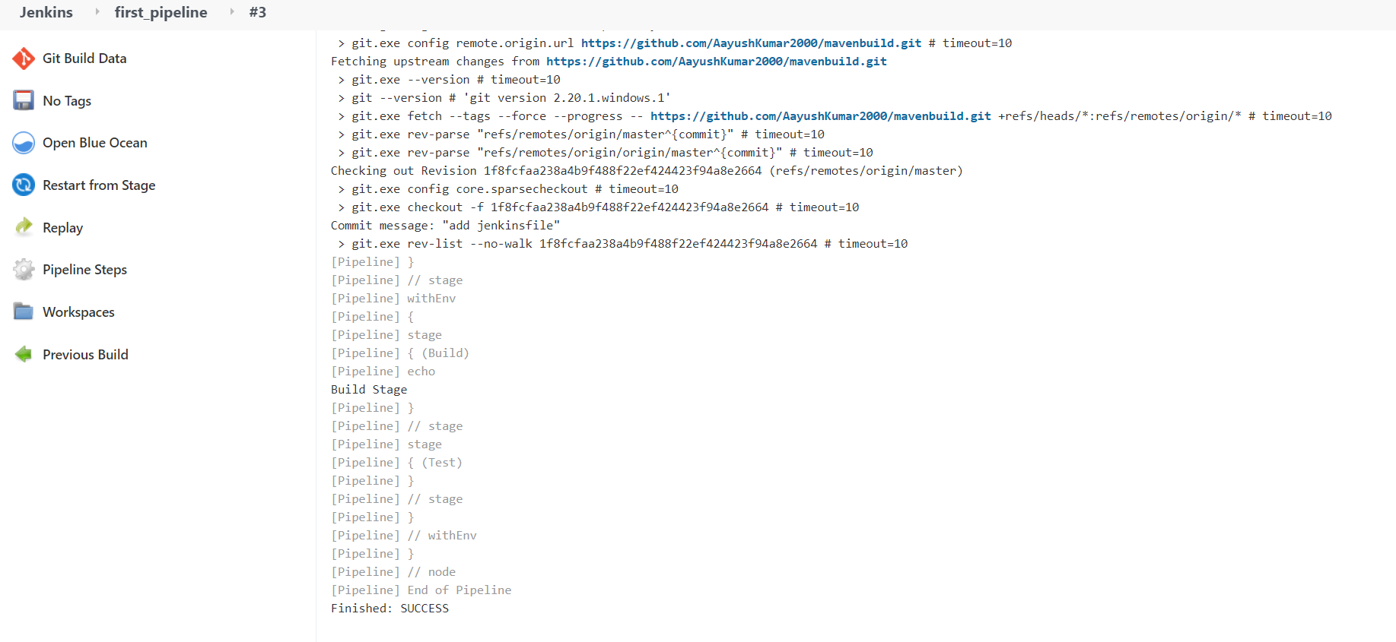

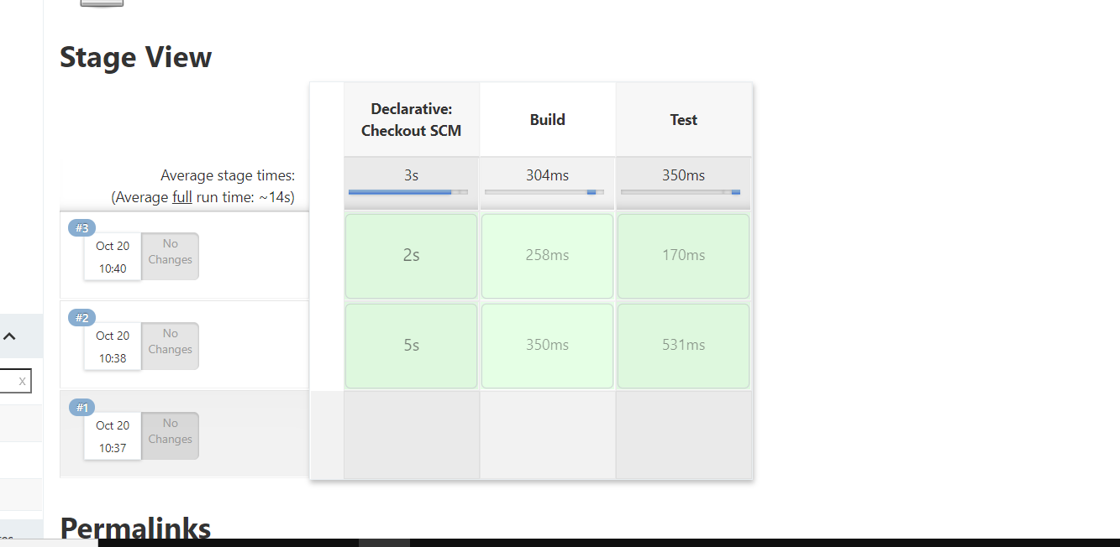

This is your jenkins file in the github:

