**EXPERIMENT-7**

Name: Aayush Kumar

R171218002

500069079

Aim: Create a pipeline using Blue Ocean.

1) To create a pipeline using Blue Ocean we need to download.

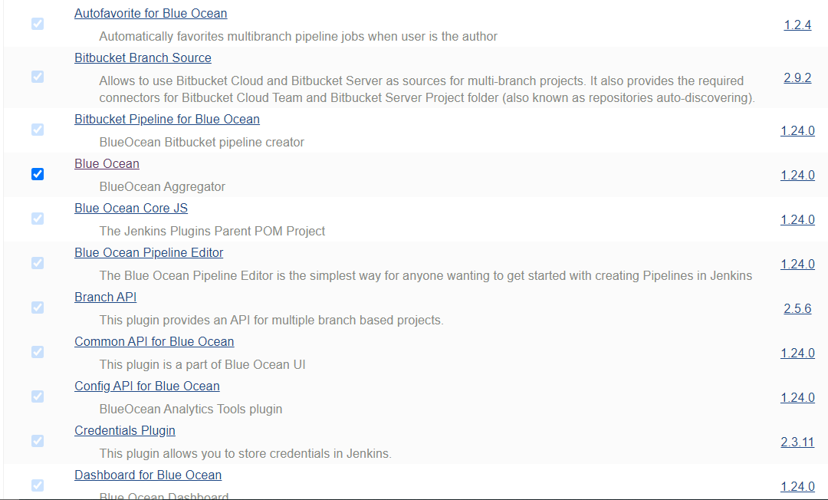

2) Select Open Blue Ocean and create a new pipeline.

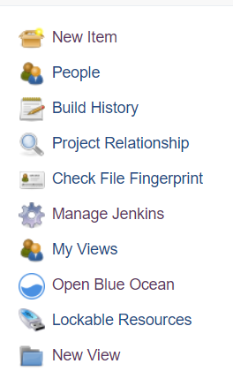

1. Connet your github repository.

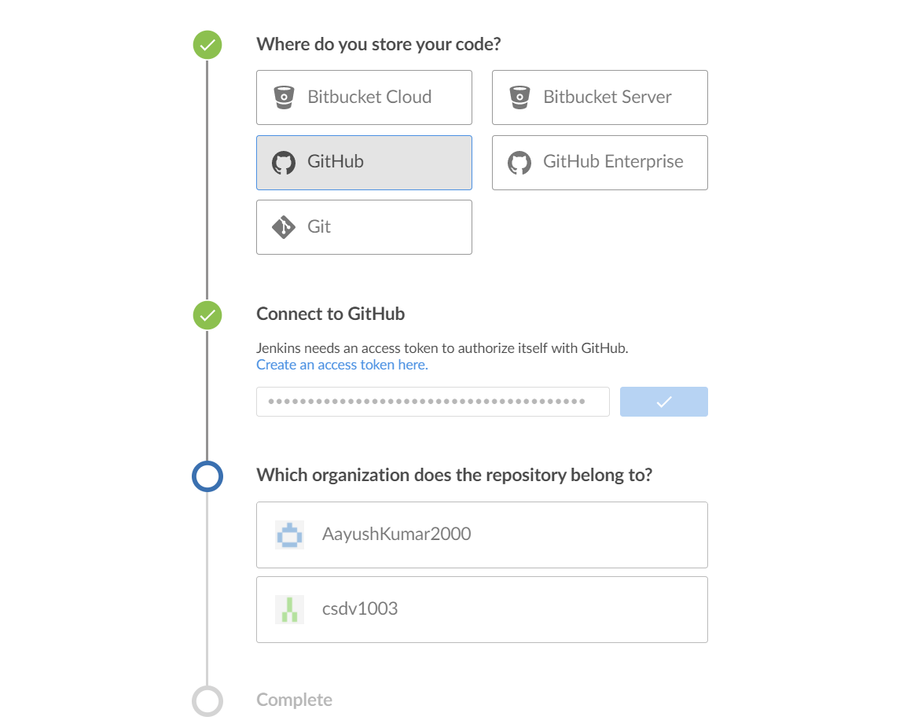

1. After making a new pipeline in Blue Ocean, if pipeline created successfully and jobs runs successfully you may see the following.

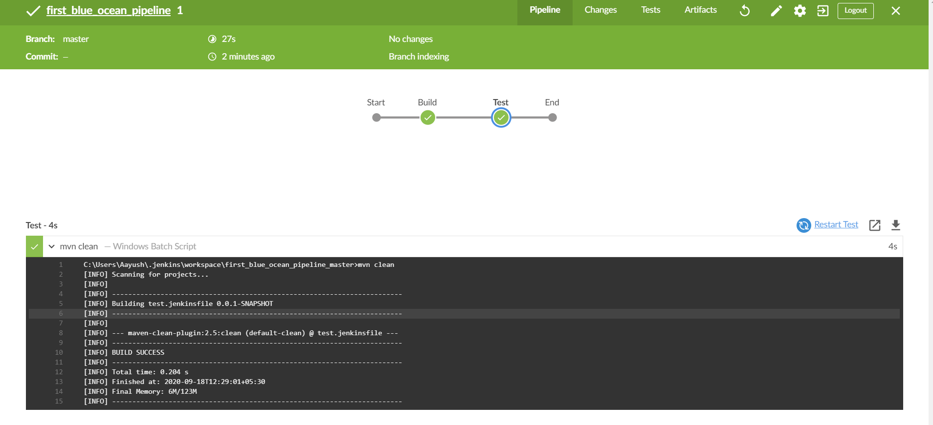

1. Now you can run this pipeline with just one click.

