**EXPERIMENT-8**

Name:Aayush Kumar

R171218002

500069079

Aim: Implementing Master/Slave architecture in Jenkins.

1. For building slave first we have to making one setting

Go to configure global setting and in agents select random option.

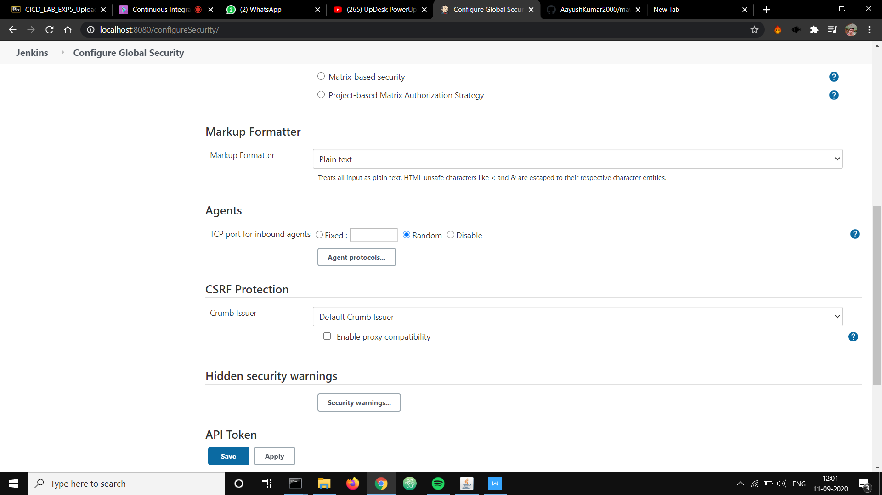

1. Select a new Node and give slave name and make it a permanent node.

3) After that you need to configure the slave as follows and give custom working directory path(anypath where you want to save build made by slave).

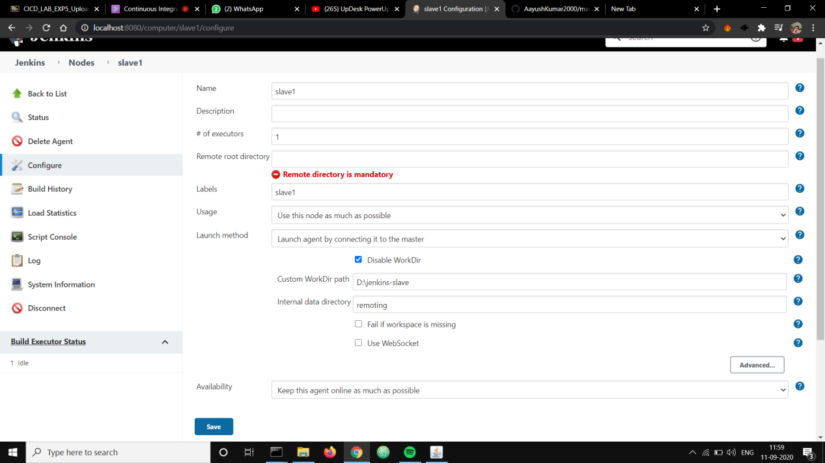

4)After the configuration done you have to launch the slave you can use the following option:

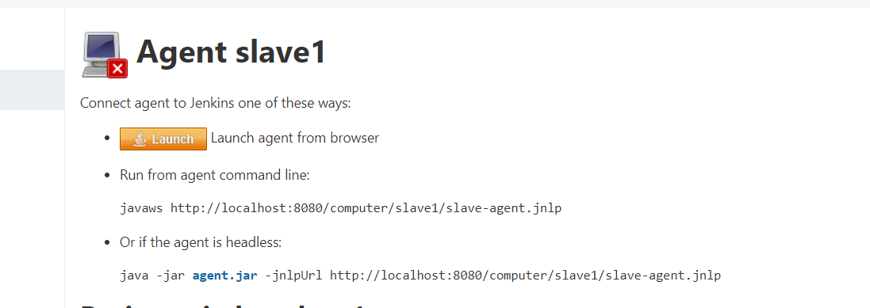

1. After slave launch it will show idle.

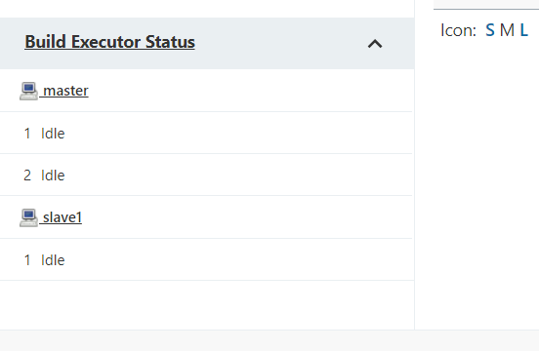

1. Create a pipe line or a job and do the following setting:

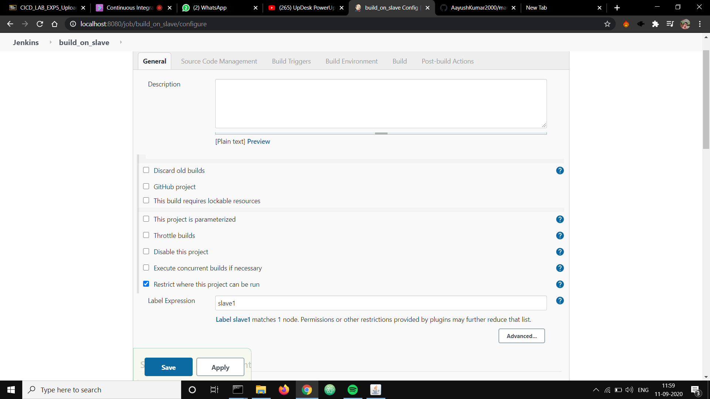

1. Now if you run the job you will see slave-1 is running this job.

