**EXPERIMENT-9**

Name: Aayush Kumar

500069079

R171218002

Aim: Uploading Artifacts on Nexus Server using command line.

1. Download Nexus and run ‘nexus.exe /run’ in the folder where you downloaded it and inside the bin folder .

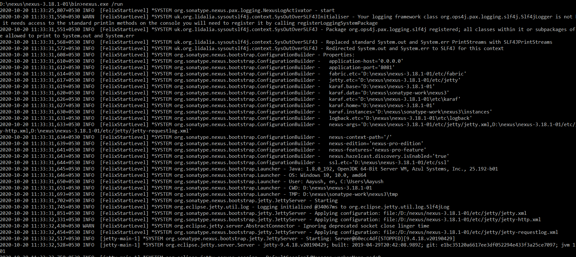

1. Nexus will launch at port 8081.

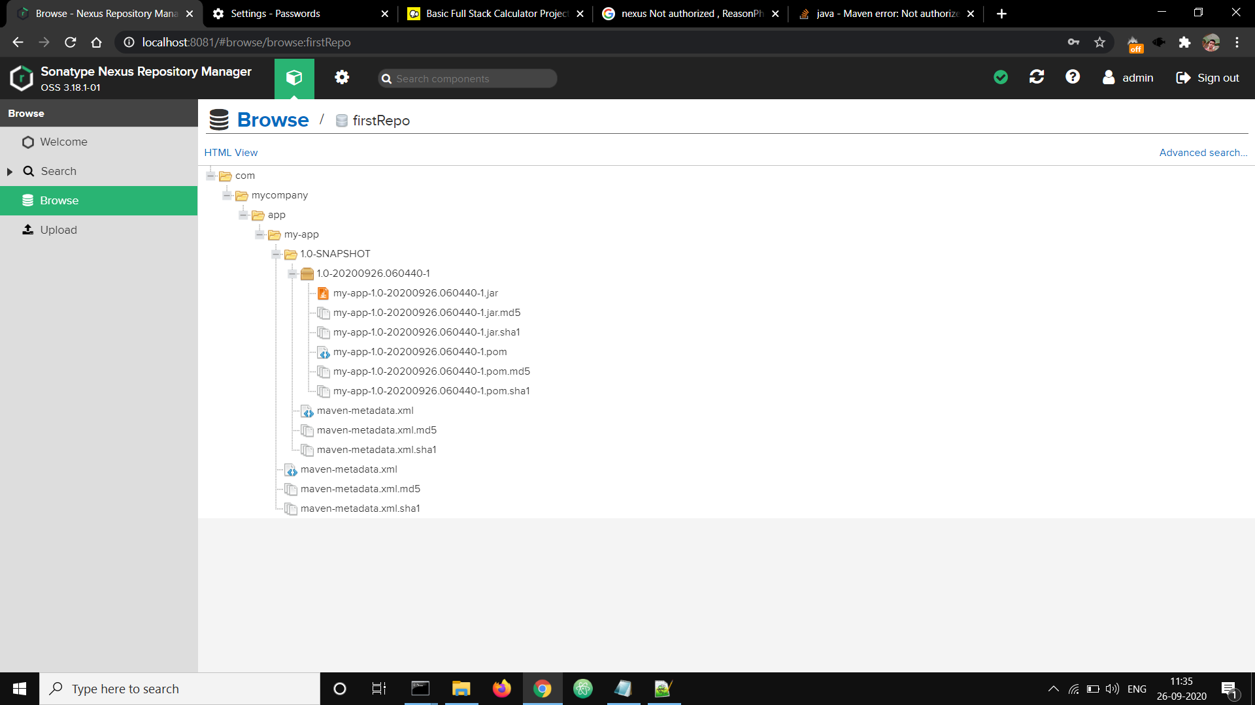

1. Now create the repository and configure it as follows.

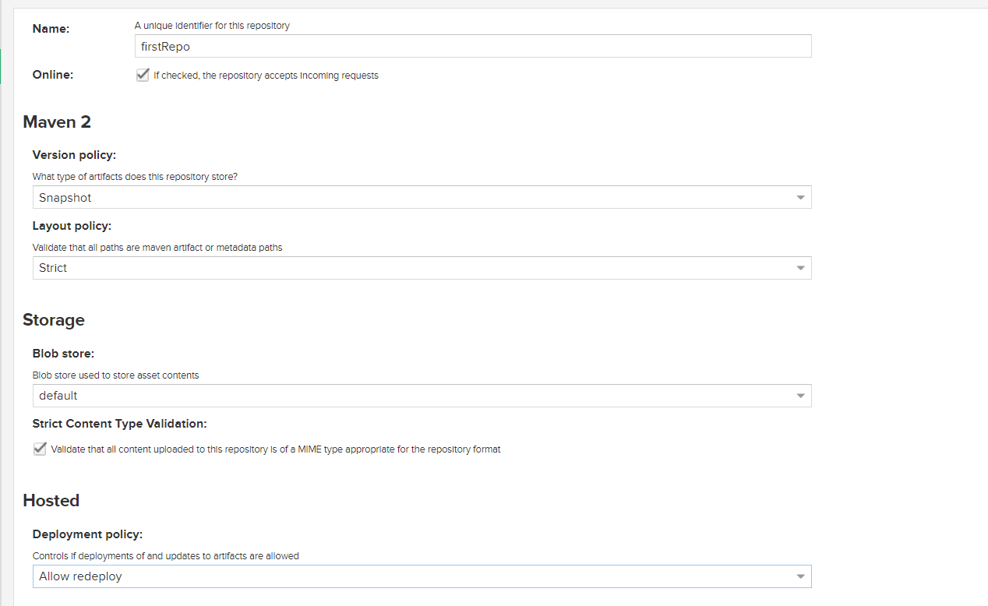

4)In the Maven project, make changes to pom.xml file and give nexus repository url.

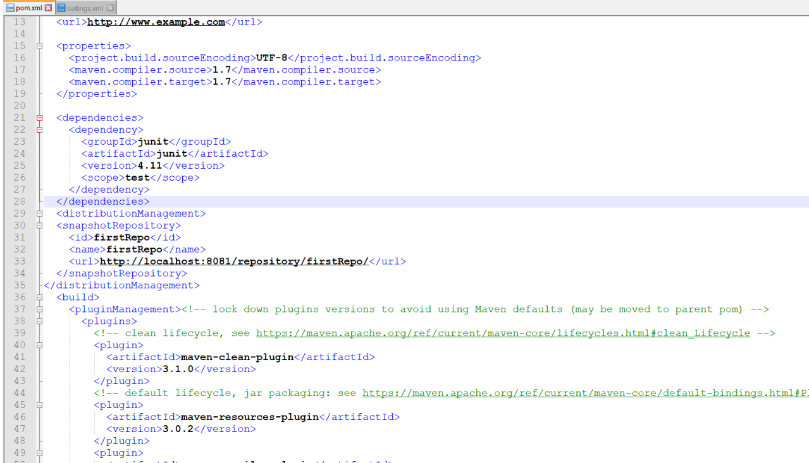

5)In the setting.xml of the apache maven do the following config inside servers tag.

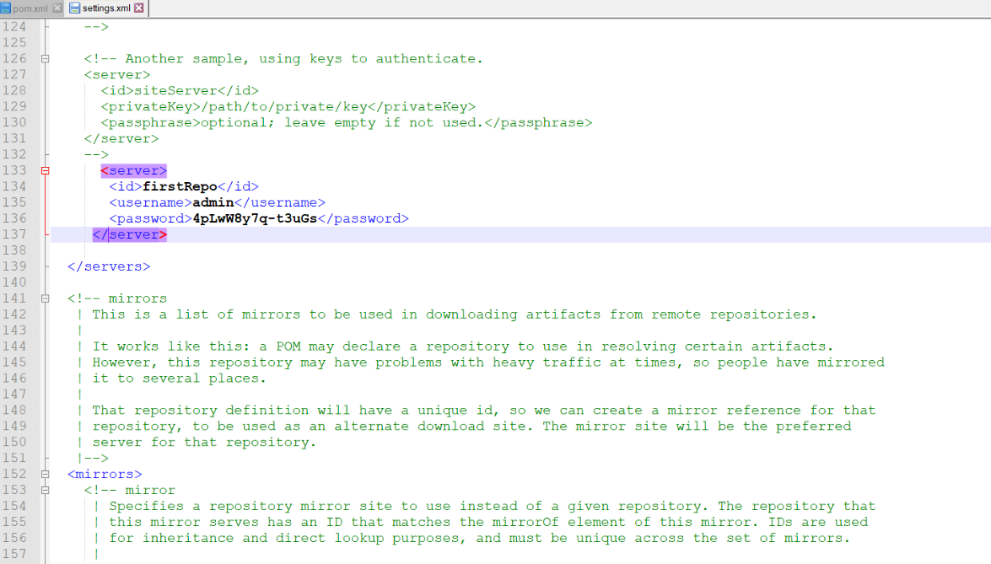

1. Now go to the project path in command line and perform goals. First clean and then any other goal.

