

**CONTINUOUS INTEGRATION**

**&**

**CONTINUOUS DELIVERY**

**LAB REPORT**

|  |  |
| --- | --- |
| **SUBMITTED BY** | **SUBMITTED TO** |
| ABHIJEET PRASAD  500069170  R171218003 | DR. HITESH KUMAR SHARMA |
| CSE - DEVOPS | DEPT. OF CYBERNETICS (SoCS, UPES) |

**TABLE OF CONTENTS**

|  |  |  |
| --- | --- | --- |
| S. NO. | TOPIC | PAGE NO. |
|  | Installation of Jenkins and executing a simple job. |  |
|  | Jenkins integration with Github |  |
|  | Jenkins integration with Github and Maven |  |
|  | Static code analysis using SonarQube |  |
|  | Jenkins integration with SonarQube |  |
|  | Creating a pipeline with Jenkinsfile |  |
|  | Creating a pipeline with BlueOcean plugin |  |
|  | Implementing Master/Slave architecture in Jenkins |  |
|  | Uploading artifacts on Nexus server using CLI |  |
|  | Jenkins integration with Nexus |  |

**OFFICIAL DOCUMENTATIONS**

|  |  |  |
| --- | --- | --- |
| S. NO. | TOOL/PLUGIN | LINK |
|  | JENKINS | <https://www.jenkins.io/doc/> |
|  | JENKINS + GITHUB |  |
|  | SONARQUBE |  |
|  | JENKINS + BLUEOCEAN |  |
|  | NEXUS |  |

1. **Installation of Jenkins and executing a simple Job**
2. INSTALLATION
   1. Windows

**To install Jenkins as a local service on your Windows machine, follow along the following steps.**

**Requirements: JDK**

* + 1. **Download Jenkins**

Head to <https://www.jenkins.io/download/> and choose Windows as your OS, and download Jenkins Stable Installer.

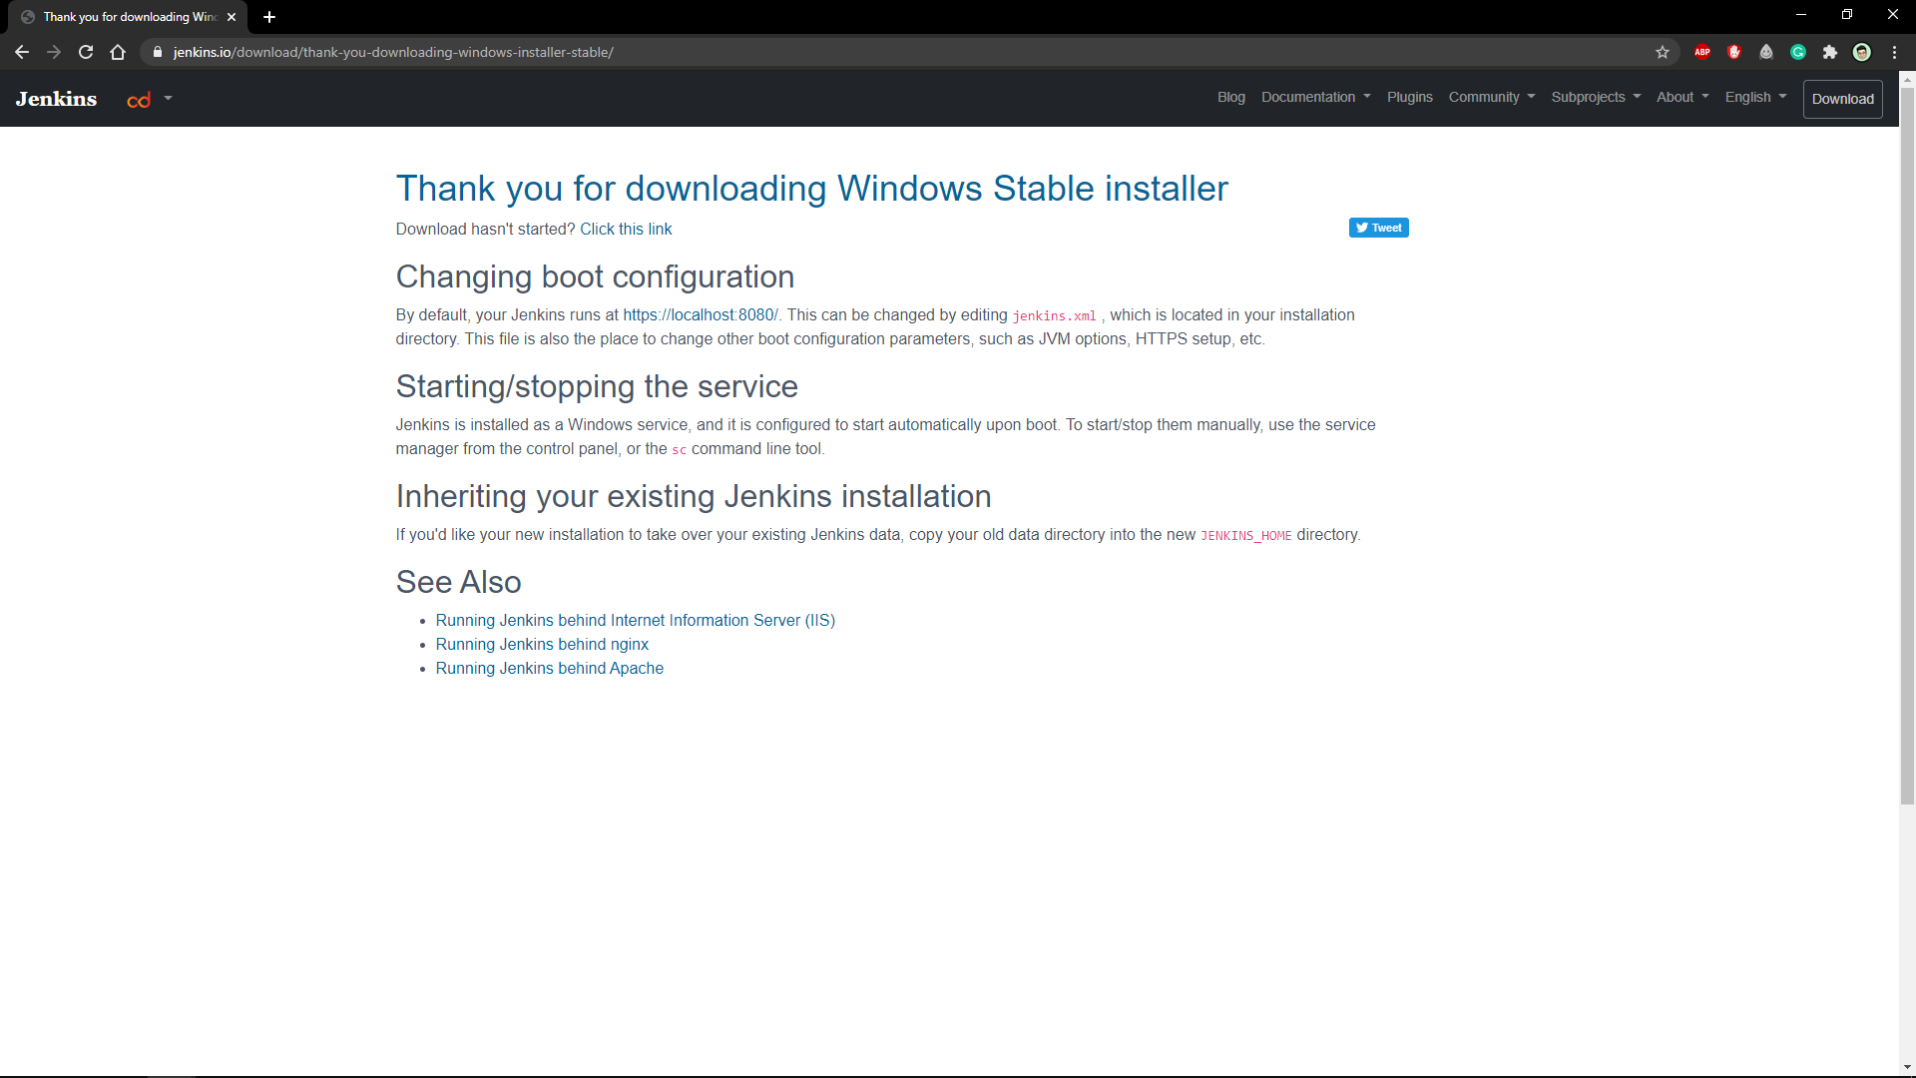

* + 1. **Install Jenkins**

Run the downloaded installer and follow the on-screen instructions. You will see a success page once it is done.

Move to the next step.

* + 1. **Test run**

Head to you web browser and navigate to <http://localhost:8080/> , you will be redirected to Jenkins login page. It’ll prompt you with the location of the default password. Find the file and paste your default password.

**DONE! We have successfully installed Jenkins on our Windows Machine.**

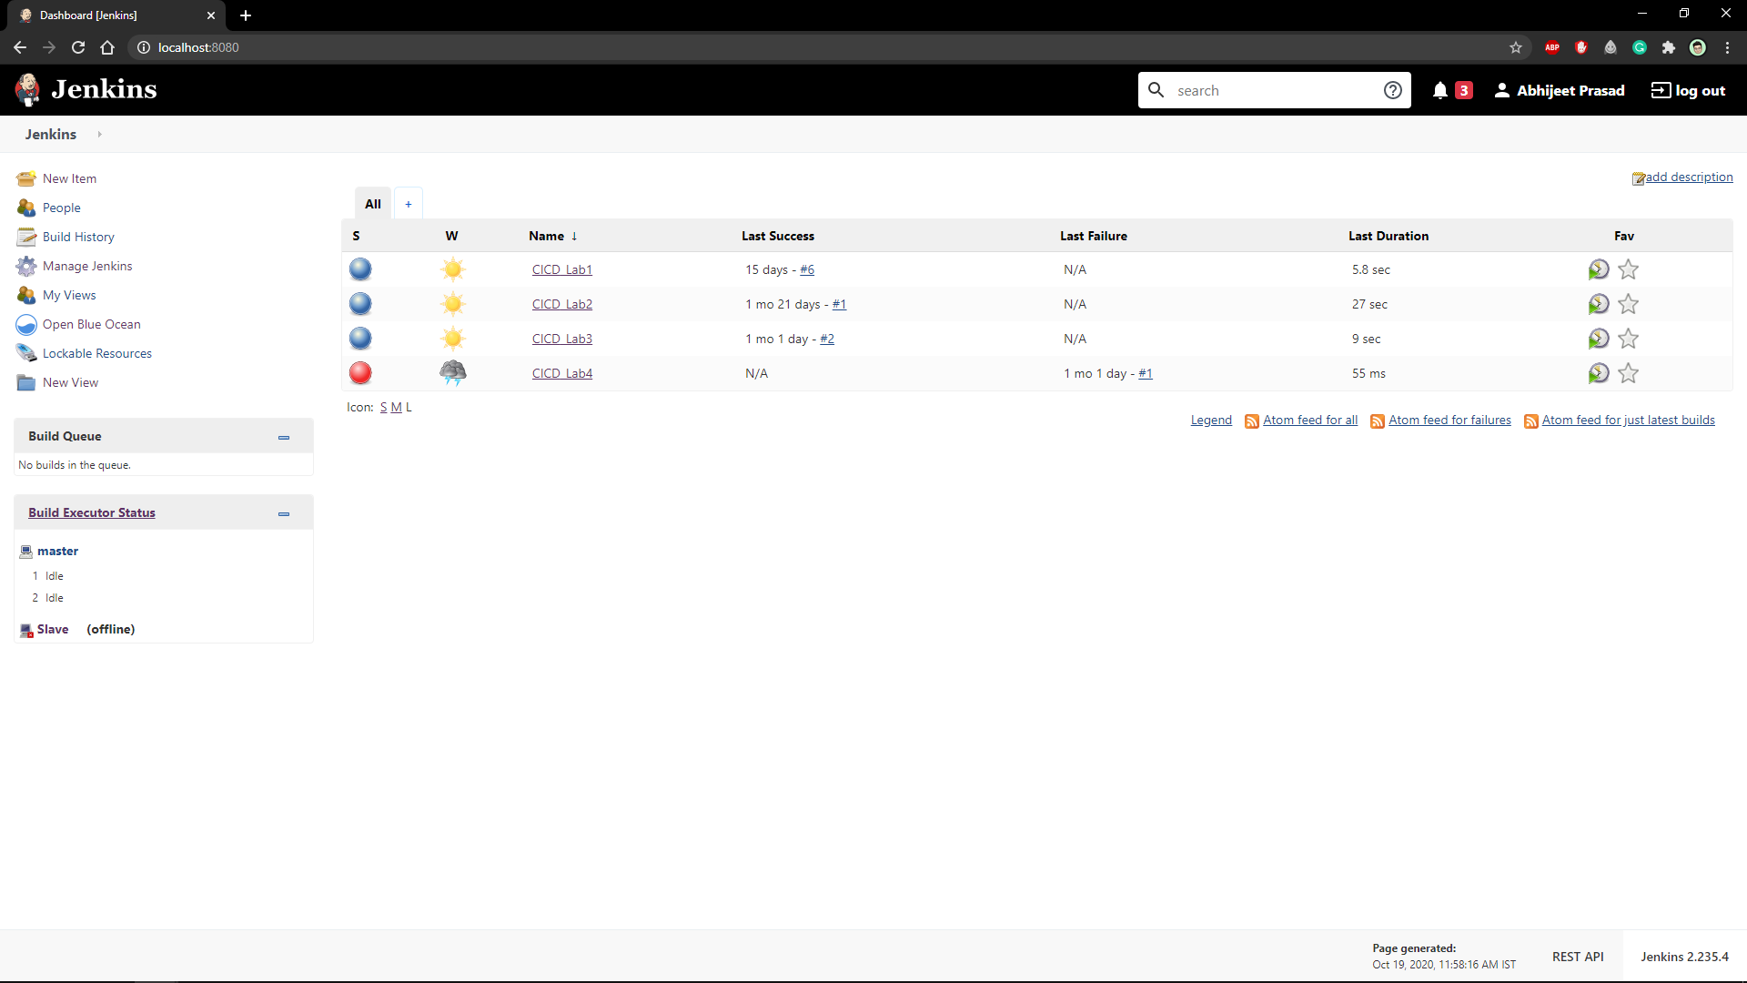

* 1. Linux/Debian

**To install Jenkins service as localhost on your Debian based Linus Distribution, follow along the following steps.**

**Requirements: JDK**

* + 1. **Install Jenkins**

Run the following commands to install Jenkins on Debian/Ubuntu Machine.

wget -q -O - https://pkg.jenkins.io/debian-stable/jenkins.io.key | sudo apt-key add -

sudo sh -c 'echo deb https://pkg.jenkins.io/debian-stable binary/ > \

/etc/apt/sources.list.d/jenkins.list'

sudo apt-get update

sudo apt-get install Jenkins

* + 1. **Run Jenkins**

Start your Jenkins service with the following command.

sudo systemctl start jenkins

1. EXECUTING A SIMPLE JOB

**To execute a simple job in Jenkins, we need a Maven Project that can perform Maven Goals. We will be executing a simple build through Jenkins.**

1. **Jenkins integration with Github**

1. **Jenkins Integration with Github and Maven**

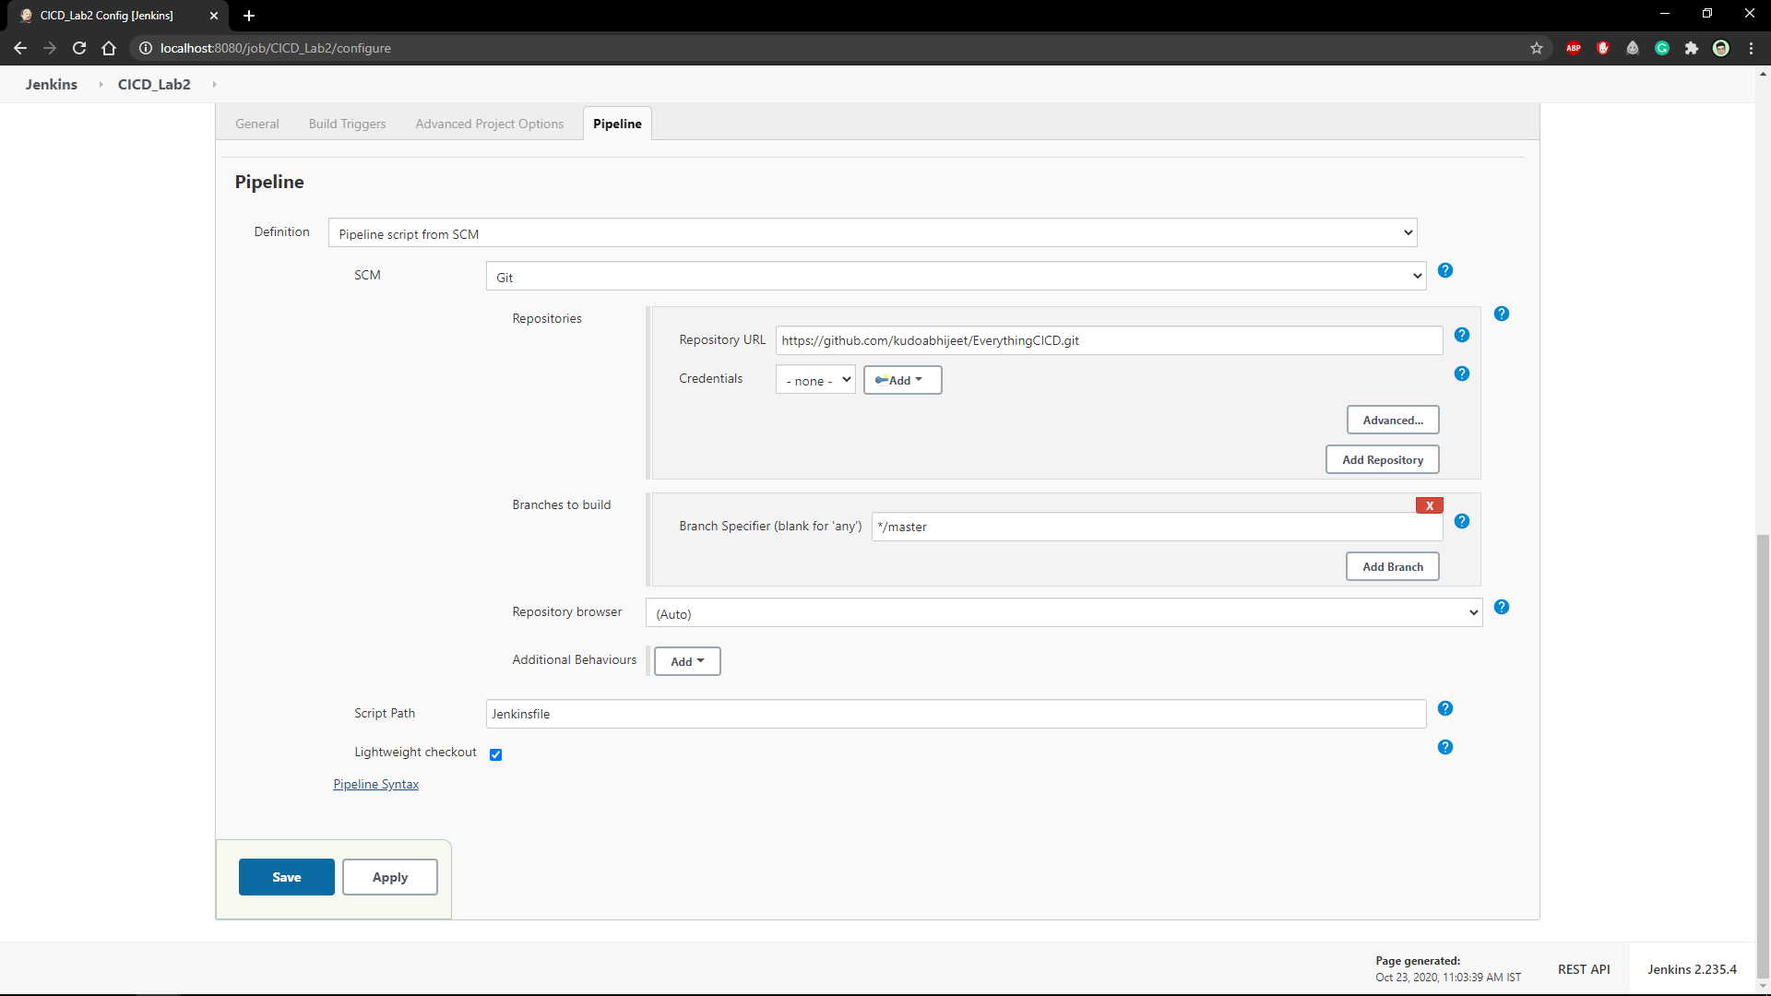

1. **Static Code Analysis using SonarQube**

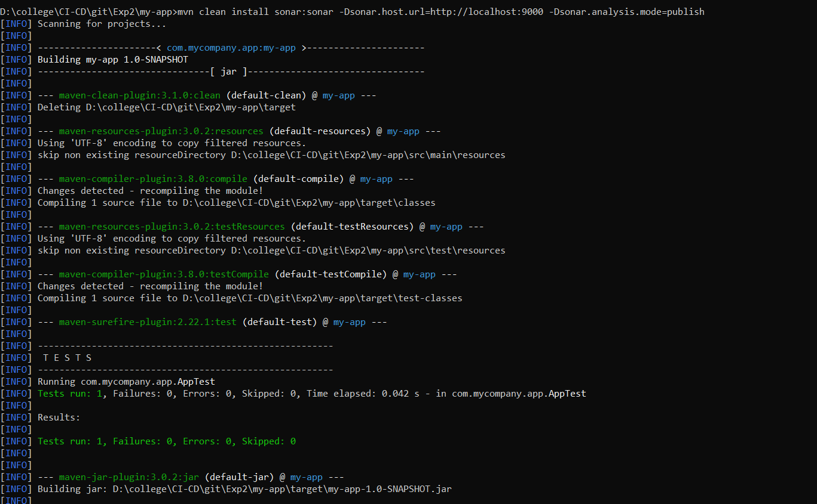

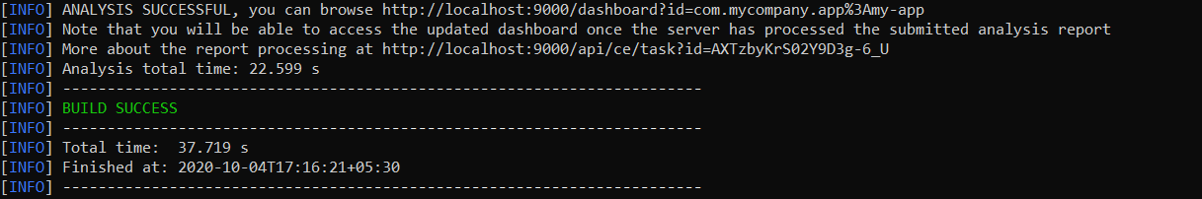

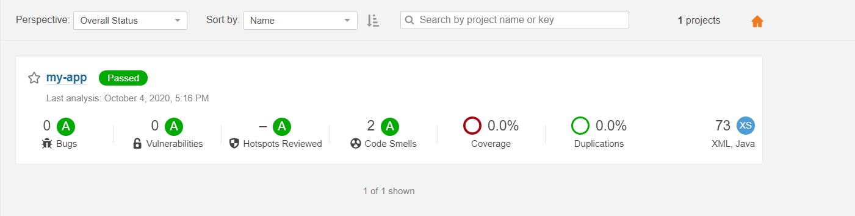

1. **Jenkins Integration with SonarQube**

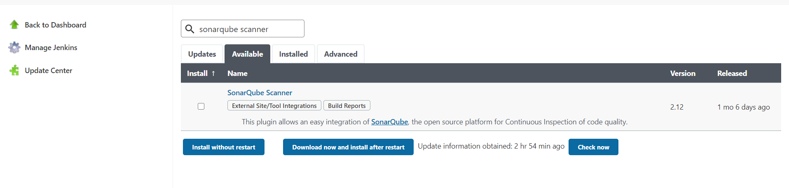

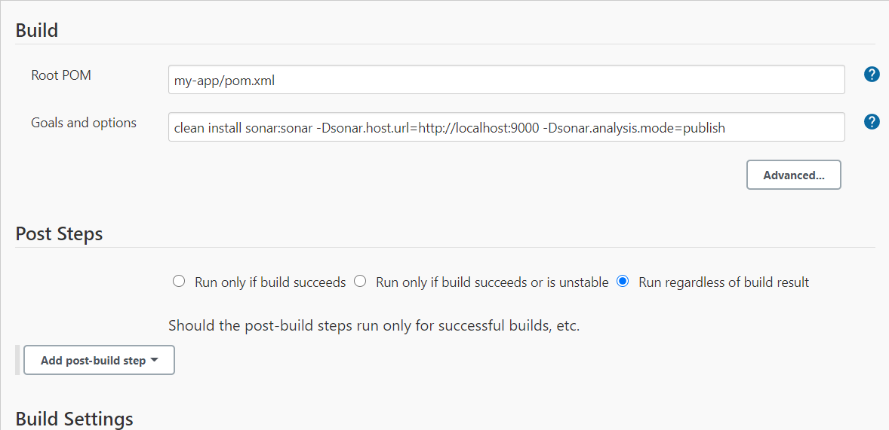

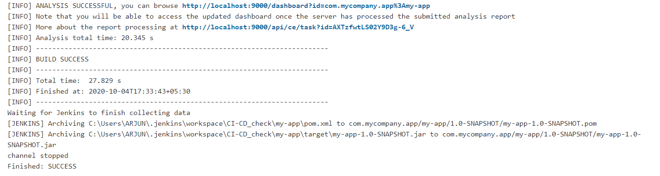

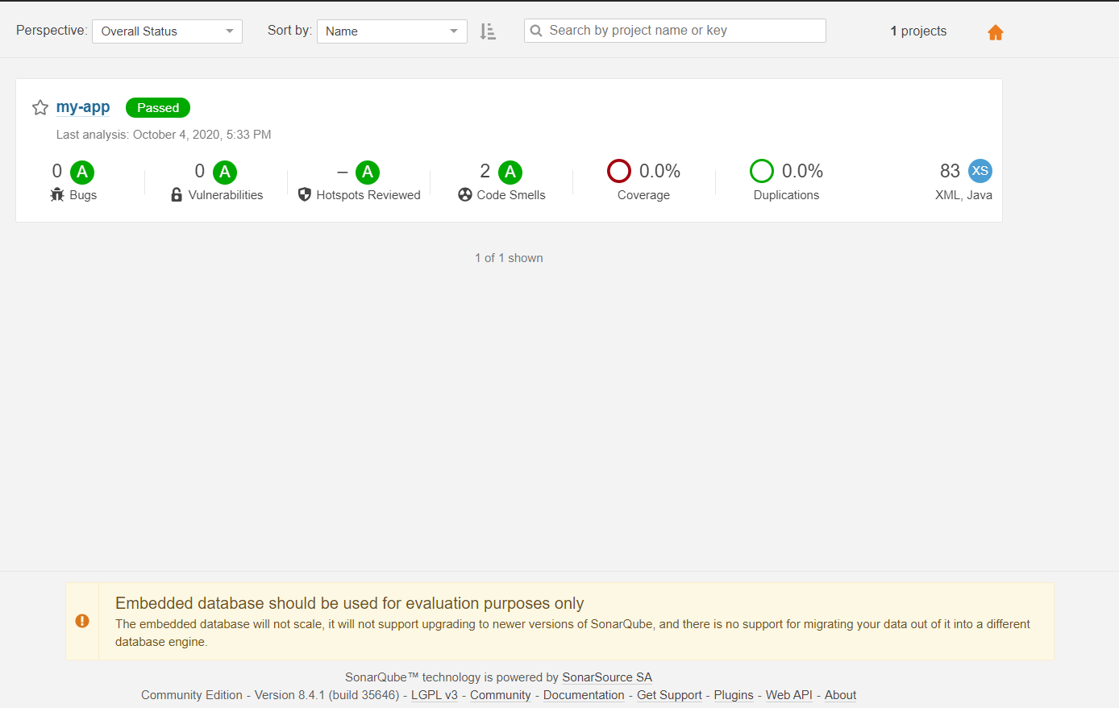

1. **Creating a Pipeline with Jenkinsfile**

1. **Creating a Pipeline with BlueOcean**

1. **Implementing Master/Slave architecture in Jenkins**

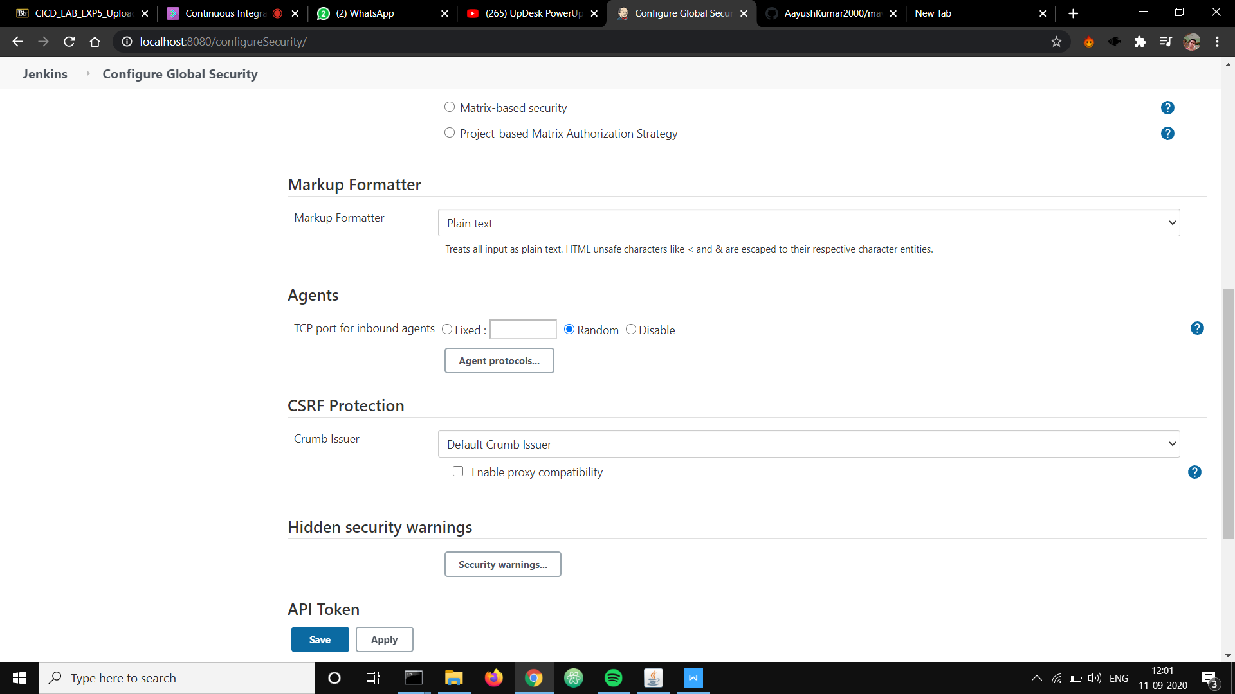

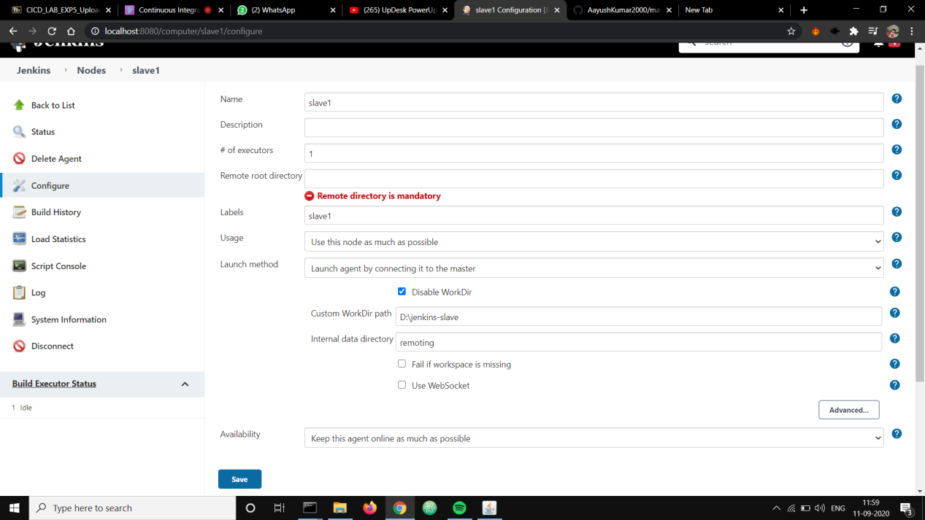

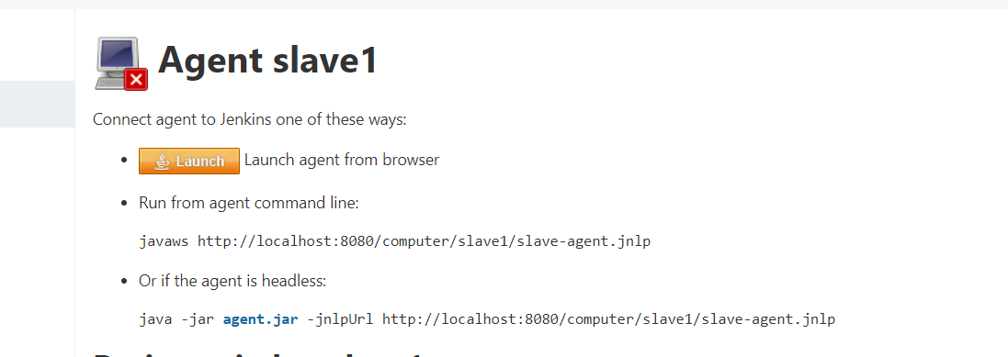

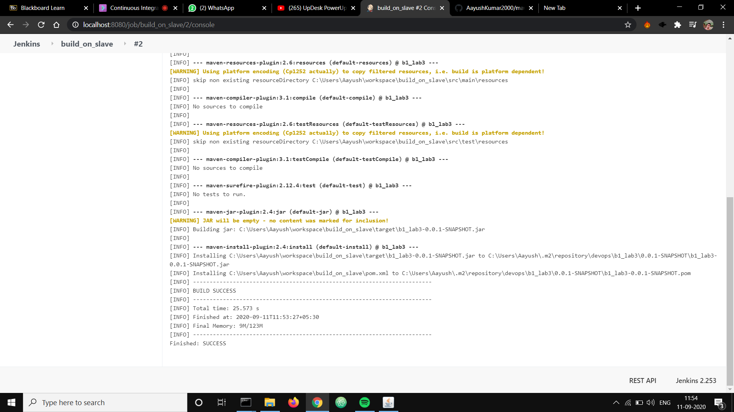

1. **Uploading artifacts onto Nexus Server using CLI**
2. **Jenkins Integration with Nexus**