**EXPERIMENT-10**

Ajay Kumar Tyagi  
500067403  
R171218008

Aim: Nexus Integration with Jenkins.

1) To integrate Nexus with Jenkins you need to install Nexus Platform plugin.

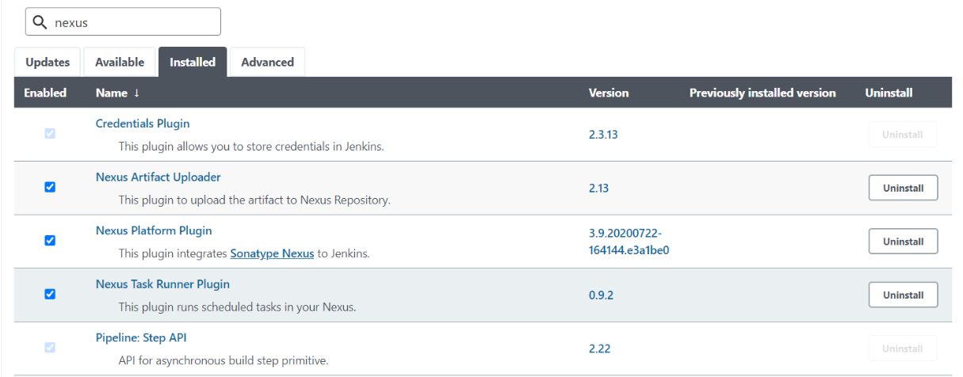

2) Now go to manage Jenkins => Global configuration. In global configuration, add jdk and Sonatype Nexus version and location.

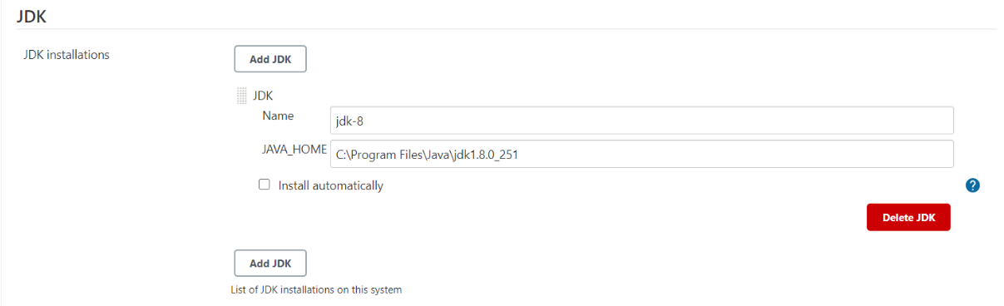  
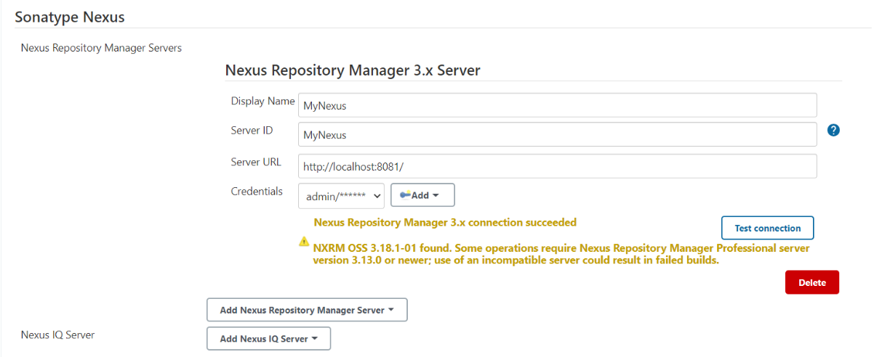

3) Now build a maven job and configure as follows.  
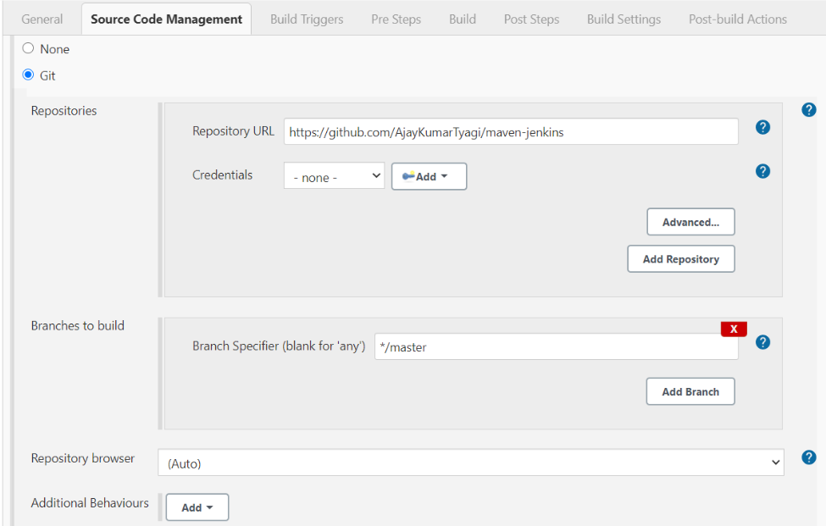

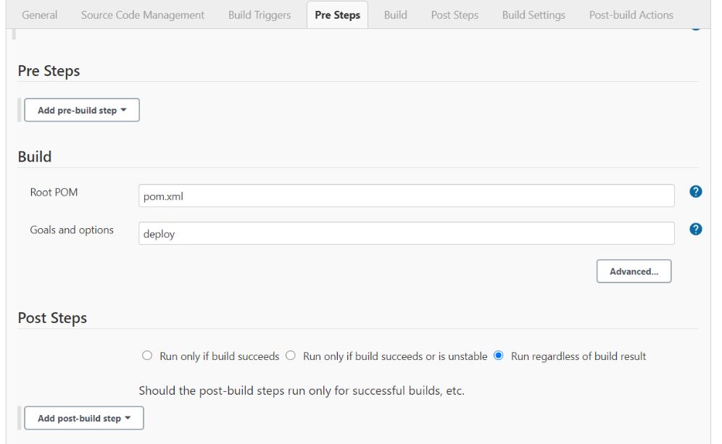

4) After running job successfully check nexus server for deployed project.

