**EXPERIMENT-11**

Ajay Kumar Tyagi  
500067403  
R171218008

**Aim-** Installation and execution of Vagrant.

1) Download vagrant from the website of Hashi Corp and install it in your system.

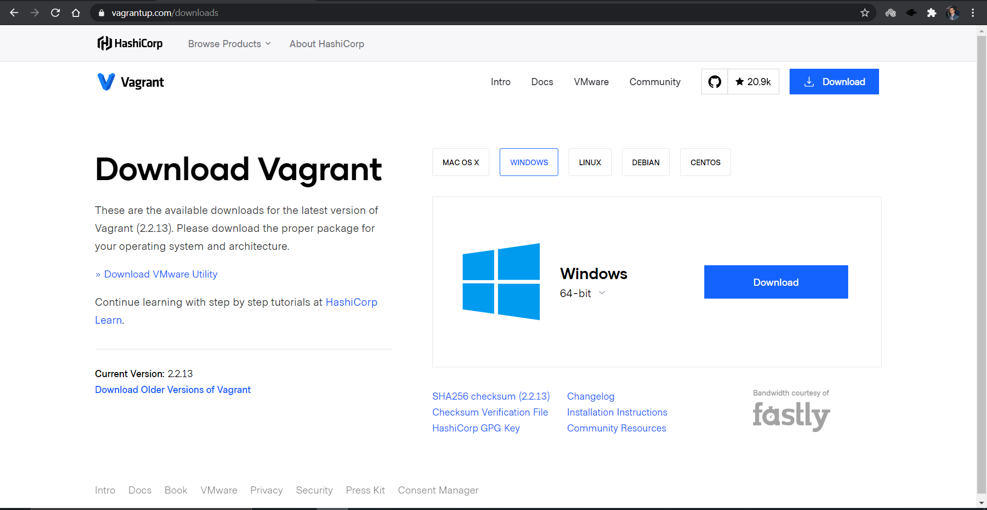

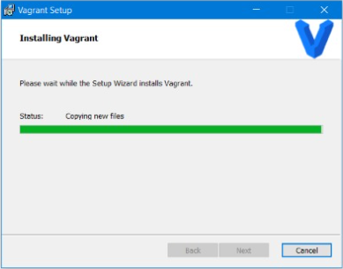

2) Now create a directory for workspace and to initialize use command vagrant init.

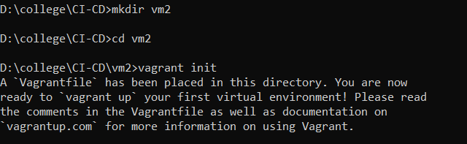

3) After initializing the vagrant successfully, vagrant file will be created in our workspace. We have to configure the vagrant file so that vagrant can create virtual machine. For this we set config.vm.box= ”Ubuntu/xenial64”.

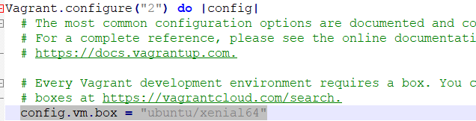

4) After successfully configuring the vagrant file, in command line run vagrant up command. This command will download Ubuntu and will create a virtual machine.

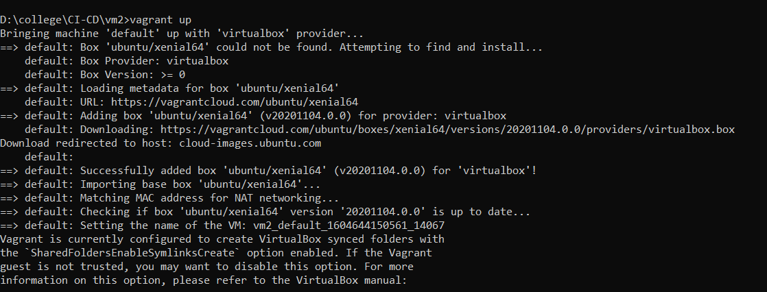

5) Now run the vagrant ssh command to attach the virtual machine to your windows command line. Now we can operate the virtual machine from windows command line.

