**EXPERIMENT-12**

Ajay Kumar Tyagi  
500067403  
R171218008

**Aim-** Configuration of docker and starting its container in vagrant.

1) First we have to attach vagrant virtual machine and add GPG key for the official docker repository to your Ubuntu-xenial as shown below.

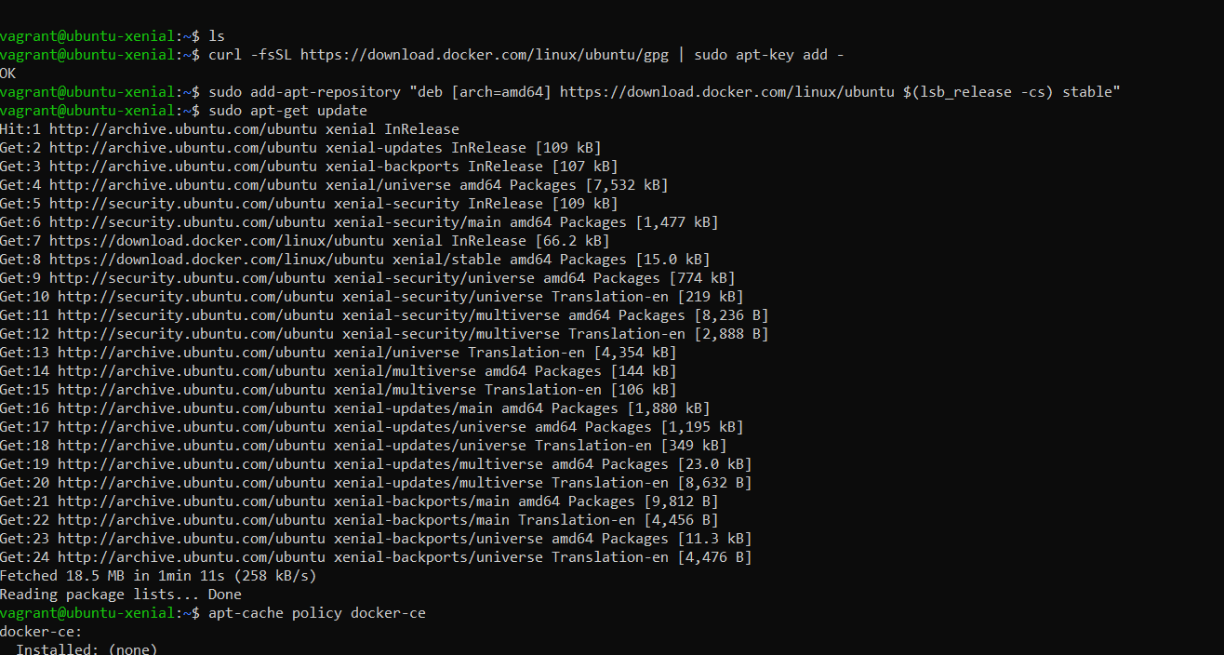

2) Use command apt-cache policy docker-ce to add docker repository to APT resources.

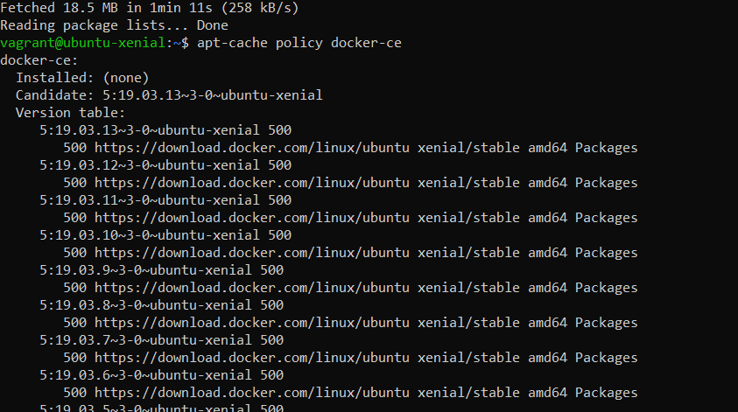

3) Now update the package database with the docker packages from the recently added repository and then update the policy. After this install the docker with sudo apt-get install –y docker-ce.

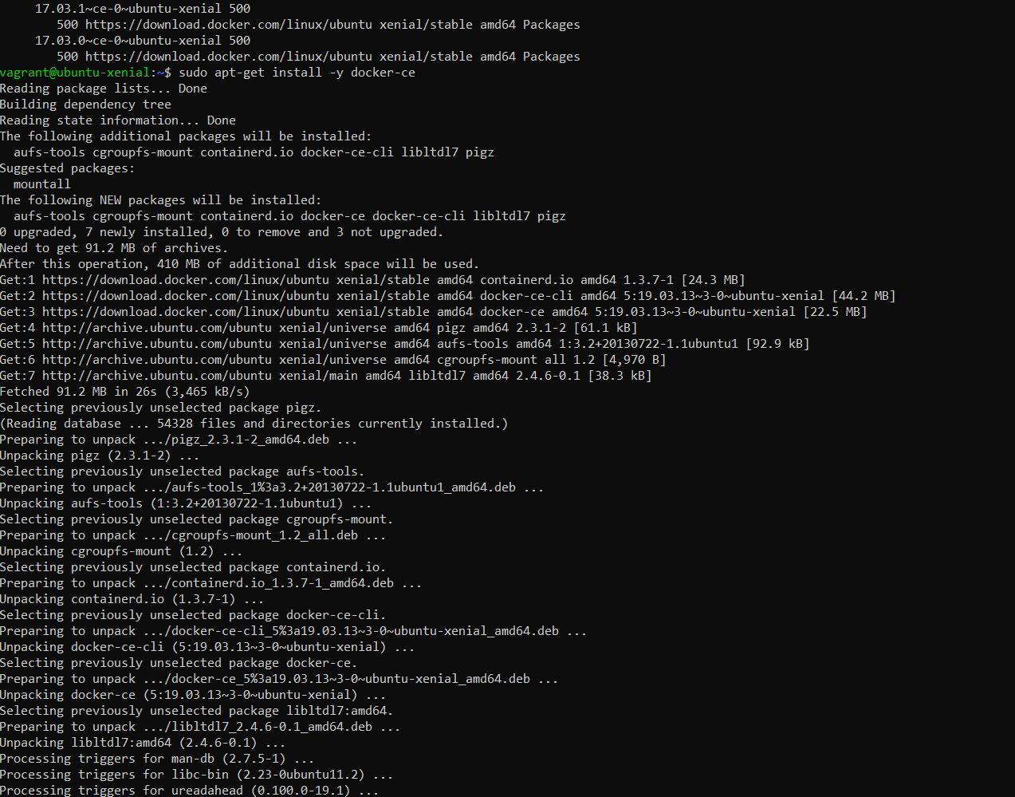

4) To verify if docker is configured, use command systemctl status docker.

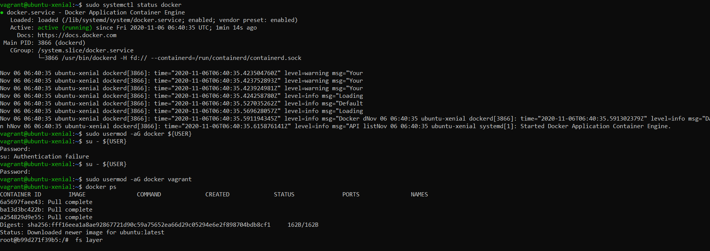

5) Now create a user for docker and add this user to vagrant group.



6) Use command docker run –it Ubuntu to create a container of Ubuntu image. This command will automatically fetch Ubuntu image from docker hub.

