**EXPERIMENT-2**

Ajay Kumar Tyagi  
500067403  
R171218008

Aim: Jenkins integration with GitHub.

1) To integrate GitHub with Jenkins, we first need to install git plugin. For this go to manage Jenkins -> manage plugins.

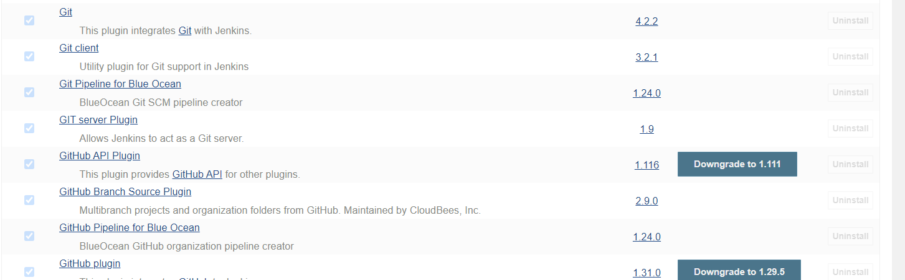

2) Now create a job and now git option will be available. Here give url of the GitHub repository. If it is a private repository, you have to give credentials.

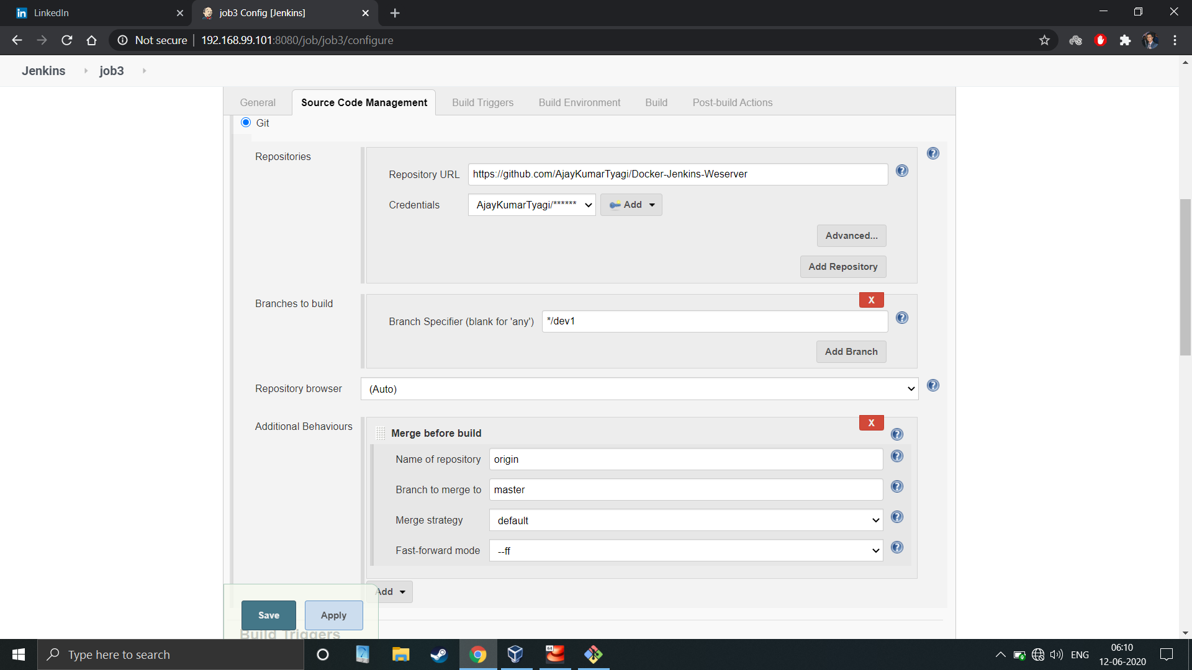

3) Jenkins will download the contents of the repository and you can perform any operations on it. Jenkins download the content in a separate workspace. It has separate workspace for every job.

