**EXPERIMENT-3**

Ajay Kumar Tyagi  
R171218008  
500067403

Aim: Jenkins integration with Maven and GitHub

1) To integrate Jenkins with Maven we need to install some plugin shown below:  


2) To integrate with GitHub we need to install git plugin.  
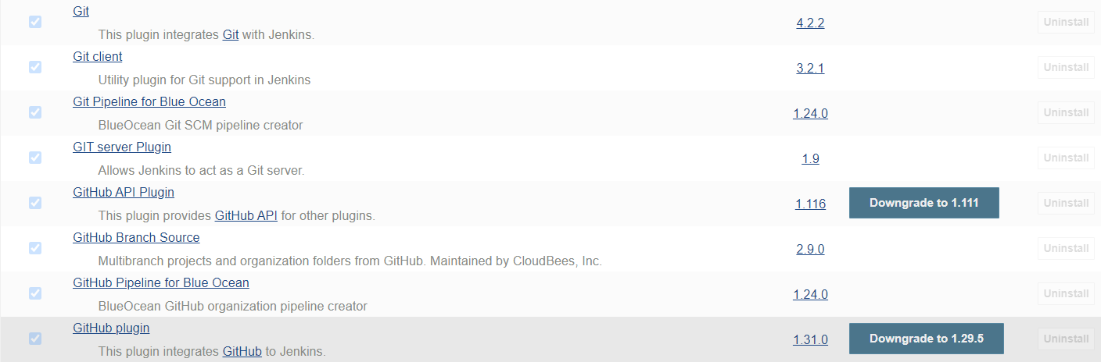

3) Now go to Manage Jenkins => Global Tool Configuration and add maven version and path.  
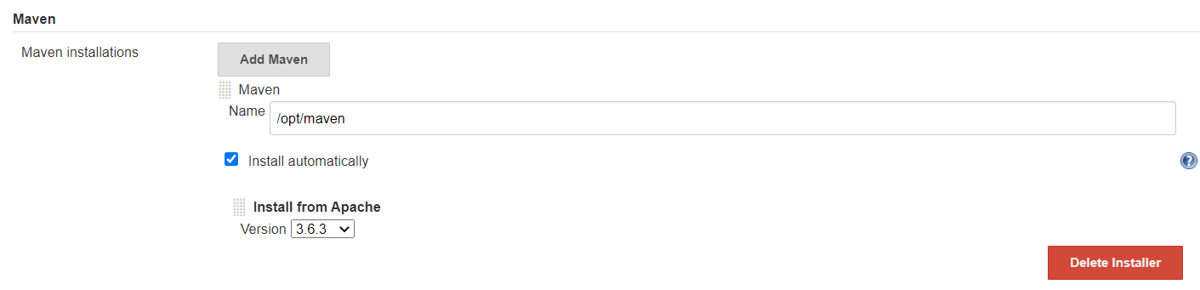

4) Now create a job and select Maven project.  
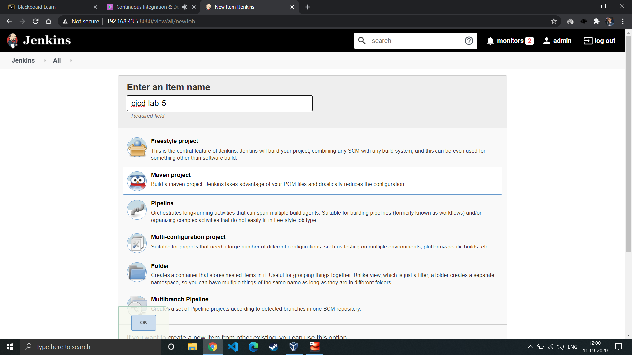

5) Now give GitHub repository url from where Jenkins will download Maven project.  
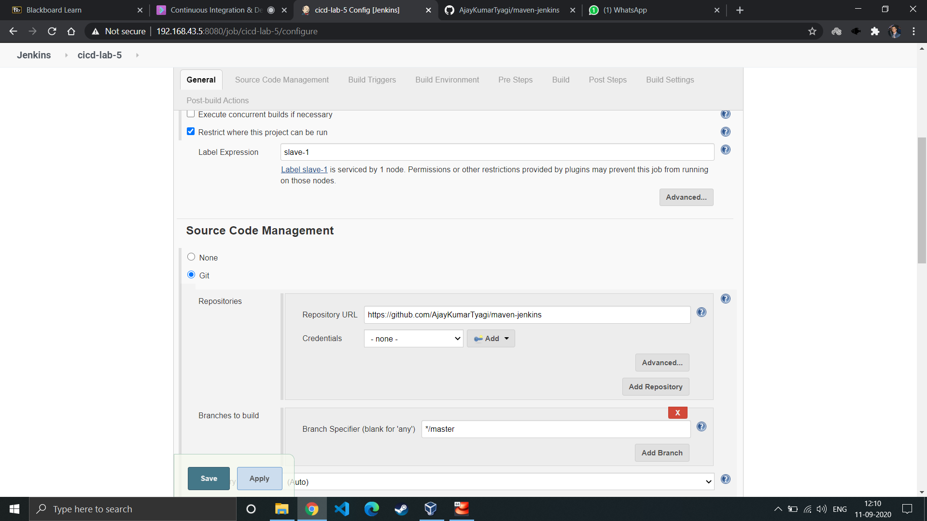

6) Now in Root POM give the location of pom.xml file and write maven goals which you want to run.  
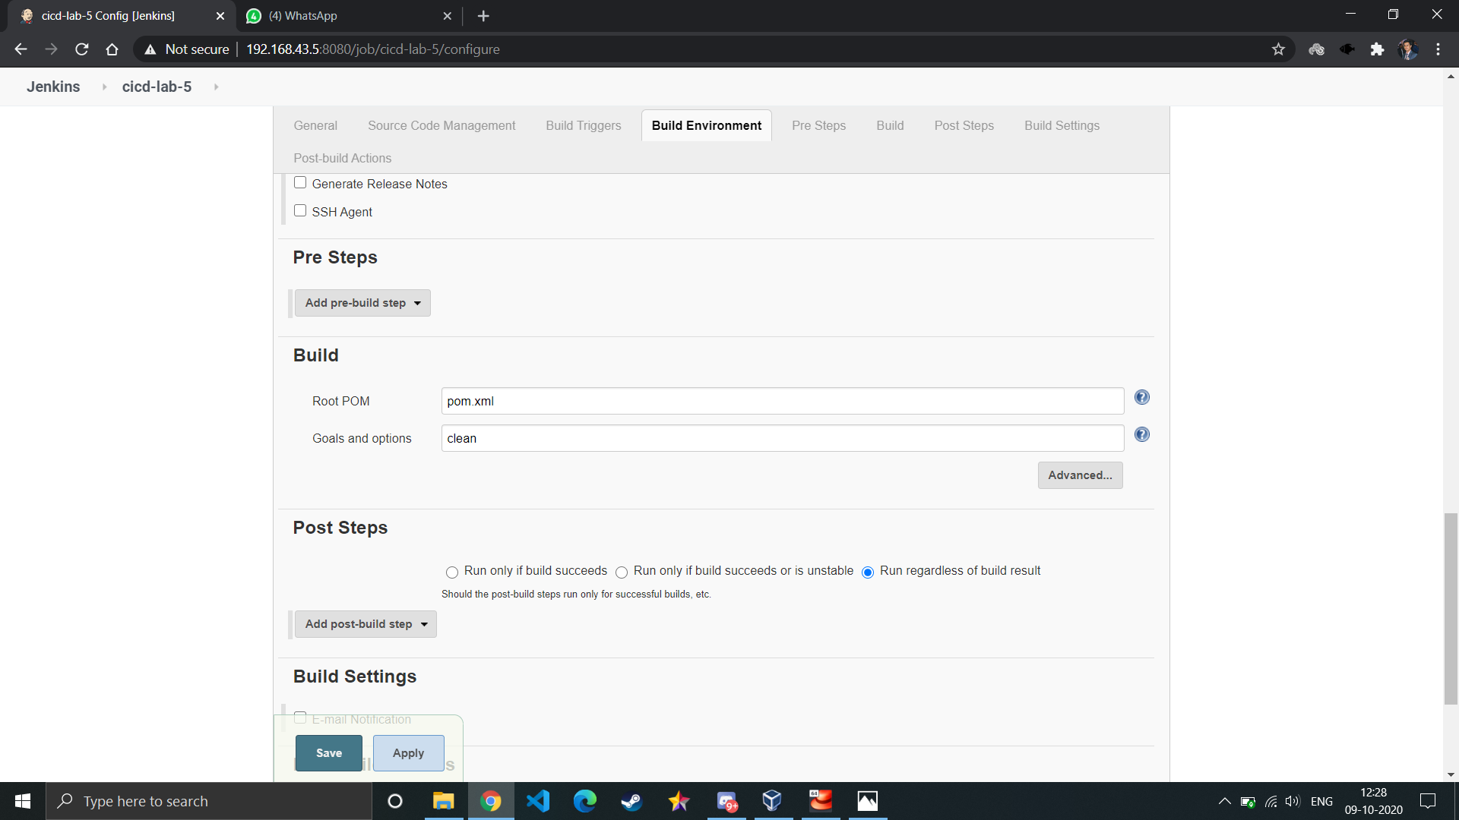

7) After running job successfully you may see the following output.  
