**EXPERIMENT-4**  
Ajay Kumar Tyagi  
500067403  
R171218008

Aim: Static code analysis using SonarQube.

1) Download SonarQube file and extract it.  


2) Now go to sonarqube-8.4.1.35646 => bin => windows-x86-64 and run StartSonar batch file using command line. SonarQube runs on port 9000.  
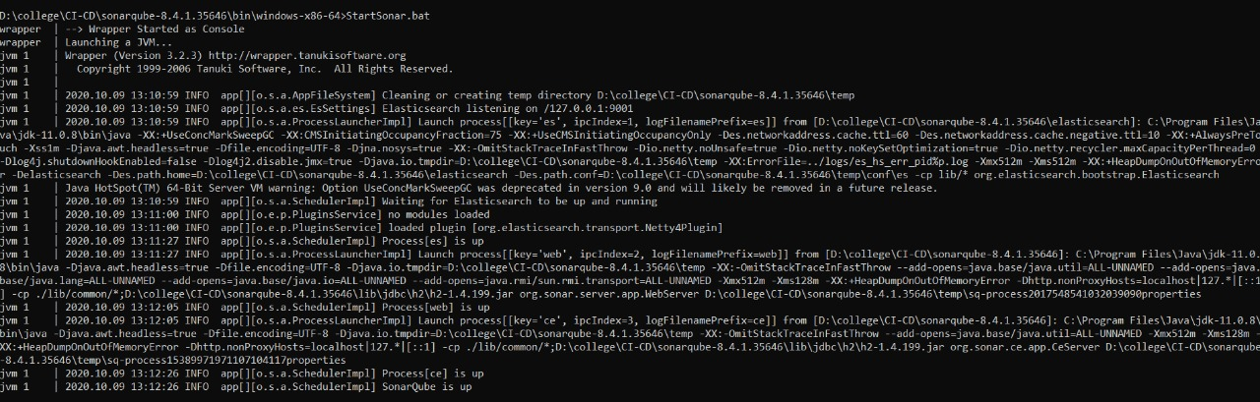

3) Now using command line got inside the maven project and run the following command.  
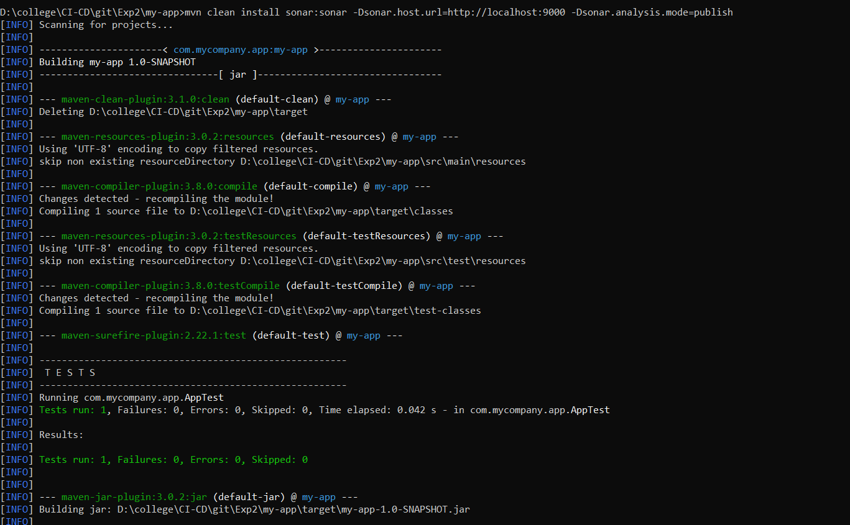

4) You will get the following output after running the command successfully.  
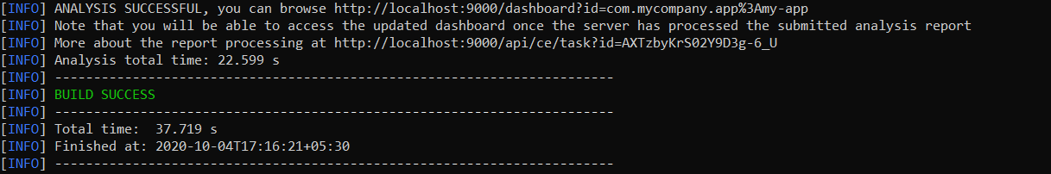

5) In SonarQube you can see your project has been deployed and can see code analysis of your project.  
