**EXPERIMENT-5**

Ajay Kumar Tyagi  
500067403  
R171218008

Aim: Jenkins integration with SonarQube.

1) To integrate Jenkins with SoanrQube, download sonarqube scanner plugin.  
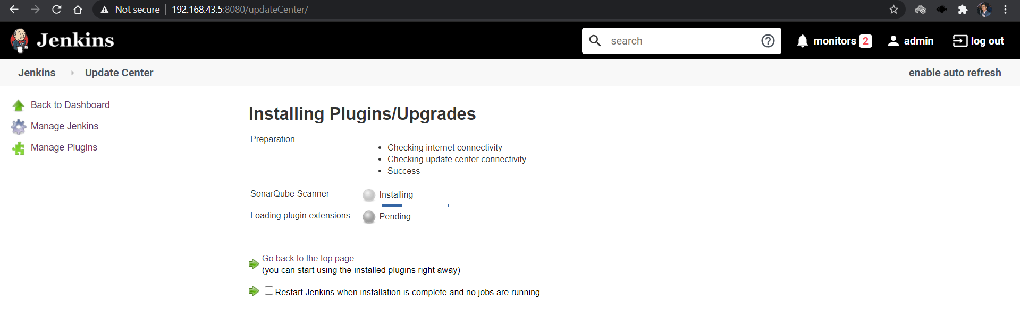

2) Now create a maven job and give GitHub Repository url and in goal write the following command.  
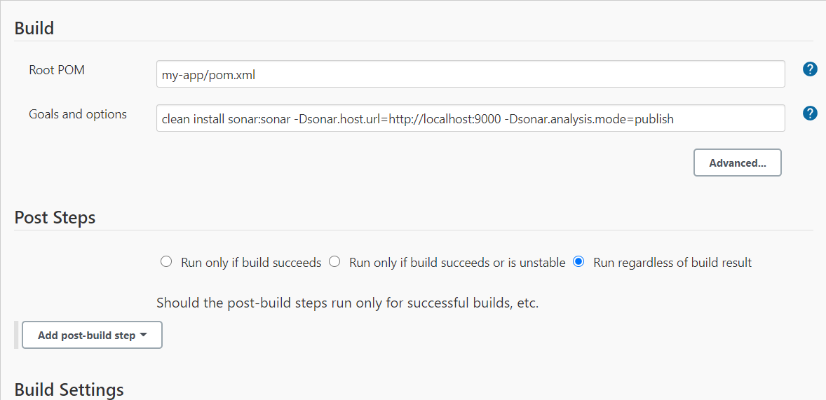

3) If this Jenkins job runs successfully, you may see the following output of the job.  
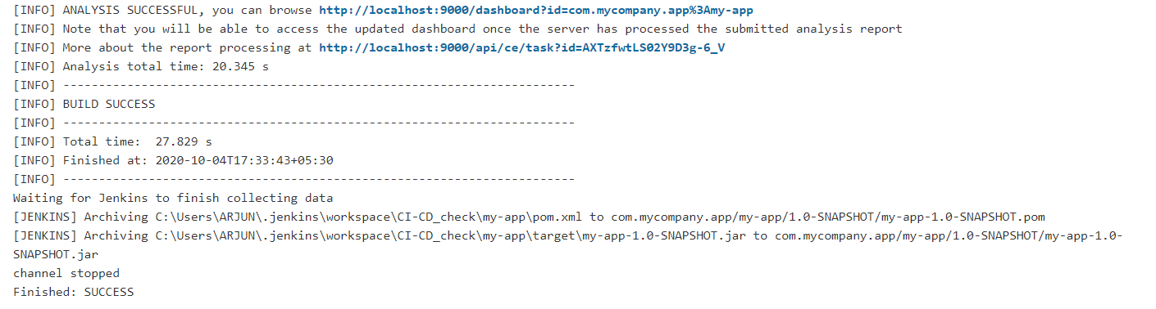

4) Now go to SonarQube and see the static code analysis of your maven project.  
