**EXPERIMENT-6**

Ajay Kumar Tyagi  
500067403  
R171218008

Aim: Create Pipeline using Jenkinsfile.

1) To create a pipeline we first need to download the following plugin. To download plugin go to manage Jenkins => manage plugins.

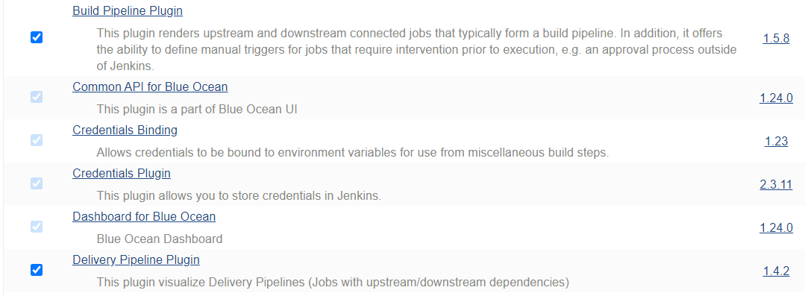

2) Now while creating a new job select pipeline instead of freestyle or maven.

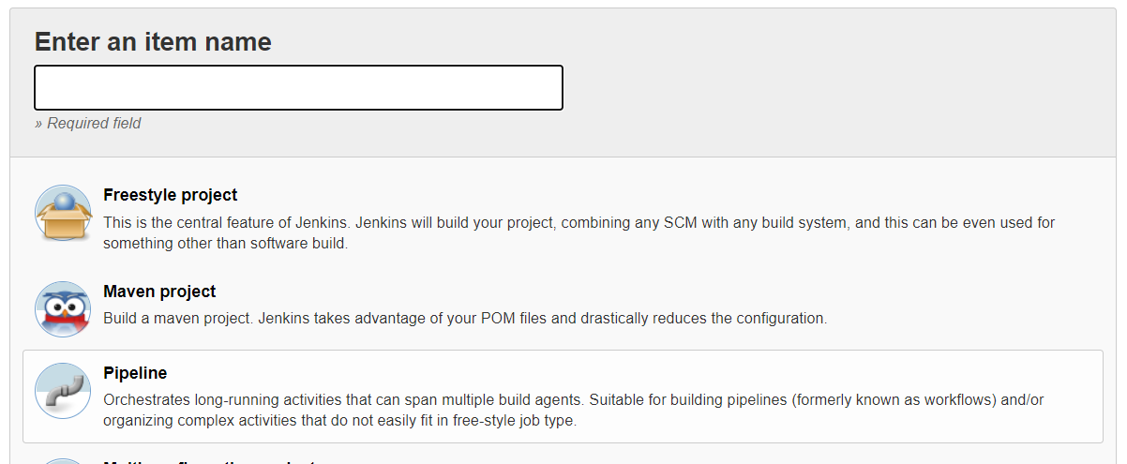

4) Now give GitHub repository url and path of Jenkisfile.

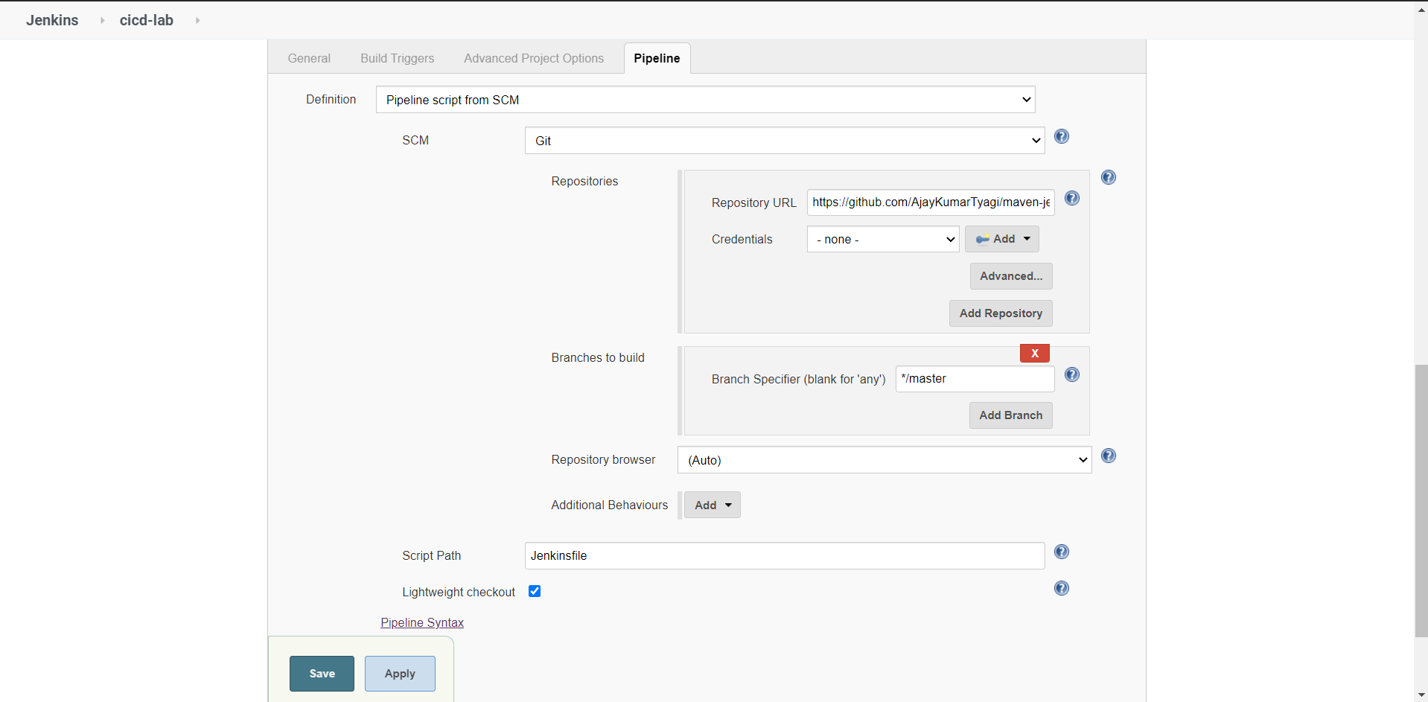

5) Jenkisfile looks like this. Based on this Jenkinsfile file further jobs will be created.

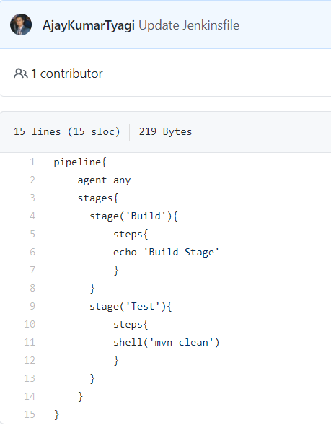  
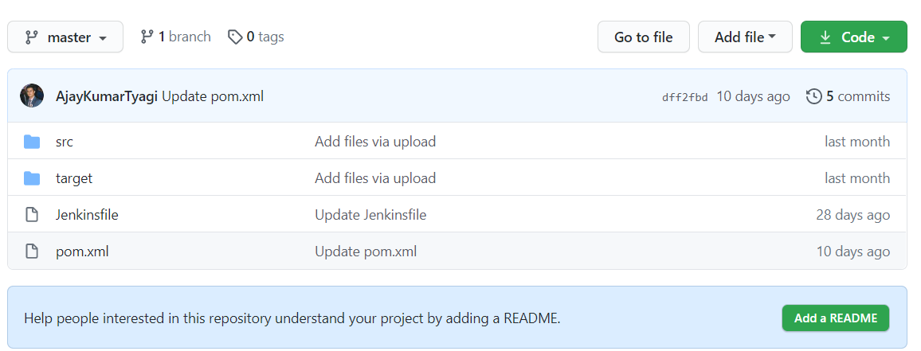

6) After running the job successfully you may see the following pipeline and output.

