**EXPERIMENT-7**

Ajay Kumar Tyagi  
500067403  
R171218008

Aim: Create a pipeline using Blue Ocean.

1) To create a pipeline using Blue Ocean we need to download.

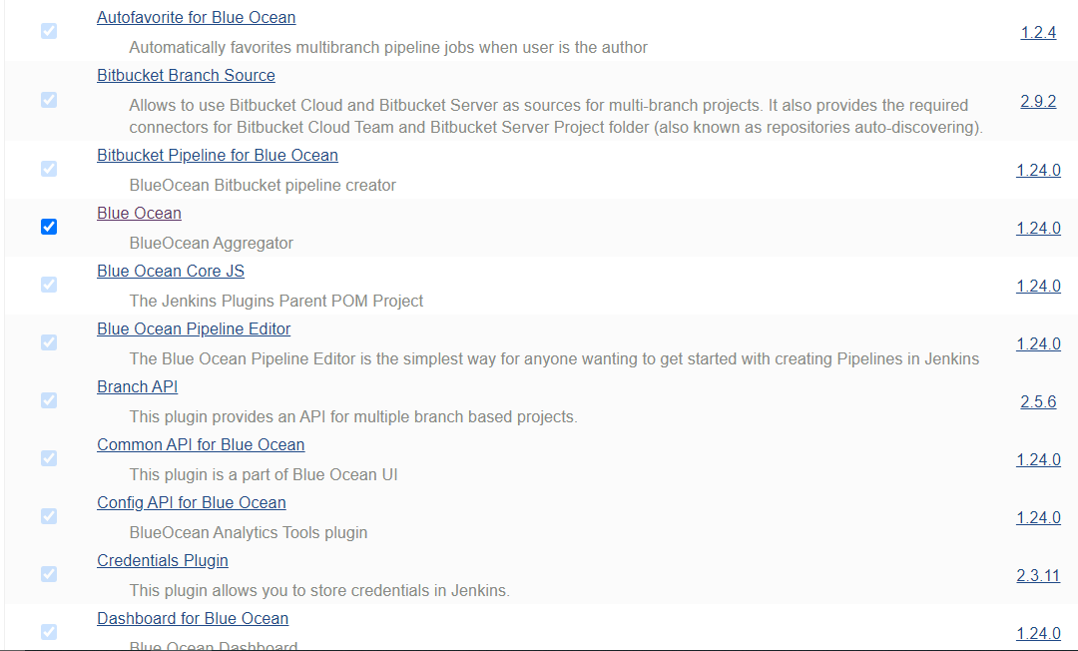

2) Select Open Blue Ocean and create a new pipeline.

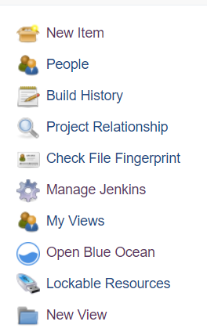

3) Now give Repository url and other necessary details.

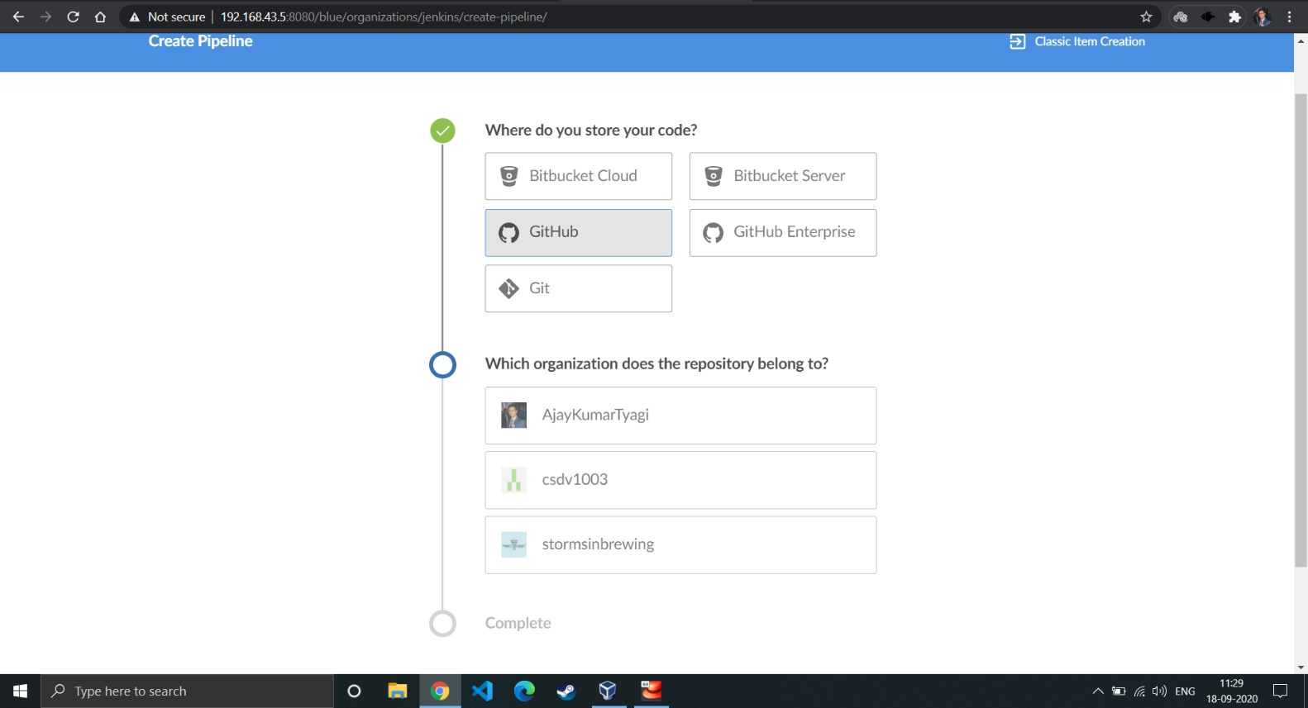

4) Blue Ocean uses Jenkinsfile to build the pipeline. So we need to have Jenkisfile on the GitHub along with the project.

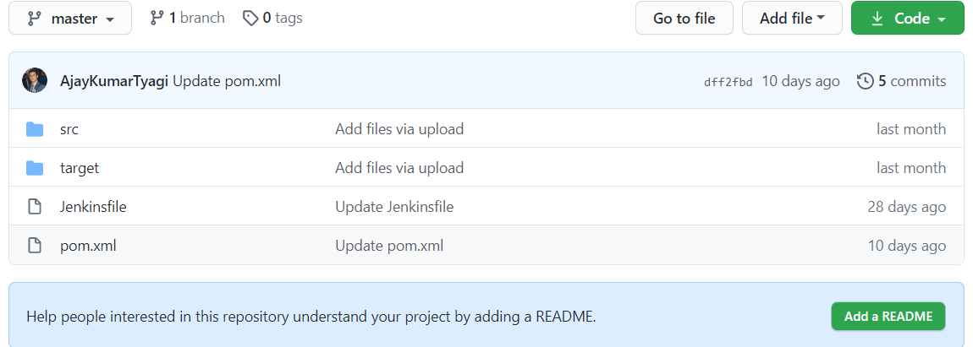

5) Jenkinsfile looks like this. This file contains all the steps that will be created.

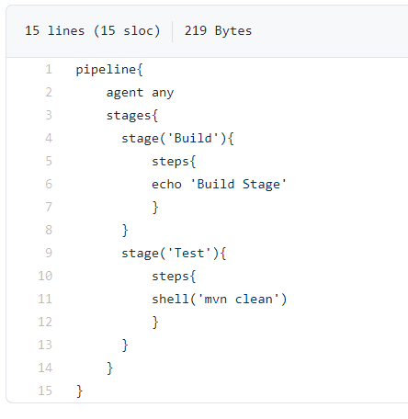

6) After making a new pipeline in Blue Ocean, if pipeline created successfully and jobs runs successfully you may see the following.

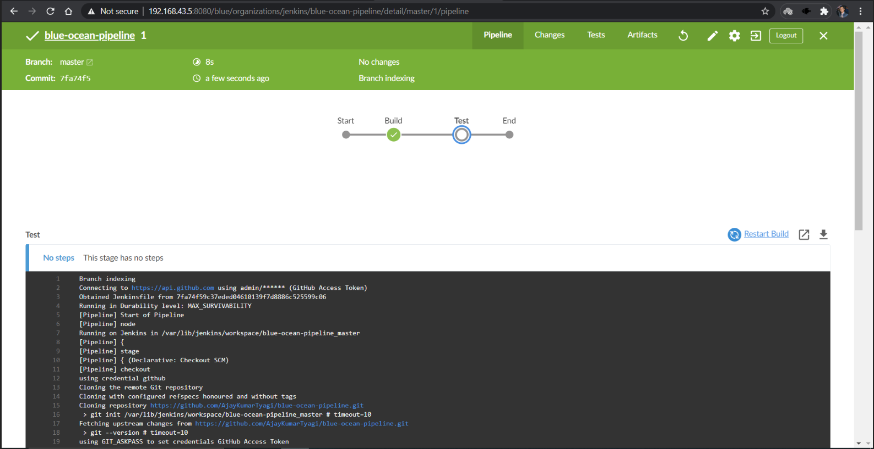

7) Now you can run this pipeline with just one click. All the pipeline you created will appear here.  
