**EXPERIMENT-8**

Ajay Kumar Tyagi  
500067403  
R171218008

Aim: Implementing Master/Slave architecture in Jenkins.

1) For implementing Master/Slave architecture we need to create slave. A slave is nothing but a node that will do work for master node. For creating a slave go to manage Jenkins => Manage Nodes and Clouds.

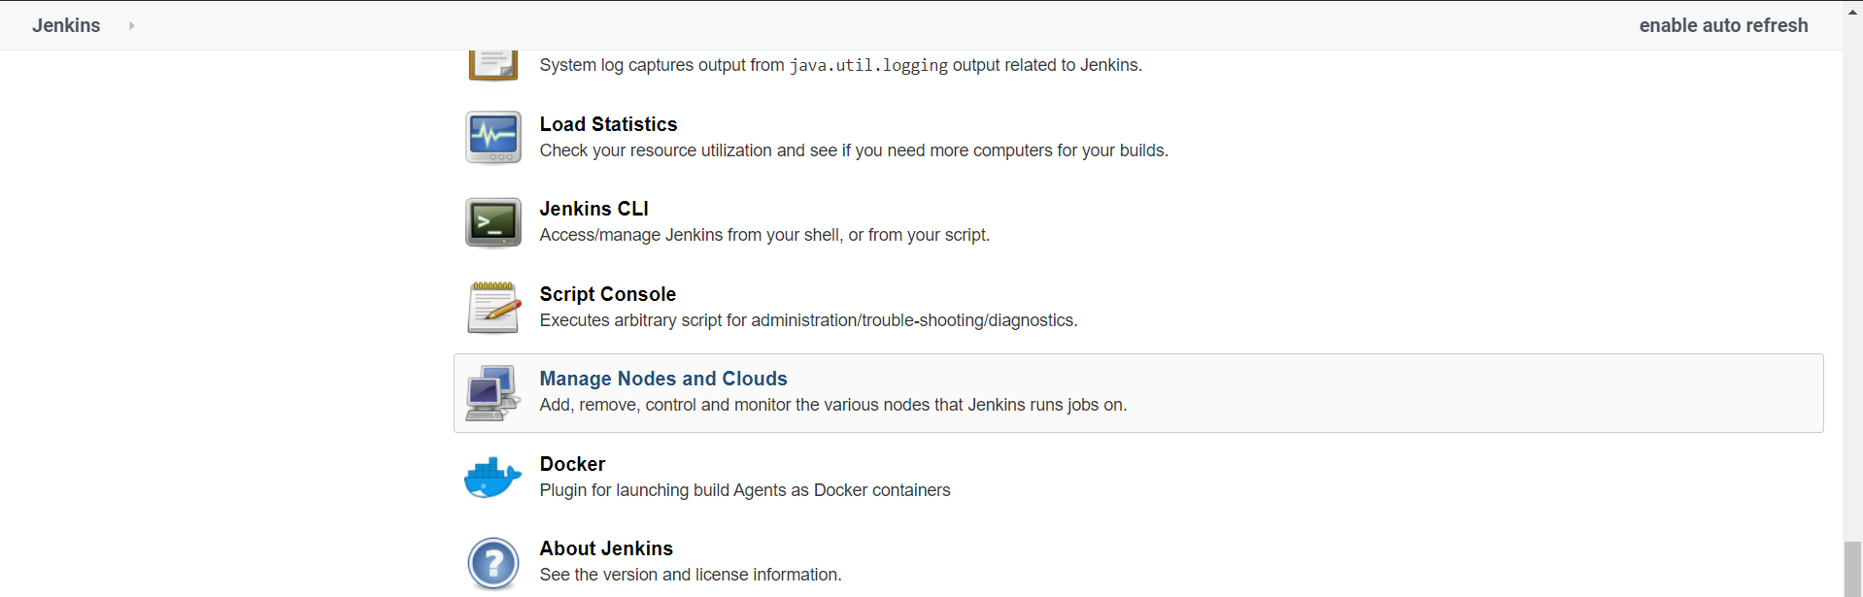

2) Select a new Node and give slave name and make it a permanent node.

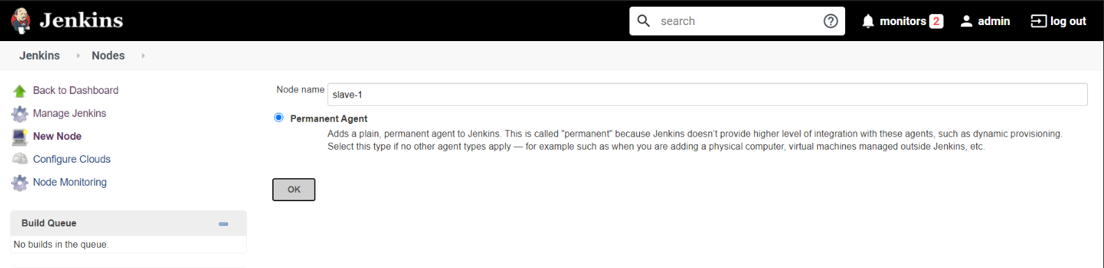

3) After that you need to configure the slave as follows.

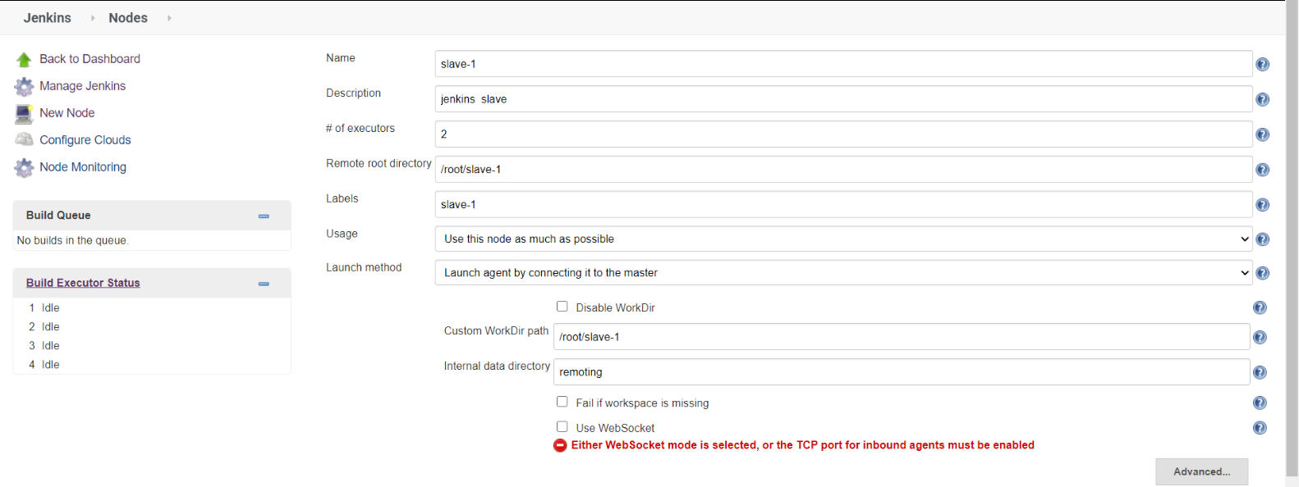

4) After configuring successfully you may see the node in Build Executor Status.

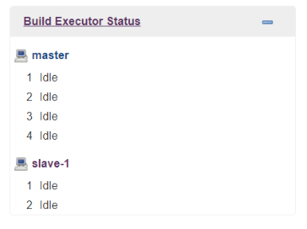

5) Now create a new maven job and select “Restrict where this project can be run” and give slave label in label expression.

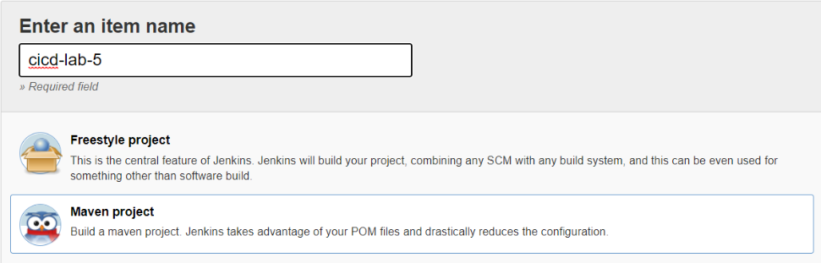  
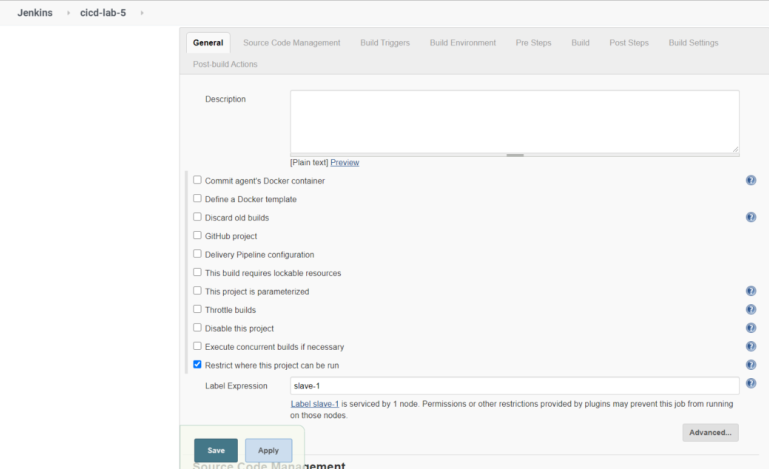

6) Now if you run the job you will see slave-1 is running this job. This is Master/Slave Architecture.

