**EXPERIMENT-9**

Ajay Kumar Tyagi  
500067403  
R171218008

Aim: Uploading Artifacts on Nexus Server using command line.

1) Download Nexus and run Nexus batch file. Nexus server runs on 8081 port. Opening nexus will show the following screen.

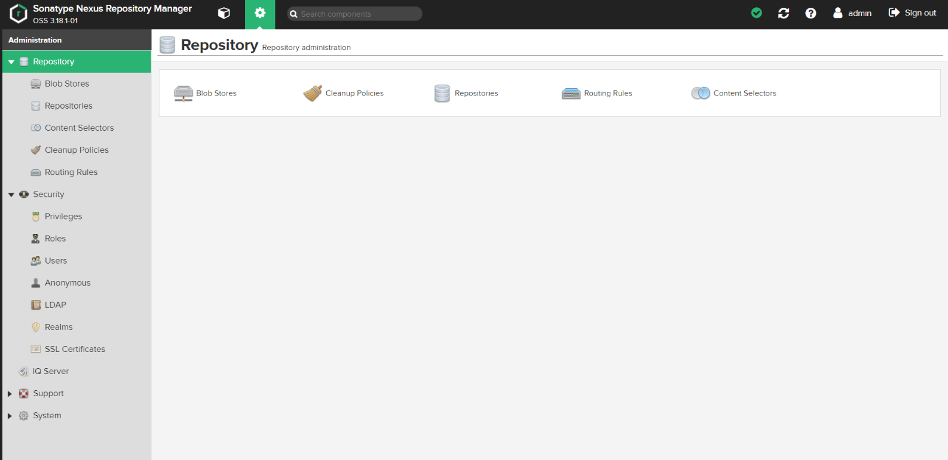

2) Now create the repository and configure it as follows.

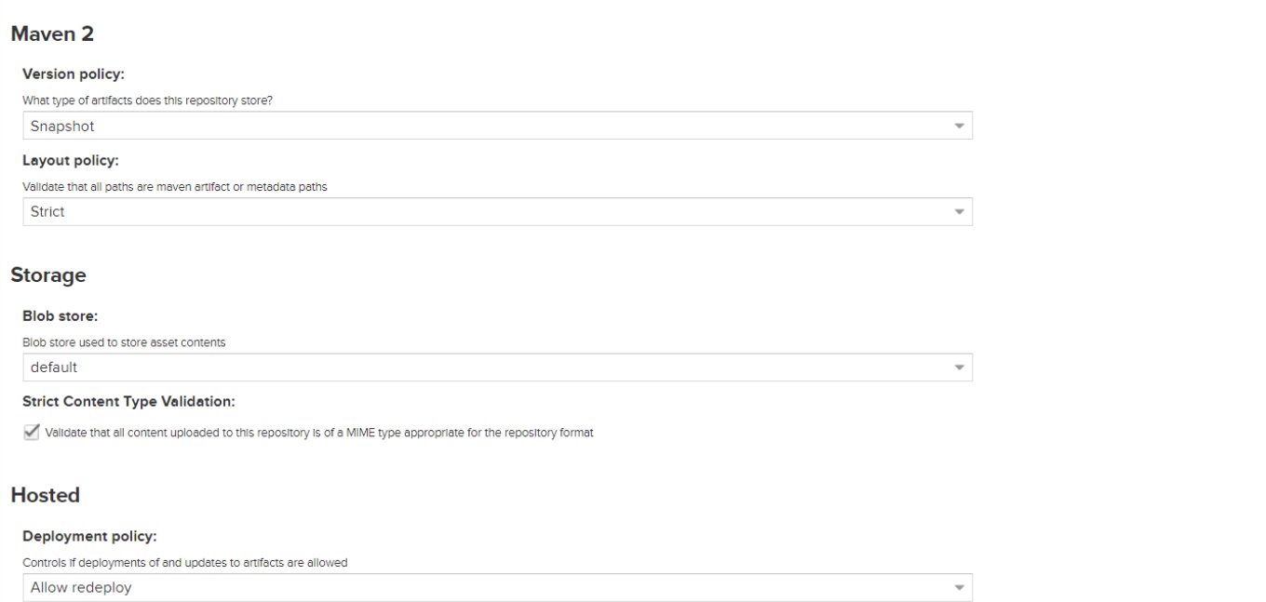

3) In the Maven project, make changes to pom.xml file and give nexus repository url.

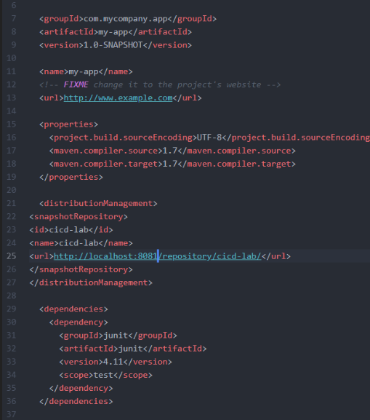

4) Now go to the project in command line and perform goals. At last deploy run mvn deploy.

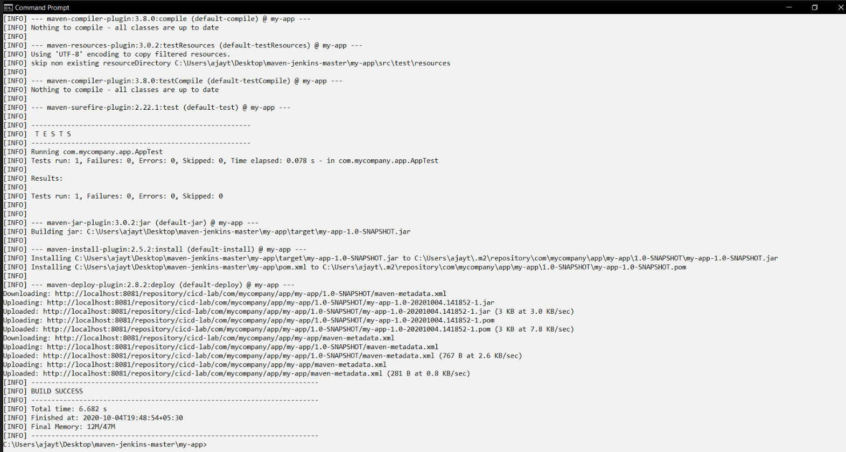

5) Now go to Nexus repository and you may see the project deployed there.

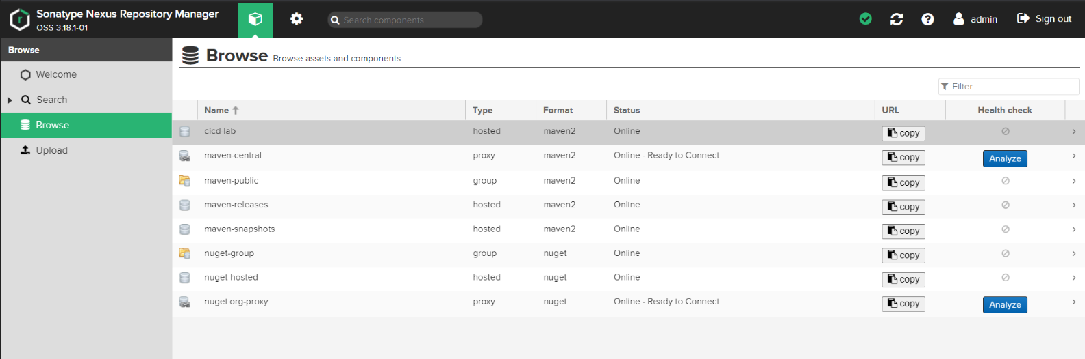

6) Inside deployed project, in snapshot you may find jar file.

