**Experiment-4**

**Create Jenkins Pipeline**

**Step-1**

Click on New Item

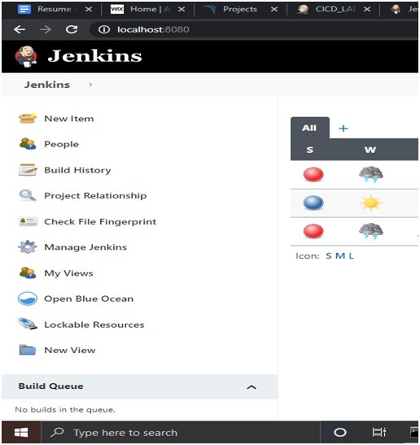

**Step 2**

Give a Name to your Item and Click On Pipeline and then click OK

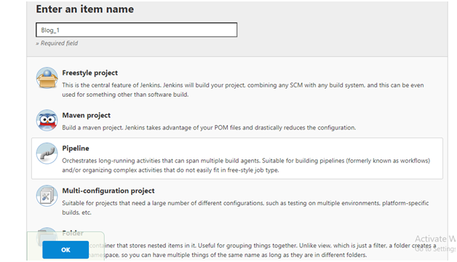

**Step-3**

Change Pipeline Definition to “Pipeline Script from SCM”

And SCM to “Git”

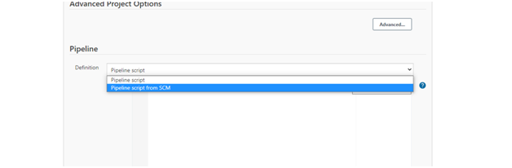

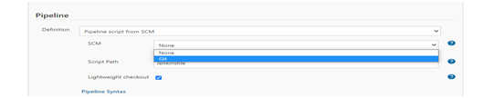

**Step -4**

Make a Repo on GitHub for this pipeline

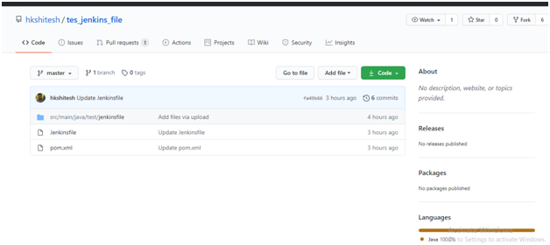

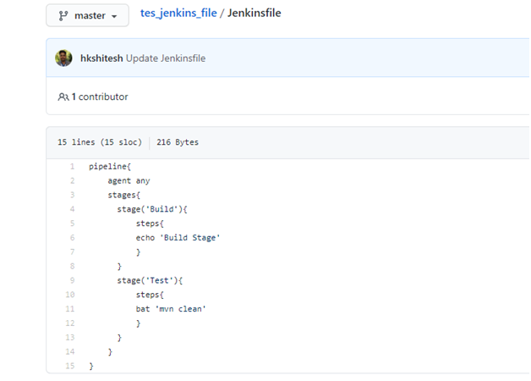

**Step-5**

Copy Repo URL and then SAVE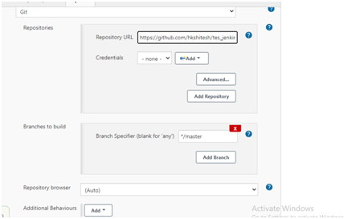

**Step 6**

Click on Build Now and check the Console Output

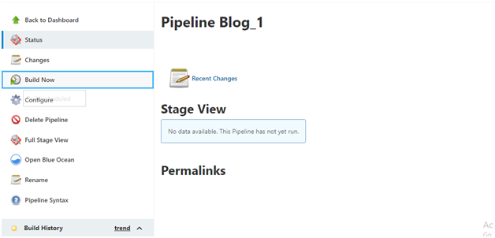

**Now, your build is successful.**

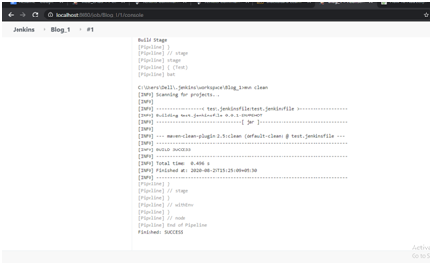

**PIPELINE:-**

