**EXPERIMENT-5 (TERRAFORM AND AWS )**

**Step 1 : Terraform Initializing**

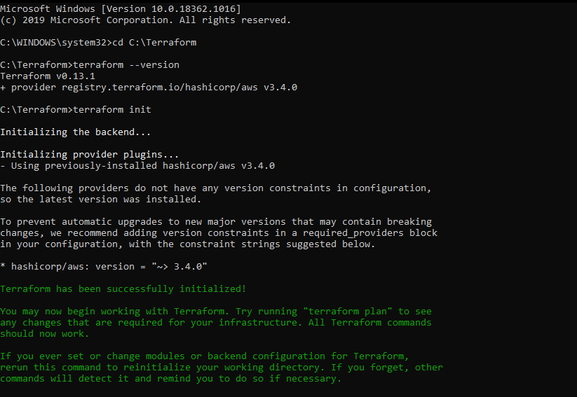

**Step 2 : Terraform Planing**

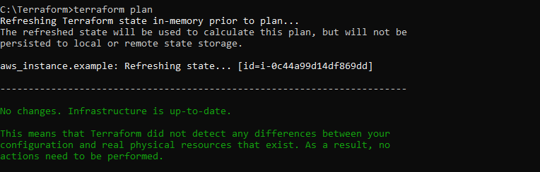

**Step 3 : Terraform Applying**

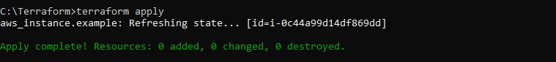

***Instance Running***

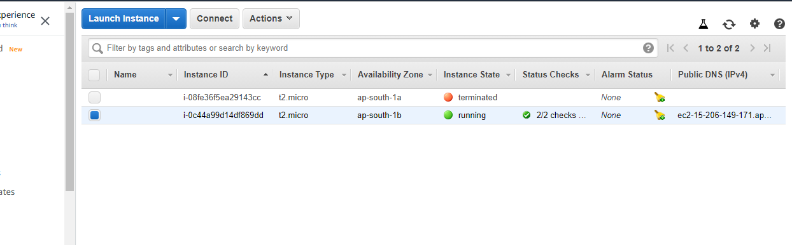

**Step 4 : Terraform Destroying**

