**Name: Animesh Jain**

**Roll Number: R171218022**

**SAP ID: 500069453**

**Lab: 4**

**Static Code Analysis using SonarQube**

**Steps**

**1.** Download Sonarqube Community Edition by clicking [here](https://www.sonarqube.org/downloads/)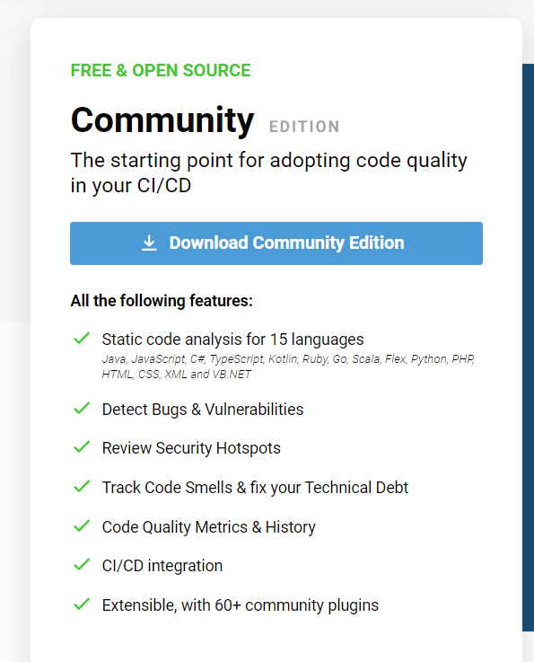

**2.** Extract downloaded zip file.

**3.** Start command prompt and go to the location where sonarqube is located.

**4.** Run command StartSonar.bat

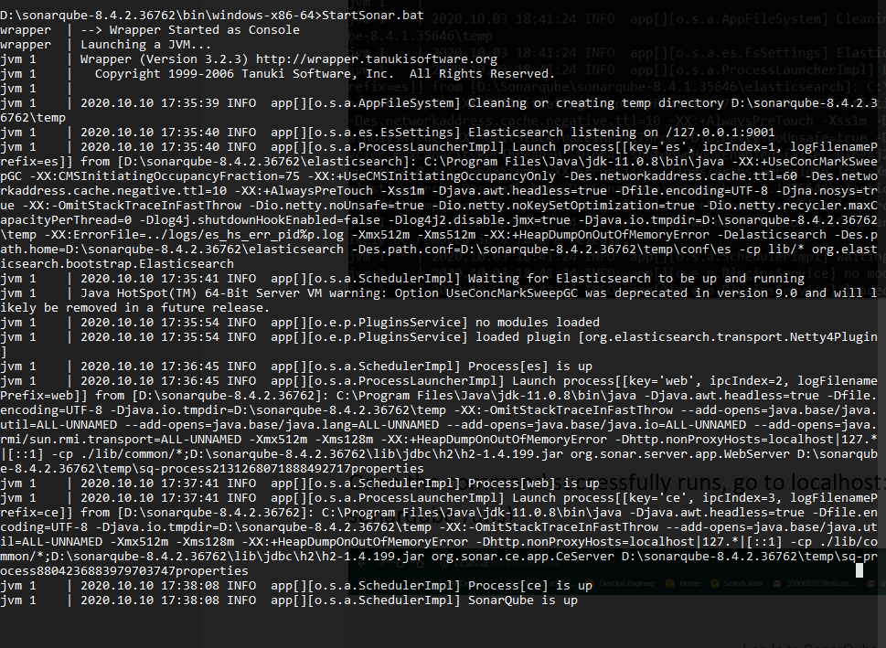

**5.** Login to Sonarqube.

**6.** Run another command prompt and go to your project location.

**7.** Run command mvn clean install sonar:sonar -Dsonar.host.url=http://localhost:9000 -Dsonar.analysis.mode=publish

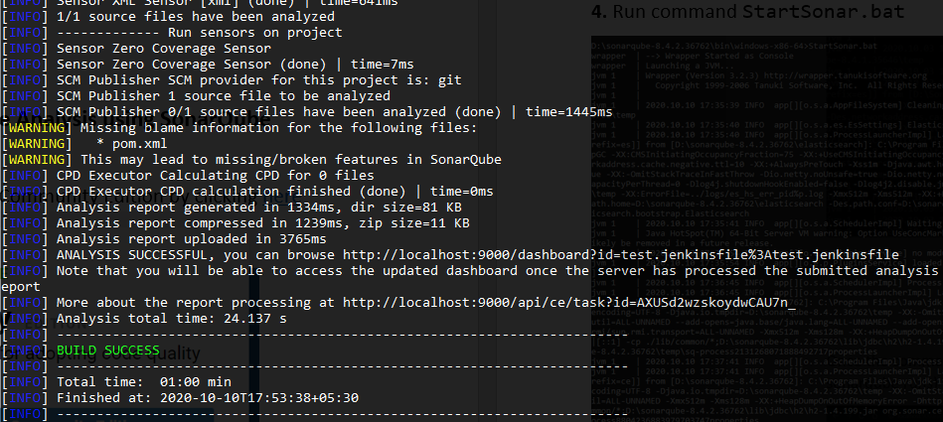

**8.** Check your Sonarqube project window.

