**Name: Animesh Jain**

**Roll Number: R171218022**

**SAP ID: 500069453**

**Lab: 5**

**Jenkins integration with sonarqube**

**Steps**

**1.** Start jenkins

**2.** Go to manage plugins

**3.** In available search SonarQube Scanner for Jenkins

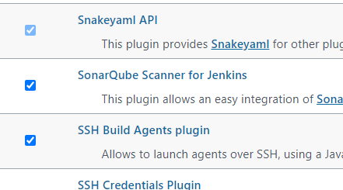

**4.** Go to System configuration and set your sonar settings

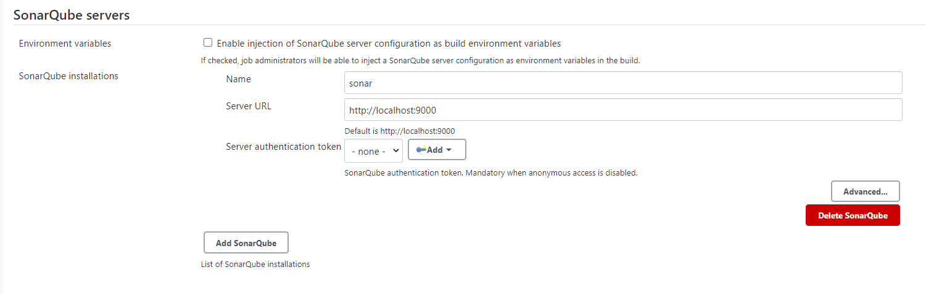

**5.** Then create new item and set your git repository path

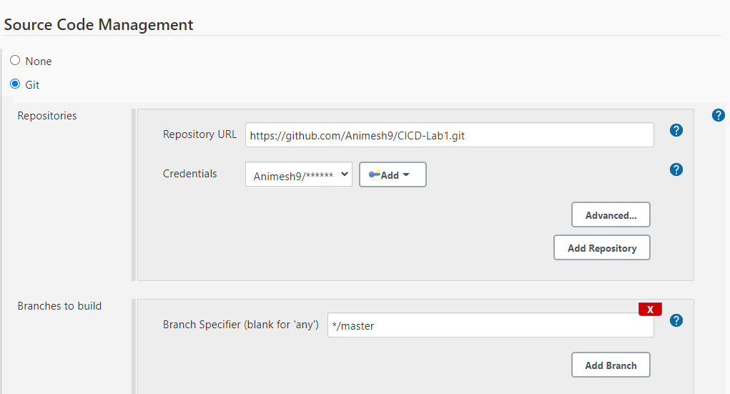

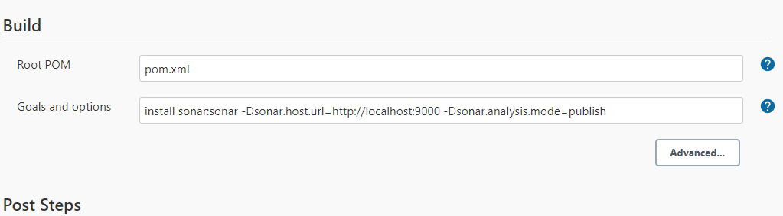

**6.** Build your project

