

**UNIVERSITY OF PETROLEUM & ENERGY STUDIES**

**Dehradun**

**CONTINOUS INTEGRATION**

**AND**

**CONTINOUS DELIVERY**

**Name: Anubhav Deshwal**

**Course: B. TECH CSE DevOps (2018-22)**

**Roll no.: R171218024**

**Sapid: 500069112**

**Experiment-11**

**vagrant**

**Step-1:** Install Virtual Box.

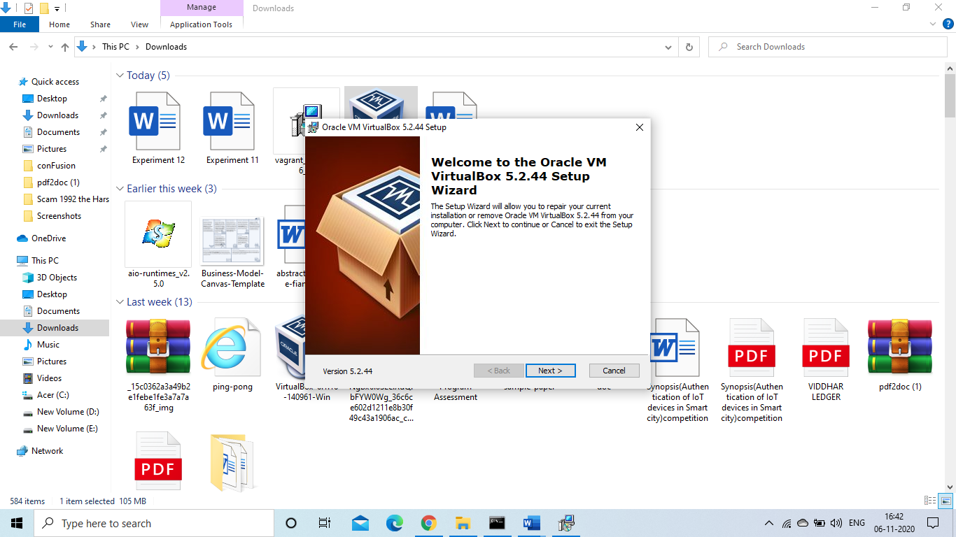

**Step-2:** Install Vagrant

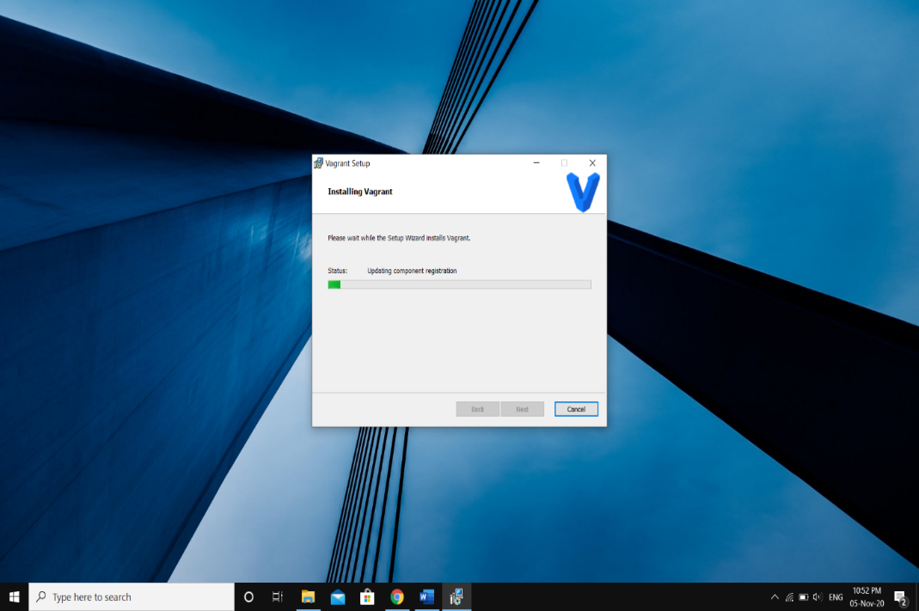

**Step-3:** Making a new folder and initializing Vagrant in it

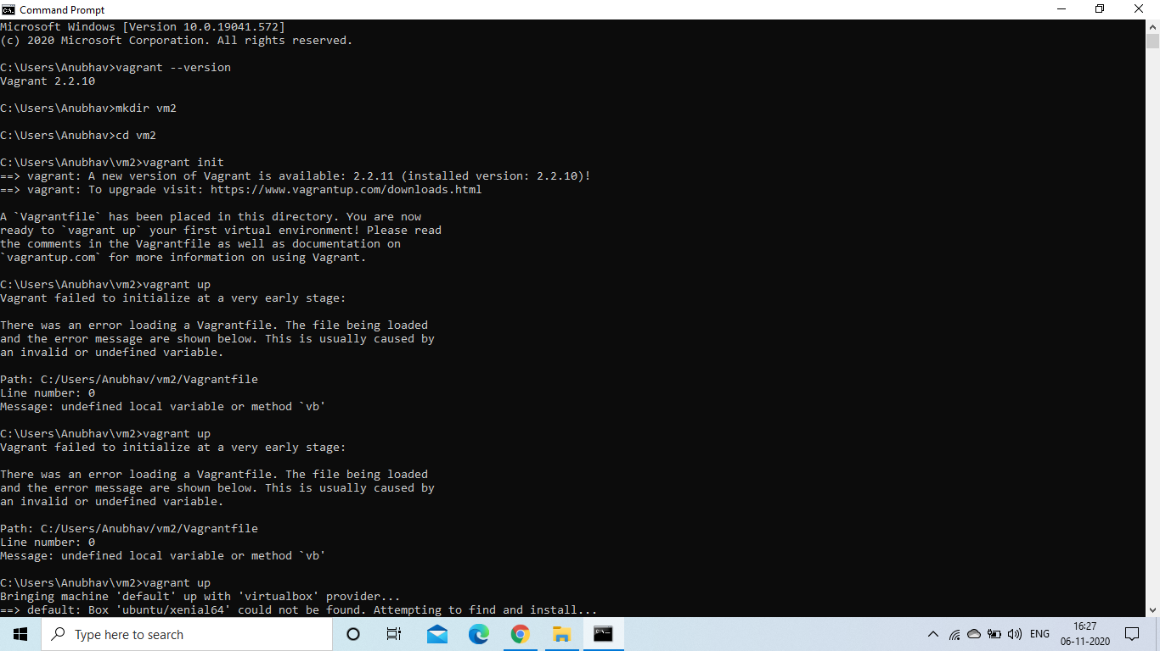

**Step-4:** After vagrantfile is created changing vb.box from “base” to “ubuntu/xenial64”

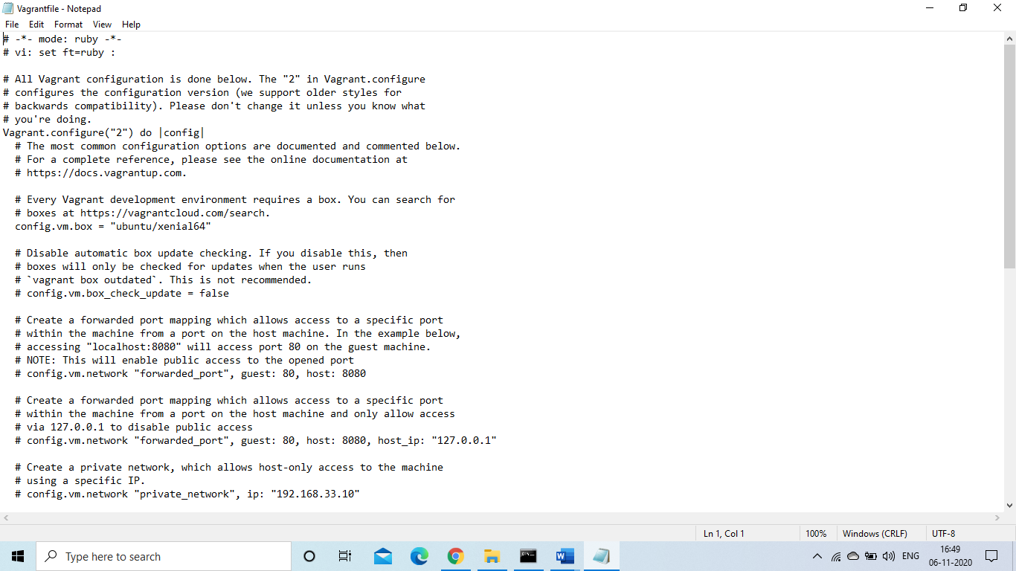

**Step-5:** Downloading the VM image using **Vagrant up** command

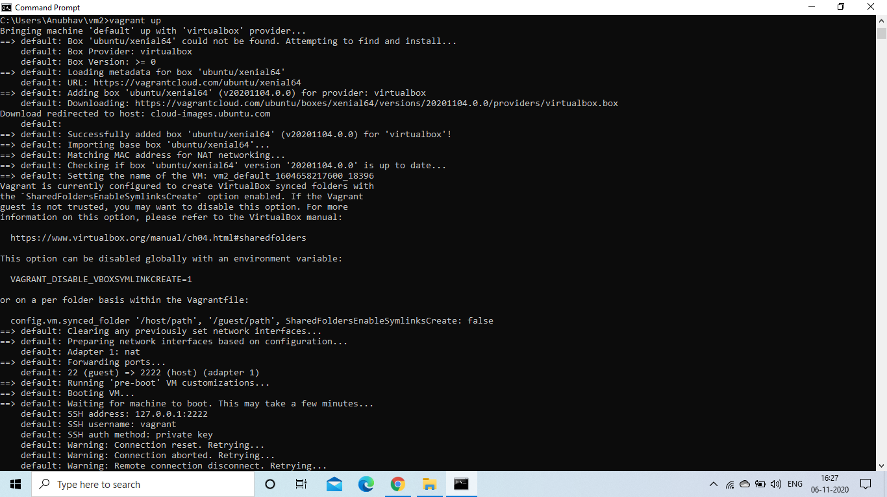

**Step-6:** Starting the VM using **Vagrant ssh** command

