

**UNIVERSITY OF PETROLEUM & ENERGY STUDIES**

**Dehradun**

**CONTINOUS INTEGRATION**

**AND**

**CONTINOUS DELIVERY**

**Name: Anubhav Deshwal**

**Course: B. TECH CSE DevOps (2018-22)**

**Roll no.: R171218024**

**Sapid: 500069112**

**Experiment-12**

**docker**

**Step-1:** Inside the Ubuntu virtual machine running using vagrant, firstly checking if machine is compatible with docker, then adding repository for docker.

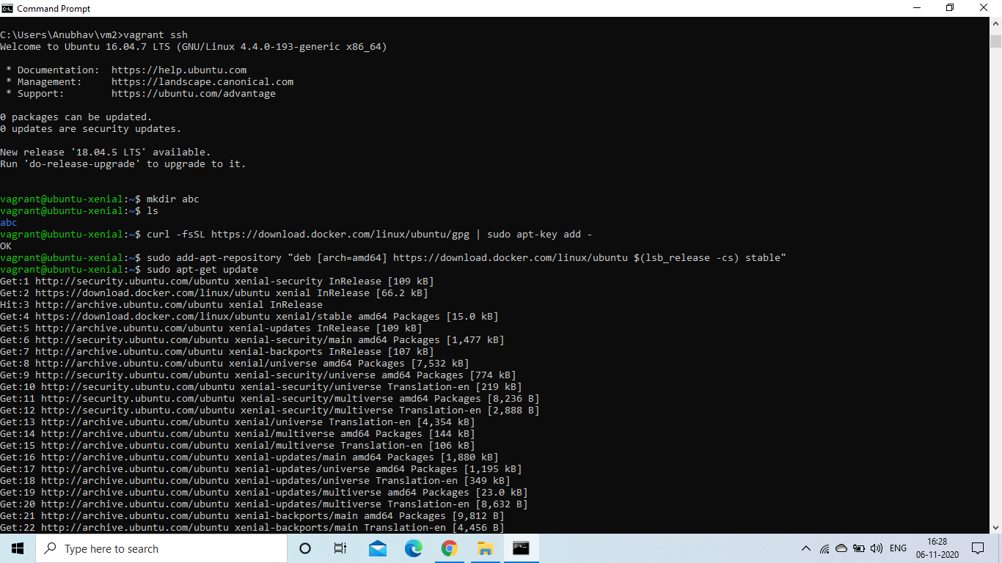

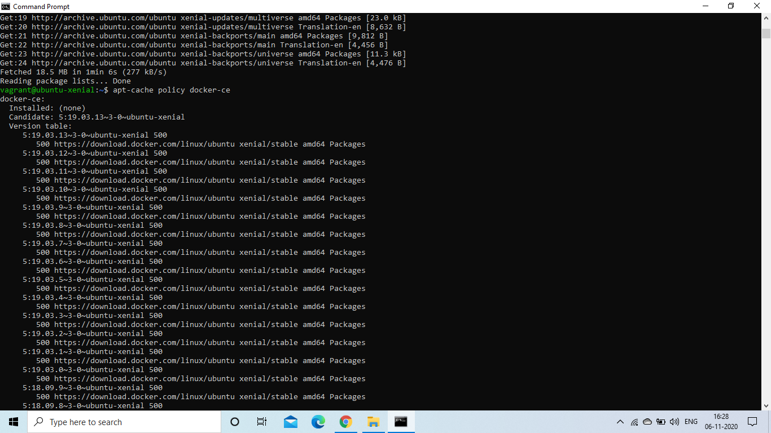

**Step-2:** Install Docker.

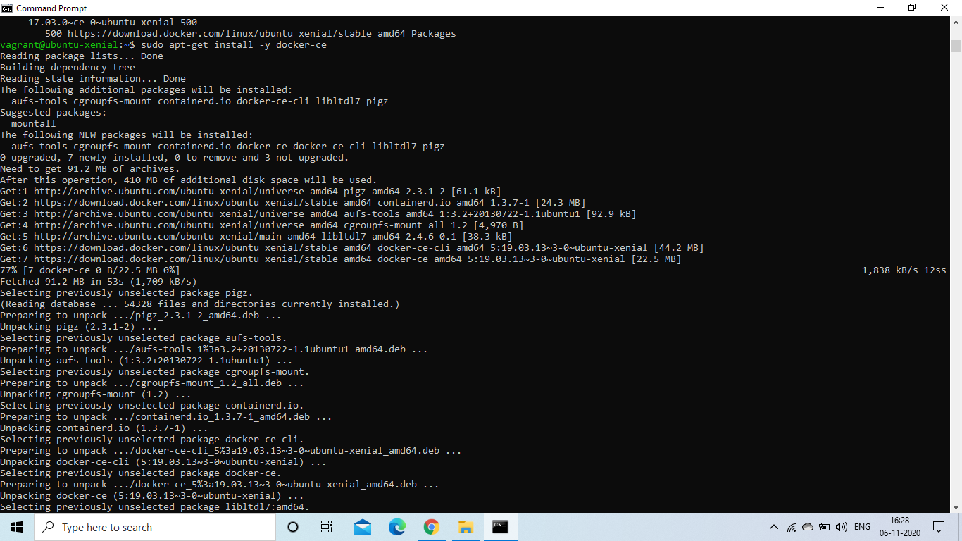

**Step-3:** Checking if docker is running or not.

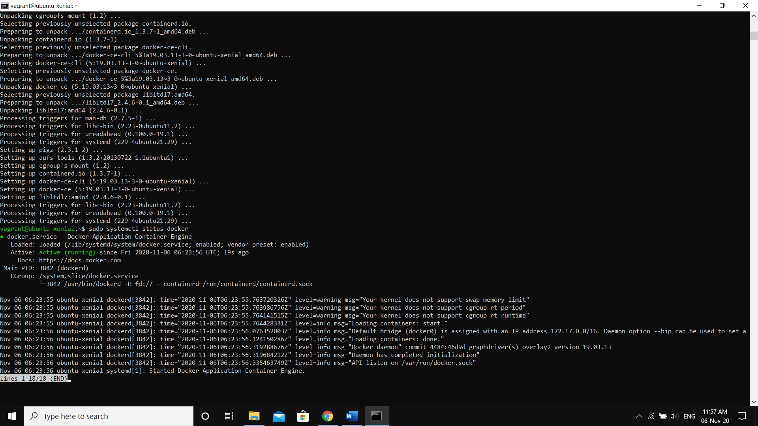

**Step-4:** Running an ubuntu container inside docker which is running on an ubuntu virtual machine using vagrant on a windows host machine.

