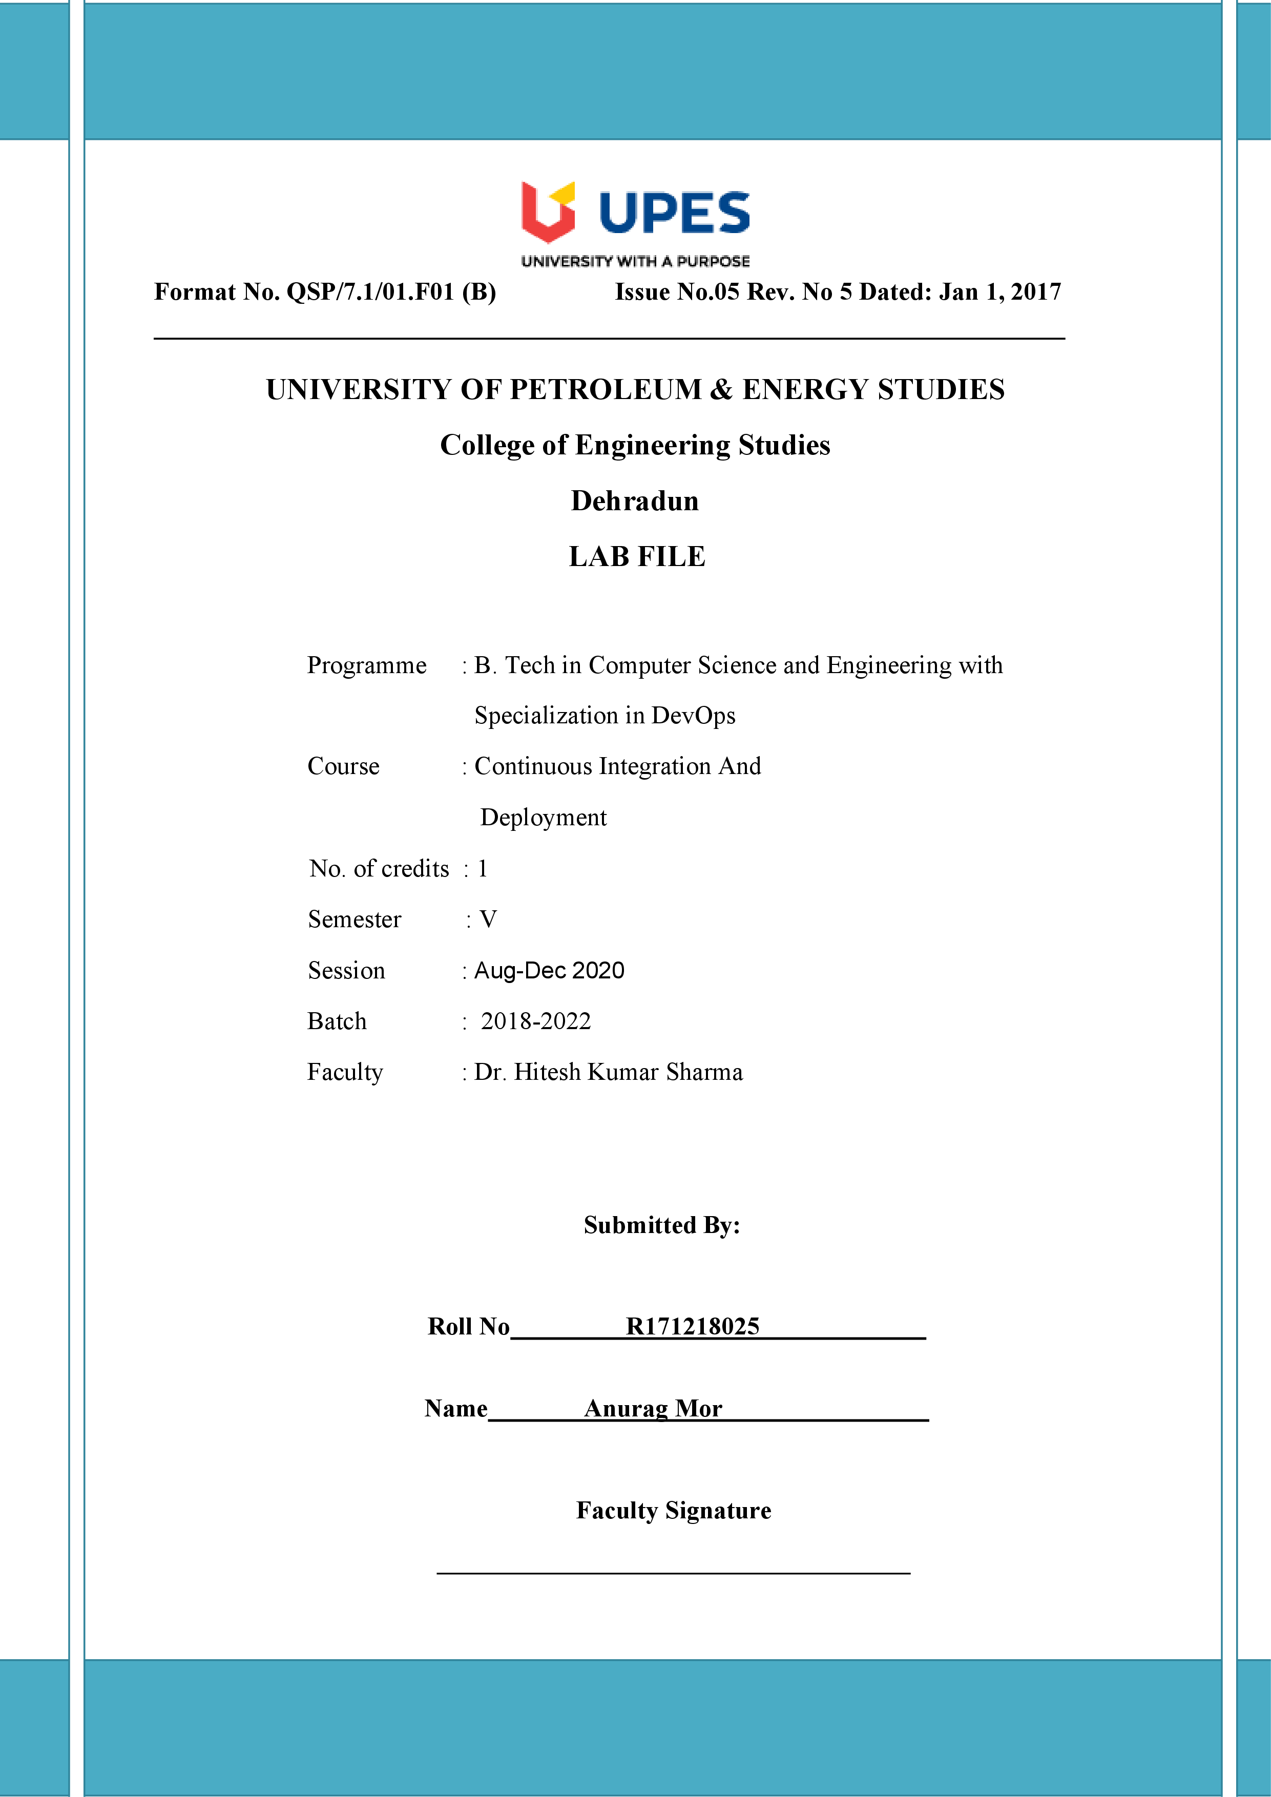

**Experiment 10 Date:- 2-10-2020**

**Aim:- Integration of Nexus Repository with Jenkins.**

**Solution:-**

1. Open command line with the path of bin/ folder of the Nexus binary downloaded and type the following command:

Nexus.exe /run

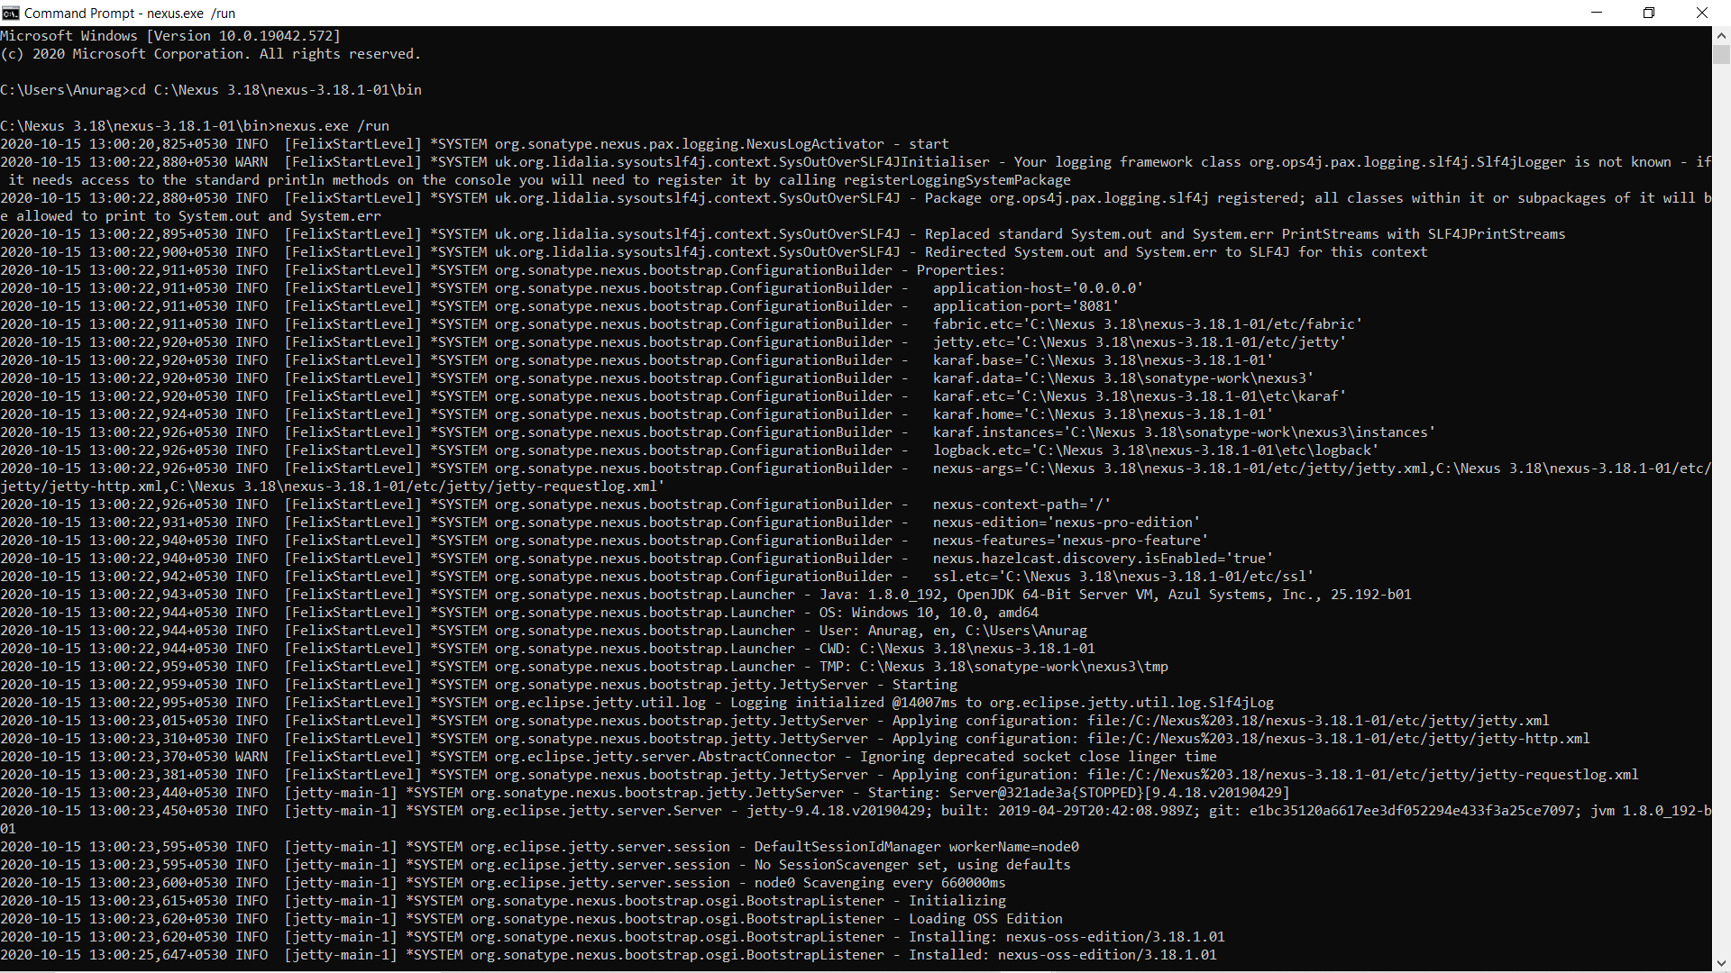

Simultaneously run the Jenkins command to run Jenkins server using command java -jar Jenkins.war

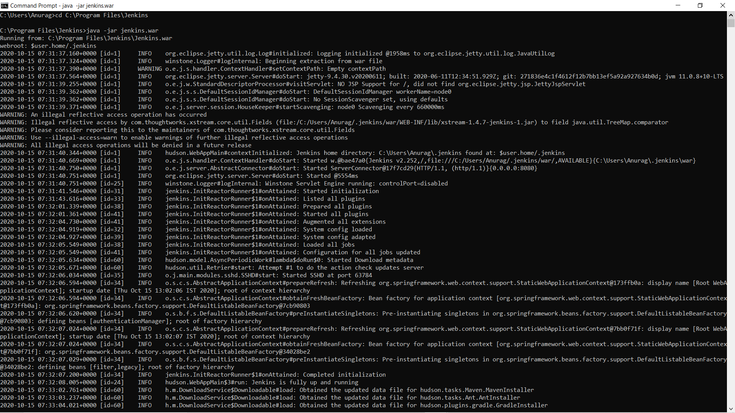

1. Open the Nexus Dashboard in a web browser at **localhost:8081** address and for Jenkins at localhost:8080.
2. Create a new user to signup or sign in as the admin.
3. Select **Maven2(Hosted)** in the Select Recipe page.
4. 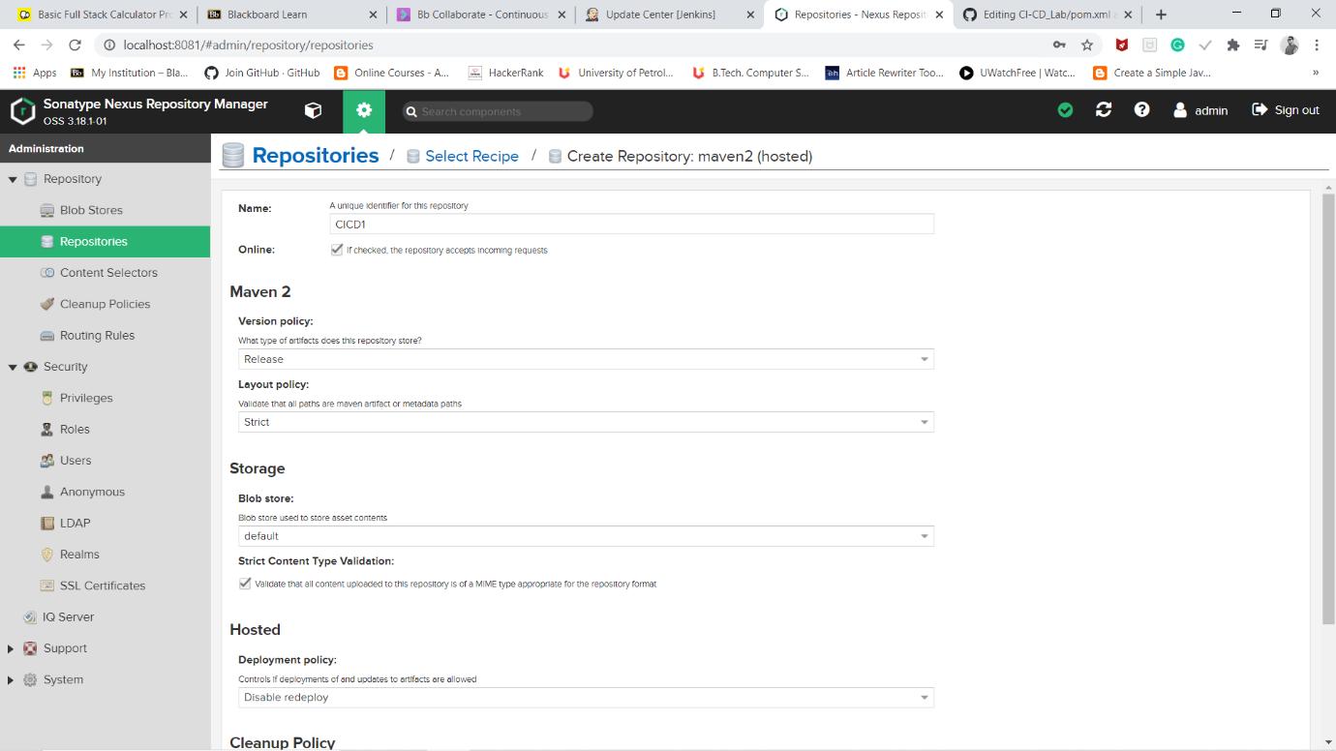
5. Go to Jenkins and configure the settings of Nexus.
6. Now make a new item “write name of the project and select as we are using maven command.
7. 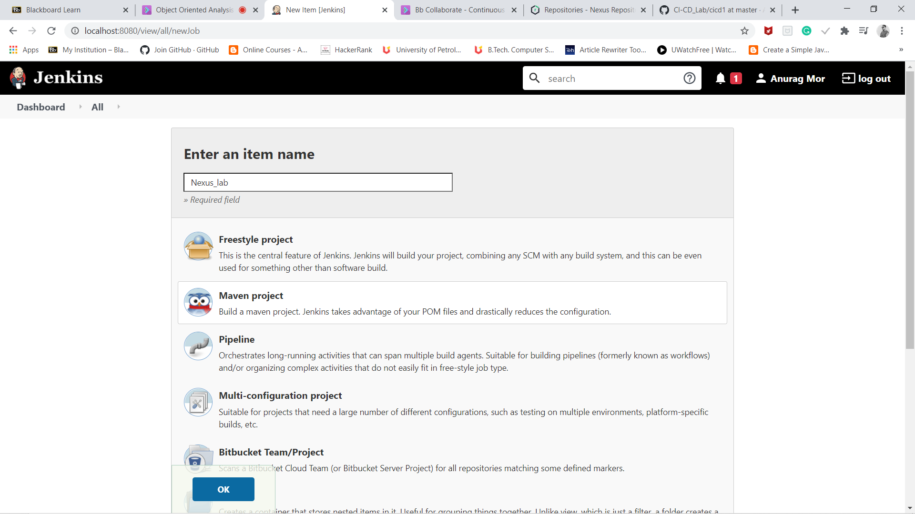
8. Now in maven goal write deploy and in github provide the git repo link which have the pom.xml change with dependencies.

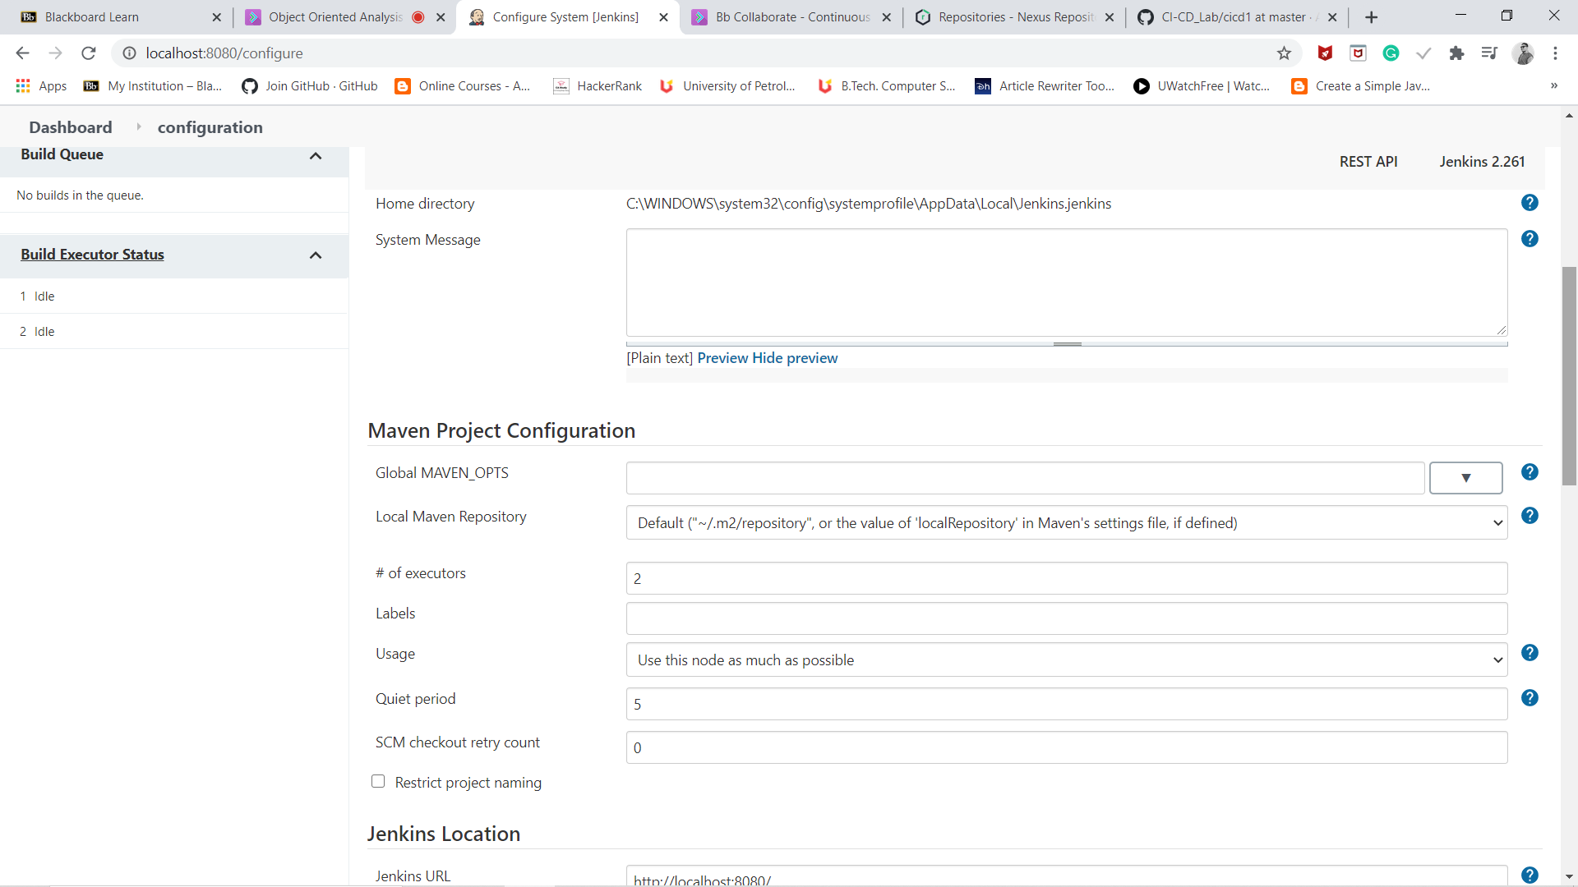

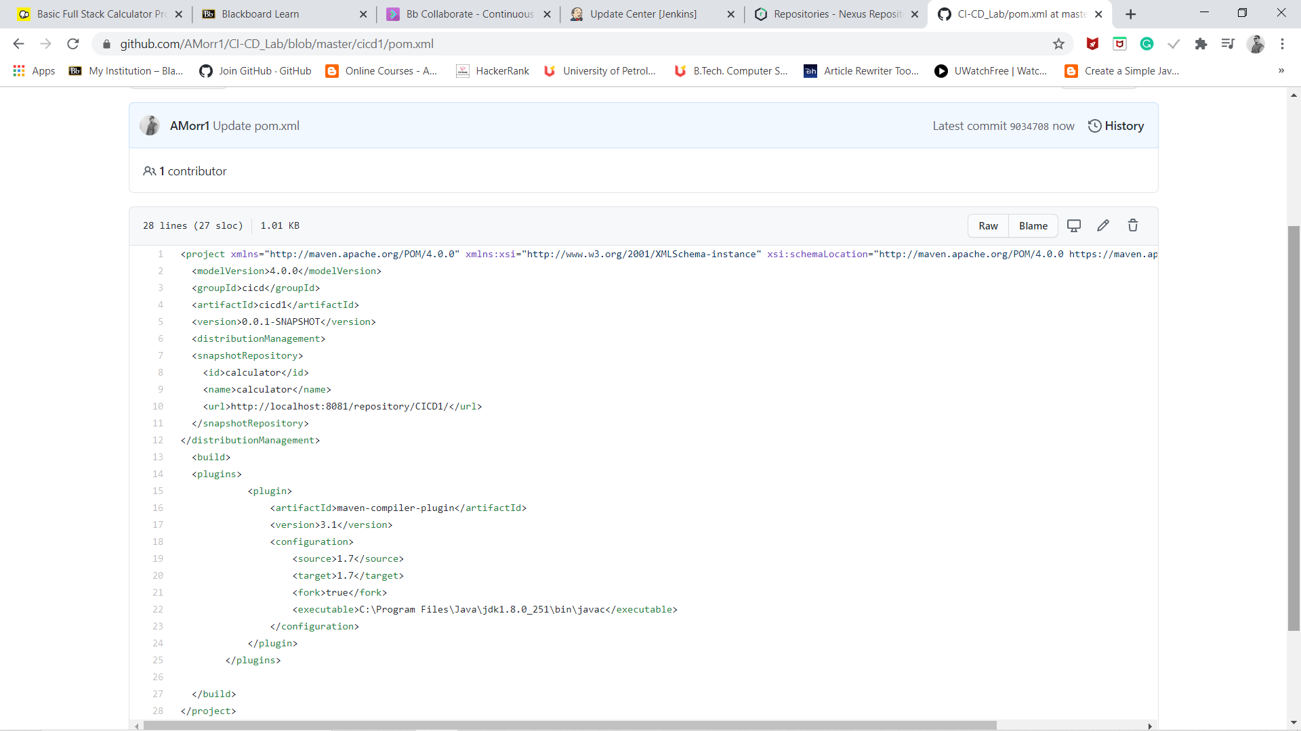

1. Now click on build option ,build is success.

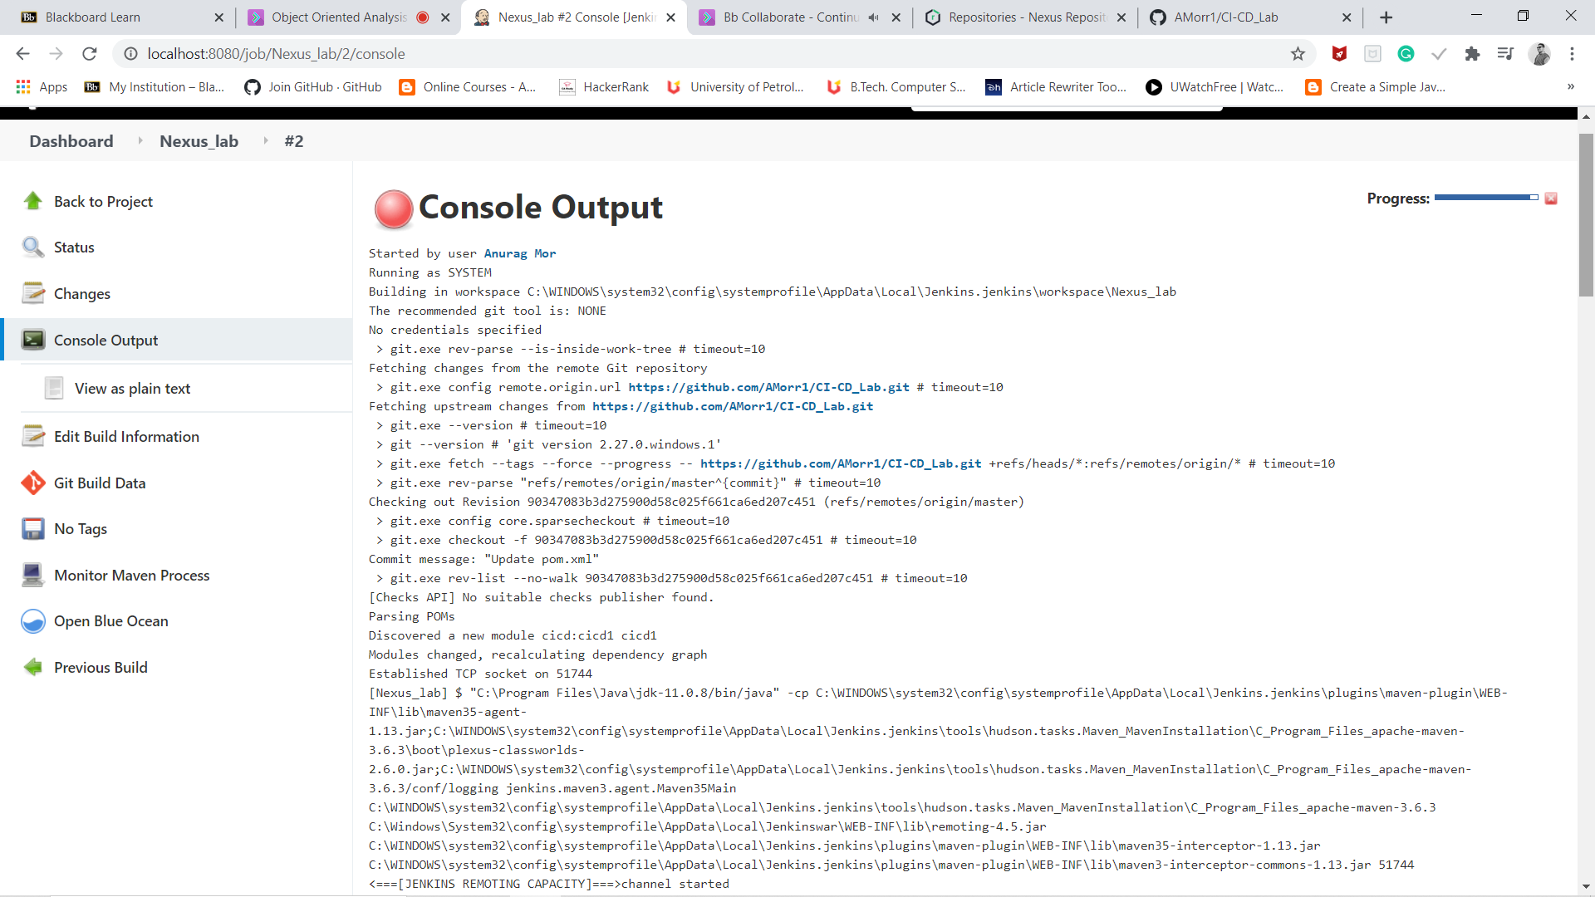

1. Check the nexus dashboard.

