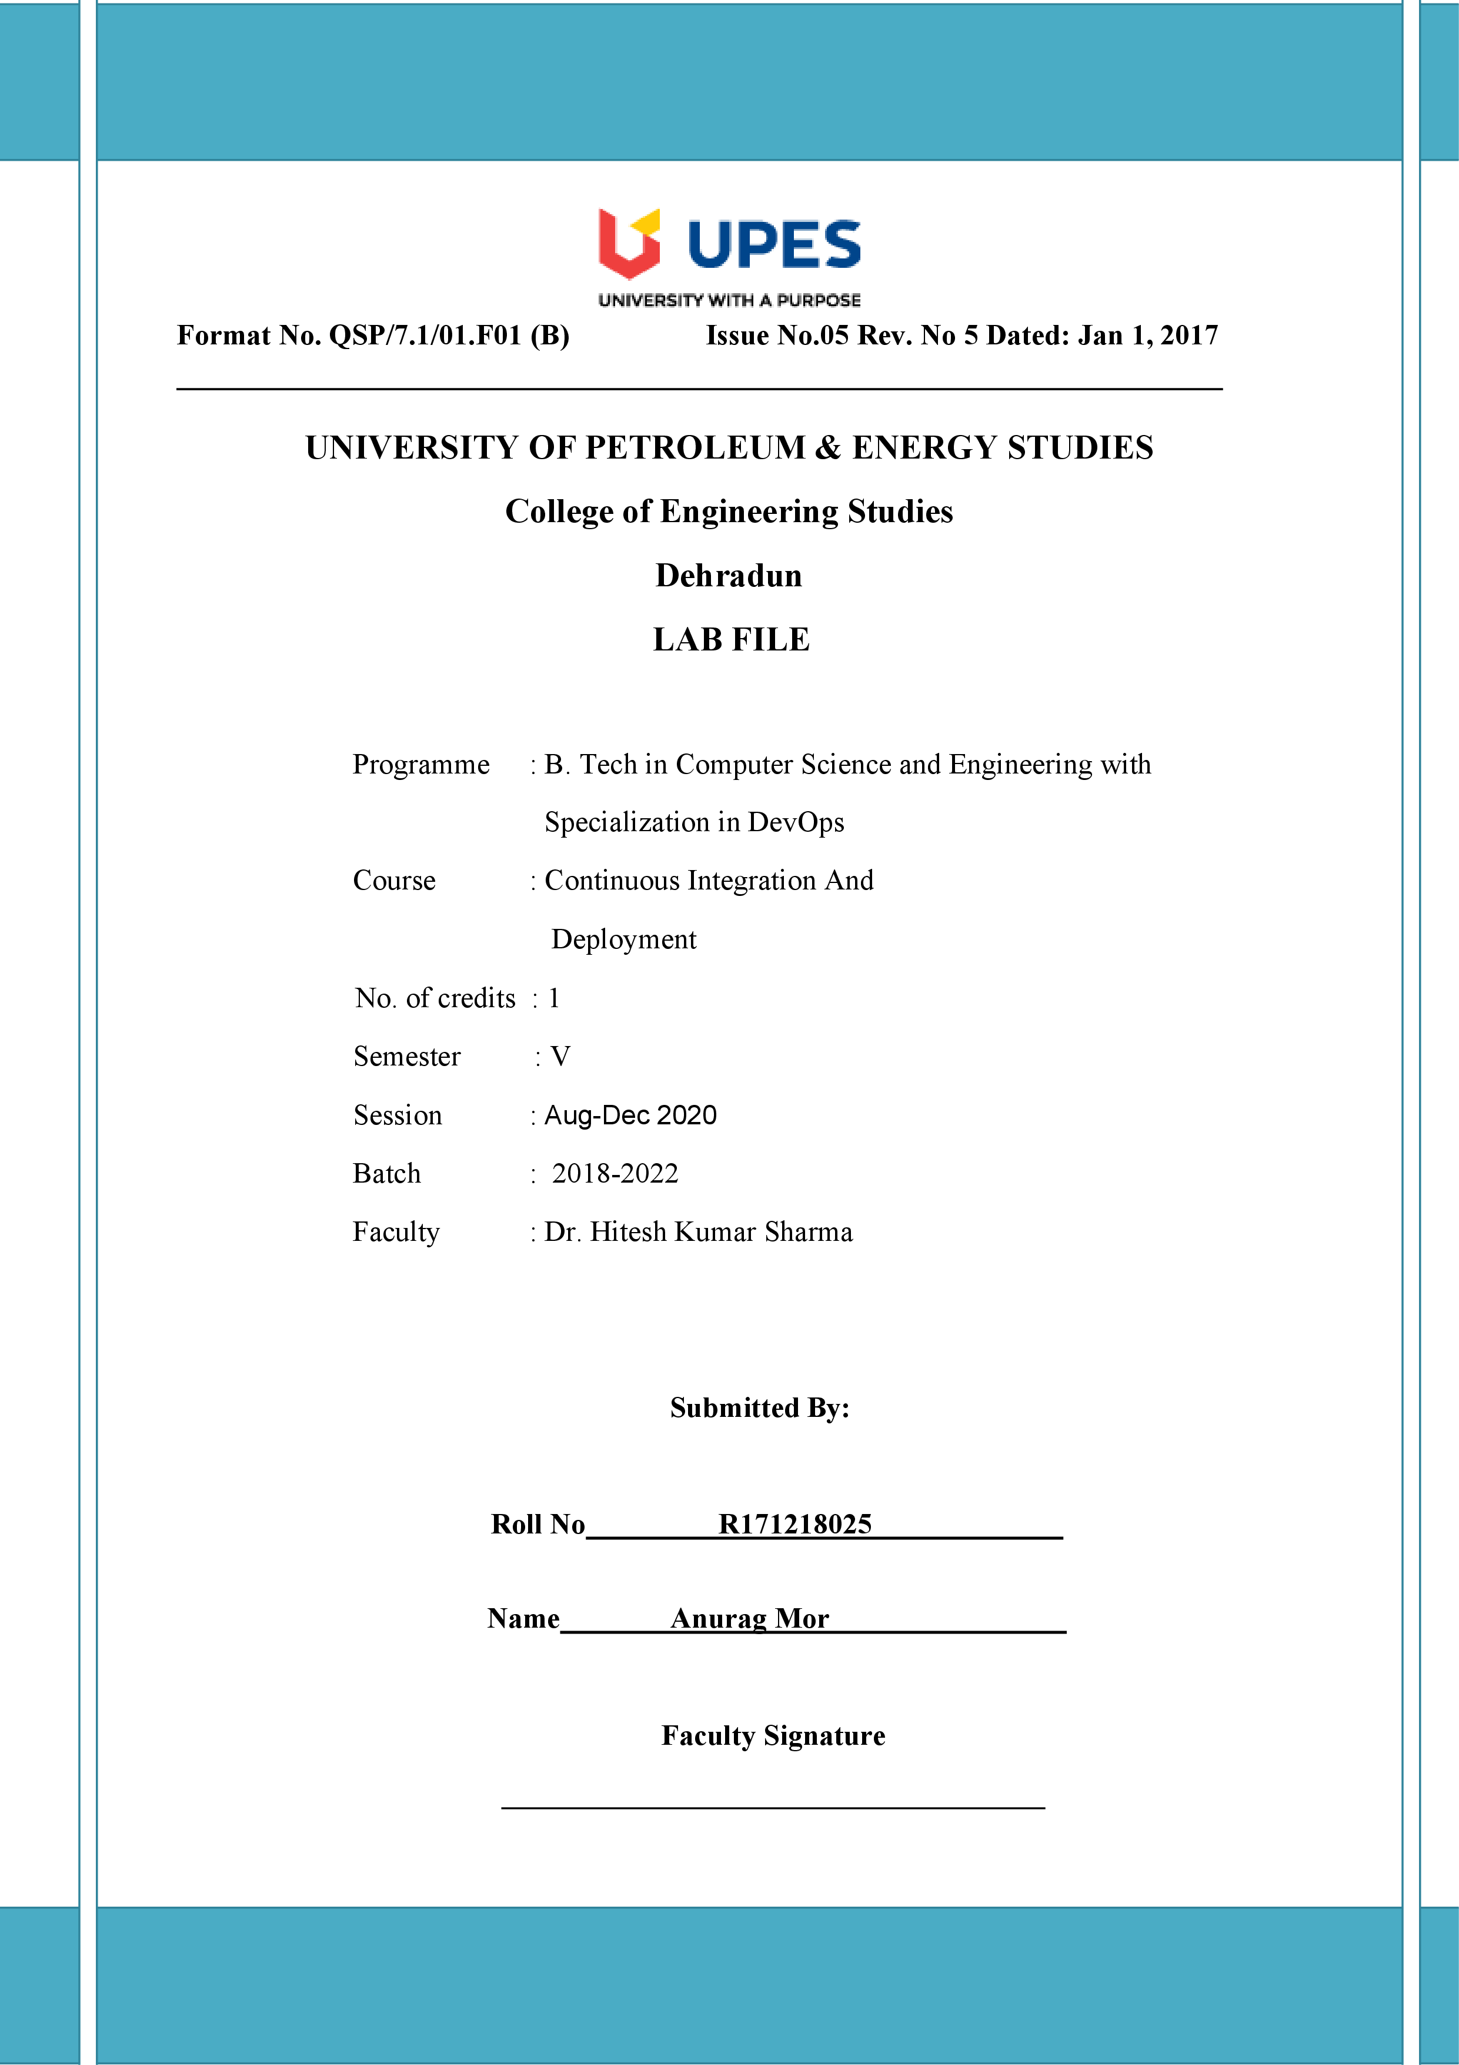**Experiment 12 09-11-2020**

**Aim:** Configuration of docker and starting its container in vagrant.

**Solution:**

**1)** In order to ensure the downloads are valid, add the GPG key for the official Docker repository to your system.

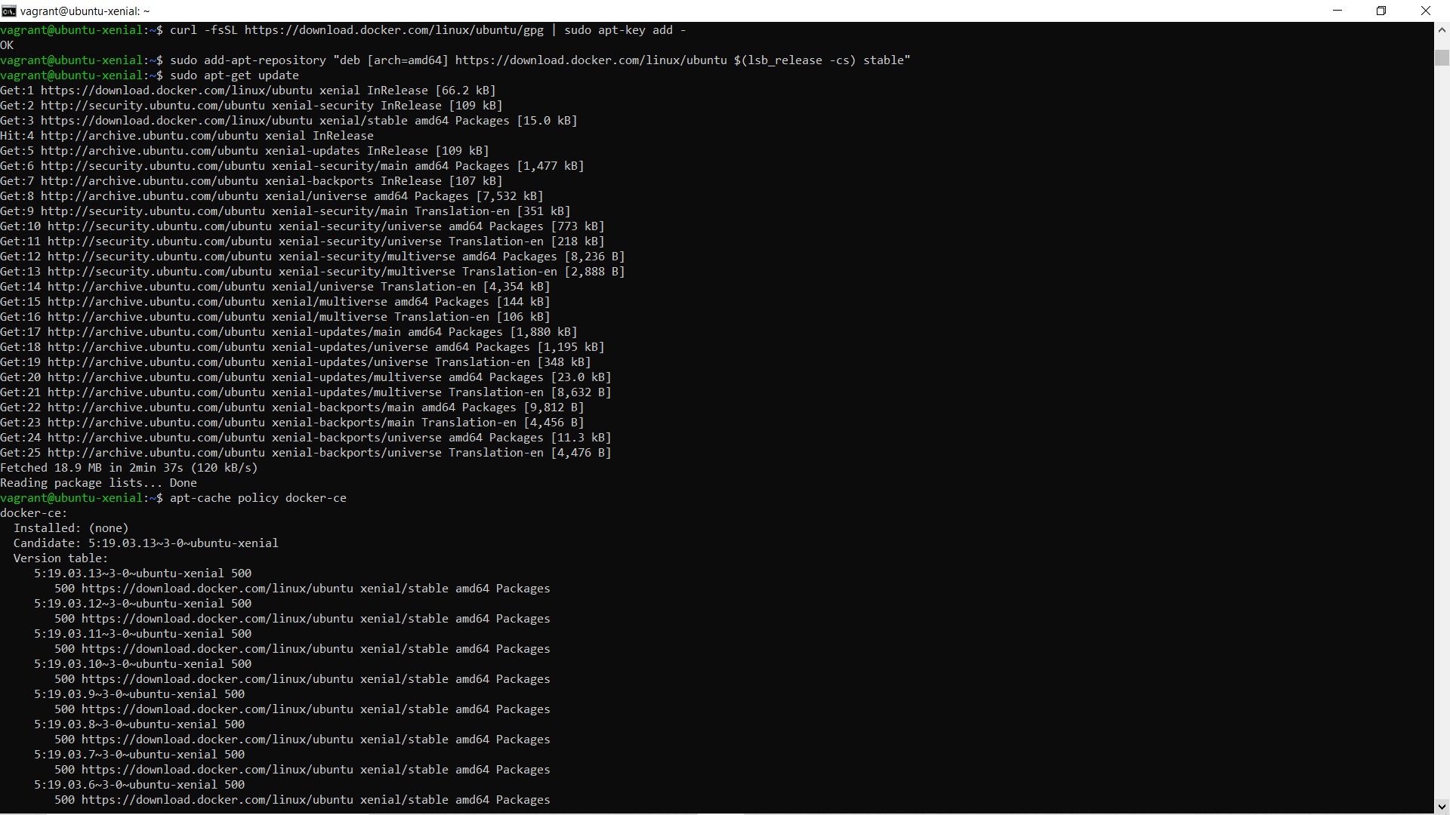

**2)** Add the Docker repository to APT sources.



**3)** Now install docker.

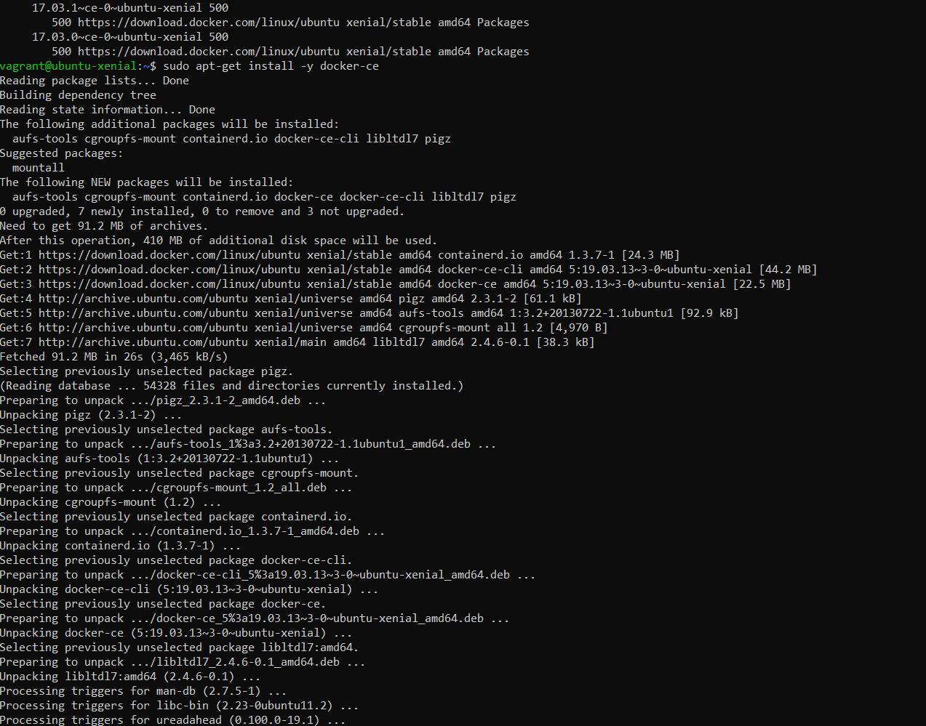

**4)** Verify that docker has been configured using the ‘systemctl status docker command’. Create a user for using docker. Create a docker container using the Ubuntu image. The command to be used ‘docker run –it –name check ubuntu.’ The following command will fetch the latest image of Ubuntu from docker hub and create a container via this image.

