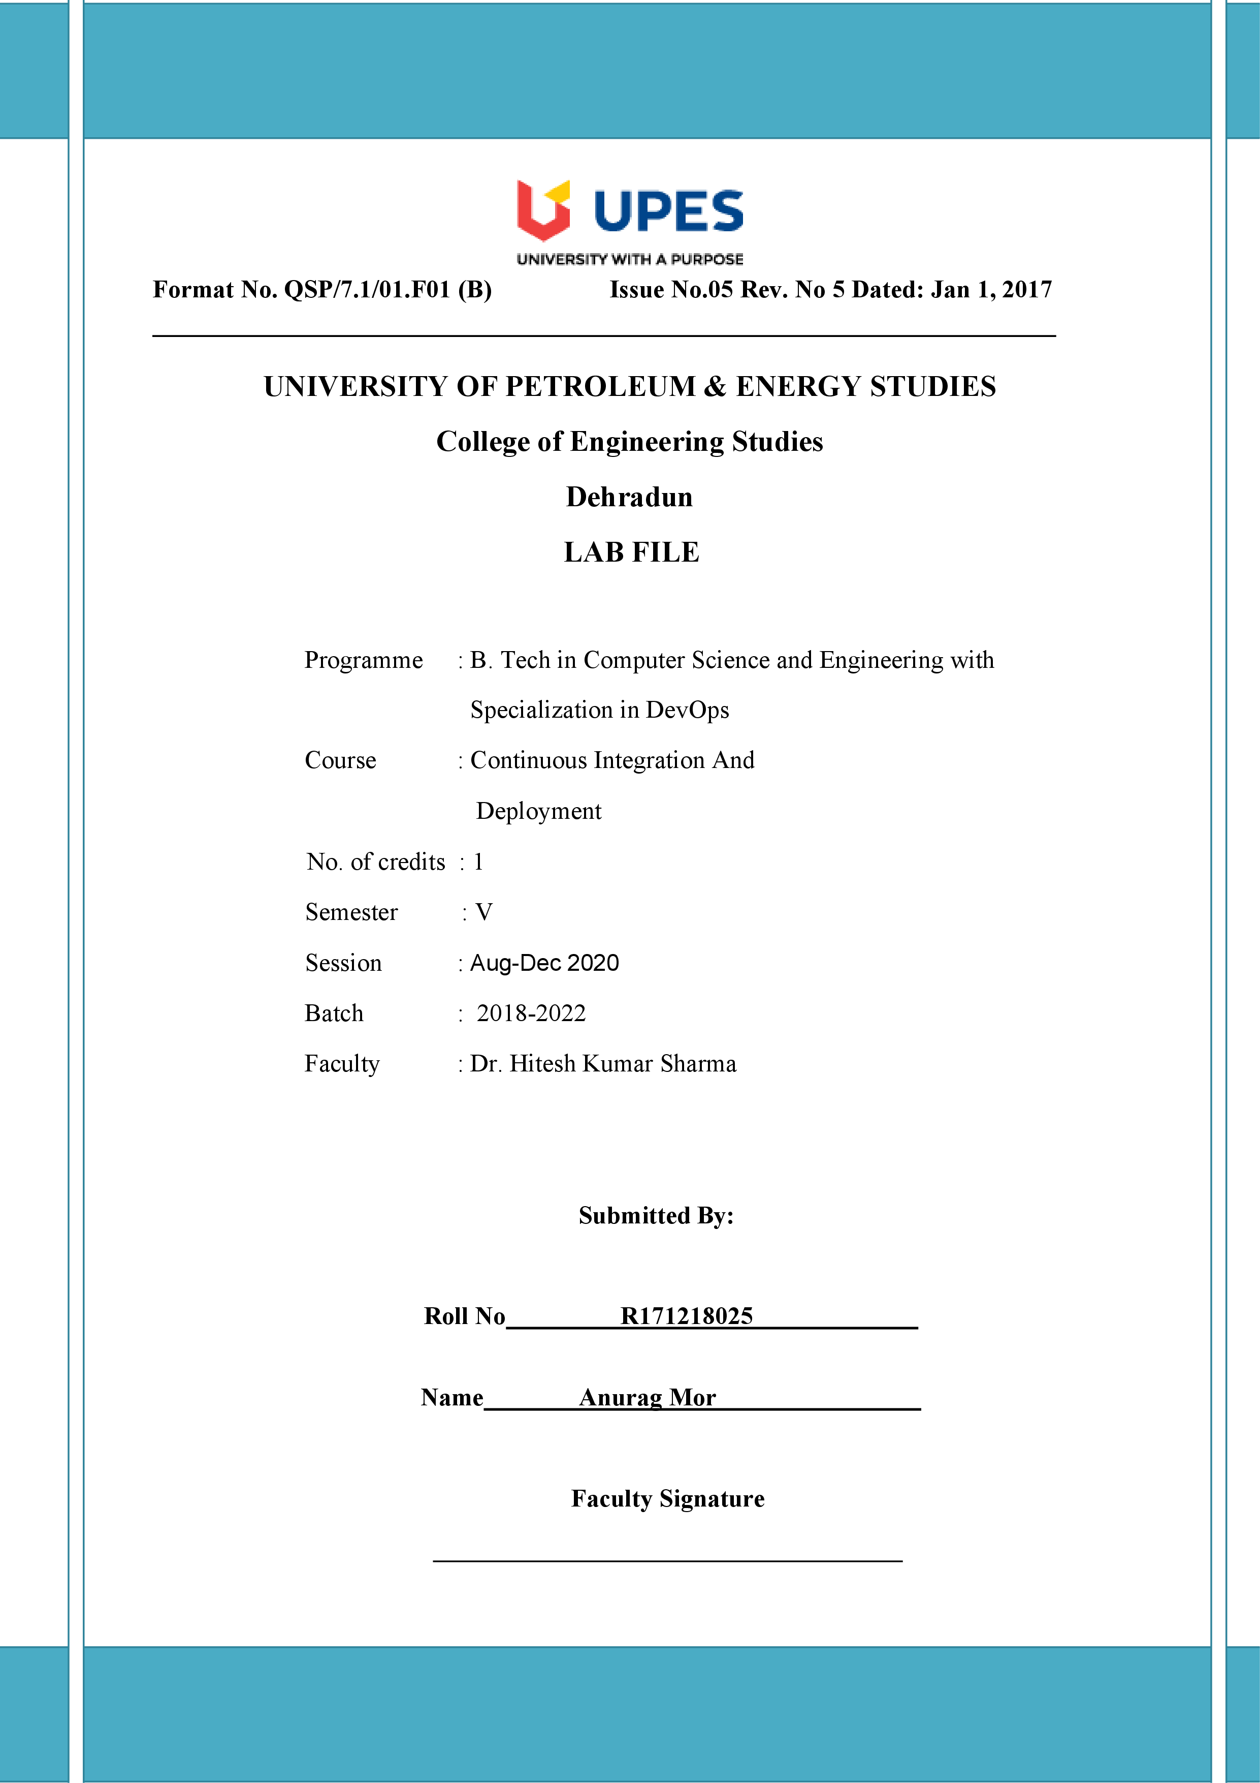

**Experiment 13 10-11-2020**

**Aim:- Deploying your first Docker Container**

**Solution:**

Step 1 - Running A Container

docker search <name>

docker search redis

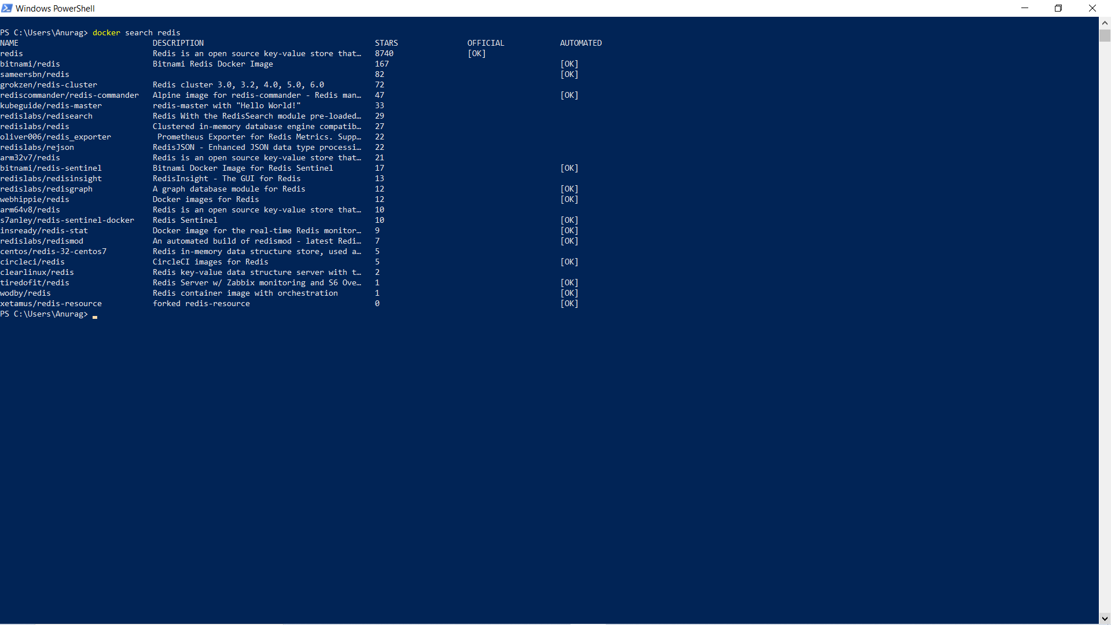

docker run <options> <image-name>

docker run -d redis

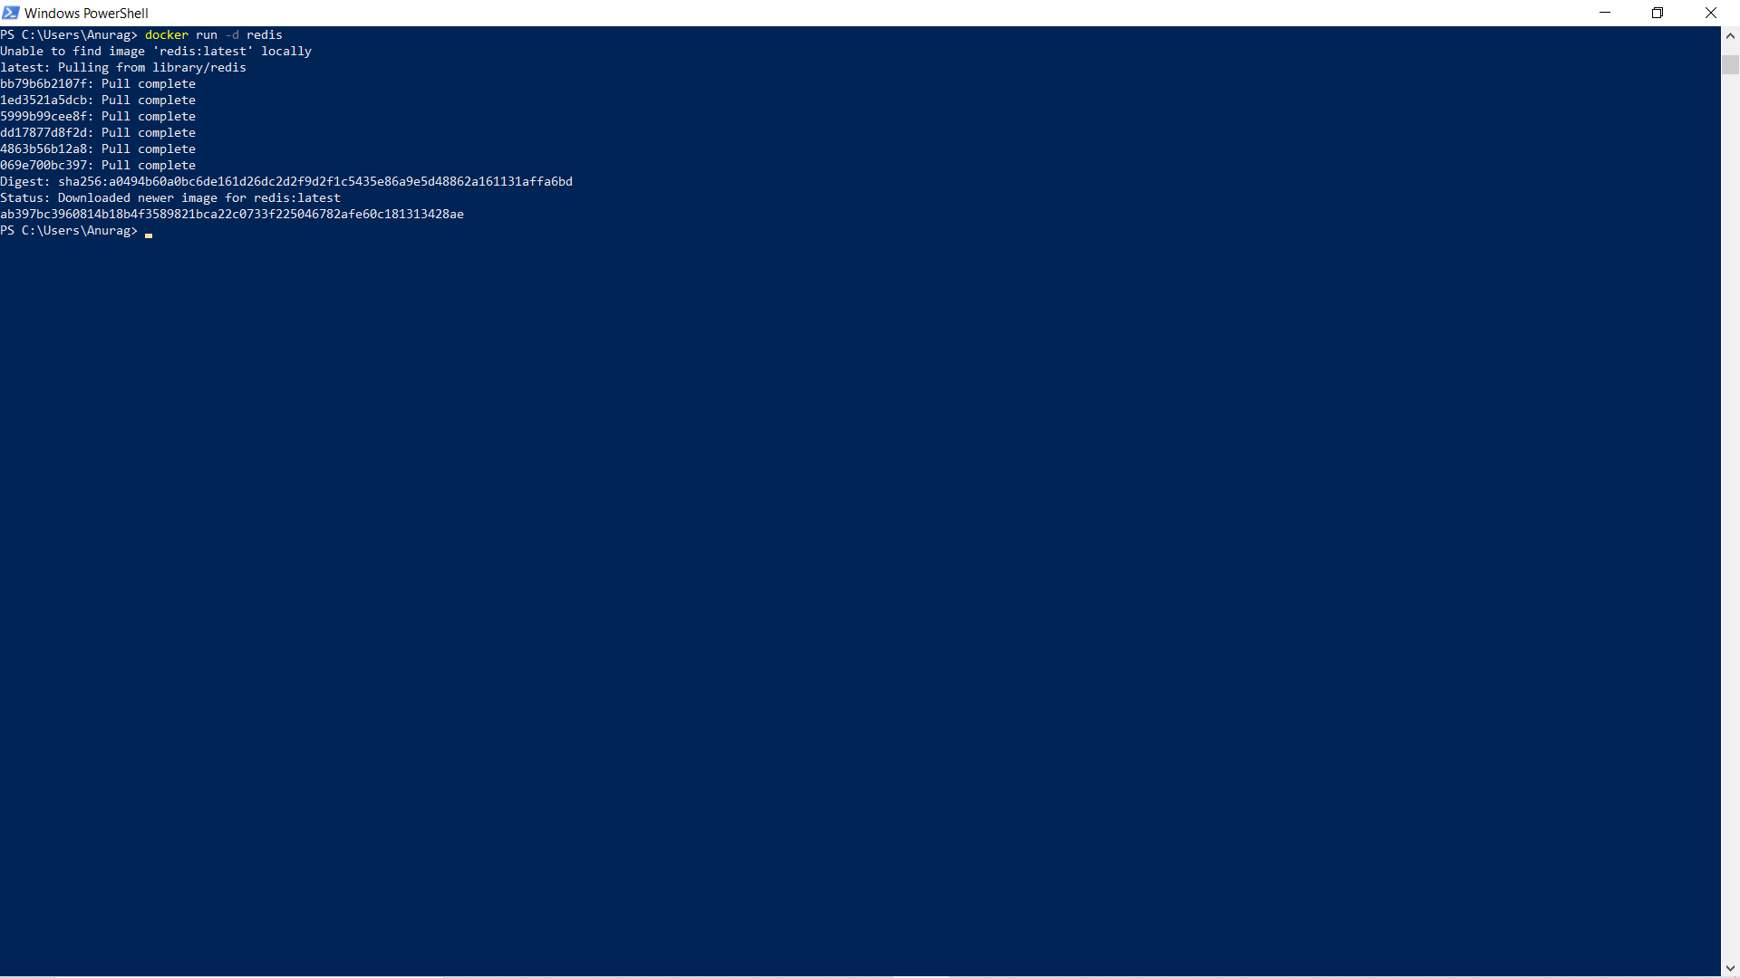

**Step 2 - Finding Running Containers**

docker ps

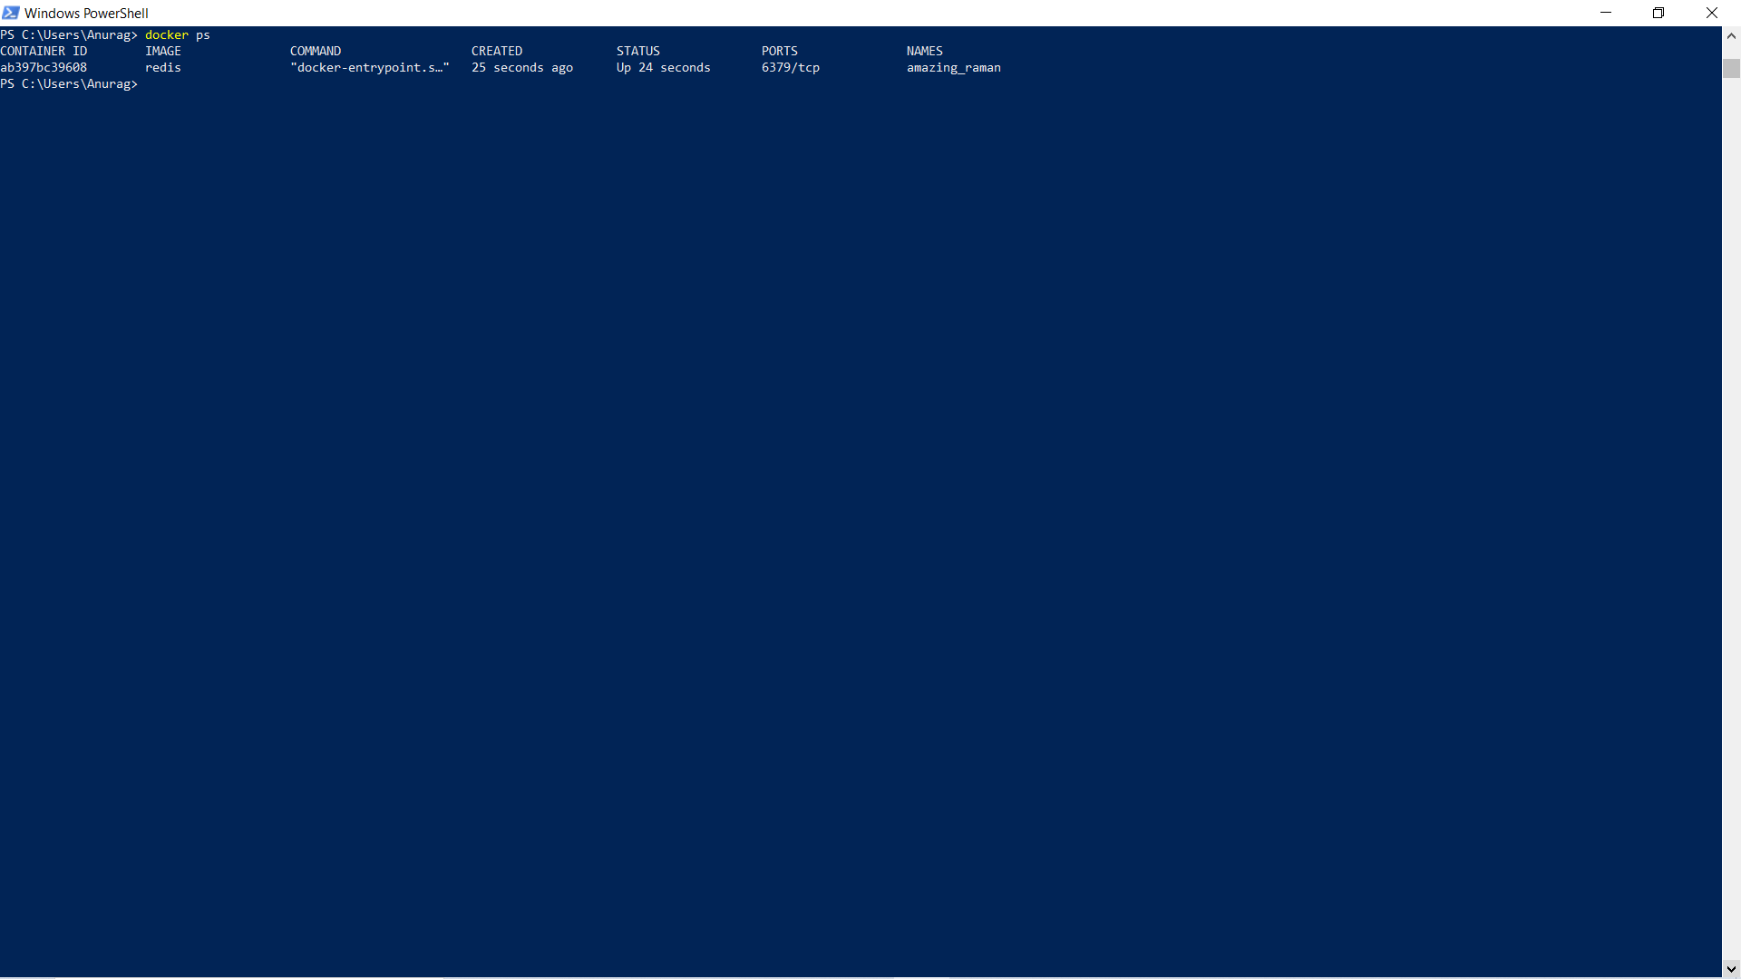

docker inspect <friendly-name|container-id>

docker logs <friendly-name|container-id>

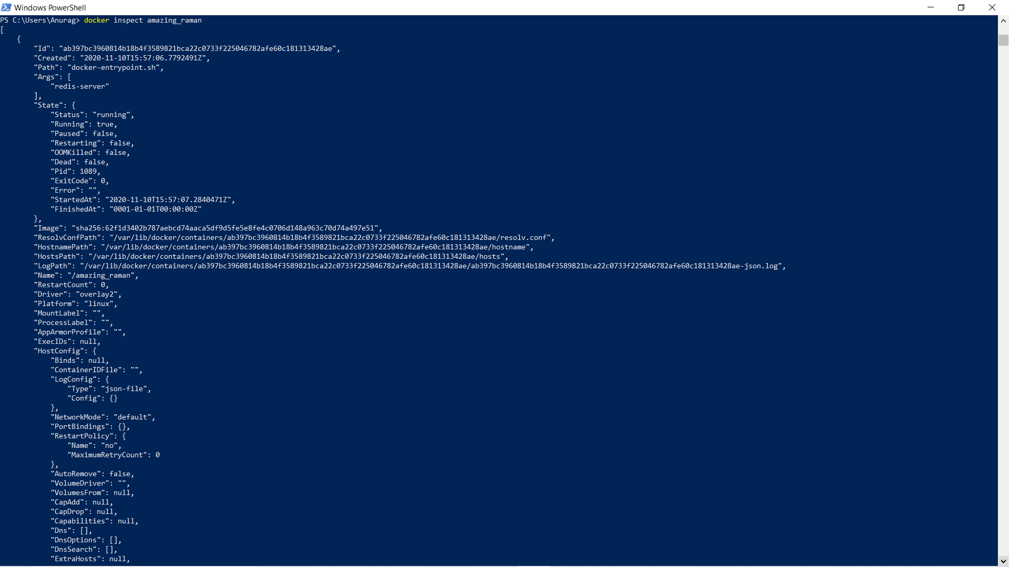

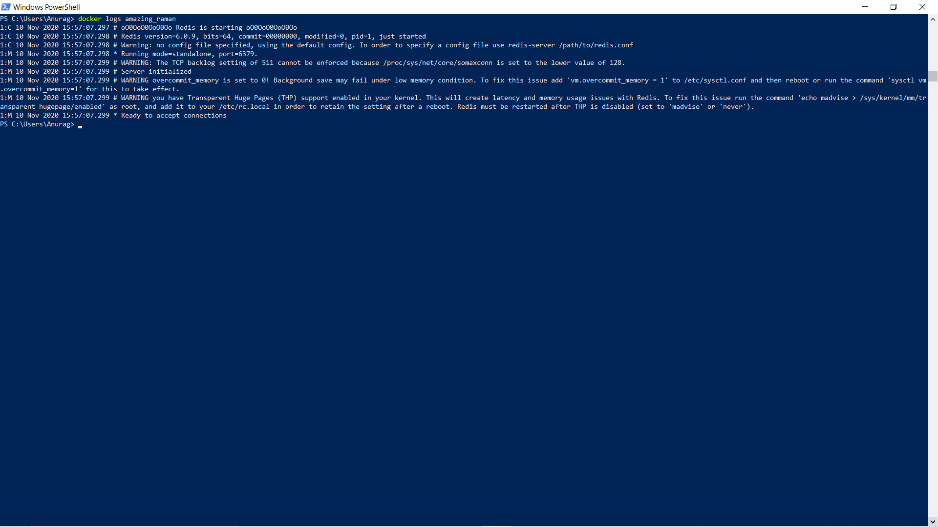

Step 3 - Accessing Redis

docker run -d --name redisHostPort -p 6379:6379 redis:latest

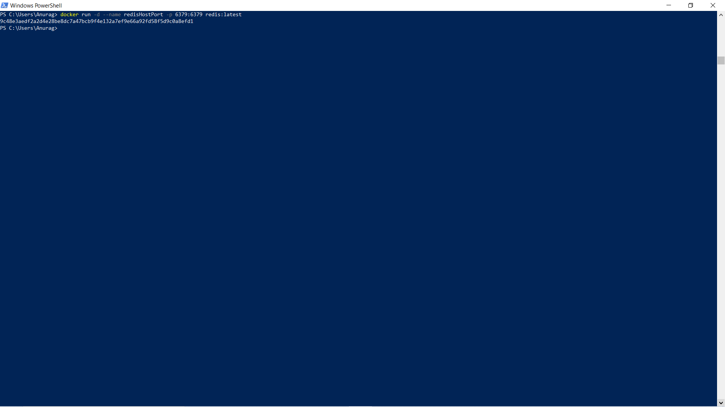

Step 4 - Accessing Redis

docker run -d --name redisDynamic -p 6379 redis:latest

docker port redisDynamic 6379

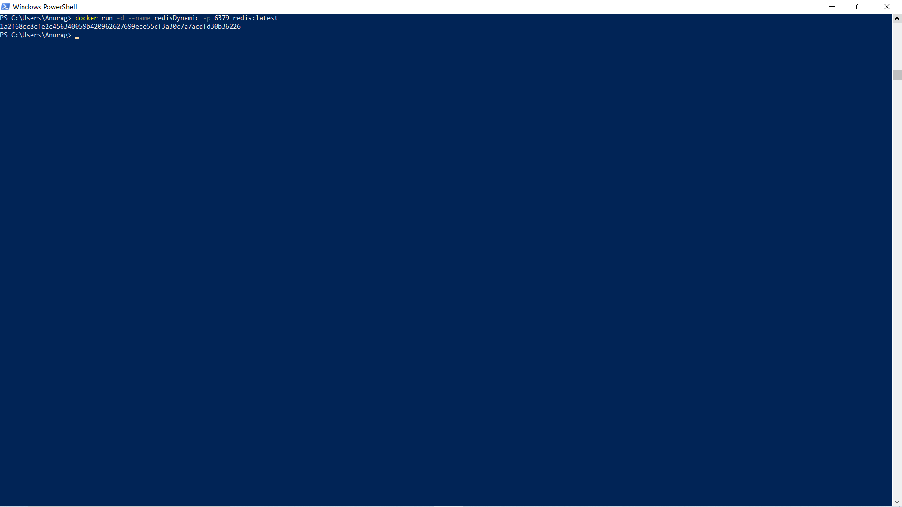

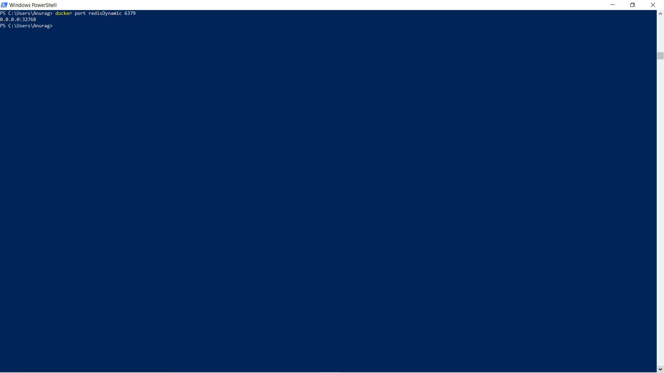

docker ps

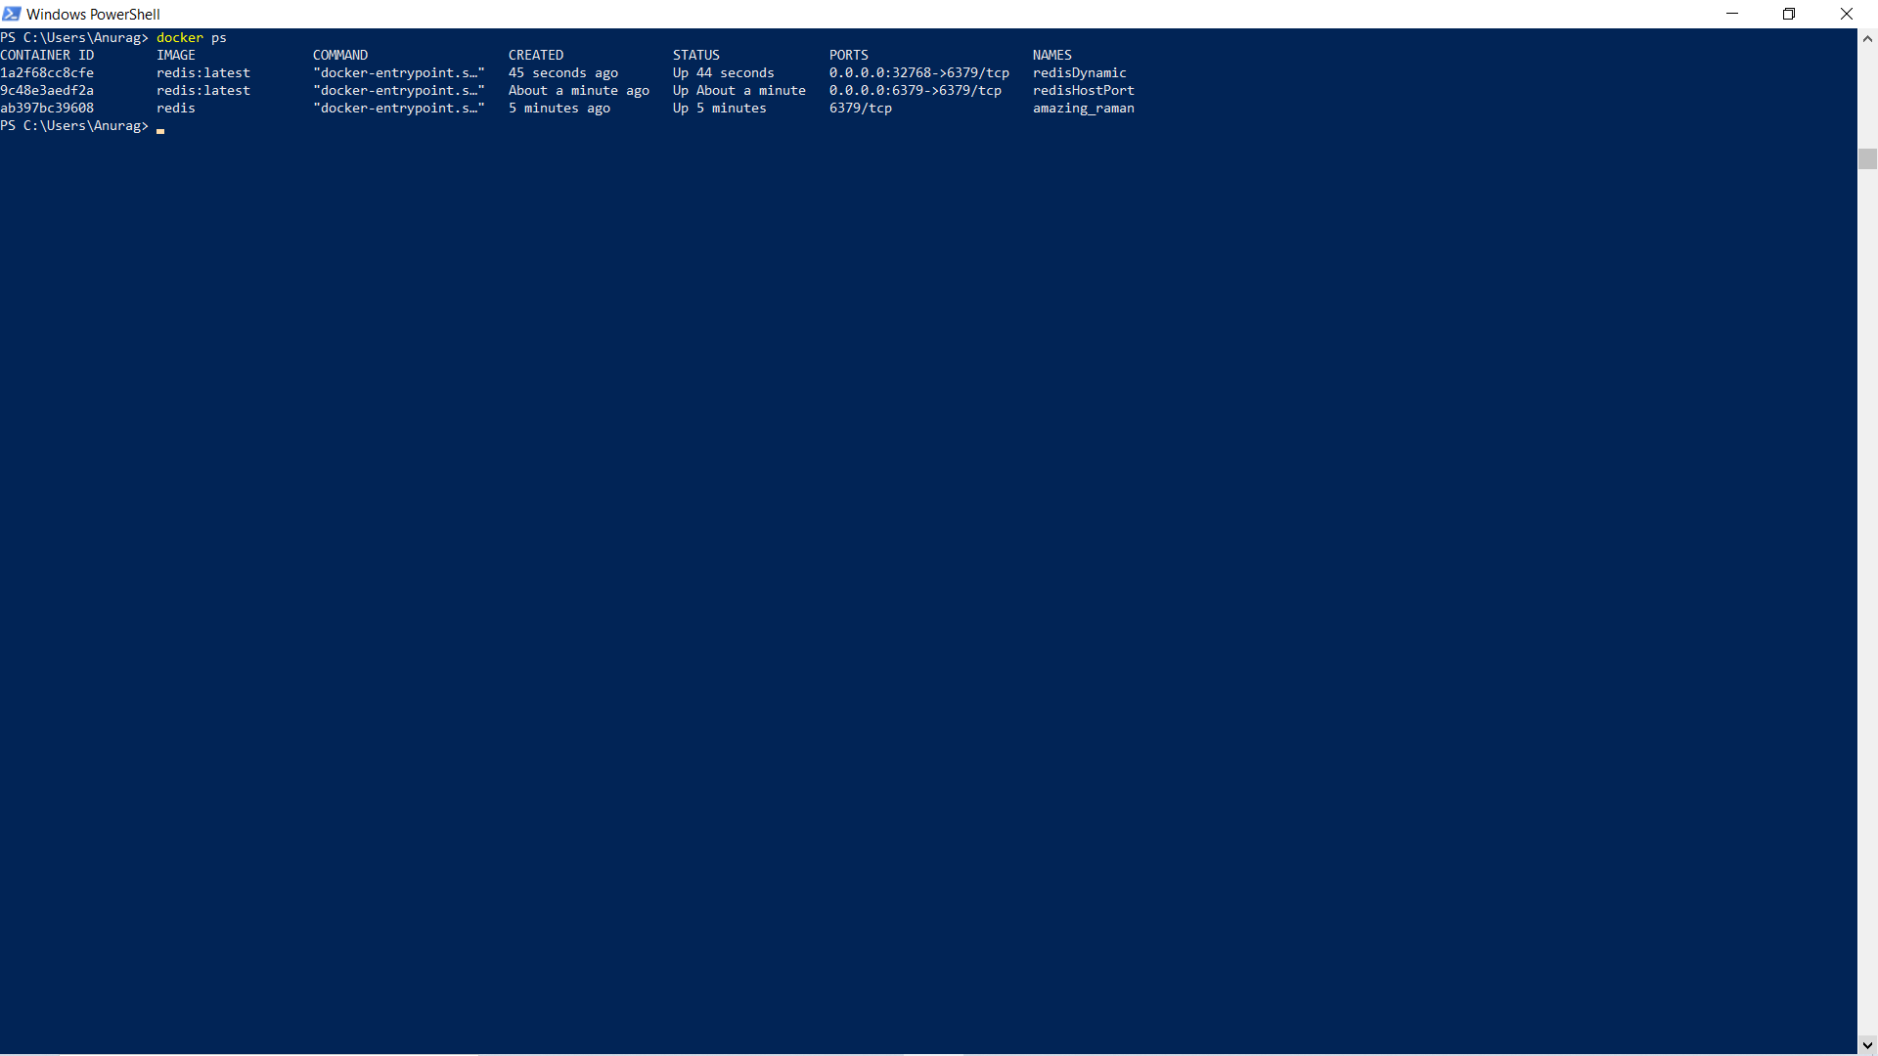

Step 5 - Persisting Data

docker run -d --name redisMapped -v /opt/docker/data/redis:/data redis

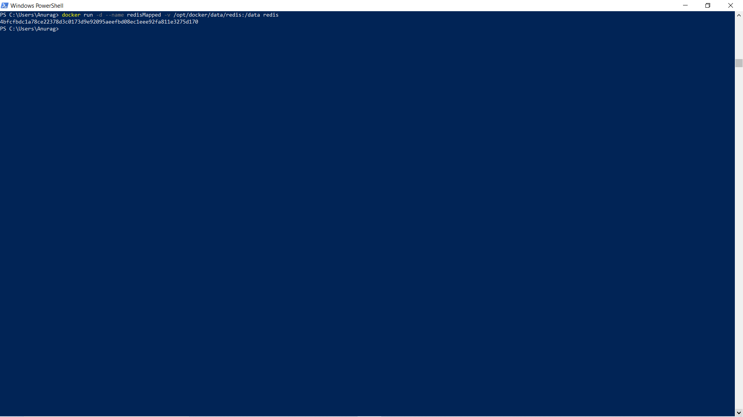

Step 6 - Running A Container In The Foreground

docker run -it ubuntu bash

