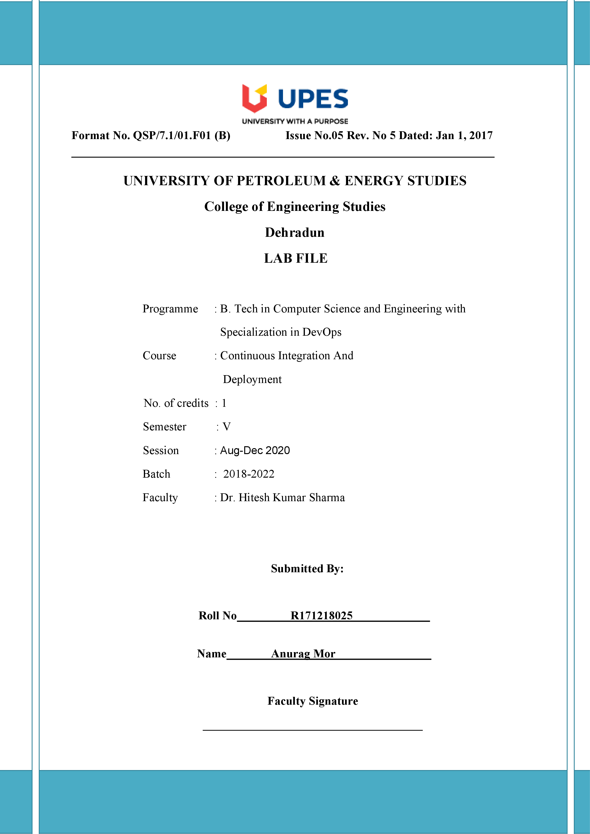

**Experiment 1 14 August 2020**

**Aim:- Installation of Jenkins and Execution of a simple Job in Jenkins**

**Solution:-**

Jenkins is an open source build automation server written in Java with a rich plugin ecosystem built for the purpose of Continuous Integration. Jenkins's base concept is the definition of the job execution starting from the SCM system to a deliverable artifact.

Downloading and Configuring the Jenkins:-

1. Download Generic java package [jenkins.war](https://jenkins.io/download/)

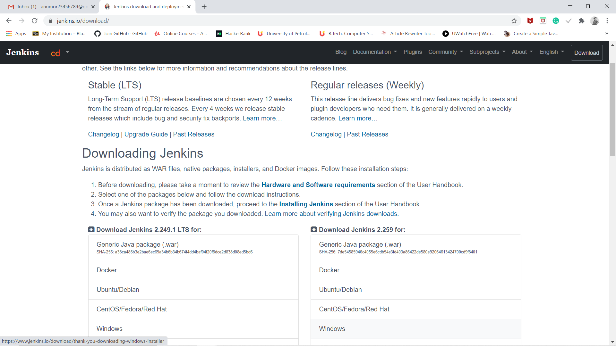

1. Now after downloading the Jenkins.war unzip it in any drive like C, D or E.

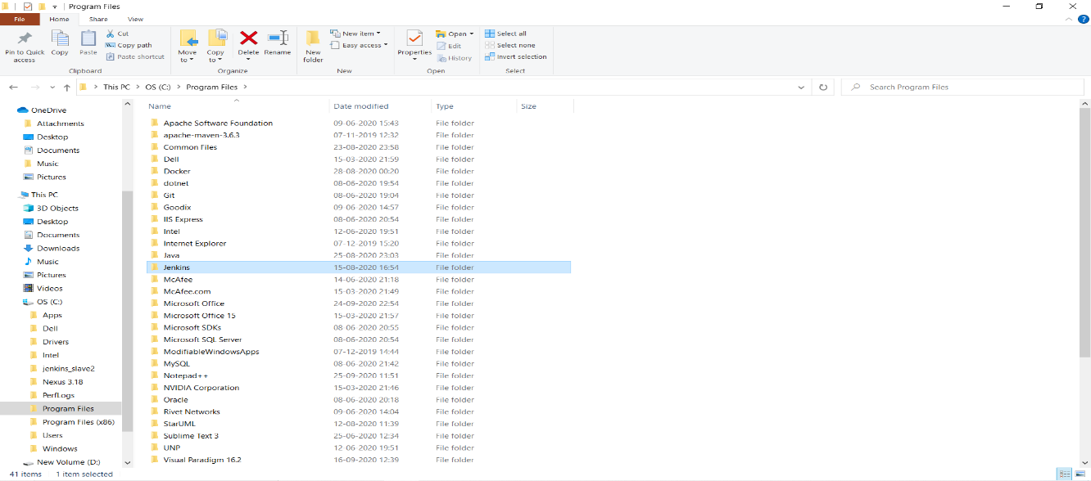

1. Now go to the Jenkins folder inside.Copy the path till there where Jenkins.war is available.

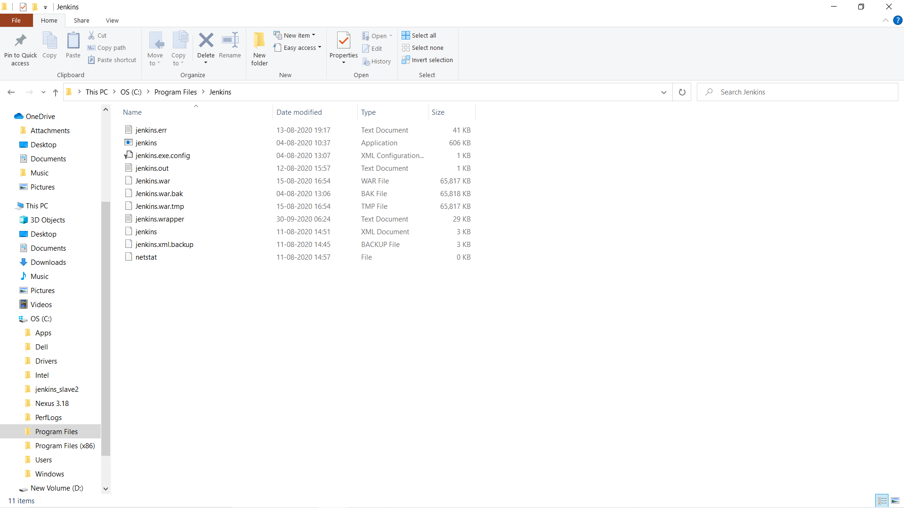

1. Now open Administator Command Prompt and go to that folder local intial using command

cd C:\Program Files\Jenkins

Now after this run the command to start the Jenkins:

java -jar jenkins.war

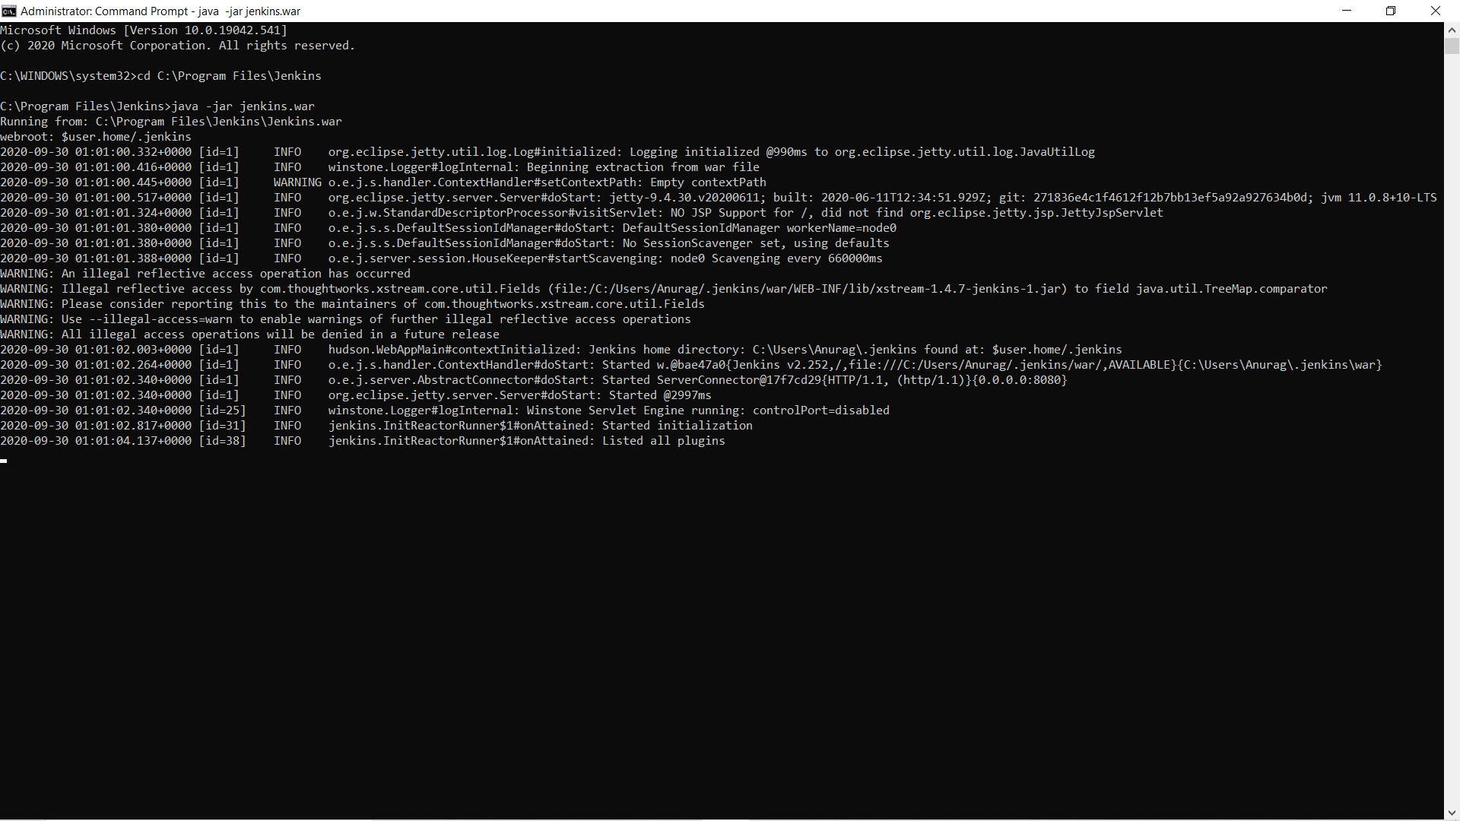

1. Once you run the command ,open google chrome and write in url :- localhost:8080 which is the default browser of Jenkins.
2. Now when Jenkins is running you will get a password in the command prompt for the intial time ,copy that password and paste it in the Jenkins intial password page.

If password is not available in command prompt then you go the path given on the Unlock Jenkins

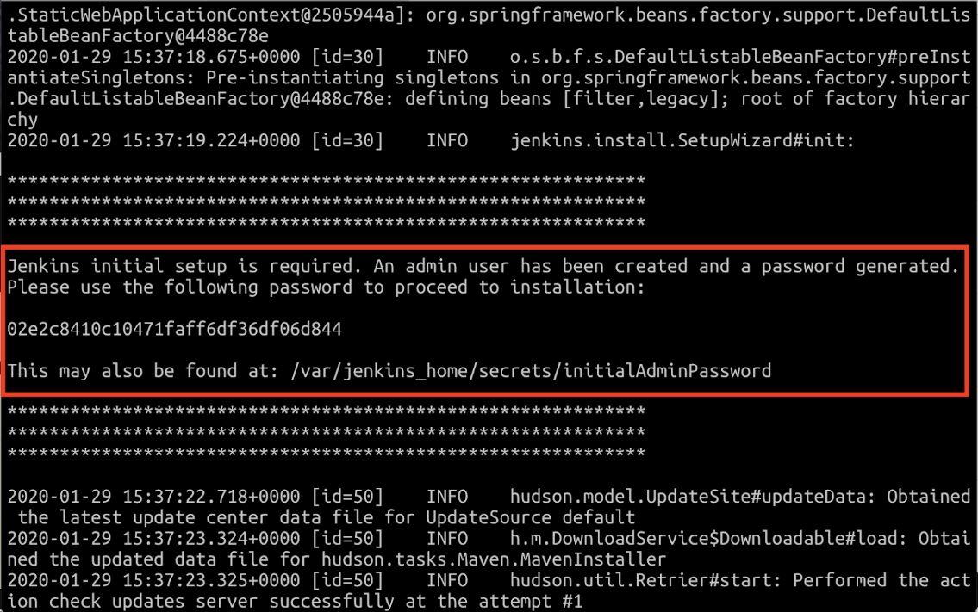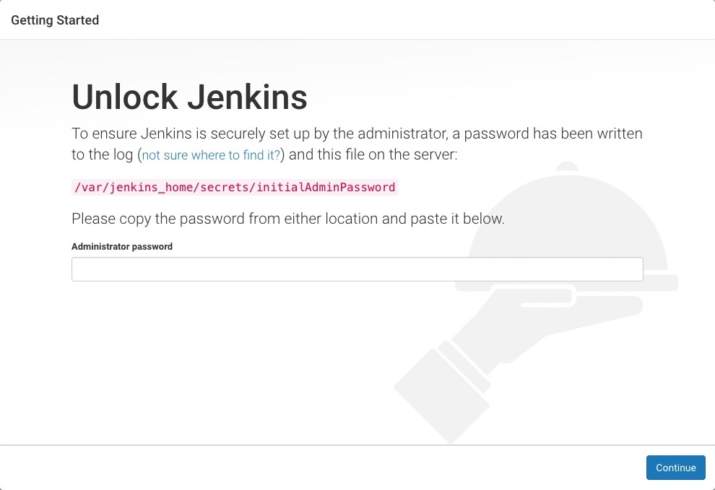

1. Now after entering the first time password it will ask for setting up the account details like username and password , set accordingly.

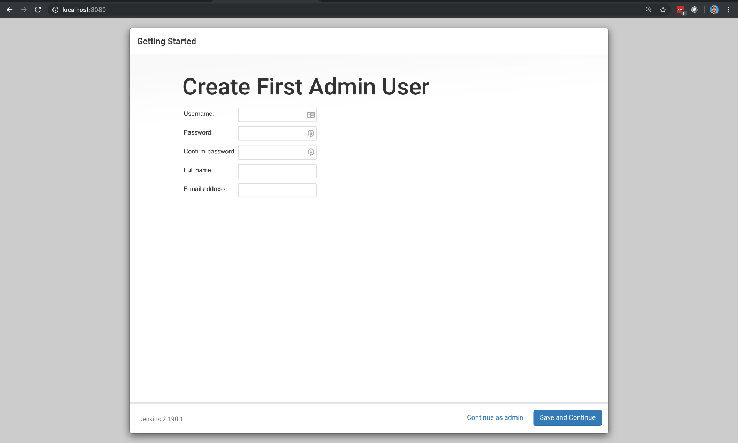

1. After this a page will come where it will ask you to install plugins so click on install suggested plugins.



And plugins will start downloading like the following picture:-

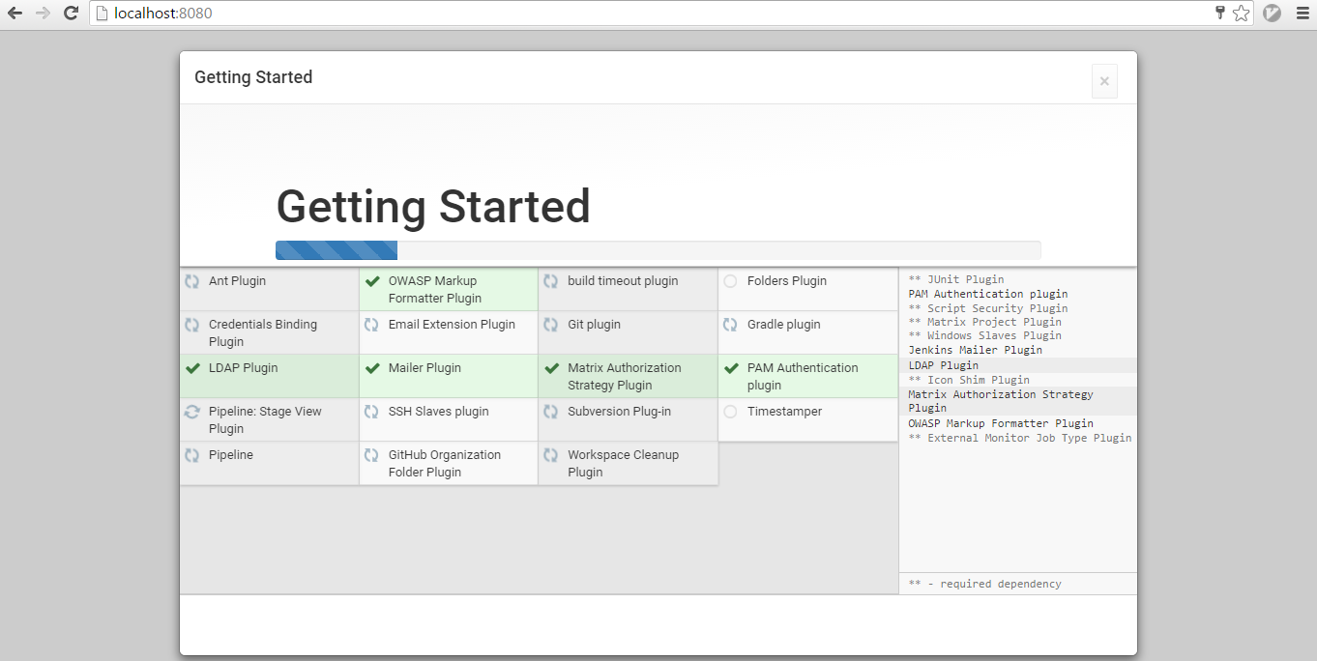

1. After the download is completed you will see your homepage of Jenkins:-

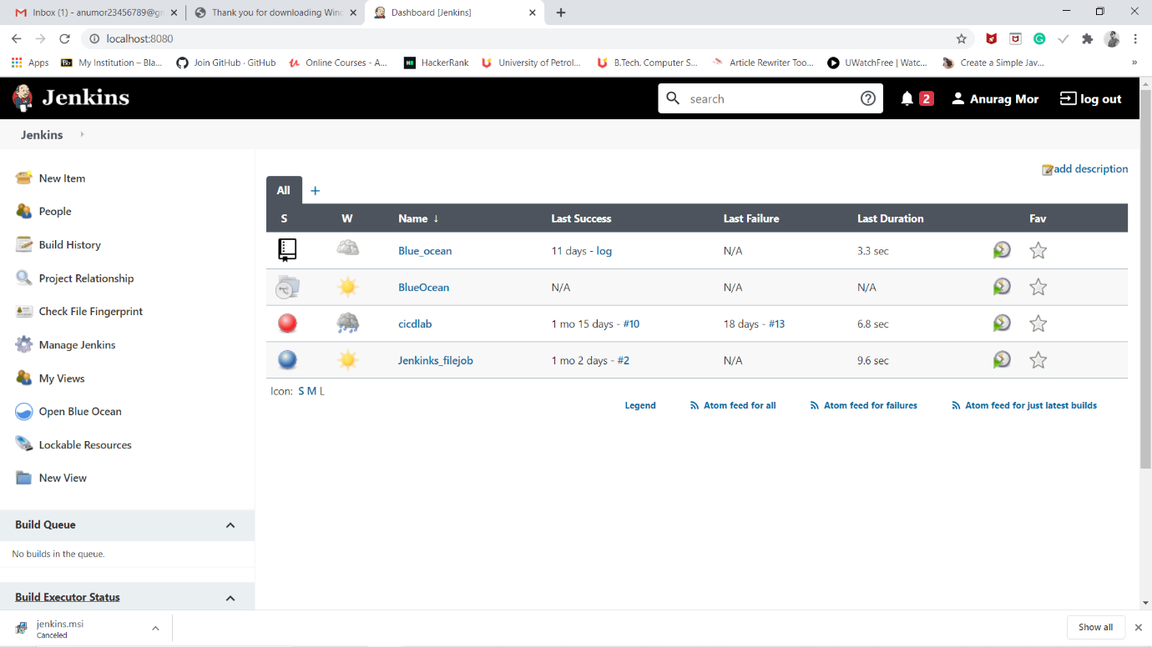

1. Now when you will again run Jenkins you will require the user name and password set by you and a window will appear like this:-

