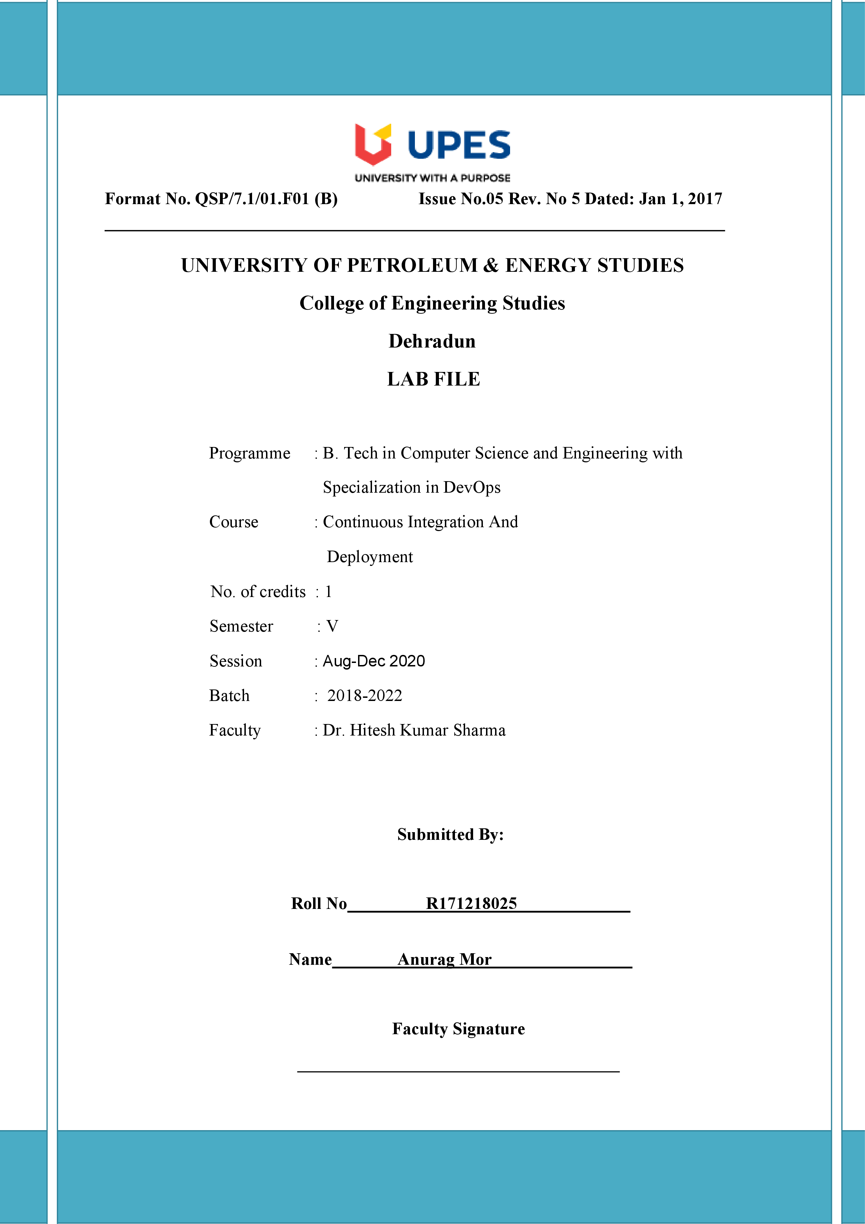

**Experiment 2 14-08-2020**

**Aim: - Jenkins Integration with GitHub**

Solution: -

1. Start you Jenkins and go to home page of Jenkins.
2. Now click on New Item

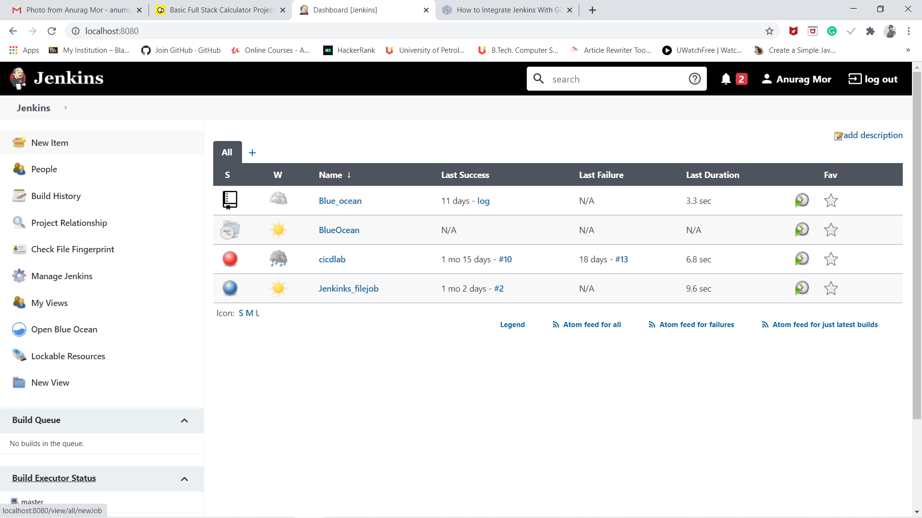

1. Now write the name of the project and choose what type of project you want to build and after choosing click on OK.

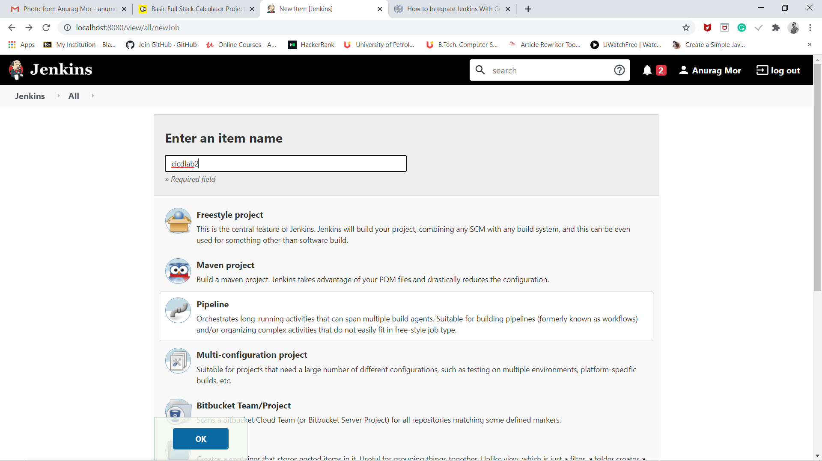

1. After this a window will appear which will ask to configure several paths.

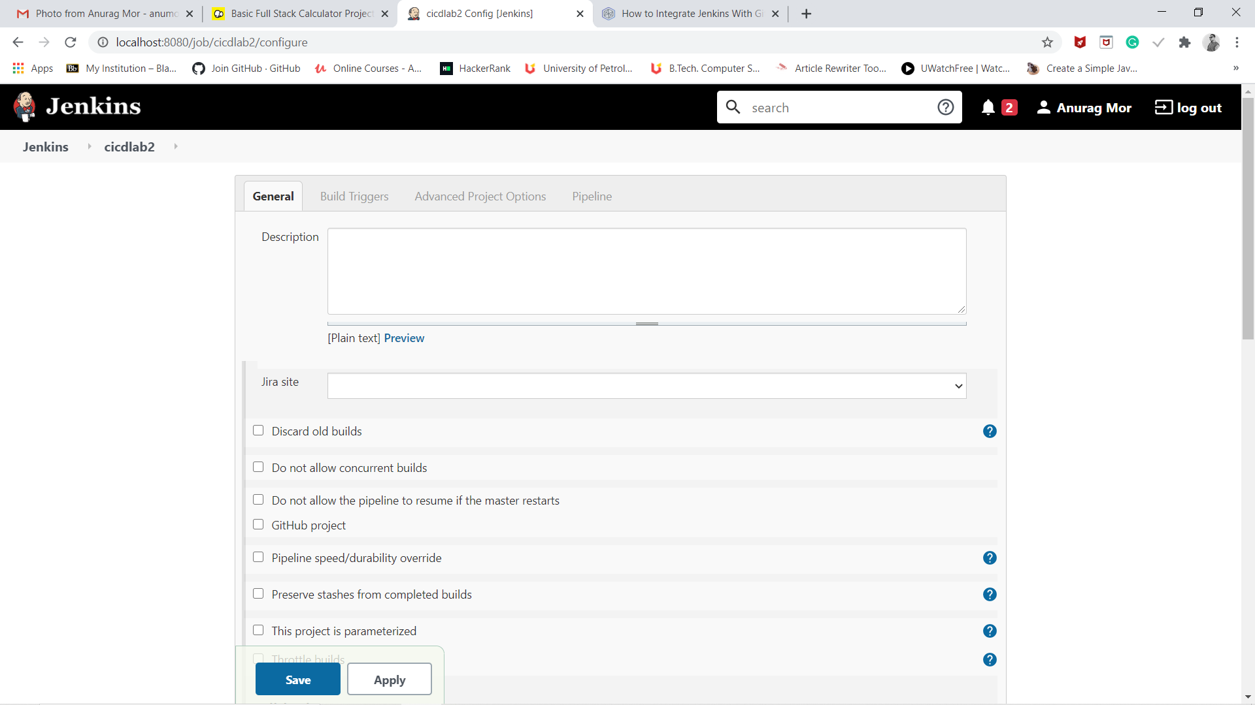

1. Now go to the section of source code management and click on git option, now you have to provide the link of repo of git in that section and now click on save option.

