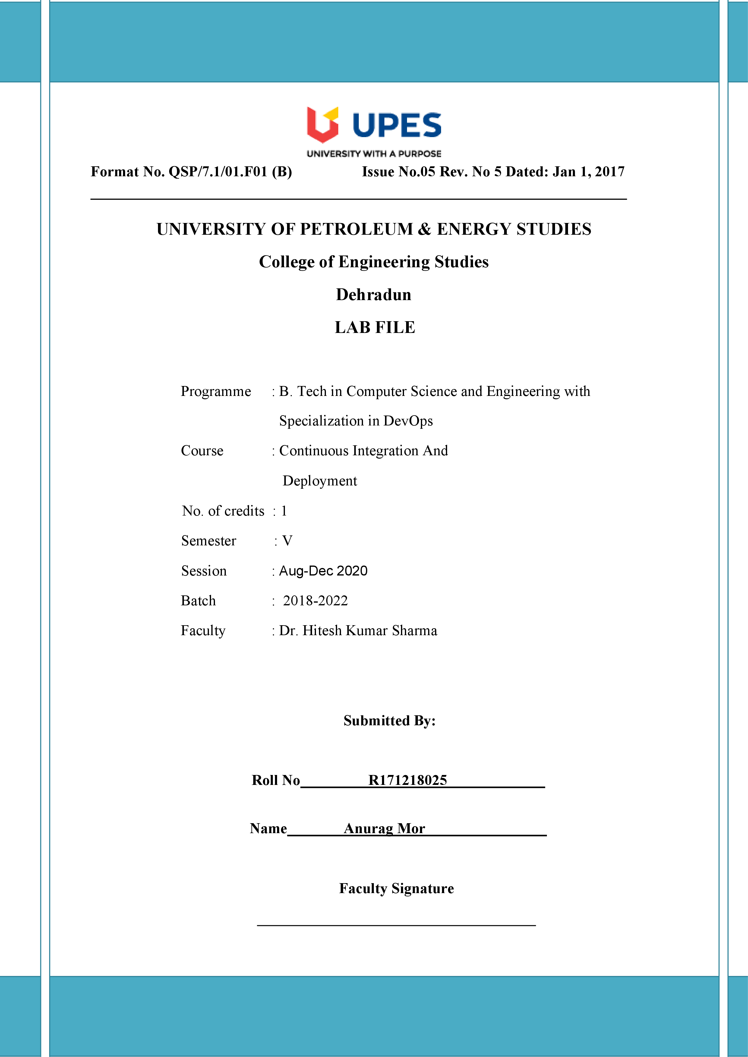

**Experiment 3 Date: - 14/08/2020**

**Aim: -** Jenkins integration with maven and github.

Solution:-

1. Open administrator command prompt and run the Jenkins commands to run Jenkins.

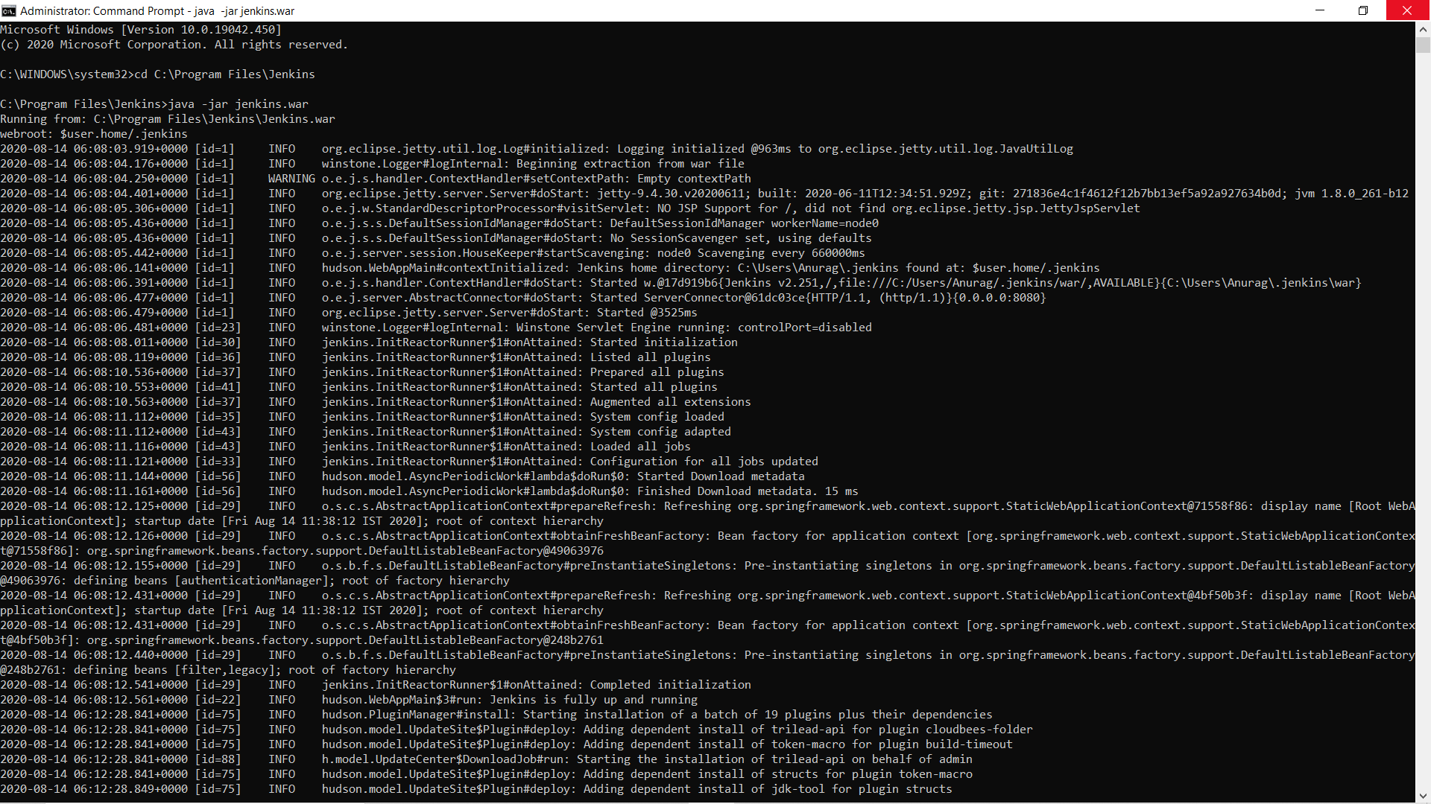

1. Now go to manage plugins check in installed plugins whether you have Maven Integration plugins or not. If you do not have that plugin then go in install and install the plugins.

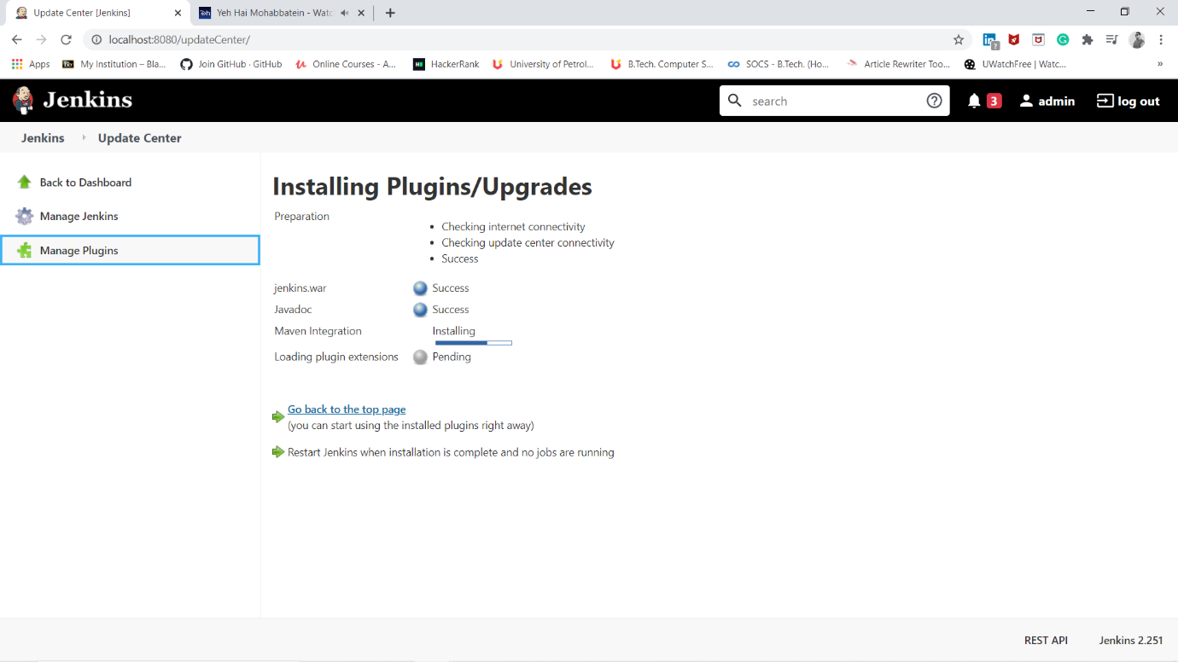

1. Now open the eclipse and make a new maven project. Now after writing the code in toolbar menu at right side you will have a perspective option in that select git option. A git window will open click on the option clone and commit. Now configure the system with git credentials. Now go back to the package explorer and left click on the option and select on commit option and select git. A new tab will be opened like in below figure. Now complete staging part and click on commit options.

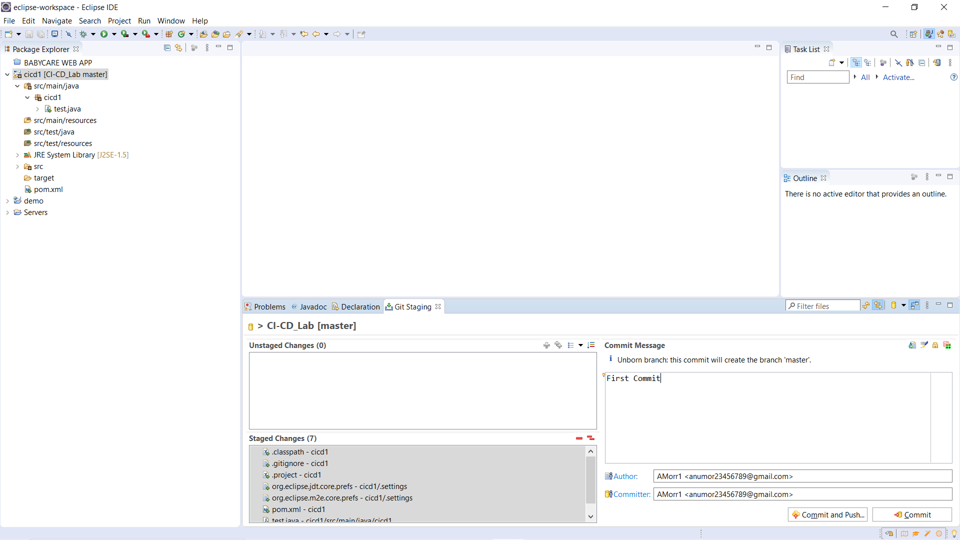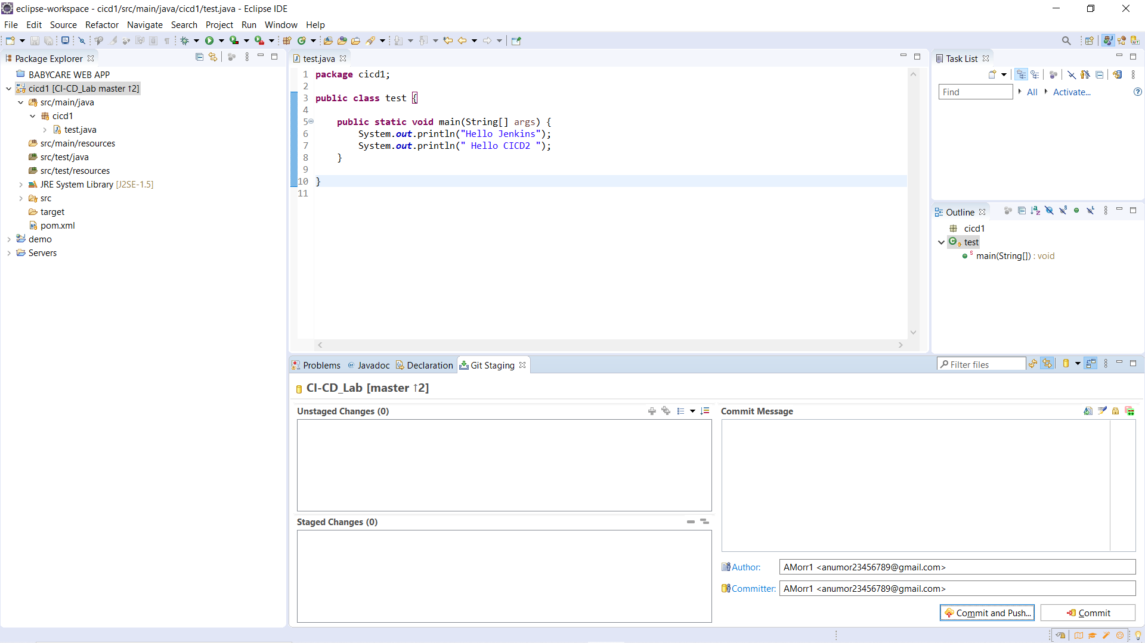

1. Now check the git repo you will see the code is pushed.

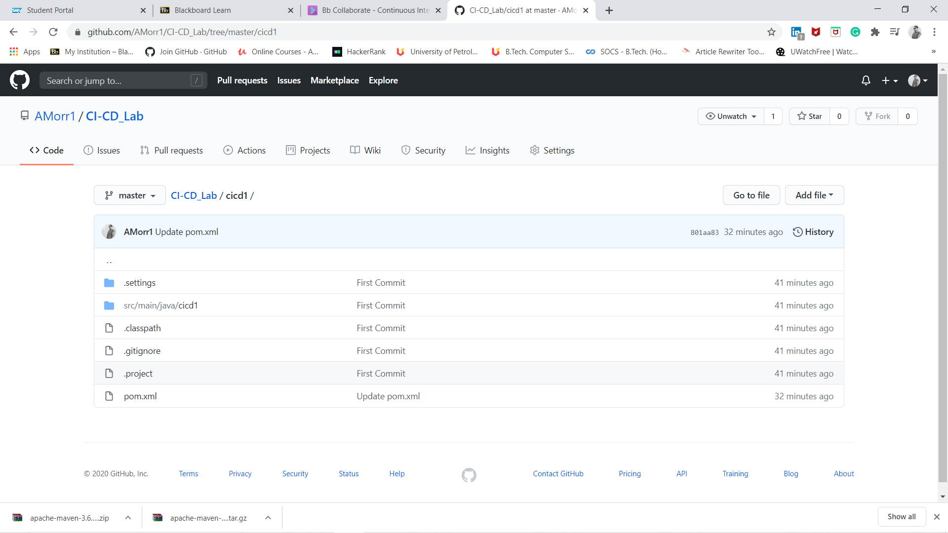  
5) Now in Jenkins make a new item and create maven project and save the option. Now open source code management and set the link of repo and also set the path of maven and write the goal you need to perform. 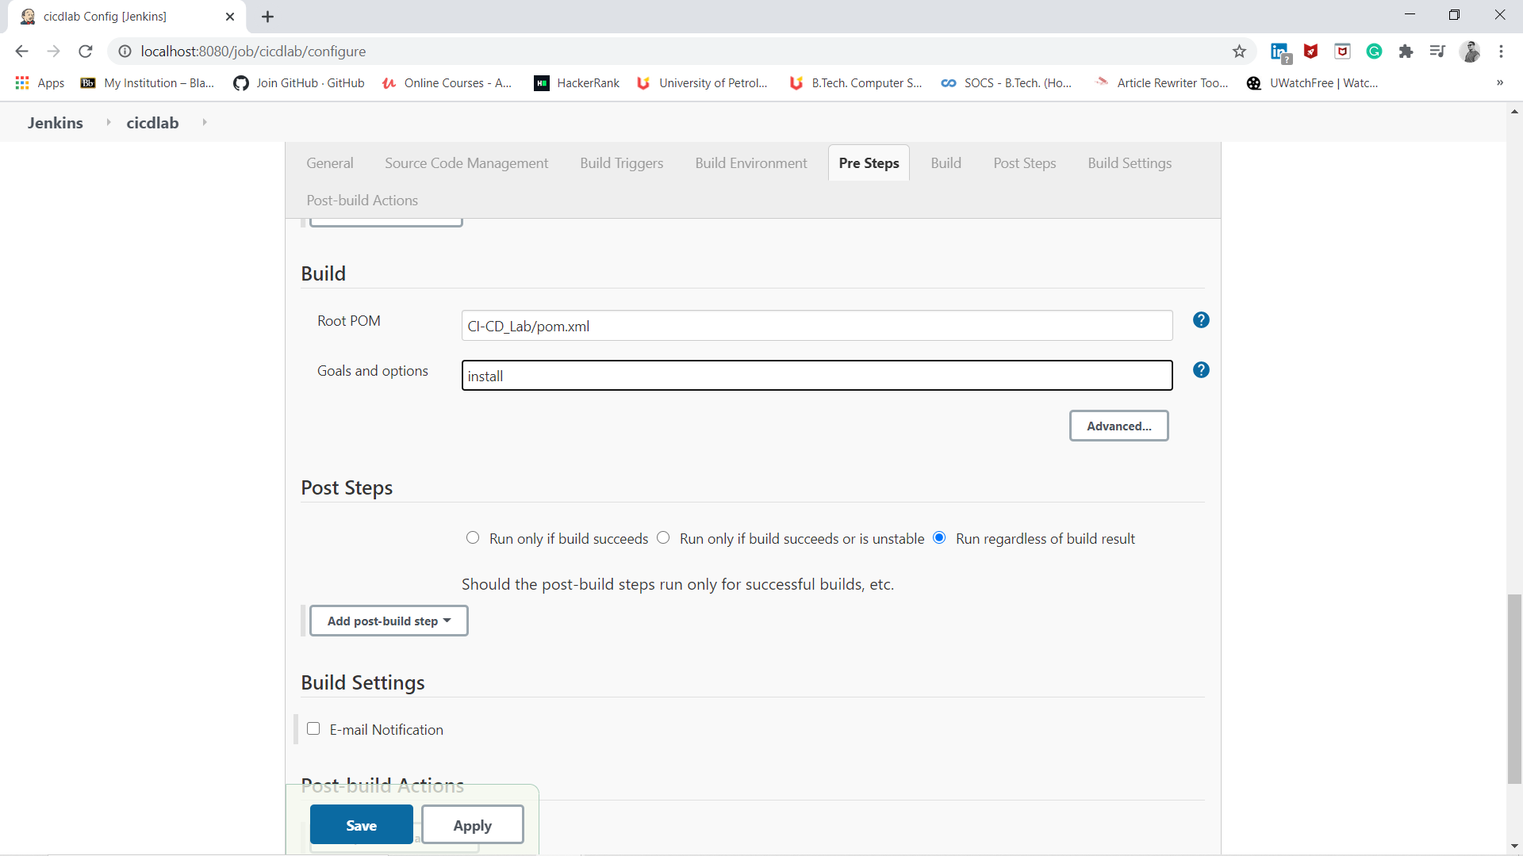

1. You will see in workspace that the project is in workspace in left menu you will see a build option click on that.

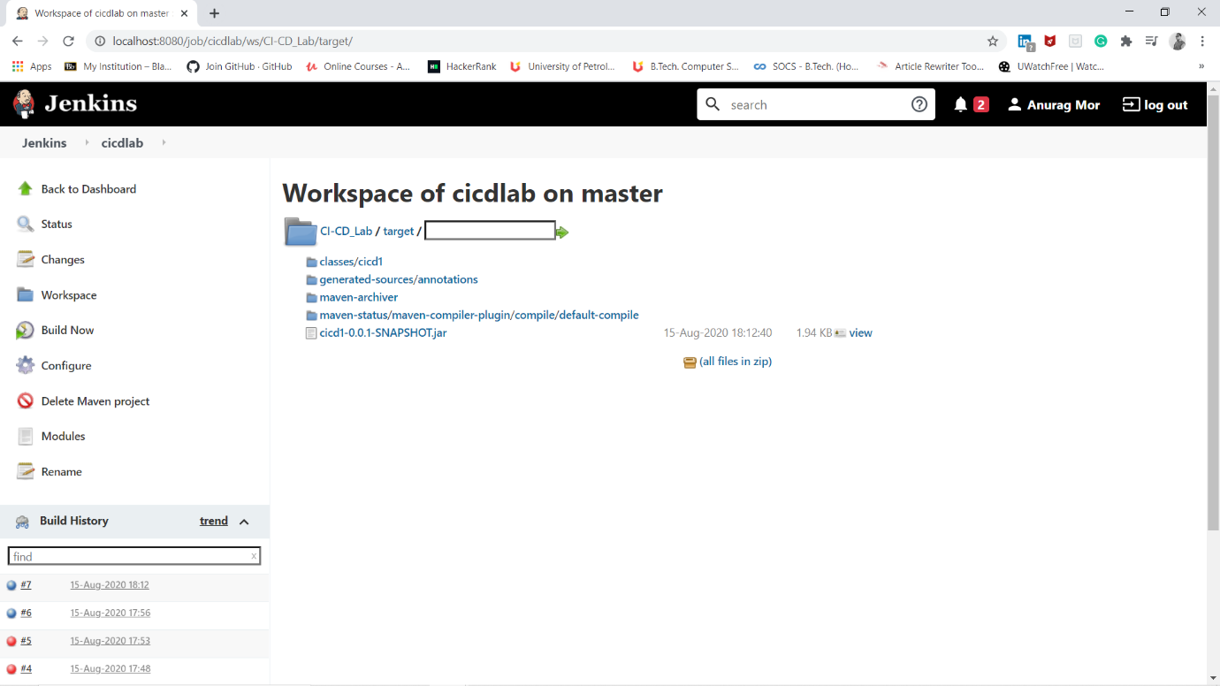

1. Now open the command prompt of build history and you will see the build is done successfully.

