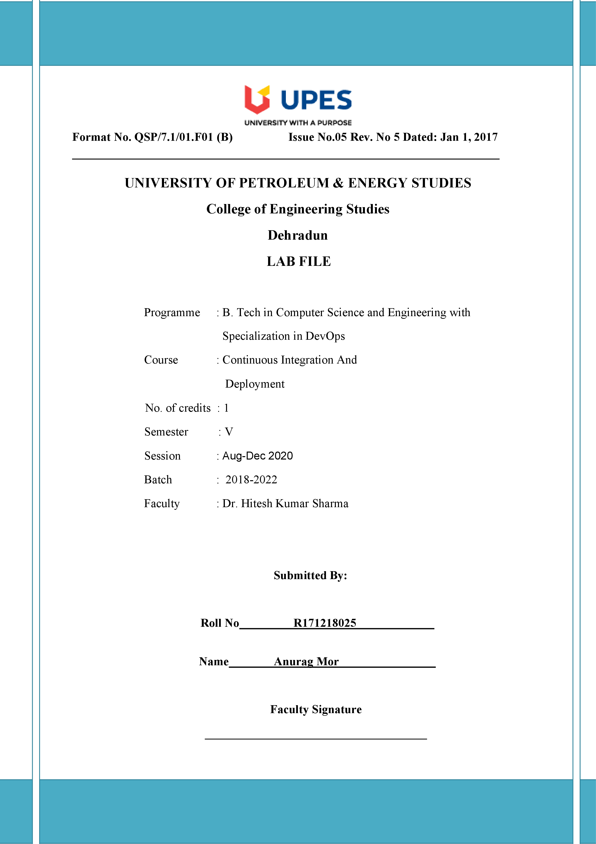

**Experiment 4 21/08/2020**

**Aim: - Static Code Analysis of SonarQube.**

Solution: -

1. Download SonarQube and unzip it in the folder you want and now to go the bin folder in that you see 4 option like windows ,Linux , macOS choose according to your machine and go inside the folder now copy the path and open command prompt and go that location run the command Startsonar.bat this will take some time to start now go to chrome and write localhost:9000 ,once SonarQube is up you will see that a login page appear by default id is admin and password is also admin.

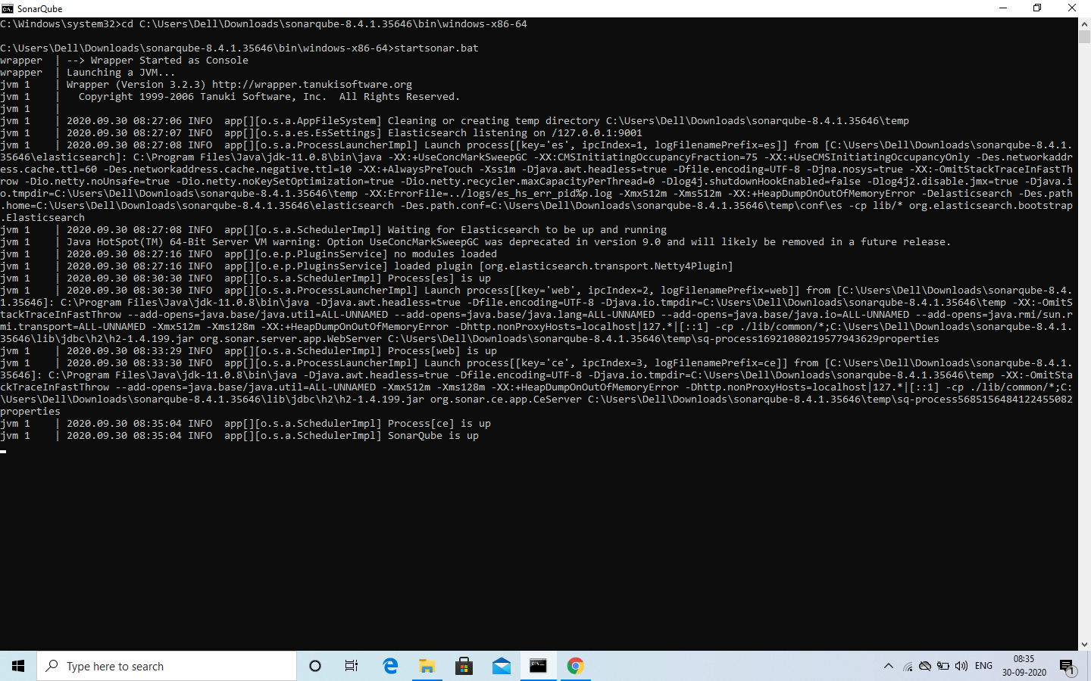

1. Now go to the maven project folder where pom.xml file is kept ,now open the pom.xml and make some changes which are required like include the dependencies of org.sonarreport.pdf. and you can copy that from mvn repository.

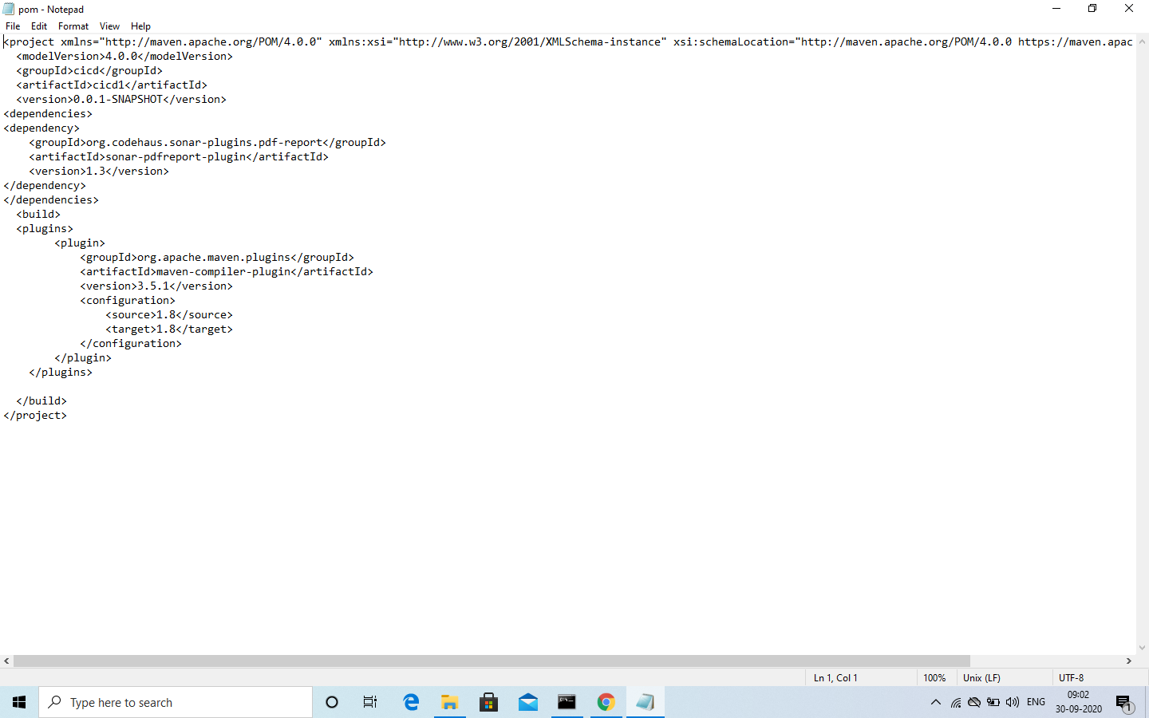

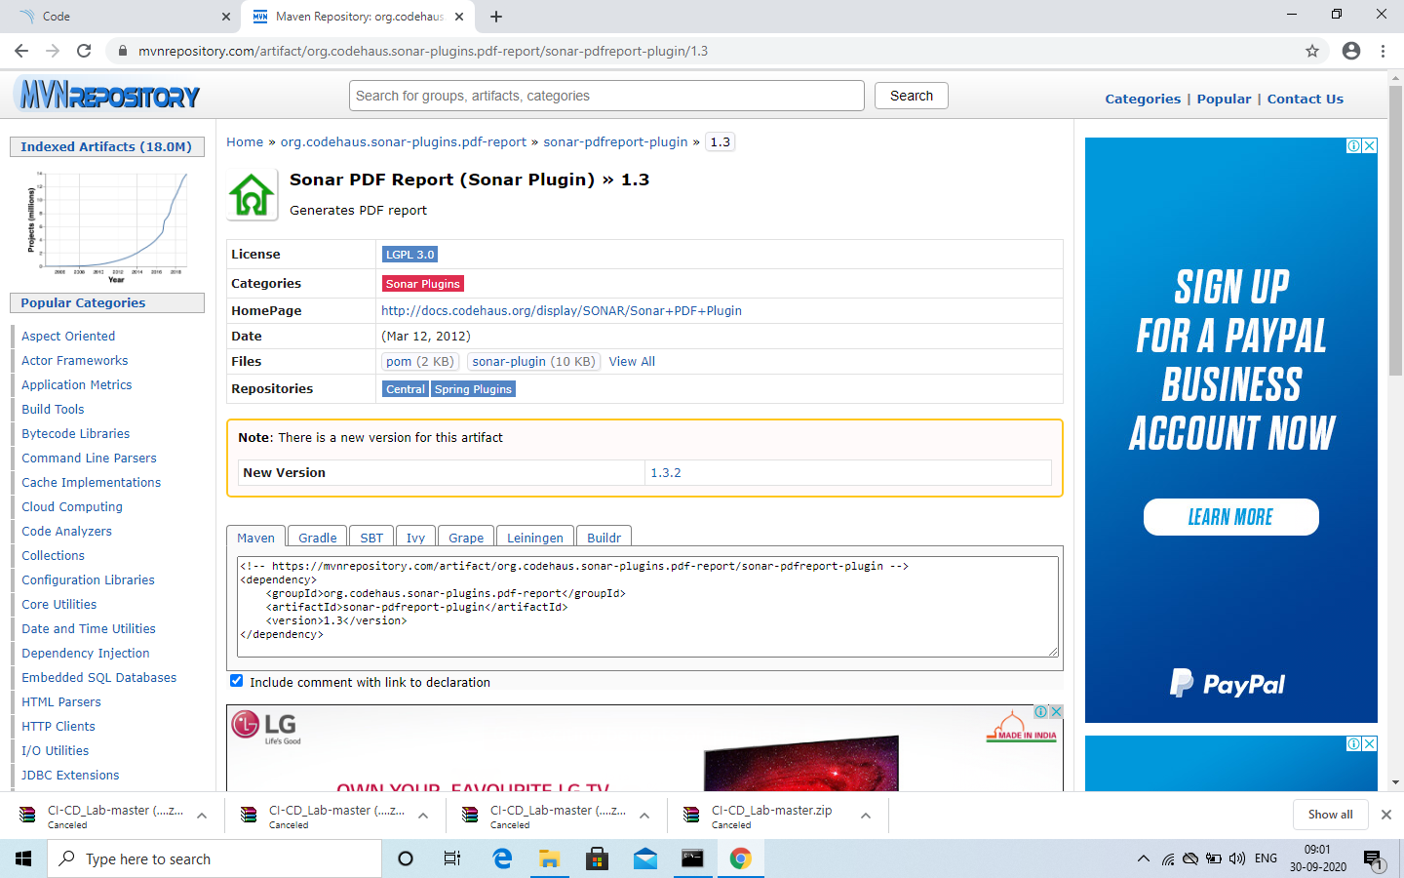

1. Now open a command prompt and go to the path where pom.xml is kept after you visited there write command to deploy

mvn clean install sonar:sonar -Dsonar.host.url=*http://localhost:9000 - Dsonar.analysis.mode=publish org.codehaus.sonar-plugins.pdf-report:mavenpdfreport-plugin:1.3:generate*

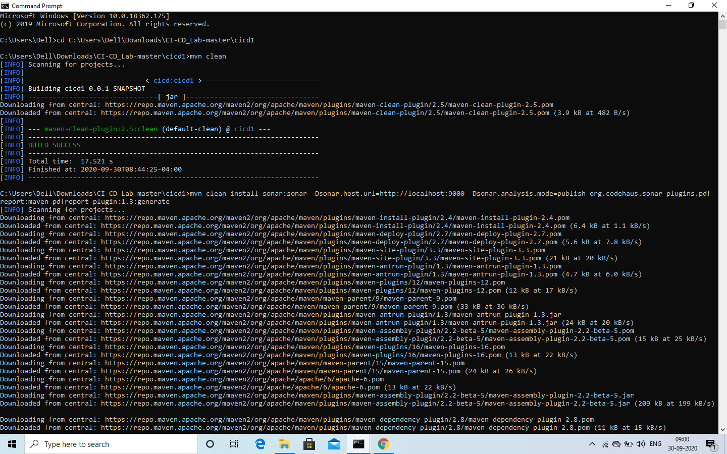

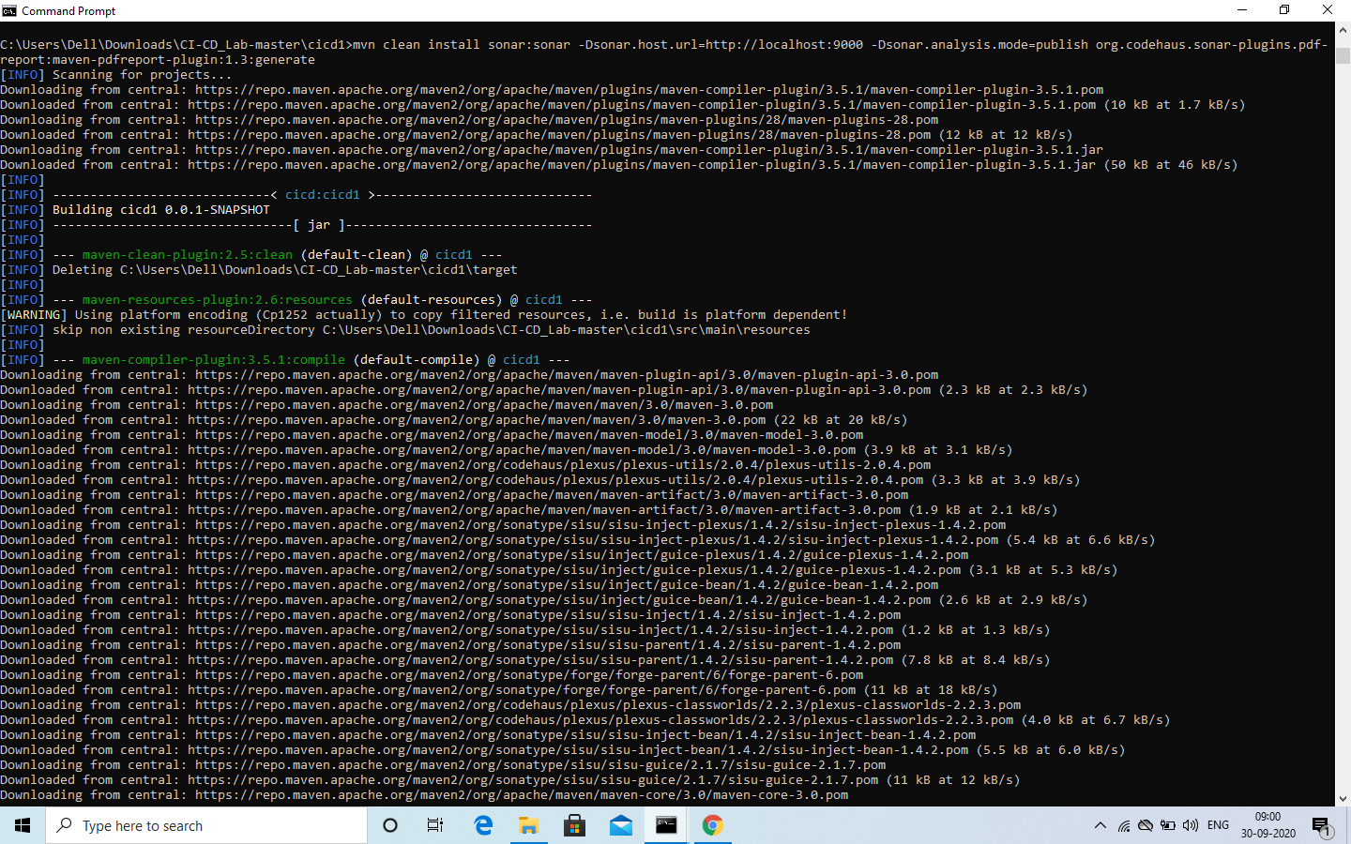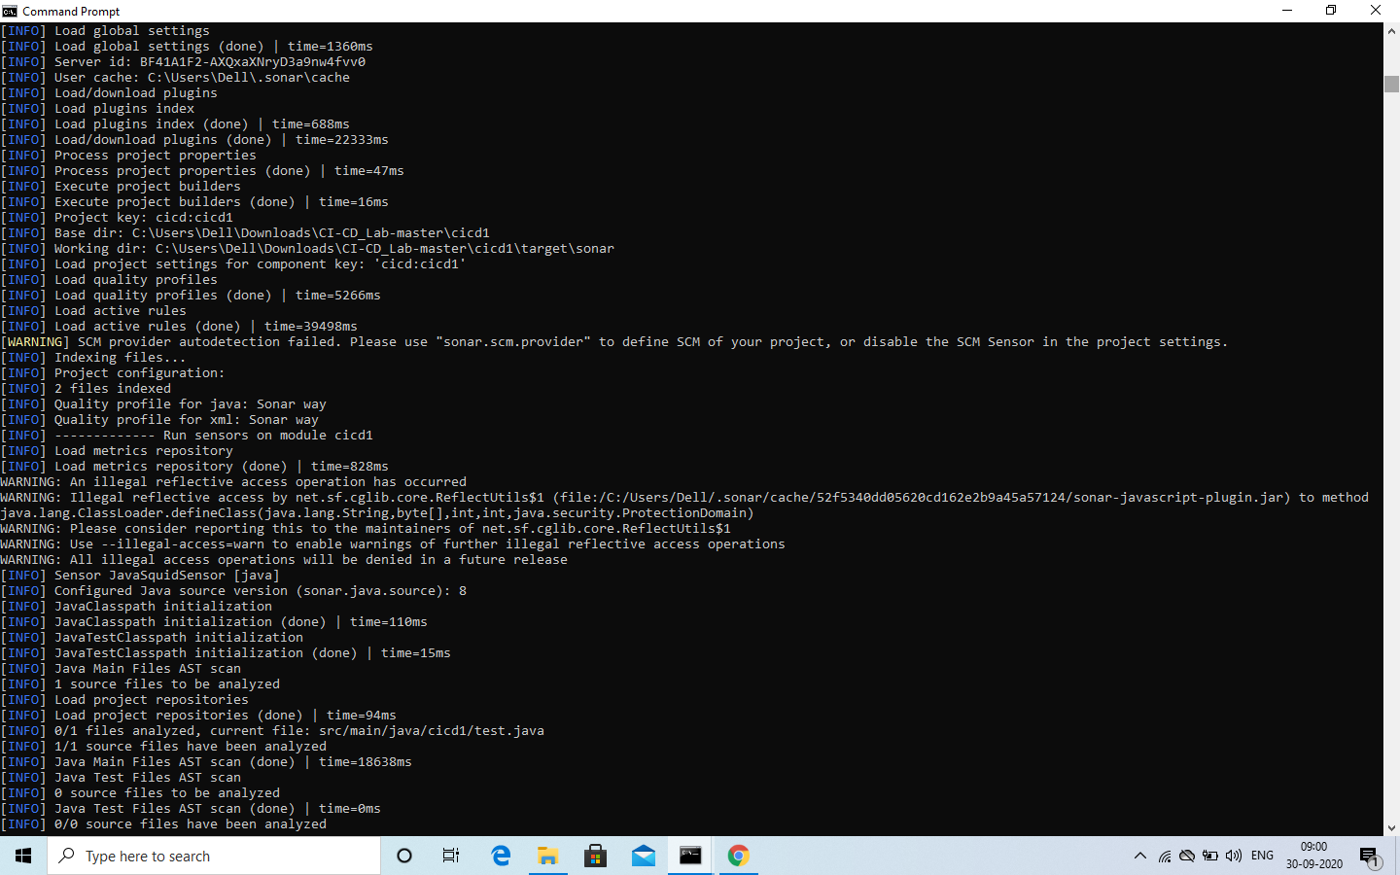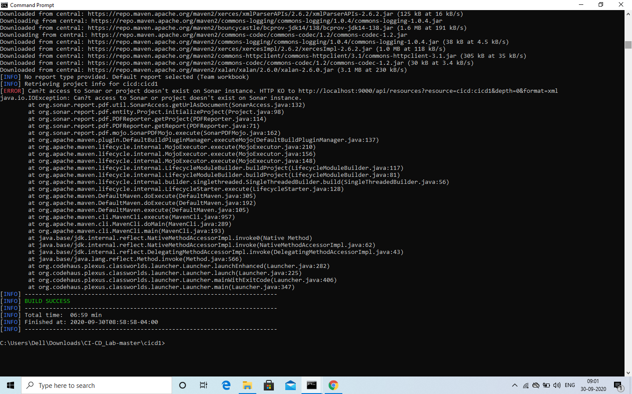

1. Now check folder you will see the target folder is also build it means this command has run the goals like clean install and then it deployed.

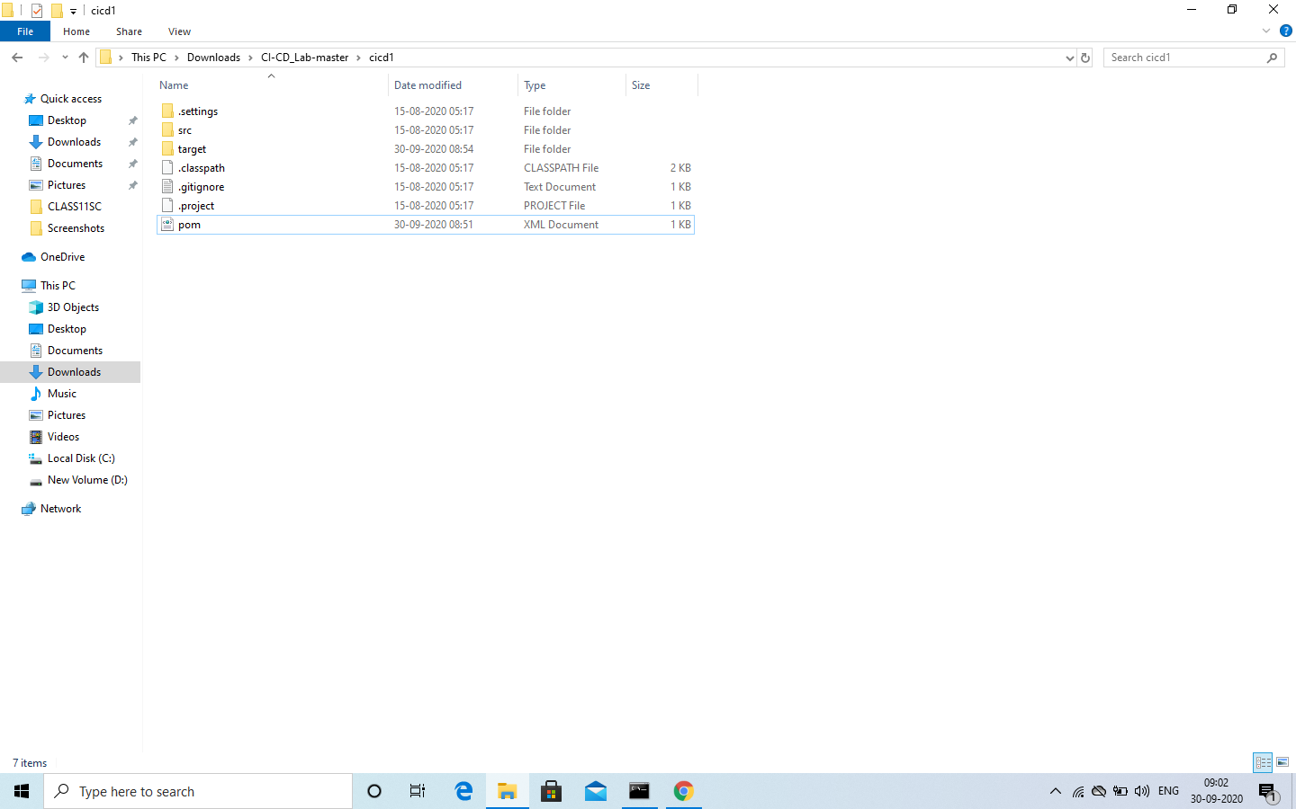

1. Now check sonarqube you will see the same project is available with the output of quality check and all.

