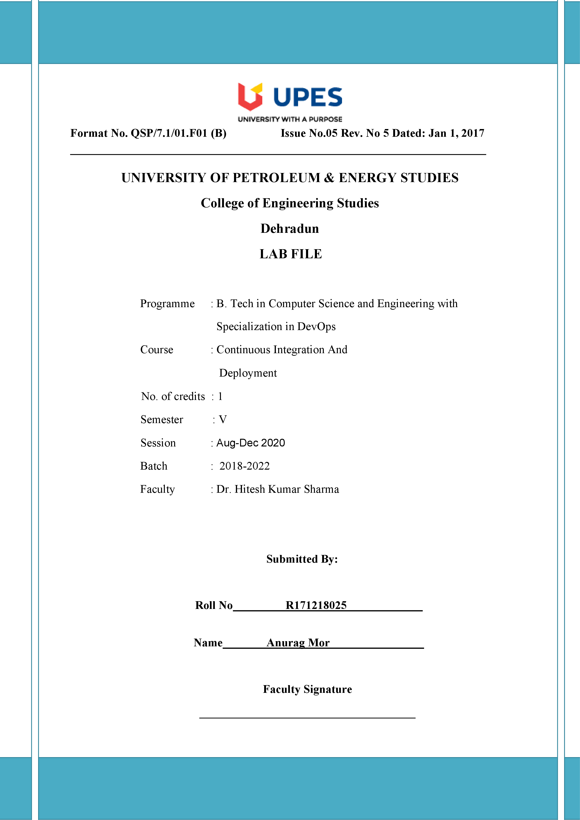

**Experiment 5 Date: -28/08/2020**

**Aim: -** Jenkins Integration with SonarQube.

Solution: -

1. Open administrative command prompt and go to the path of the folder where Startsonar.bat and run command Startsonar.bat and server will be up.
2. Now open eclipse and make a maven project and push it to GitHub through maven.

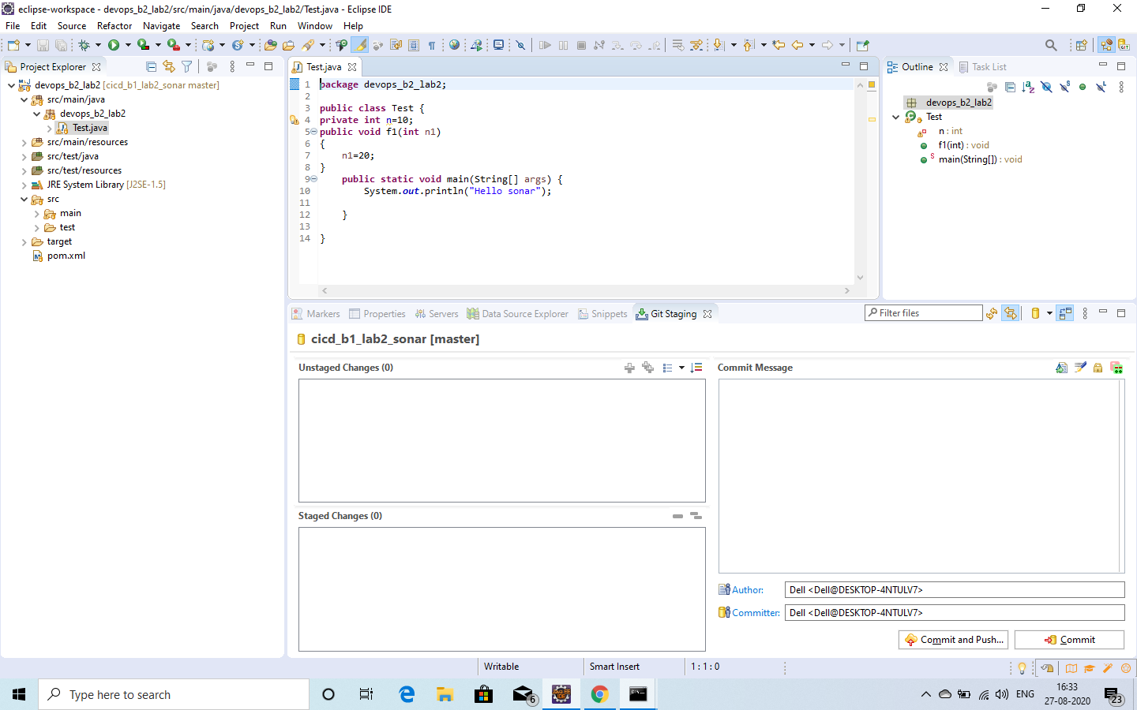

1. Now open your GitHub and copy the link of repo.

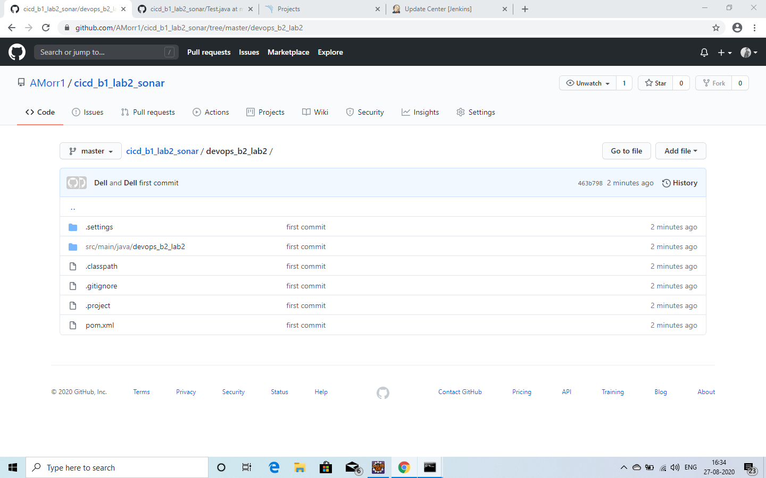

1. Now open the new command prompt and start the server and now go to the new item and make a maven project and now configure the settings of the maven (deploy) , git and provide the link of sonarqube where the quality check will be done.
2. Now click on build option you will see the deploy command has output build success.

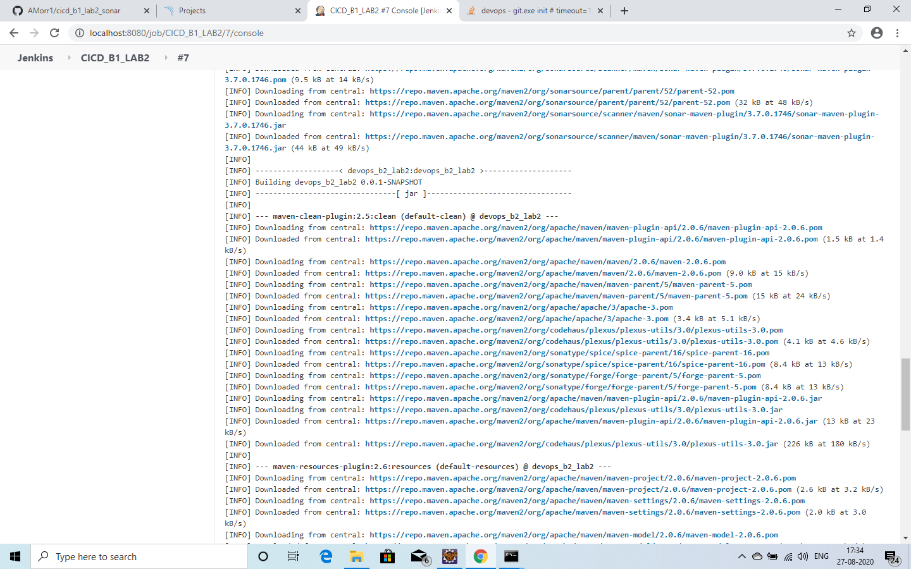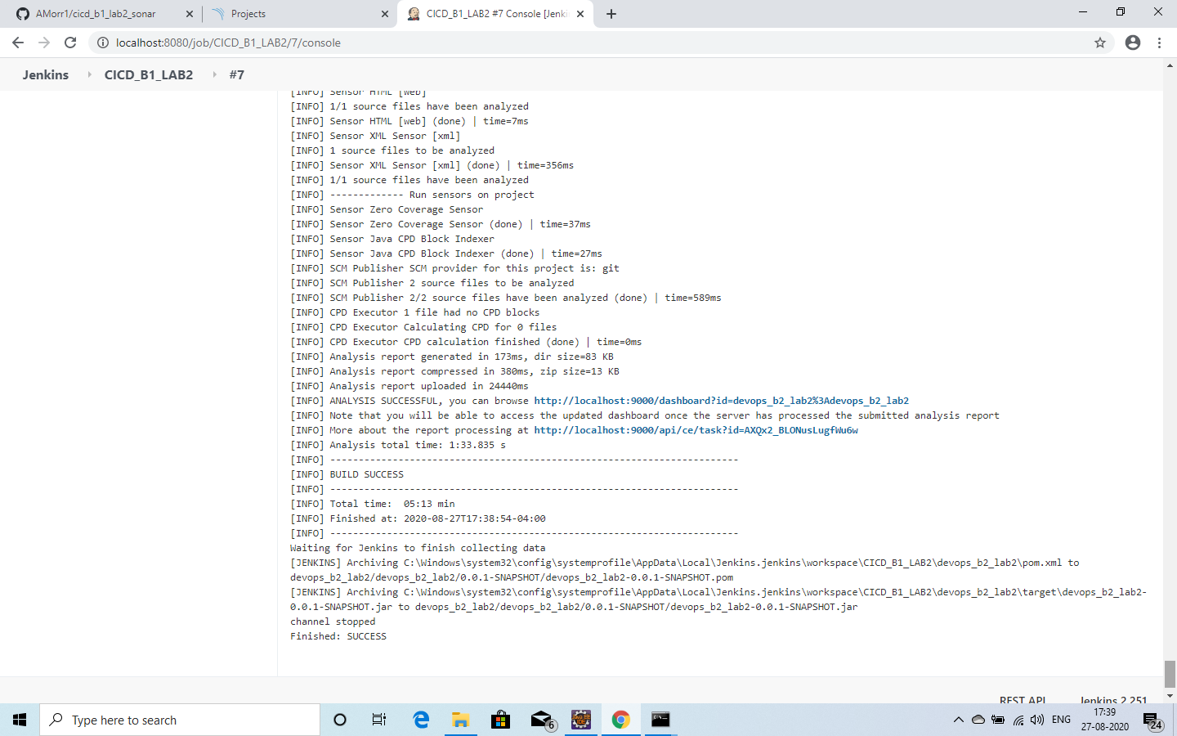

1. Now check SonarQube you will see that your project has been done the quality check.

